COVID-19 Global Data Analysis
Findings Report
Based on Power BI Dashboard Analysis | Source: Our World in Data | Days 131–143

779M  Total Cases | 7.12M  Total Deaths | 0.91%  Global Death Rate | 13.72bn  Vaccine Doses | 65%  Vaccination Rate

1. Cases & Deaths Overview
The first dashboard page establishes the scale of the global COVID-19 pandemic. From January 2020 to May 2026, the world recorded 779 million confirmed cases and 7.12 million deaths — a global death rate of 0.91%. A total of 239 countries and territories were affected.

1.1 United Kingdom Profile
Metric | Value | Context
Total Cases | 25.1 million | 36.84% of the UK population
Total Deaths | 232,112 | 6th highest globally
Death Rate | 0.92% | 1 in 109 who contracted COVID died

1.2 Top 5 Countries by Total Deaths
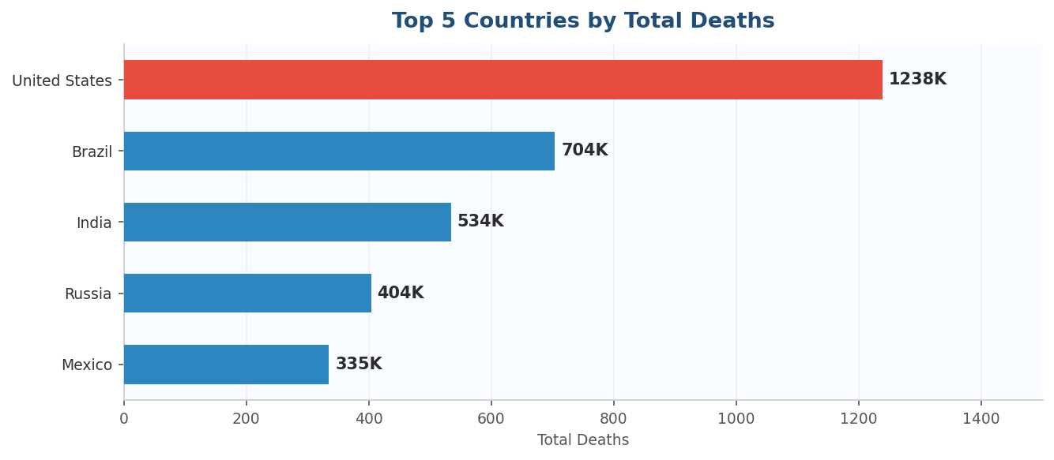

Key Finding: The United States recorded 1,238K deaths — nearly double Brazil in second place. The US, Brazil, India, Russia and Mexico together account for over half of all global deaths.

1.3 Deaths by Continent
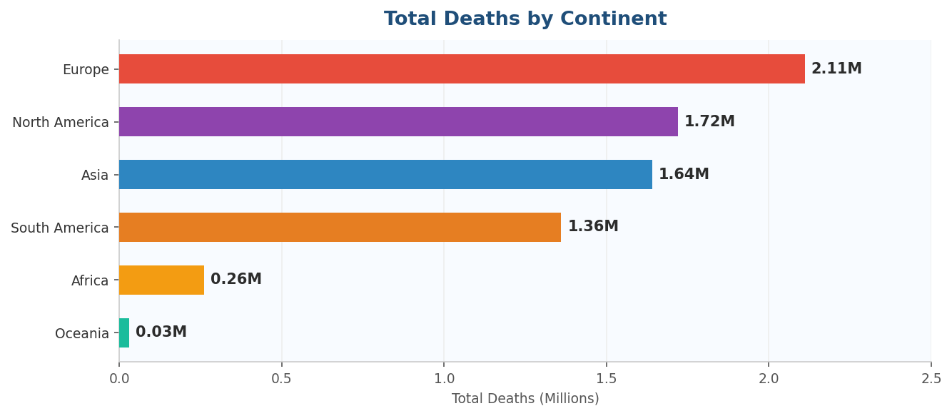

Continent | Total Deaths | Key Context
Europe | 2.11M | Hardest hit — older population, early unvaccinated wave
North America | 1.72M | US alone drove the majority of deaths
Asia | 1.64M | Lower than expected — early SARS experience helped
South America | 1.36M | Brazil and Peru were the biggest contributors
Africa | 0.26M | Youngest population + possible underreporting
Oceania | 0.03M | Island geography aided natural containment

Key Finding: Europe recorded the most deaths despite having some of the strongest healthcare systems in the world — primarily because the first wave hit before vaccines existed and before COVID treatment protocols were established.

2. Vaccination Progress
The second dashboard page analyses the global vaccination rollout. A total of 13.72 billion doses were administered worldwide, with 5.19 billion people fully vaccinated — representing a 65% global vaccination rate. A further 2.84 billion booster doses were administered.

2.1 Top 5 Countries by Vaccination Rate
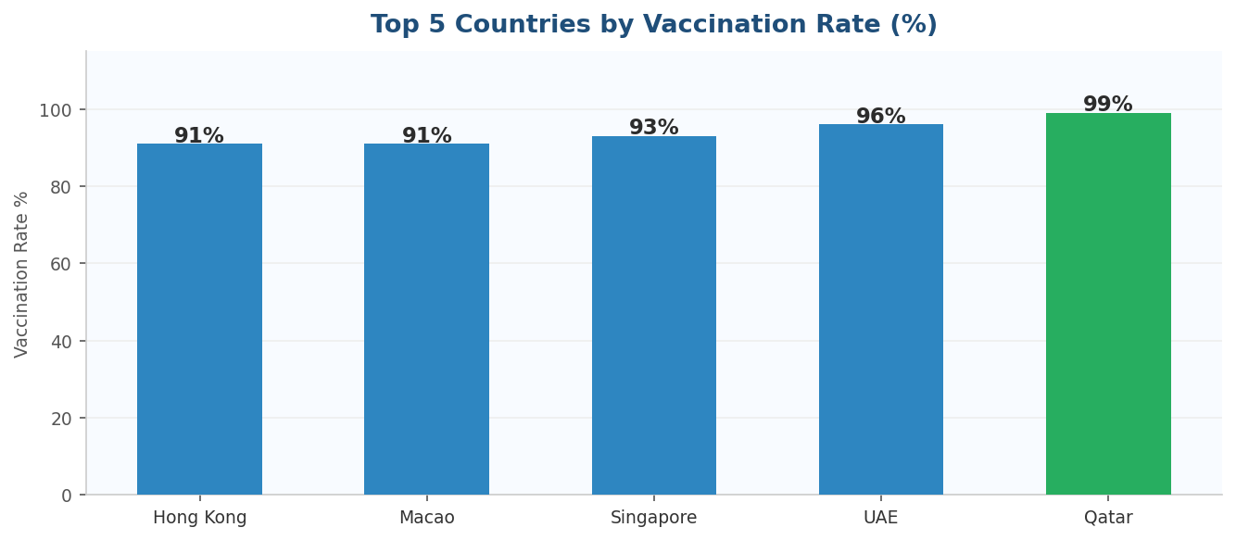

Key Finding: Qatar (99%), UAE (96%), Singapore (93%), Macao (91%) and Hong Kong (91%) led globally. All five are small, wealthy, high-density nations with strong centralised health systems that enabled rapid and comprehensive rollouts.

2.2 Vaccination by Continent
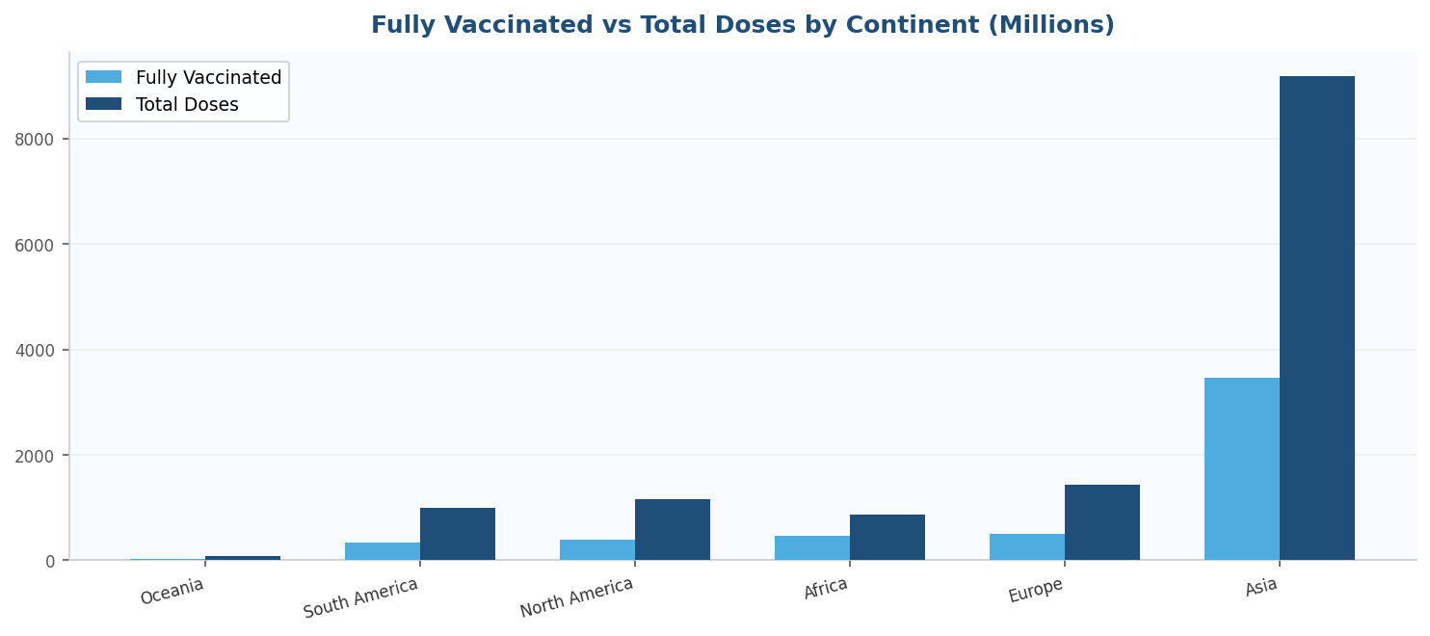

Continent | Fully Vaccinated | Total Doses | Note
Asia | 3,469.91M | 9,179.81M | Largest share globally — China led
Europe | 495.14M | 1,426.60M | High uptake across EU nations
Africa | 463.32M | 874.76M | Lower rate despite high doses — large population
North America | 394.56M | 1,159.07M | US and Canada drove volume
Oceania | 28.07M | 88.34M | Smallest reach — smallest population

Key Finding: Asia administered over 9 billion doses — more than the rest of the world combined. This reflects the sheer scale of China and India's populations rather than a higher vaccination rate.

3. Risk & Demographics Analysis
The third dashboard page explores the relationship between demographic factors and COVID outcomes. The average global stringency index was 42.68, the average R number was 0.91 and the average GDP per capita was $27.63K.

3.1 Highest Death Rates by Country
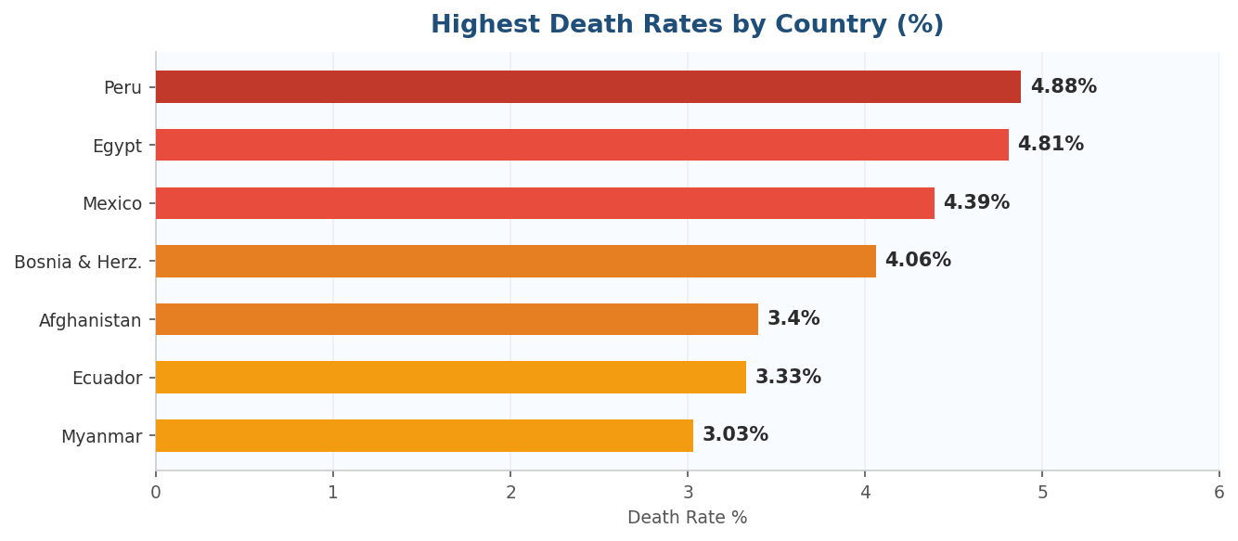

Country | Death Rate | GDP/capita | Context
Peru | 4.88% | $15,662 | Hospitals overwhelmed, late lockdown
Egypt | 4.81% | $16,798 | High diabetes prevalence, underfunded healthcare
Mexico | 4.39% | $22,040 | Late response, significant undercounting
Bosnia & Herz. | 4.06% | $20,528 | Fragmented health system, ageing population
Afghanistan | 3.40% | $3,934 | Conflict zone, near-zero testing capacity

Key Finding: The GDP vs Death Rate scatter plot shows a clear pattern — lower income countries cluster at higher death rates. However there are significant outliers in every direction, confirming that wealth helps but does not guarantee survival.

4. Deaths: Volume vs Severity
The fourth and most analytically interesting dashboard page directly compares two different measures of COVID impact — the volume of deaths (absolute count) versus the severity of deaths (death rate %). This reveals that the most deadly country and the deadliest country are not the same.

4.1 The Key Contrast
Metric | United States | Peru
Total Deaths | 1,238,123 | 221,071
Death Rate % | 0.91% | 4.88%
Total Cases | 103.4 million | 4.5 million
Why the difference? | Mass testing captured millions of mild cases — large denominator keeps rate low | Only critically ill were tested — tiny denominator makes rate appear high

Key Finding: Same virus. Completely different story depending on how you measure it. The US had the most deaths but Peru was nearly 5x more deadly if you caught COVID there. Context changes everything in data analysis.

4.2 Continental Volume vs Severity
The scatter plot on Page 4 places every country on two axes simultaneously — X axis for total deaths (volume) and Y axis for death rate % (severity). This reveals four distinct quadrant patterns:

Volume | Severity | Countries & Reason
HIGH | HIGH | Peru, Mexico, Egypt — overwhelmed hospitals AND undertesting
HIGH | LOW | US, Brazil — mass testing reduced apparent rate
LOW | HIGH | Sudan, Somalia — conflict zones, near-zero testing
LOW | LOW | Most of Asia, Oceania — early action, mass vaccination

5. Overall Conclusions
- Europe suffered the highest death toll by continent (2.11M) despite strong healthcare systems — primarily because the first wave hit before vaccines existed.
- The United States recorded the most deaths of any single country (1.24M) but Peru had nearly 5x the death rate (4.88%) — driven by testing capacity differences.
- Asia administered over 9 billion vaccine doses — more than the rest of the world combined, led by China and India.
- Qatar, UAE and Singapore achieved over 90% vaccination rates — small, wealthy, centralised nations that could mobilise rapidly.
- Countries with lower GDP consistently showed higher death rates — but wealth alone did not guarantee survival, as shown by Luxembourg's high early death rate.
- The global R number averaged 0.91 — just below the spreading threshold. Europe averaged above 1.0, meaning the virus was actively growing there throughout the pandemic.
- The most important lesson from the data: no single factor predicts COVID outcomes. The countries that did best combined early action, mass testing, rapid vaccination and strong public health systems simultaneously.

Bottom Line: The pandemic was not won or lost by any single policy, demographic factor or level of wealth. It was decided by the speed, consistency and equity of the response — and the Power BI dashboard shows exactly which countries got that right and which ones did not.

Days 131–143 | 365 Days of Data Analysis | Mannan Hakim | MBA | Tool: Power BI

