
SVKM’s NMIMS
School of Technology Management & Engineering,
Mumbai Campus

Year:-5TH | Program:- B. Tech Integrated | Semester:- IX

Subject:- Mobile Application Development
Subject Code:-702AI0E002
Mini Project Title
ReportR: Civic Issue Reporting and Resolution Platform
Team Details
Vansh Panchal – C139
Sooumya Modi – C155
Mannan Sheth – C158
Aryan Shroff – C159

Bachelor of Technology (Computer Engineering)
Fifth Year, Semester IX
Faculty: Prof Aishwarinandini Bishnu
AY 2026-27

TABLE OF CONTENTS
Chapter 1: Introduction
1.1 Introduction to the Project
1.2 Problem Statement
1.3 Objectives of the Project
1.4 Scope of the Project
1.5 Proposed Solution
1.6 Organization of the Report
Chapter 2: System Analysis
2.1 Existing System
2.2 Limitations of the Existing System
2.3 Proposed System
2.4 Feasibility Study
2.5 Functional Requirements
2.6 Non-Functional Requirements
Chapter 3: System Requirements
3.1 Hardware Requirements
3.2 Software Requirements
3.3 Development Tools and Technologies
3.4 Emulator and Physical Device Requirements
Chapter 4: System Design
4.1 System Architecture
4.2 System Flowchart
Chapter 7: Results and Discussion
7.1 Screenshots of the Application
7.2 Emulator Execution Results
7.3 Physical Device Execution Results
7.4 Limitations of the Project
Chapter 8: Conclusion and Future Scope
8.1 Conclusion
8.2 Learning Outcomes
8.3 Future Enhancements

CHAPTER 1: INTRODUCTION

1.1 Introduction to the Project
ReportR is a mobile application for reporting civic issues and following their progress. Residents can capture or select a photograph, review suggested issue categories, attach a location and description, and submit a report to a shared community feed. The app is designed to make local problems visible and to give residents and responsible authorities a consistent record to act on.
The project uses a Flutter mobile client and a Node.js and Express backend. The client supports report creation, personal and public report views, maps, analytics, profile functions, notifications and evidence for resolution. The backend receives authenticated requests, coordinates report validation and persistence, and integrates with external services for image analysis, media storage and push notifications. MySQL stores accounts and report records.
ReportR treats a report as a process rather than a one-time form. Reports move through statuses such as Issue Raised, Verification pending, In Progress, Resolved or Invalid Report. Community confirmations help indicate that an issue affects other residents, while resolution notes and repair photographs provide evidence about completed work.

1.2 Problem Statement
Residents frequently encounter damaged roads, overflowing waste, drainage problems, broken streetlights and similar public-space issues. Reporting channels may be fragmented across calls, paper forms and social media. Residents can lack clear feedback after submitting a complaint, while authorities may receive incomplete descriptions or reports that are difficult to locate and compare.
A practical civic reporting tool must help a person document an issue accurately, associate it with a place, avoid unnecessary duplicate reports, and provide a transparent way to follow status changes. It should also protect private account information while making public issue details useful to the community.

1.3 Objectives of the Project
1. Provide a straightforward Flutter interface for capturing or selecting evidence and creating a civic issue report.
2. Use image-based issue suggestions as an aid, while allowing the reporter to review and select categories before submission.
3. Attach geographic coordinates and a readable place label to reports, and show reported issues on a map and in a community feed.
4. Authenticate users through a phone-number workflow using a code delivered as an in-app push notification.
5. Keep report status, personal history, community confirmations and impact analytics available in the app.
6. Use duplicate detection, report verification and community resolution evidence to support consistent issue handling.
7. Protect private recordings, PDFs and personal account details through authenticated backend access.

1.4 Scope of the Project
The current scope covers the Flutter client, the Express API, MySQL-backed accounts and reports, image-based issue prediction and verification, cloud media handling, push notification delivery, map display, and community reporting and resolution features. A report can include one or more selected issue categories, a description, a location, an image, and optional audio evidence. The app generates a PDF copy for the reporter and provides actions to view, save or share it.
Community features include a public feed, priority and distance sorting, report details, one confirmation per account, resolution contributions, and community or personal analytics. A repair photo may be checked against the original report image. The app includes English, Hindi and Marathi interface text. Operational use depends on service configuration such as database credentials, API keys, Firebase setup, media storage credentials and a valid maps key.
The project is a working prototype and academic mini project. It does not claim to replace municipal dispatch systems, guarantee that an AI classification is correct, prove a person’s identity from GPS data, or guarantee a service response time. Report content and location accuracy still depend on information provided by the reporter and configured services.

1.5 Proposed Solution
ReportR brings evidence capture, location, structured categories and follow-up into one mobile workflow. The user reviews suggested issue labels and report details, submits once, and can then follow the report in personal or community views. Duplicate checks look for an active report with an exact matching issue keyword within 100 metres; the server performs the authoritative check again at upload time.
The backend stores report records in MySQL and places image and other media files in cloud storage. AI services assist with identifying visible issues and assessing submitted evidence. Push notifications deliver sign-in codes and selected report updates. Authorization rules keep owner documents and recordings private while community screens expose only the information needed to understand an issue.

1.6 Organization of the Report
Chapter 1 introduces ReportR, its problem, objectives, scope and proposed approach. Chapter 2 reviews the existing process, limitations, feasibility and system requirements. Chapter 3 lists hardware and software requirements and development technologies. Chapter 4 explains the system architecture and main application flow. Chapter 7 presents selected interface captures, execution observations and limitations. Chapter 8 concludes the report, summarizes learning outcomes and identifies future enhancements.

CHAPTER 2: SYSTEM ANALYSIS

2.1 Existing System
Civic problems are commonly communicated through municipal helplines, in-person offices, web portals and informal community channels. These methods can be effective but may require residents to know the correct department, repeat location details, or contact the organization again to learn whether action has been taken. Informal posts can reach neighbors quickly but often lack structured status, ownership and evidence history.
A mobile-first reporting system can use the phone camera and location services to collect context at the point where a problem is observed. A common record can make a report easier to review and can let the reporter see later changes without relying on a separate conversation channel.

2.2 Limitations of the Existing System
• Report details may be spread across different channels, making it difficult to retrieve a consistent history.
• Location descriptions can be vague when a resident must type an address without map or GPS assistance.
• Photos, descriptions and issue categories may not be collected together in a structured format.
• Reporters may receive limited feedback after submitting a concern, reducing visibility into its progress.
• Repeated complaints about the same place may be difficult to distinguish from separate nearby problems.
• Public updates can unintentionally reveal personal information if account and evidence access are not separated.

2.3 Proposed System
ReportR provides a guided mobile workflow that collects a photo, candidate issue categories, a user-authored description and a geographic position. The Flutter app calls authenticated Express endpoints for account, report, feed, analytics and authority functions. The backend validates input, checks for nearby matching reports, stores report data, and delegates image/media and notification work to configured services.
Once a report is accepted, it appears in the owner’s report history and, when its status permits, in the community feed. Residents can confirm an issue once per account. Resolution contributions can include a note and an optional repair photograph. The system uses explicit status and evidence rules so that an unverified photo does not automatically mark a report as resolved.

2.4 Feasibility Study

Technical feasibility
The implementation uses established tools: Flutter and Dart for the mobile application, Node.js and Express for the API, and MySQL for structured data. The project contains modules for authentication, report uploads, maps, analytics, notifications, private media delivery and issue verification. The architecture is technically feasible for a prototype and can be run locally when the database and service credentials are configured.

Operational feasibility
The app follows familiar mobile patterns: camera or gallery selection, form entry, location retry, report lists and status cards. The community feed and report detail pages expose the information needed to understand a civic issue. New users can start with a phone number and receive a sign-in code through a ReportR notification on the device. Clear connectivity and notification prompts remain important for successful operation.

Economic feasibility
Flutter, Dart, Node.js, Express and MySQL can be used with widely available development tooling. Maps, push messaging, AI analysis and media storage depend on third-party services and may have usage limits or costs according to their current plans. This report does not assume a particular free allowance or production hosting price; those costs should be estimated for the intended deployment.

2.5 Functional Requirements
1. User access: collect the user’s name and phone number, send a one-time code through push notification, verify the code and create an authenticated session.
2. Issue capture: take a photograph or choose an existing image and request issue predictions from the backend.
3. Category review: allow users to inspect predictions, select one or more issue categories and edit the report description.
4. Location handling: request foreground location permission, obtain coordinates, allow retry and retain the reported issue location with the report.
5. Report submission: validate required fields, precheck nearby exact-keyword duplicates, save a recoverable local draft, create a PDF and upload report data and media.
6. Report access: show personal reports and permitted public community reports with descriptions, categories, locations, status and priority.
7. Map and search: display issue markers when maps are configured, support location centering and location search, and retain a browsable report list when map tiles are unavailable.
8. Community participation: accept a unique confirmation per account and resolution notes or optional repair photographs subject to configured proximity and evidence rules.
9. Analytics: present community totals and personal impact measures such as submitted, active, resolved and invalid reports.
10. Privacy and media: restrict owner PDFs and recordings to authorized access and omit private account details from community-facing report data.
11. Language support: provide English, Hindi and Marathi interface translations for key product workflows.

2.6 Non-Functional Requirements
• Usability: screens should provide clear labels, loading states, errors and retry actions, and keep report creation within a guided mobile flow.
• Performance: network and media operations should run asynchronously, show progress and avoid blocking normal interface interaction.
• Reliability: preserve report drafts and evidence locally when upload steps fail, and allow the user to retry without losing report details.
• Security: authenticate protected API calls, validate submitted data, and keep private PDFs, recordings and account fields out of public responses.
• Privacy: request location only for features that need it, explain its use, and avoid exposing reporter identity in community listings.
• Maintainability: keep Flutter screens, service classes, data models, Express routes and persistence logic separated by responsibility.
• Compatibility: support Android devices meeting the project’s minimum platform configuration; iOS configuration is included in the Flutter project but requires its own build and service setup.
• Localization: preserve translated interface meaning while keeping canonical report categories and user-authored descriptions stable.

CHAPTER 3: SYSTEM REQUIREMENTS

3.1 Hardware Requirements
Development requires a computer capable of running Flutter tooling, an Android SDK and an Android build environment. A modern multi-core processor, at least 8 GB RAM and available storage for SDKs, dependencies, source files and build output are recommended. An Android phone or emulator is required for device-level interaction.
The mobile experience uses a camera or image picker, network connectivity and location services. Microphone access is optional when recording an audio description. A phone with Google Play Services is needed for the configured Android maps experience. GPS quality and geocoding availability affect how precisely a report can be located and labelled.

3.2 Software Requirements
• Flutter SDK and a compatible Dart SDK for building the mobile client.
• Android Studio or another supported Android development environment, including Android SDK and platform build tools.
• Node.js and npm for running the backend and its Express dependencies.
• MySQL server with the ReportR database and applicable schema migrations.
• Internet access for authenticated API calls and configured external services.
• Environment configuration for database access, backend URL, Firebase messaging, Gemini issue analysis, cloud media storage and Google Maps where those features are used.
• Android device permissions for camera, location, notifications and optional microphone access.

3.3 Development Tools and Technologies
• Flutter and Dart provide the cross-platform mobile UI, navigation, form validation, local persistence and platform integrations.
• Node.js and Express provide REST API routing, authentication middleware, request validation and coordination of report workflows.
• MySQL stores user, report, status history and community contribution data.
• Firebase Cloud Messaging delivers the sign-in code and configured app notifications to a registered device.
• Google Gemini services support image-based issue prediction and repair-evidence verification.
• Cloudinary stores submitted report media; authenticated backend endpoints mediate access to private audio and PDF files.
• Google Maps SDK supports map display and geographic interaction when a valid API key is configured.
• Flutter packages provide camera and gallery access, location, geocoding, secure storage, local preferences, PDF generation, audio recording and playback, and network requests.

3.4 Emulator and Physical Device Requirements
An Android emulator can be used for repeatable interface checks when the relevant image, permission and location fixtures are configured. To test location-dependent behavior, the emulator must have a simulated position or the physical device must have location enabled and an available position fix. Push notification flows require the configured Firebase project and a reachable device token.
A physical Android device should run Android 7.0 (API 24) or later, have internet access, and grant the permissions needed for the selected feature. For local backend development over USB, Android Debug Bridge port reverse can map the app’s loopback request to the computer’s backend port. The Flutter configuration and backend port must match; reconnecting the phone requires repeating the reverse rule.

CHAPTER 4: SYSTEM DESIGN

4.1 System Architecture
ReportR uses a client-server architecture. The Flutter application presents screens and calls the backend through a shared API client. The Express server authenticates protected requests and routes them to feature services. MySQL persists structured records, while cloud services handle image analysis, media and push notifications. The mobile client does not connect directly to the database.
Component | Responsibility
Flutter client | Screens, navigation, input validation, media capture, location, local draft recovery and report presentation.
Node.js / Express API | Authentication, request validation, report workflows, community routes, analytics and private media authorization.
MySQL database | User accounts, issue reports, status history, community confirmations and resolution contributions.
AI and mapping services | Image-based issue suggestions, report verification, repair-evidence checks, geocoding and map tiles.
Cloud media and messaging | Report image and attachment storage, signed private media retrieval and device notifications.
The application is divided into feature screens and service classes. Screens handle user interaction, while services such as authentication, prediction, location, reports, map access and analytics wrap API or platform operations. Data models translate JSON responses into typed report, session and analytics values. Backend route modules delegate common calculations and storage behavior to reusable model and media services.

4.2 System Flowchart
The principal report flow proceeds through the following stages:
1. Open ReportR and complete phone-based verification using a push-delivered one-time code.
2. Capture or select an issue photograph; request image analysis and review the suggested categories.
3. Enter or edit the category and description, obtain the location and check required fields.
4. Ask the backend for nearby exact-keyword matches within 100 metres; if one is returned, present its details for the user to review.
5. When no matching active report is found, save the report and evidence locally, generate its PDF and submit the multipart request to Express.
6. The backend validates the request and repeats the duplicate check under a database lock before AI verification and cloud upload.
7. Persist the report and its status, return the result to the app, and show the report in owner and community views as allowed.
8. Accept later community confirmations or resolution evidence; update status and history when documented rules are met.
Data flow in brief: Android phone running Flutter → authenticated HTTPS/JSON or multipart request → Node.js/Express API → MySQL and configured AI, cloud media, mapping and messaging services → API response and refreshed Flutter view.

CHAPTER 7: RESULTS AND DISCUSSION

7.1 Screenshots of the Application
The following captures illustrate representative ReportR screens available in the project’s device-validation artifacts. They show the sign-in, report-entry, community-feed and analytics interfaces. Some captures originate from deterministic integration fixtures; the fixture values are illustrative and should not be read as live civic service statistics.

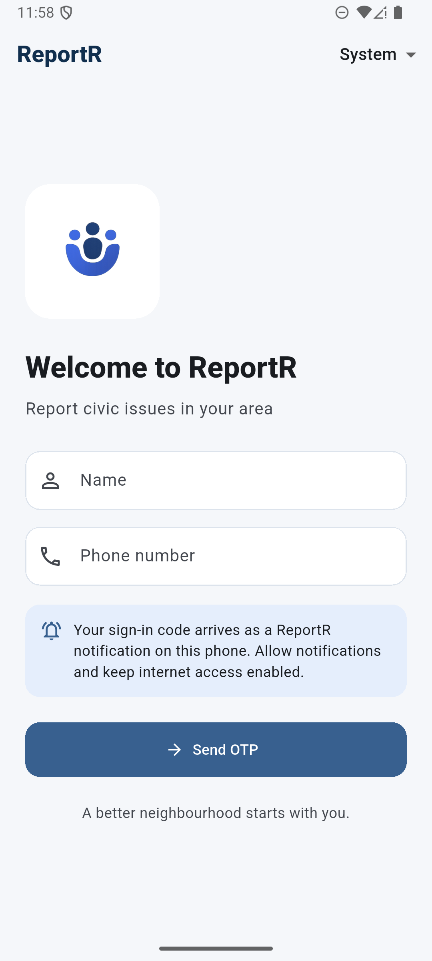
Figure 1. ReportR sign-in screen with the phone number and push-notification code workflow.

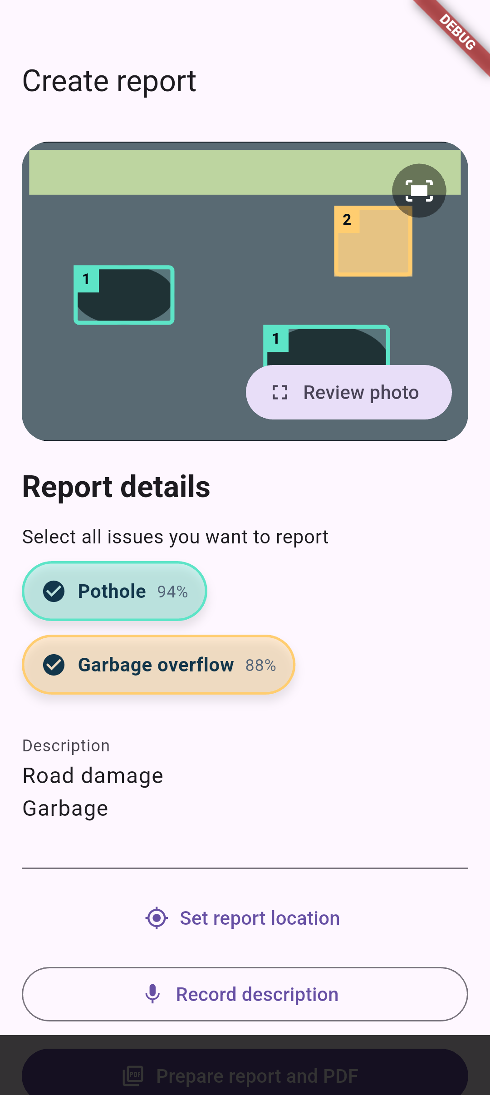
Figure 2. Report form showing reviewed issue predictions, editable details and location action.

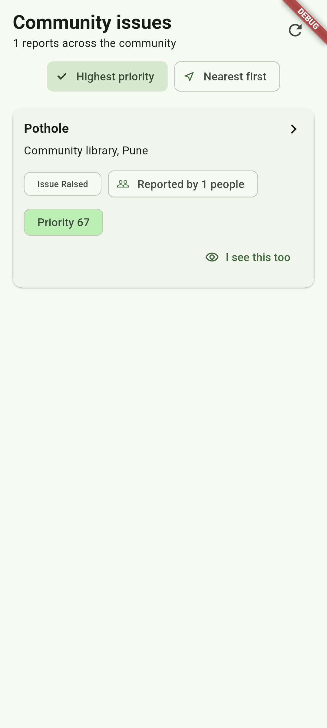
Figure 3. Community feed with issue category, location, status, confirmations and priority.

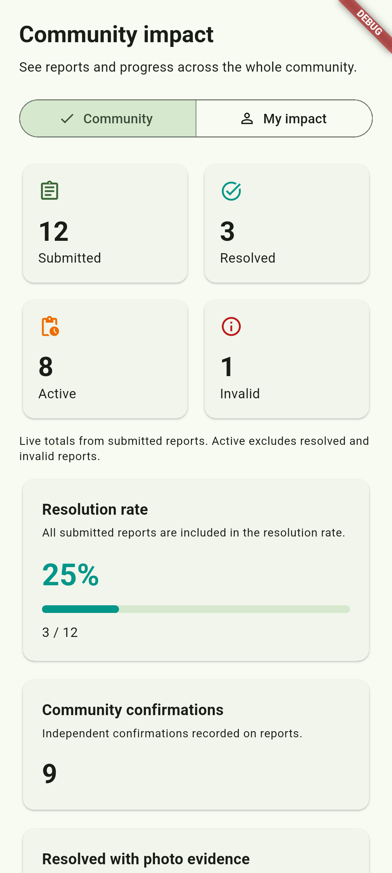
Figure 4. Community impact analytics with report totals, resolution rate and confirmation measures.

7.2 Emulator Execution Results
The repository contains Flutter unit, widget and Android integration workflows for the primary application features. Documented integration checks exercise prediction review, category selection, report details, community reporting and PDF-related flows with controlled fixtures. These checks help verify the client workflow without submitting test reports to a production service.
The Android emulator is useful for repeatable screen captures and permission-flow checks. Location-dependent cases require a configured emulator position or an injected test fixture. Live Google Maps tiles require a configured Maps key, and requests that depend on Gemini, Firebase or cloud media require valid service configuration or controlled test boundaries.

7.3 Physical Device Execution Results
The app is structured to run on a physical Android phone over USB using Flutter tooling and Android Debug Bridge. The device can provide camera, gallery, location, microphone, audio playback and push-notification capabilities that are not fully represented by a screenshot-only review. For local development, a USB reverse rule can route the phone’s loopback connection to the backend process running on the development computer.
A complete physical-device evaluation should confirm first-run permissions, push token registration, current-location acquisition, image capture and selection, report submission, push-delivered sign-in, private PDF/audio access and map configuration. Results depend on the phone’s Android version, network, GPS conditions and the keys and credentials configured for the test environment.

7.4 Limitations of the Project
• Image predictions and verification are probabilistic and should assist review rather than replace human or authority judgment.
• GPS positions can be inaccurate or spoofed; the application checks reported distances but cannot establish a user’s physical identity from coordinates alone.
• Location labels and map tiles depend on device services, geocoding availability and a valid Google Maps API configuration.
• Push sign-in depends on Firebase configuration, notification permission and delivery to the current device.
• Live report creation depends on availability of MySQL, the Express backend, AI endpoints and cloud media credentials.
• The local USB setup is intended for development. A deployed service requires production hosting, credential management, monitoring, backups, scaling and operational support.
• The community workflow provides structured evidence and status history but does not guarantee municipal acknowledgement or completion time.

CHAPTER 8: CONCLUSION AND FUTURE SCOPE

8.1 Conclusion
ReportR demonstrates an end-to-end civic issue reporting workflow built around a Flutter mobile client and a Node.js/Express backend. It combines photo-based issue reporting, editable categories and descriptions, location, authenticated submission, report history, community visibility, confirmations, analytics and evidence-based resolution updates.
The project’s main contribution is the integration of these functions into a single flow with explicit status, privacy and retry behavior. The backend remains the authority for report acceptance and duplicate checks, while the mobile client gives residents a practical way to capture evidence and follow changes. The system provides a foundation for further evaluation with residents and local authorities.

8.2 Learning Outcomes
• Developed a modular Flutter application with screen navigation, reusable widgets, localization, state handling and native device integrations.
• Connected a mobile client to a REST backend using JSON and multipart requests, authentication tokens, input validation and structured errors.
• Applied data modeling and relational persistence for user accounts, reports, status history and community contributions.
• Integrated device camera, gallery, location, notifications, audio and PDF capabilities into a mobile workflow.
• Worked with external AI, mapping and cloud media services, including failure handling and service-configuration requirements.
• Applied privacy boundaries to public and owner-only report data and designed retryable local draft handling.
• Used automated and device-level checks to review workflows, screen states and backend behavior.

8.3 Future Enhancements
• Pilot the application with residents and municipal staff, then refine categories, accessibility and report status language based on observed use.
• Add authority-side assignment, service-level tracking and structured status updates for departments responsible for each issue type.
• Improve issue and location search with database indexing and geospatial queries as report volume grows.
• Provide clearer data-retention controls, privacy notices and tools for reviewing or deleting account data where policy allows.
• Add operational dashboards for backend health, notification delivery, upload failures and AI-service availability.
• Expand map filtering and route-aware issue discovery while maintaining an accessible list view.
• Improve model evaluation with consented, locally representative images and measure prediction quality before broader deployment.
• Plan production hosting, backups, rate limits, secret rotation and security review before handling city-wide traffic.

