**MULTIHOP D2D COMMUNICATION TO MINIMIZE AND BALANCE SAR IN 5G**

**Abstract**

5G is the 5th generation mobile network. It is a new global wireless standard after 1G, 2G, 3G, and 4G networks. 5G enables a new kind of network that is designed to connect virtually everyone and everything together including machines, objects, and devices. But this system causes high specific absorption rate (SAR). Hence, we introduce a novel technique.

In this paper, we propose an elegant method of band selection with appropriate data rate for multi-hop packet routing, to minimize and also to balance the transmission power and hence the associated EMF effect on us in terms of the Specific Absorption Rate (SAR). Theoretical analysis has been presented for linear networks that results an upper bound on the number of hops permitted for a given spectrum band. Simulation results on random networks show that the proposed technique achieves a better improvement in terms of SAR, compared to the conventional direct communication via base station.

**CHAPTER 1**

**INTRODUCTION**

With the rapid increase in the usage of wireless technologies, exposure to associated radiation and the electromagnetic field (EMF) is becoming a major concern for any living being and our ecosystem. During recent years, it has been observed that the volume of wireless traffic is getting doubled in every four years, with an affinity towards higher frequency, resulting huge energy generated from numerous sources and being transmitted through space. It is a well-studied fact that the effect of EMFs on living creatures depends on the transmission power and the frequency as well. Several studies have reported findings on development of various health problems such as stress, headache, tiredness, anxiety, decreased learning potential, impairment in cognitive functions and poor concentration, as a result of exposure to microwave radiation emitted from mobile phones.

EMF disrupts the chemical structures of tissue since a high degree of electromagnetic energy absorption can change the electrical balance in the body. As a result of this exposure, the functions of organs are affected. Though most of the studies considered the effects on human beings, lot of research reports also have been published on the effects of radiation on insects, birds and also on plants and vegetation. This exposure occurs in the far-field and can be reduced by increasing the distance between user’s body and the source of the radio frequency (RF) radiation. For Wi-Fi systems, access points (routers) should be at least one meter away from where we are working. But in case of mobile handsets, the distance cannot be increased much. EMF exposure also can be reduced by limiting the transmission power of the wireless devices.

In the 5G or future wireless technologies, the prospect of multihop D2D communication techniques may enable us to reduce the transmission energy of the sources that in turn may help us to limit the harmful effects of associated EMFs on our ecosystem. In wireless networks, it is a well-established fact that instead of routing packets directly, nodes may conserve significant amount of energy by routing packets via multiple hops through some intermediate nodes. To improve the network performance, multi-hop D2D communication has recently attracted many researchers to forward packets via users’ devices serving as relay nodes which results improved energy efficiency and outage probability.

But the question is why a node will relay others traffic consuming its own resources, especially its limited energy reserve? It is a great challenge to motivate the individual users to serve as relay nodes. Various incentive schemes and policies have proposed in the context of ad hoc networks. In authors proposed a novel energy incentive based technique of preferential band selection using cognitive radio for ad hoc IoT networks, and multihop D2D networks as well, to motivate nodes to serve as relay nodes to support multi-hop communication preserving its energy resource, and to achieve significantly better QoS and coverage.

In this work, we have investigated the multi-hop routing strategy for future wireless technologies and have proposed a novel technique for multi-hop packet routing with appropriate band assignment to reduce the EMF pollution in terms of SAR (Specific Absorption Rate) by balancing it across the network. Analysis has been done for SAR balance on a linear network with uniform traffic generated at each node that represents a worst case scenario of load imbalance, and may be extended easily for random networks. Simulation results on random network show the proposed technique will be highly effective for future wireless technologies to reduce the harmful effects of associated EMFs on our ecosystem.

With the increasing heterogeneity of user requirements in the future wireless networks and the rapid growth for wireless broadband services (e.g., augment (or virtual) reality application, mobile high-definition television, instant file sharing and online gaming, as well as sensitive data collection smart sensing mobile target tracking for smart cities), currently the evolution of cellular networks to the fifth generation (5G) mobile communication networks makes great efforts to meet these demands by new technologies , including Device-to Device (D2D) communications.

D2D communications can improve cellular network performance from different aspects (e.g., overall throughput, spectrum efficiency, energy efficiency), which is mainly embodied in the following application scenarios.

1) The wireless application terminals in proximity communicate with each other instead of relay via a Base Station (BS), which can offload the data traffic of nearby User Equipment’s (UEs) from the BS. Therefore, the BS is capable to relay more data traffic for any communication pair far away from each other.

2) When the wireless application terminals at the edge of cell coverage want to communicate with the application servers in the core network, in order to improve the network service quality, they can fall back on other UEs to relay data traffic from the BS to themselves and vice versa.

Usually, D2D communication modes include underlay in-band D2D, overlay in-band D2D, and out-band D2D communications, where underlay D2D UEs share the same cellular frequency bands with cellular UEs, overlay D2D UEs adopt the dedicated licensed frequency bands, and out-band D2D UEs employ unlicensed frequency bands. On the one hand, underlay mode potentially outperforms the other two in terms of spectral efficiency, since it allows D2D UEs and cellular UEs to share the same channel within each cell. On the other hand, within an underlay mode, the higher transmission power will generate the stronger intended received signals, while it will lead to the more severe interference to other signals. Therefore, co-channel interference should be effectively controlled.

In order to enable the benefits of D2D communications underlay cellular networks, a number of efforts have been devoted to the research of efficient spectrum sharing D2D systems in underlay mode. For example, many researchers focus on the scenario where the source and destination UEs are within the communication range of each other. For convenience, this is referred to as D2D communication pair. With the aid of relaying UEs, the transmission quality of such D2D communication pair can be further improved, which has attracted the attention of many researchers. In particular, the source and destination UEs are not within the transmission range of each other, the establishment of a relaying link between each other can avoid forwarding data traffic via a BS.

When a UE with poor coverage communicates with an application server in the core network, by using a UE that is close to both a BS and itself to forward data from the BS to itself and vice versa, it can improve cellular coverage quality. Although there are a few relevant works in this aspect, there is room for further improvement. For example, in the most recent relevant literatures, the authors in design a delay-aware D2D opportunistic relay enforcement framework (for short, DORE), which aims at maximizing cellular downlink throughput under delay constraint by performing relay and mode selection for UEs. Learning from the idea in , the authors in increase Quality-of-Service (QoS) constraints for relay selection and extend the maximum number of relays from one to two (for short, DTO-MROD).

The wireless signal energy will decay quickly with the increase of propagation path length. Even if the propagation path becomes relatively short, the signal strength may drop sharply due to natural barriers and artificial obstacles (e.g., trees and buildings). Therefore, poor coverage is common in actual cellular environments. However, in the existing schemes, the maximum number of relays is limited to the fixed value, which hardly improves such poor coverage. Furthermore, in the aspect of the improvement of cellular coverage quality, transmission powers of underlay D2D relaying links should be carefully adjusted to improve energy efficiency, just like that in topology control for wireless networks. The above problems motivate our work in this paper and the main contributions are as follows.

Different from DORE and DTO-MROD that adopt out-band D2D communication mode, we employ underlay in-band D2D to avoid interference coming from other wireless technologies (e.g., WiFi, Bluetooth, ZigBee) working in unlicensed frequency bands. Also, in order to alleviate cellular co-channel interference in underlay mode, we try to avoid reusing the same cellular frequency bands in one-hop communication range of any receiving-end. Existing works related to underlay in-band D2D focus on the allocation of reusable cellular frequency bands for a D2D communication pair either adopting direct communication mode or with the help of relaying UEs, where the aim is to offload cellular traffic and improve D2D traffic.

The work in this paper pays attention to pre-allocating reusable cellular frequency bands for D2D relaying links, where the aim is to provide a choice for any cellular receiving UE to enhance its cellular traffic. Different from the distance-based cellular spectrum reusing mode to mitigate co-channel interference, we explore reusing mode by combining distance with antenna emission angle of BS to control co-channel interference. In view of the heterogeneity of receiving sensitivity at receiving-ends, the setting of Signal to Interference plus Noise Ratio (SINR) threshold should also be varied to satisfy a good application experience, which brings complexity to system design.

Different from the existing link power adjustment based on SINR threshold, we propose a new method based on Bit Error Rate (BER) threshold, which directly expresses user experience and simplifies system parameter setting. Unlike DORE and DTO-MROD that use a greedy algorithm based on a centralized search, we explore a greedy algorithm based on a distributed local search to find an appropriate relaying UE for a receiving UE, which effectively relieves the burden of cellular infrastructure.

Different from DORE and DTO-MROD with the constrained number of relays, in this paper, there is no limit imposed on the maximum number of relays that are located in the path from the BS to any receiving UE, which improves downlink throughput of receiving UEs in poor coverages, in particular, cell-edge UEs without line-of-sight. Unlike DORE and DTO-MROD without the adjustment of transmission power, we design a power adjustment scheme based on potential game to improve energy efficiency in terms of cellular coverage quality, where we accelerate convergence of game decision algorithm in power adjustment process by the first-bin-search-then-sequential-search in the action space of the potential game.

In underlay D2D mode, the reasonable distribution of spectrum resource in space and adjustment of transmitting power are conducive to controlling co-channel interference and improving throughput. The existing works focus on the allocation of reusable cellular spectrum for D2D communication pairs. For example, in, a cellular UE’s spectrum can be reused by a D2D pair as soon as the distance between the cellular UE and D2D receiver is more than the present minimum distance. However, it never takes advantage of antenna emission angle for BS to form interference-free subspace. Also, co-channel interference can be efficiently managed by adopting power control mechanisms in underlay D2D mode. The existing works focus on adjusting power level for each link by setting individual SINR targets for all links.

As mentioned in the previous text, in order to satisfy a good application experience, the setting of SINR threshold should be varied, which will complicate system parameter settings.

By balancing the real-time load of different cellular regions, the service capacity of the whole cellular network can be further enhanced. For example, the literatures utilize D2D communications as bridges to flexibly detour traffic among different tier cells, which takes advantage of both the direct traffic offloading (e.g., via one-hop D2D communications) and the relay-aid traffic offloading (e.g., via two-hop D2D communications) to efficiently detour traffic from congested regions. However, these works assume that any BS can dynamically dispatch the allocated cellular spectrum resources and efficiently coordinate with other BSs, which increase the burden of BSs. In a damaged infrastructure environment, the multi-hop D2D communication mode without involvement of cellular infrastructure is used to keep end-to-end connectivity and improve data transmission performance. A D2D system “Relay-by-Smartphone” is a typical example, which is developed for disaster relief applications.

Since it uses Industrial Scientific Medical (ISM) band, the potential impact on Wi-Fi and Bluetooth services still needs to be explored. Even if cellular infrastructure is in good condition, such a multi-hop D2D communication mode can efficiently offload cellular traffic and enhance whole network capacity. For example, in a source UE communicates with a destination UE via a relay, where the literatures usually select a UE to act as a relay while the literatures [24-adopt a dedicated access node as a relay. They both reduce BS load and improve D2D traffic. The relay functionality of D2D communications can be exploited to improve cellular coverage quality (e.g., coverage extension, capacity improvement), which draws researchers’ attention.

However, some works do not consider how the relay is selected if more UEs can be used for this purpose Some works tackle relay selection problem (e.g., the literatures select relaying UEs based on graph theory, while the literatures do so based on the collaboration for both obtaining in-band spectrum for D2D pair and improving traffic of cellular UE), but they do not consider multiple QoS constraints (e.g., both delay and energy) for relay selection.

There are also works that consider energy constraints to select relays. For example, the literature aims at helping UEs with low battery level by selecting neighboring UEs with high battery level to relay their traffic. However, it doesn't necessarily ensure that the network capacity is increased. The literature summarizes a group of research works which focus on exploring the throughput and delay scaling laws of hybrid wireless networks, where there exist two types of network elements: BSs which are assumed to have infinite-bandwidth wire line connections between each other, and UEs which are able to operate in D2D mode and cellular mode. Therefore, the routing path between a source-destination pair may consist of D2D links, cellular links, as well as wired links, where D2D communications use dedicated frequency band, ISM band, or other unused band.

The literatures investigate the relay selection and resource allocation problem for the purpose of coverage quality (e.g., improving throughput for cell-edge UEs), where only the literature considers transmitting power adjustment for D2D links to control the power radiated into neighbouring cells. The works in focus on uplink throughput optimization, whereas the work in considers downlink one. Moreover, these works will consider one relay at most if bit rate is increased, while other QoS constraints (e.g., both delay and energy) are not considered for relay selection.

Some works explore downlink D2D relaying mode to extend coverage for mm Wave networks The other works also consider improving performance of small cell network by indirect transmission or direct transmission mode .In addition, the literature investigates both coverage extension and proximity communication. The literature uses a full-duplex relay to assist a cellular uplink transmission, while the literatures employ a full-duplex relay to assist a cellular downlink transmission. Furthermore, the literature adopts a hybrid half-duplex/full-duplex relaying mode to address cellular downlink transmission problem. In these works, a relay is selected only for the purpose of traffic increase, and the maximum number of hops in a transmission path is usually limited to the fixed value (i.e., two).

The works in the literatures are closest to the topic of our paper. However, as mentioned in the previous text, their D2D relaying links employ the unlicensed spectrum, and the maximum number of relays is limited to the fixed value. Moreover, there is not fine regulation of transmission power in their schemes. Distributed transmission power adjustment can effectively control co-channel interference in underlay mode. At the same time, it can reduce the load of cellular infrastructure and avoid the single point of failure. Game theory is widely used in various network information systems which is one of the most investigated tools because it offers an efficient distributed framework.

An exact potential game can characterize the set of Nash Equilibrium (NE), in which a potential function can track the changes in the payoff due to the unilateral deviation of a player, and one or more NE points may exist and coincide with the points that maximize the potential function. As long as one can identify potential functions for a potential game, it can find at least one NE of the potential game by solving for the potential maximizes. Therefore, some existing works have modeled their power control problems as potential games. However, these works mainly focus on offloading cellular traffic and improving performance of D2D communication pairs, rather than enhancing cellular coverage quality. Also, the game decision-making algorithms used by them to get NE also need to be further improved. In a potential game, there are usually two algorithms to get its NE (i.e., a best response algorithm and a better response algorithm).

In the former, whenever a game player has an opportunity to make decision (i.e., adjusting its power), it chooses an action (e.g., a transmitting power level) that maximizes its utility. In the latter, each game player makes a small decrement in its action if the change improves its utility; otherwise, the player still adopts its previous action. For the potential game for power control, a main drawback of the best response algorithm is that, being greedy, it leads to a biased steady-state power-level distribution due to the “first-mover advantage”. Following the better response algorithm, the transmitting power distribution is much fairer than that produced by the best response algorithm. However, the best response algorithm converges faster than the better response algorithm. In general, there may be a fundamental conflict between efficiency and fairness. In this paper, we will adopt the better response algorithm due to its fairness, but we will try to speed up its convergence.

During recent years, it has been observed that the volume of wireless traffic is getting doubled in every four years, with an affinity towards higher frequency, resulting huge energy generated from numerous sources and being transmitted through space. There is considerable confusion and misunderstanding about the meaning of the maximum reported Specific Absorption Rate (SAR) values for cell phones (and other wireless devices). SAR is a measure of the rate of RF (radiofrequency) energy absorption by the body from the source being measured – in this case, a cell phone. SAR provides a straightforward means for measuring the RF exposure characteristics of cell phones to ensure that they are within the safety guidelines set by the FCC.

What SAR Shows:

* The FCC requires that cell phone manufacturers conduct their SAR testing to include the most severe, worst-case (and highest power) operating conditions for all the frequency bands used in the USA for that cell phone.
* The SAR values recorded on the FCC’s authorization and in the cell phone manual to demonstrate compliance with Commission rules.

The SAR value used for FCC approval does not account for the multitude of measurements taken during the testing. Moreover, cell phones constantly vary their power to operate at the minimum power necessary for communications; operation at maximum power occurs infrequently.

* In this work, we have investigated the multi-hop routing strategy for future wireless technologies and have proposed a novel technique for multi-hop packet routing with appropriate band assignment to reduce the EMF pollution in terms of SAR (Specific Absorption Rate) by balancing it across the network.
* Analysis has been done for SAR balance on a linear network with uniform traffic generated at each node that represents a worst case scenario of load imbalance, and may be extended easily for random networks.
* Simulation results on random network show the proposed technique will be highly effective for future wireless technologies to reduce the harmful effects of associated EMFs on our ecosystem.

**CHAPTER 2**

**LITERATURE REVIEW**

**[1] B. O. Anyaka and U. B. Akuru:**

Several studies abound on electromagnetic field (EMF) radiation and its adverse impact on human health with majority of the conclusions resulting from these studies being positive. To this end, a number of sources have been identified to emit levels of EMF radiation such as power transmission lines, base transmitter stations (BTS), mobile phones and many household appliances, some of which have been classified as extremely low frequency (ELF) non-ionizing radiating devices. The global system of mobile telecommunications (GSM) revolution supports to a large extent the proliferation of mobile phones and random BTS siting in developing countries of which EMF emissions can assume very dangerous dimensions for human health. This study is undertaken to investigate the dilemma posed by wireless telecommunication devices that emit EMF radiations e.g. mobile phones and its transceivers, as against their relevance. Correlations were arrived at concerning their indirect effects on human health, from which possible safety measures were proposed and relevant suggestions made.

**Summary:** Electromagnetic wave effect on human health: Challenges for developing countries.

**[2] K. Megha, P. S. Deshmukh, B. D. Banerjee, A. K. Tripathi, and M. P. Abegaonkar:**

Public concerns over possible adverse effects of microwave radiation emitted by mobile phones on health are increasing. To evaluate the intensity of oxidative stress, cognitive impairment and inflammation in brain of Fischer rats exposed to microwave radiation, male Fischer-344 rats were exposed to 900 MHz microwave radiation (SAR = 5.953 x 10(-4) W/kg) and 1800 MHz microwave radiation (SAR = 5.835 x 10(-4) W/kg) for 30 days (2 h/day). Significant impairment in cognitive function and induction of oxidative stress in brain tissues of microwave exposed rats were observed in comparison with sham exposed groups. Further, significant increase in level of cytokines (IL-6 and TNF-alpha) was also observed following microwave exposure. Results of the present study indicated that increased oxidative stress due to microwave exposure may contribute to cognitive impairment and inflammation in brain.

**Summary:** Microwave radiation induced oxidative stress, cognitive impairment and inflammation in brain of Fischer rats.

**[3] L. Gherardini, G. Ciuti, S. Tognarelli, and C. Cinti:**

There is a growing concern in the population about the effects that environmental exposure to any source of “uncontrolled” radiation may have on public health. Anxiety arises from the controversial knowledge about the effect of electromagnetic field (EMF) exposure to cells and organisms but most of all concerning the possible causal relation to human diseases. Here we reviewed those in vitro and in vivo and epidemiological works that gave a new insight about the effect of radio frequency (RF) exposure, relating to intracellular molecular pathways that lead to biological and functional outcomes. It appears that a thorough application of standardized protocols is the key to reliable data acquisition and interpretation that could contribute a clearer picture for scientists and lay public. Moreover, specific tuning of experimental and clinical RF exposure might lead to beneficial health effects.

**Summary:** Searching for the perfect wave: the effect of radiofrequency electromagnetic fields on cells.

**[4] A. Das and S. Kundu:**

The ever-increasing use of mobile phones, IoT, and the related infrastructures like wireless access points and mobile base stations is becoming a prominent source of non-ionizing electromagnetic field (EMF) having some harmful effects on our ecology. In this work, the effect of the non-ionizing electromagnetic radiation of BTS (Base Transceiver Station) and the Wi-Fi access points on our ecological system has been investigated over frequency band 900 MHz to 2500 MHz. A testbed is designed utilizing sensors to measure the EMF strength over a given region, and a heat map is generated. Using the standard safe limit of specific absorption rate (SAR) this heat map may enable us to issue alerts whenever the measured EMF exceeds the SAR limit.

The stream of data from these sensors may be uploaded on a cloud to implement an adaptive transmitter power control mechanism to reduce the signal strength dynamically to maintain the safe limit of SAR. A modular design is proposed to implement a cloud-based transmission power control mechanism that can be applied for BTS as well as Wi-Fi routers in cellular networks.

**Summary:** To protect ecological system from electromagnetic radiation of mobile communication.

**[5] J. Gui and J. Deng:**

The future wirelesses networks need to improve spectrum and energy efficiency to satisfy the increasing demand for high data rate. Device-to device (D2D) communications have the ability to address this problem. This paper focuses on the underlay D2D relay function to improve cellular coverage quality. Although there are a few relevant works in this aspect, there is room for further improvement. For example, there is the constraint on the number of relays in a transmission path, which hardly meets the requirement of the cell-edge devices to fully improve their cellular throughput. Also, there is little energy constraint for underlay D2D relay selection, which is difficult to guarantee the service life of underlay D2D relaying links. Furthermore, without careful regulation of transmission power in terms of cellular coverage improvement, it is not conducive to the improvement of spectrum and energy efficiency in this aspect.

Therefore, this paper proposes the improved scheme to deal with these problems, which can: 1) improve spectrum efficiency by using underlay spectrum sharing mode and alleviating its weakness (e.g., co-channel interference); 2) enhance comprehensive performance of underlay D2D relaying links by jointly considering multiple Quality-of-Service (QoS) metrics; 3) reduce overhead of relay selection by proposing a greedy algorithm based on a distributed local search; and 4) improve both energy efficiency and convergence time by designing a new power adjustment scheme based on the improved potential game decision algorithm. The theoretical analysis proves the existence of Nash equilibrium, and the simulation results show that the proposed game decision algorithm accelerates convergence and the proposed whole scheme improves cellular coverage quality.

**Summary**: Multi-hop relay-aided underlay D2D communications for improving cellular coverage quality

**[6] Z. Zheng, L. Gao, L. Song, and J. Huang:**

A properly designed incentive mechanism is important for cooperative relay networks, as it will encourage relays assisting sources' data transmissions. However, previous related studies didn't give enough consideration to the topology effect, i.e., how the network topology can substantially influence the relay selection and profit distribution in cooperations. In this paper, we quantify the topology effect in multi-source-multi-relay networks analytically, by using a multi-node Nash bargaining framework based on the network exchange theory. The proposed multinode Nash bargaining outcome guarantees not only the individual satisfaction for each node, but also the social optimality for the entire network (of all nodes). Then, we propose a distributed incentive mechanism, named as natural algorithm, which enables each node to take advantage of the network topology to reach a multi-node Nash bargaining outcome through proper source/relay selection and payment bargaining. Simulation results illustrate the profit distribution among relays and sources under different network topologies.

**Summary:** Topology-aware incentive mechanism for cooperative relay networks.

**CHAPTER 3**

**EXISTING METHOD**

In order to improve coverage quality for a single underlay cellular network, we need to consider the optimization problem of downward throughput in such a scenario, where an eNB (evolved Node B) is located at the center of the cell, and UEs are randomly distributed in the cell. Although the maximum transmission power of the eNB can be designed to be large enough in theory, the actual value is limited due to the problem of adjacent cellular interference management. Usually, this maximum transmission power hardly ensures that the UEs at cell edge can reach an ideal BER level (e.g., 10-10). For a UE that is closer to the eNB, it only needs a smaller transmission power to achieve the same BER level.

The throughput optimization problem is closely related to the BER level of each link in the network. When the BER level of a link (e.g., one with a long distance) is relatively large (or bad), by building a path that consists of some links (e.g., each with a short distance), throughput can be improved if the BER level of this path is smaller (or better) than that of the long link. We assume that all cellular spectrum resources in a cell are uniformly divided into N groups of Resource Blocks (RBs). The N groups of RBs form a set of channels, which is denoted as C (e.g., cj represents the jth channel in C). Also, we assume that the number of UEs in the cell is M, and such a set of these UEs is denoted as U.

When a UE wants to communicate with an application server in the core network, it firstly needs to obtain some RBs as its communication frequency band, where, based on Time Division Duplexing (TDD) mode, this communication frequency band may act as an upward channel from itself to the eNB and a downward channel from the eNB to itself. Such a UE is referred to as a target UE, which does not necessarily succeed in obtaining the channel when the number of RBs is limited. The channels in C are scheduled and pre-allocated to the target UEs by the eNB. Each channel is pre-allocated to one target UE at most, but it may be reused by the UEs that are acting as relays. The question we want to study is that, when the number of target UEs is far larger than the number of channels (i.e., N), how to utilize the relaying UEs in order to maximize the throughput from the eNB to the target UEs that obtain a group of RBs.

In terms of the above described scenario, only N target UEs can receive their data from the eNB simultaneously. They form a set of receiving UEs, which is denoted as Uc. Except for the UEs in Uc, the other UEs in U can act as potential relays, which belong to the set Ur. When the eNB broadcasts data at its maximum transmission power, the UEs in the approximate circular region centered at the eNB can guarantee that their receiving BER levels are not larger than the desired BER level. The radius of this approximate circular region is denoted as Rth. Also, in order to avoid selecting a relay close to the eNB, we assume that the distance of any potential relaying UE from the eNB to itself must be more than a preset value rth (e.g., 120m).

The eNB is equipped with at least N adaptive directional antennas and the same number of cellular interfaces, and each UE is equipped with at least two omnidirectional antennas and the same number of cellular interfaces. Therefore, the eNB can transmit data to at least N target UEs simultaneously, while each UE can transmit and receive data at the same time. For example, in Fig.1, the eNB can transmit data to UEi, UEj, UEk simultaneously, since they obtain their own channels from the eNB respectively and thus become the members of Uc. Due to the limited channels, UEa, UEb, UEc, UEd, UEe do not get their desired channels. Therefore, they may act as potential relays and thus become the members of Ur. These potential relays have ability to receive and transmit data simultaneously.

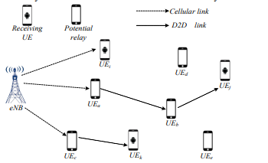

**Fig.1. Example for cellular network topology with underlay D2D communications**

To improve the network performance, multi-hop D2D communication has recently attracted many researchers to forward packets via users’ devices serving as relay nodes which results improved energy efficiency and outage probability. Various incentive schemes and policies have proposed in the context of ad hoc networks. In, authors proposed a novel energy incentive based technique of preferential band selection using cognitive radio for ad hoc IoT networks, and Multihop D2D networks as well, to motivate nodes to serve as relay nodes to support multi-hop communication preserving its energy resource, and to achieve significantly better QoS and coverage.

**Disadvantages:**

* High SAR values.
* Low energy efficiency and outage probability.

**CHAPTER 4**

**PROPOSED METHOD**

By convention, the harmful effects of EMFs on human bodies are measured in terms of the parameter called SAR (Specific Absorption Rate). During mobile phone use, the temperature rises in human body parts due to exposure from strong EMF source. SAR is a quantity defined as the rate of RF power absorbed per unit mass of the body. In cellular communication, it is obvious that the handset transmits at maximum transmission power when it is either in the area with very low field strength of received signals, such as at cell boundaries, or under the influence of multi-path fading, or due to the presence of obstacles. SAR value is dependent on the distance of separation of the body and the radiation source expressed as:



Where, E in (V /m) is the electric field, SAR is in (Watt/kg), σ(S/m) is the tissue conductivity and mass density of the tissue is ρ (kg/m3).

It is obvious that with the advent of IoT (Internet of Things), and 5G, there will be an exponential growth in wireless traffic on terrestrial paths intercepting not only the human beings but all the living creatures on the ground along with trees, plants and vegetation, having a great impact on our biodiversity. Hence, it is high time to propose new techniques to sustain the growth of wireless traffic minimizing its harmful effects on our ecosystem keeping the SAR value as low as possible. Since, the effects of EMFs on living beings depend on the transmission power and the frequency of operation as well, it is important to investigate the relation between the two. From information theoretic point of view, Shannon-Hartley theorem says that the error-free information transmission rate k in bits/sec is upper bounded as given by:



it is obvious that with a given frequency band of operation, a wireless network with shorter communication range D will be less harmful in terms of SAR.

So, if we use multi-hop network for our future wireless technologies like 5G, then EMF effects will be minimized. In conventional cellular communication, even with the facility of transmission power control, the nodes at the cell edges have to transmit with maximum power to route their packets via base station, though the nodes close to the base station may limit their transmission power depending on their distance from the base station. In this respect, routing via multi-hop paths offers a good option for energy efficient routing. By the Nearest Neighbour Routing (NNR), a node forwards its packets via nearest neighbours in multi-hop paths minimizing the power required at individual nodes and also the total power over the end to end path.

In this paper, a technique for packet routing via multi-hop paths over appropriate band is proposed to minimize, and balance the SAR values throughout the network. For analysis, we focus on linear networks that simply represent the worst case of load imbalance in multi-hop packet routing, as has been described later. Balancing of SAR over such networks shows that it can be easily applied to any random network as well. Here, we assumed a linear network with n nodes, sending data packets following the Nearest Neighbour Routing, NNR, such that a node always forwards its packets to the nearest neighbour towards the receiver. Packet generation rate is same for all nodes. All nodes are transmitting data with a fixed transmission energy that is sufficient to cover a distance D, such that the network remains connected throughout its lifetime.

It is to be noted that D<< Dmax, the maximum distance that a mobile device has to cover to reach the base station directly, i.e., the cell radius. Hence it is obvious that by NNR, the nodes will be able to transmit with much less power conserving energy significantly. Each node is assumed to generate a single packet per unit time and forwarding the data to the nearest neighbour to finally reach the base station. As shown in Fig 1, it is clear that in every round, node n has to transmit its own packet and additional (n − 1) packets from all its preceding nodes, (n − 1), (n − 2), . . . , 2, 1 and so on, whereas node 1 transmits only its own packet with zero relay load per unit time, i.e., the loads of the nodes are highly imbalanced. Hence, in an attempt to balance the transmission power and the packet transmission time at each node,

Appropriate frequency bands along with matching bandwidth are assigned to support required transmission rates for each node with various loads. To balance the transmission time at each node, if node 1 transmits with a rate k bits per sec, node i with a load of i packets per unit time should transmit at a rate i.k bits per sec. As a consequence, NNR will attempt to decrease the SAR value for all nodes by reducing the transmission power, but higher data transfer rate will result higher SAR value. So, to balance the SAR values across the nodes, appropriate frequency bands are assigned to the nodes depending on their loads as shown in Fig. 1.

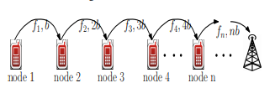

**Fig 1: A Linear Network with n nodes**

Our objective is to achieve, SAR1 = SAR2 = SAR3 = . . . = SARn

So, from above equation assuming all other parameters to be same for the network, we have,

C:\Users\ymts0326\Downloads\cd.PNG

For a given frequency spectrum of operation, (fmax − fmin) the maximum frequency band fmax can be assigned to the node with minimum load, i.e. node-1, and an upper bound on the value of n can be attained as:

C:\Users\ymts0326\Downloads\ds.PNG

Here, n is the number of nodes in a linear network where SAR values are balanced for all nodes. Fig.2 shows the numerical results following, where transmission rate of transmitter is varied from 10 Kbps to 3000 Kbps for different frequency bands of operation. It shows that at higher frequency bands, the linear network may support larger number of nodes with balanced SAR values. But it decreases with increase in the minimum transmission rate k.

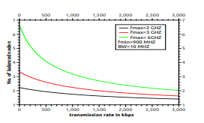

**Fig. 2: No of balanced nodes (n)**

Number of balanced nodes can be calculated but to minimize the SAR value of each balanced node or to keep the SAR value of each balanced node within the safe level, transmission distance between the transmitter and the receiver plays a significant role. According to the FCC the safe limit of SAR for human body is 1.6 W/kg. The safe transmission distance for different transmission bands, assuming the transmission rate to be 1 Mbps. It is clear that at 2.4 GHz band the transmission range should be less than 80 m., and that essentially necessitates multi-hop communication, relaying packets through intermediate nodes to reach either the base station, or the destination.

Extensive simulation studies have been done to evaluate the performance of the proposed SAR balancing technique. In simulation we have considered one cell with radius 1000 m with 100 randomly distributed mobile nodes following random way-point mobility model with some boundary conditions. Here, nodes are sending data packets in multi-hop paths to the base station. We have measured the effective SAR value for human body at a distance of 2cm from the hand set. The traffic generation at each node follows Poisson arrival process with mean traffic arrival rate λ = 10 calls/sec. Similarly, the call holding time is assumed to follow exponential distribution with mean value µ = 2 time units for all nodes. Network topology is not static; it is changing with time due to node mobility. We have implemented our proposed procedure for SAR minimization and balancing on Mat lab. Total run time of the simulation is 2 hours.

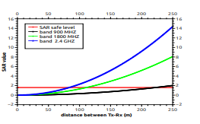

**Fig. 3: Safe transmission range**

The comparison of SAR level with k = 6M bps for 2 hop, 3 hop and direct data transmission methods at different frequency bands. From this is evident that the proposed technique results nearly balanced SAR values across the network. In case of lower bands the reduction in SAR value with increase in number of hops is more prominent. As for example, in 900 MHz band SAR value is nearly 60% lower with 3 hops, compared to that with 2 hops, whereas for 2.4 GHz band the improvement is 30% only. For direct communication to the base station, the SAR values are much unbalanced, and communication by the proposed scheme via 2hops and 3hops result about 40%, and 70% improvement in SAR, over it, in LTE 8 band. The improvement is even higher in case of higher bands as is evident.

**CHAPTER 5**

**SOFTWARE REQUIREMENTS**

**What Is MATLAB?**

MATLAB is an elite dialect for specialized registering. It incorporates calculation, representation, and programming in a simple to-utilize condition where issues and arrangements are communicated in natural numerical documentation. Run of the mill utilizes incorporate

• Math and calculation

• Algorithm advancement

• Data obtaining

• Modeling, reenactment, and prototyping

• Data examination, investigation, and representation

• Scientific and designing illustrations

• Application advancement, including graphical UI building

MATLAB is an intuitive framework whose important records thing is an exhibit that doesn't require dimensioning. This allows you to address several specialized processing issues, specifically people with framework and vector data, in a small quantity of the time it might take to compose a program in a scalar non intuitive dialect, as an instance, C or FORTRAN.

The name MATLAB stays for grid studies facility. MATLAB modified into to start with composed to offer simple access to framework programming created thru the LINPACK and EISPACK ventures. Today, MATLAB vehicles fuse the LAPACK and BLAS libraries, putting the cutting element in programming for network calculation.

MATLAB has advanced over a time of years with contribution from several customers. In college situations, it's miles the same old educational system for early on and propelled courses in arithmetic, designing, and technological know-how. In industry, MATLAB is the tool of selection for high-profitability research, development, and exam.

MATLAB highlights a collection of extra utility-precise preparations called device booths. Important to most clients of MATLAB, tool kits allow you to examine and practice particular innovation. Tool compartments are exhaustive accumulations of MATLAB capacities (M-records) that extend out the MATLAB situation to take care of precise instructions of problems. Territories in which device stash is reachable incorporate flag dealing with, manage frameworks, neural systems, fluffy purpose, wavelets, recreation, and several others.

**The MATLAB System:**

The MATLAB machine includes five predominant parts.

**Development Environment:**

This is the set of tools and facilities that assist you use MATLAB functions and files. Many of that system are graphical consumer interfaces. It includes the MATLAB computing device and Command Window, a command history, an editor and debugger, and browsers for viewing help, the workspace, files, and the hunt direction.

**The MATLAB Mathematical Function:**

This is a wonderful collection of computational algorithms starting from essential features like sum, sine, cosine, and complex mathematics, to extra sophisticated features like matrix inverse, matrix Eigen values, Bessel competencies, and fast Fourier transforms.

**The MATLAB Language:**

This is an excessive-degree matrix/array language with manipulate go with the go with the flow statements, competencies, statistics systems, input/output, and object-oriented programming talents. It permits every programming in the small to hastily create quick and dirty throw-away programs, and programming in the big to create entire massive and complicated software applications.

**Graphics:**

MATLAB has huge facilities for showing vectors and matrices as graphs, further to annotating and printing those graphs. It consists of immoderate-degree capabilities for two-dimensional and three-dimensional facts visualization, image processing, animation, and presentation images. It additionally includes low-stage functions that allow you to completely customize the appearance of image graphs further to assemble whole graphical consumer interfaces on your MATLAB packages.

**The MATLAB Application Program Interface (API):**

His is a library that lets in you to write C and FORTRAN packages that engage with MATLAB. It includes centers for calling workout routines from MATLAB (dynamic linking), calling MATLAB as a computational engine, and for analyzing and writing MAT-documents.

**5.2 MATLAB WORKING ENVIRONMENT:**

## MATLAB DESKTOP:

MATLAB Desktop is the precept MATLAB utility window. The computing device consists of five sub windows, the summon window, the workspace software, the prevailing catalog window, the order records window, and at the least one figure home windows, which are confirmed simply whilst the patron indicates a realistic.

The order window is the vicinity the consumer types MATLAB orders and expressions on the provoke (>>) and where the yield of these costs is shown. MATLAB characterizes the workspace because the association of factors that the purchaser makes in a work consultation. The workspace application demonstrates these elements and a few information approximately them. Double tapping on a variable in the workspace software dispatches the Array Editor, which can be applied to get statistics and wage instances regulate certain homes of the variable.

The gift Directory tab over the workspace tab demonstrates the substance of the prevailing registry, whose way is seemed within the gift index window. 1For case, in the home windows working framework the manner may be as consistent with the subsequent: C:MATLABWork, demonstrating that registry work is a subdirectory of the number one catalog MATLAB, that's added in force C. Tapping on the bolt inside the gift index window demonstrates a rundown of as of late utilized approaches. Tapping at the capture to at least one aspect of the window allows the customer to exchange the prevailing catalog.

MATLAB utilizes an inquiry way to discover M-information and other MATLAB associated documents, which might be kind out in catalogs within the PC report framework. Any report hold going for walks in MATLAB must reside in the ebb and go with the flow registry or in an index this is on are looking for manner. Of course, the facts provided with MATLAB and math works device kits are integrated into the inquiry manner. The least traumatic approach to look which indexes are at the inquiry manner. The best method to peer which catalogs are quickly the search way, or to consist of or adjust an inquiry manner, is to pick out set way from the File menu the computing device, and after that utilization the set way change container. It is extremely good exercise to feature any normally applied catalogs to the pursuit manner to preserve a strategic distance from again and again having the exchange the existing index.

The Command History Window incorporates a file of the orders a customer has entered in the rate window, together with each gift and beyond MATLAB classes. Already entered MATLAB orders may be selected and re-done from the fee history window by using right tapping on a sum on or association of orders. This interest dispatches a menu from which to choose exclusive picks however executing the orders. This is helpful to pick special choices notwithstanding executing the summons. This is a precious element even as attempting different things with distinct orders in a work consultation.

**Using the MATLAB Editor to create M-Files:**

The MATLAB manager is both a word processor specific for making M-information and a graphical MATLAB debugger. The proofreader can display up in a window without everybody else, or it could be a sub window inside the desktop. M-statistics are supposed by means of the growth .M, as in pixelup.m. The MATLAB editorial manager window has diverse draw down menus for errands, as an example, sparing, seeing, and troubleshooting files. Since it plays out some primary tests and furthermore makes use of shading to separate among exceptional components of code, this content material device is suggested because the apparatus of choice for composing and changing M-capacities.

To open the proofreader, sort adjust at the incite opens the M-report filename. In a supervisor window, organized for changing. As referred to before, the file has to be within the momentum catalog, or in an index inside the pursuit way.

**Getting Help:**

The important approach to get help online is to utilize the MATLAB help program, opened as a different window either by tapping on the question mark image (?) on the desktop toolbar, or by writing help program at the provoke in the order window. The assistance Browser is a web program coordinated into the MATLAB desktop that shows a Hypertext Markup Language (HTML) records. The Help Browser comprises of two sheets, the assistance pilot sheet, used to discover data, and the show sheet, used to see the data.

**CHAPTER 6**

**COMMUNICATION**

Communications System Toolbox™ offers algorithms and gear for the layout, simulation, and analysis of communications systems. These capabilities are furnished as MATLAB ® features, MATLAB System gadgets™, and Simulink ® blocks. The machine toolbox includes algorithms for source coding, channel coding, interleaving, modulation, equalization, synchronization, and channel modeling. Tools are supplied for bit blunders charge evaluation, producing eye and constellation diagrams, and visualizing channel characteristics. The machine toolbox additionally

Provides adaptive algorithms that allow you to version dynamic communications structures that use OFDM, OFDMA, and MIMO techniques. Algorithms support fixed-point facts arithmetic and C or HDL code era.

**Key Features**

* Algorithms for designing the physical layer of communications systems, which includes supply coding, channel coding, interleaving, modulation, channel fashions, MIMO, equalization, and synchronization
* GPU-enabled System objects for computationally intensive algorithms together with Turbo, LDPC, and Viterbi decoders
* Interactive visualization equipment, consisting of eye diagrams, constellations, and channel scattering capabilities
* Graphical tool for evaluating the simulated bit mistakes rate of a machine with analytical outcomes
* Channel models, consisting of AWGN, Multipath Rayleigh Fading, Rician Fading, MIMO Multipath Fading, and

LTE MIMO Multipath Fading

* Basic RF impairments, along with nonlinearity, section noise, thermal noise, and section and frequency offsets
* Algorithms available as MATLAB features, MATLAB System objects, and Simulink blocks
* Support for fixed-point modeling and C and HDL code technology

**System Design, Characterization, and Visualization**

The layout and simulation of a communications gadget requires analyzing its reaction to the noise and interference inherent in real-world environments, reading its behavior the usage of graphical and quantitative manner, and determining whether the resulting overall performance meets requirements of acceptability. Communications System Toolbox implements a selection of obligations for communications machine layout and simulation. Many of the functions, System objects™, and blocks inside the device toolbox perform computations associated with a specific thing of a communications gadget, consisting of a demodulator or equalizer. Other talents are designed for visualization or evaluation.

**System Characterization**

The system toolbox offers several standard methods for quantitatively characterizing system performance:

▪ Bit error rate (BER) computations

▪ Adjacent channel power ratio (ACPR) measurements

▪ Error vector magnitude (EVM) measurements

▪ Modulation error ratio (MER) measurements

Because BER computations are fundamental to the characterization of any communications system, the system toolbox provides the following tools and capabilities for configuring BER test scenarios and accelerating BER simulations:

**BERtool** — a graphical user interface that enables you to analyze BER performance of communications systems. You can analyze performance via a simulation-based, semi analytic, or theoretical approach.

**Error Rate Test Console** — A MATLAB object that runs simulations for communications systems to measure error rate performance. It supports user-specified test points and generation of parametric performance plots and surfaces. Accelerated performance can be realized when running on a multicore computing platform.

**Multicore and GPU acceleration** — A capability provided by Parallel Computing Toolbox™ that enables you to accelerate simulation performance using multicore and GPU hardware within your computer.

**Distributed computing and cloud computing support** — Capabilities provided by Parallel Computing Toolbox and MATLAB Distributed Computing Server™ that enable you to leverage the computing power of your server farms and the Amazon EC2 Web service. Performance Visualization The system toolbox provides the following capabilities for visualizing system performance:

**Channel visualization tool** — for visualizing the characteristics of a fading channel

**Eye diagrams and signal constellation scatter plots** — for a qualitative, visual understanding of system behavior that enables you to make initial design decisions

**Signal trajectory plots** — for a continuous picture of the signal’s trajectory between decision points

**BER plots** — for visualizing quantitative BER performance of a design candidate, parameterized by metrics such as SNR and fixed-point word size

**Analog and Digital Modulation**

Analog and digital modulation strategies encode the facts circulation into a sign this is appropriate for transmission. Communications System Toolbox presents some of modulation and corresponding demodulation abilities. These talents are available as MATLAB features and gadgets, MATLAB System Modulation sorts provided by the toolbox are:

**Analog,** including AM, FM, PM, SSB, and DSBSC

**Digital,** including FSK, PSK, BPSK, DPSK, OQPSK, MSK, PAM, QAM, and TCM

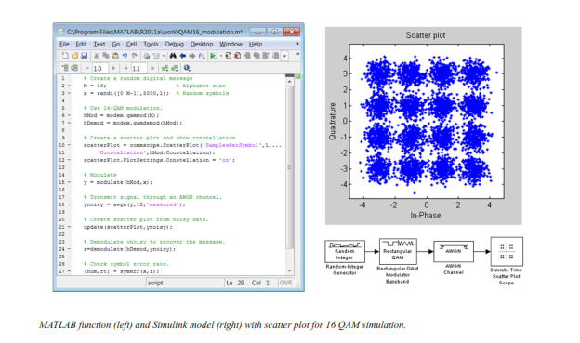

**Source and Channel Coding**

Communications System Toolbox affords source and channel coding talents that can help you develop and compare communications architectures fast, enabling you to discover what-if eventualities and avoid the need to create coding competencies from scratch.

**Source Coding**

Source coding, also referred to as quantization or signal formatting, is a manner of processing facts a good way to lessen redundancy or prepare it for later processing. The system toolbox offers a diffusion of styles of algorithms for imposing source coding and interpreting, inclusive of:

* Quantizing
* Companding (*µ*-law and A-law)
* Differential pulse code modulation (DPCM)
* Huffman coding
* Arithmetic coding

**Channel Coding**

* Orthogonal area-time block code (OSTBC) (encoder and decoder for MIMO channels)
* Turbo encoder and decoder examples

The gadget toolbox offers application functions for developing your personal channel coding. You can create generator polynomials and coefficients and syndrome deciphering tables, in addition to product parity-take a look at and generator matrices.

The system toolbox additionally presents block and convolutional interleaving and deinterleaving functions to reduce facts errors as a result of burst mistakes in a conversation machine:

**Block,** including General block interleaver, algebraic interleaver, helical scan interleaver, matrix interleave, and random interleave

**Convolutional,** including General multiplexed interleaver, convolutional interleaver, and helical interleaver

**Channel Modeling and RF Impairments**

Channel Modeling

* Communications System Toolbox provides algorithms and tools for modeling noise, fading, interference, and different distortions which might be commonly found in communications channels. The system toolbox supports the subsequent styles of channels:
* Additive white Gaussian noise (AWGN)
* Multiple-enter multiple-output (MIMO) fading
* Single-enter single-output (SISO), Rayleigh, and Rician fading
* Binary symmetric

A MATLAB channel object provides a concise, configurable implementation of channel models, enabling you to

Specify parameters such as:

* Path delays
* Average path gains
* Maximum Doppler shifts
* K-Factor for Rician fading channels
* Doppler spectrum parameters
* For MIMO systems, the MATLAB MIMO channel object expands these parameters to also include:
* Number of transmit antennas (up to 8)
* Number of receive antennas (up to 8)
* Transmit correlation matrix
* Receive correlation matrix

To combat the effects noise and channel corruption, the system toolbox provides block and convolutional coding and decoding techniques to implement error detection and correction. For simple error detection with no inherent correction, a cyclic redundancy check capability is also available. Channel coding capabilities provided by the system toolbox include:

* BCH encoder and decoder
* Reed-Solomon encoder and decoder
* LDPC encoder and decoder
* Convolutional encoder and Viterbi decoder

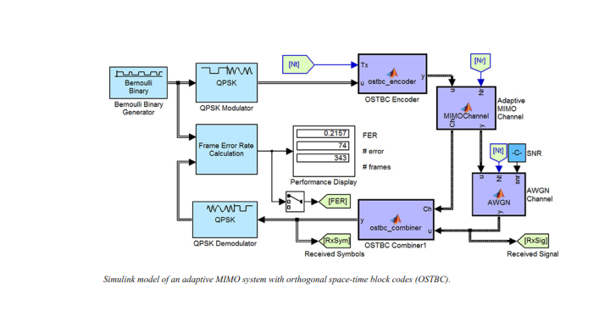

**RF Impairments**

To model the effects of a nonideal RF front end, you can introduce the following impairments into your communications system, enabling you to explore and characterize performance with real-world effects:

* Memoryless nonlinearity
* Phase and frequency offset
* Phase noise
* Thermal noise

You can include more complex RF impairments and RF circuit models in your design using SimRF.

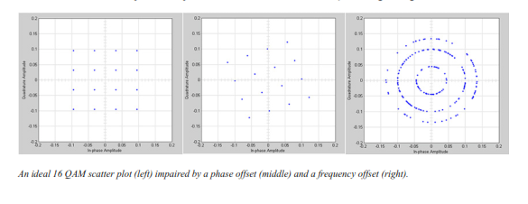

**Equalization and Synchronization**

Communications System Toolbox lets you discover equalization and synchronization strategies. These techniques are usually adaptive in nature and tough to design and symbolize. The machine toolbox affords algorithms and tools that will let you swiftly select the proper approach on your communications machine. Equalization To compare one-of-a-kind techniques to equalization, the device toolbox offers you with adaptive algorithms which include:

* LMS
* Normalized LMS
* Variable step LMS
* Signed LMS
* MLSE (Viterbi)
* RLS
* CMA

These adaptive equalizers are available as nonlinear decision feedback equalizer (DFE) implementations and as

Linear (symbol or fractionally spaced) equalizer implementations.

**Synchronization**

The device toolbox provides algorithms for each service segment synchronization and timing phase synchronization. For timing section synchronization, the machine toolbox presents a MATLAB Timing Phase Synchronizer object that offers the following implementation techniques:

* Early-late gate timing method
* Gardner’s method
* Fourth-order nonlinearity method

**Stream Processing in MATLAB and Simulink**

Most verbal exchange structures cope with streaming and frame-primarily based statistics using a aggregate of temporal processing and simultaneous multi frequency and multichannel processing. This form of streaming multidimensional processing can be visible in superior communication architectures consisting of OFDM and MIMO. Communications System Toolbox enables the simulation of advanced communications structures via helping move processing and frame-based simulation in MATLAB and Simulink. In MATLAB, circulate processing is enabled by way of System items™, which use MATLAB objects to symbolize time-based and facts-driven algorithms, sources, and sinks. System objects implicitly manipulate many information of flow processing, including information indexing, buffering, and management of set of rules state.

You can mix System gadgets with fashionable MATLAB functions and operators. Most System items have a corresponding Simulink block with the identical abilities. Simulink handles circulation processing implicitly with the aid of coping with the float of information thru the blocks that make up a Simulink model. Simulink is an interactive graphical environment for modeling and simulating dynamic systems that uses hierarchical diagrams to symbolize a machine version. It includes a library of widespread-reason, predefined blocks to represent algorithms, resources, sinks, and device hierarchy.

**Implementing a Communications System**

Fixed-Point Modeling Many communications systems use hardware that requires a fixed-point representation of your design.

Communications System Toolbox supports fixed-point modeling in all relevant blocks and System objects™ with tools that help you configure fixed-point attributes.

Fixed-point support in the system toolbox includes:

* Word sizes from 1 to 128 bits
* Arbitrary binary-point placement
* Overflow handling methods (wrap or saturation)
* Rounding methods: ceiling, convergent, floor, nearest, round, simplest, and zero

Fixed-Point Tool in Simulink Fixed Point™ facilitates the conversion of floating-point data types to fixed point. For configuration of fixed-point properties, the tool tracks overflows and maxima and minima.

**Code Generation**

Once you've got advanced your set of rules or communications device, you can robotically generate C code from it for verification, rapid prototyping, and implementation. Most System gadgets, functions, and blocks in Communications System Toolbox can generate ANSI/ISO C code the use of MATLAB Coder™, Simulink Coder™, or Embedded Coder™. A subset of System gadgets and Simulink blocks also can generate HDL code. To leverage present highbrow belongings, you can choose optimizations for specific processor architectures and integrate legacy C code with the generated code.

You can also generate C code for both floating-point and fixed-point data types.

DSP Prototyping’s are used in communication system implementation for verification, rapid prototyping, or final hardware implementation. Using the processor-in-the-loop (PIL) simulation capability found in Embedded Coder, you can verify generated source code and compiled code by running your algorithm’s implementation code on a target processor. FPGA PrototypingFPGA is used in communication systems for implementing high-speed signal processing algorithms. Using the FPGA-in-the-loop (FIL) capability found in HDL Verifier™, you can test RTL code in real hardware for any existing HDL code, either manually written or automatically generated HDL code.

**CHAPTER 8**

**EXPERIMENTAL RESULTS**

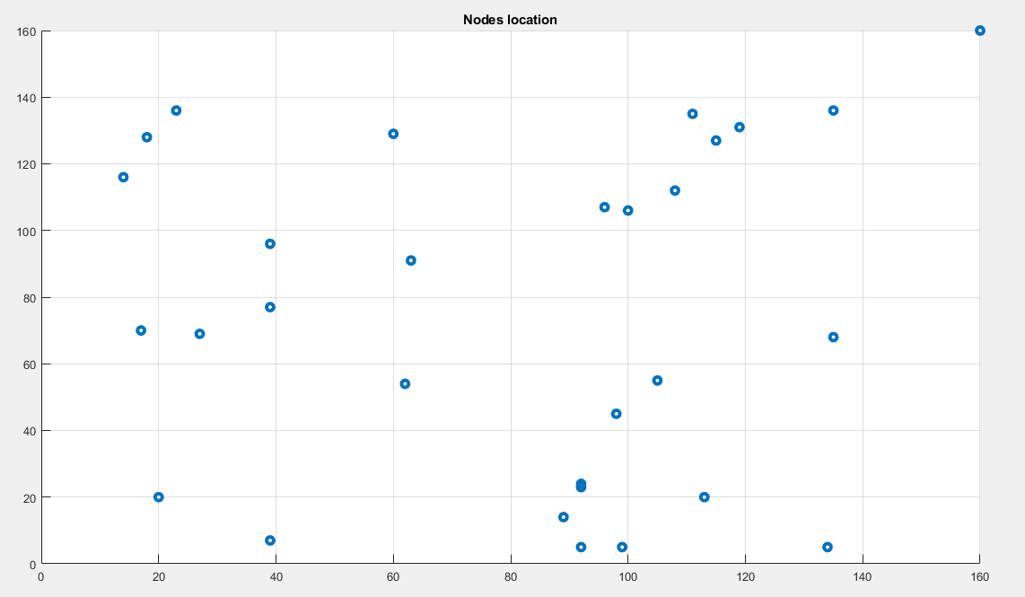

**Figure: 1**

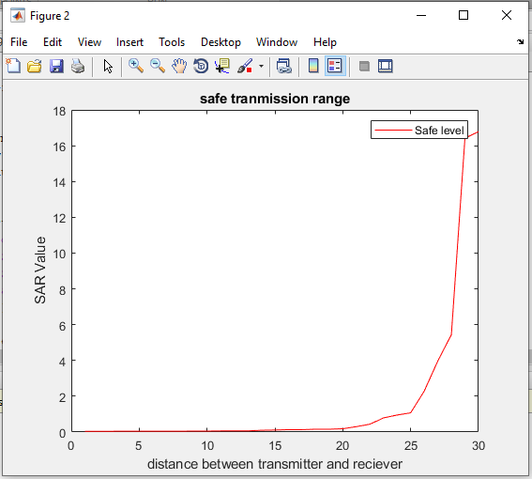

**Figure: 2**

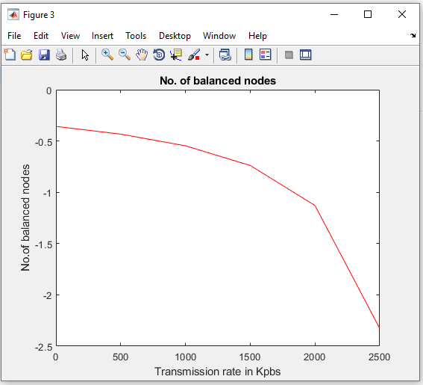

**Figure: 3**

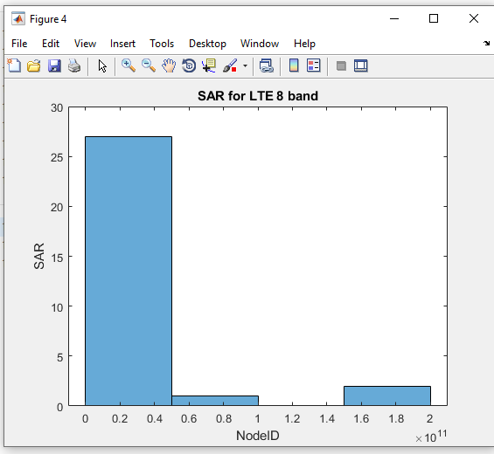

**Figure: 4**

**CHAPTER9**

**CONCLUSION**

Here in this project we are introducing a novel technique. In this paper, we proposed an elegant method of band selection with appropriate data rate for multi-hop packet routing, to minimize and also to balance the transmission power and hence the associated EMF effect on us in terms of the Specific Absorption Rate (SAR). Theoretical analysis has been presented for linear networks that results an upper bound on the number of hops permitted for a given spectrum band. Simulation results on random networks show that the proposed technique achieves a better improvement in terms of SAR, compared to the conventional direct communication via base station.

**CHAPTER 10**

**REFERENCES**

[1] B. O. Anyaka and U. B. Akuru, “Electromagnetic wave effect on human health: Challenges for developing countries,” in 2012 International Conference on Cyber-Enabled Distributed Computing and Knowledge Discovery, Oct 2012, pp. 447–452.

[2] K. Megha, P. S. Deshmukh, B. D. Banerjee, A. K. Tripathi, and M. P. Abegaonkar, “Microwave radiation induced oxidative stress, cognitive impairment and inflammation in brain of fischer rats,” 2012.

[3] L. Gherardini, G. Ciuti, S. Tognarelli, and C. Cinti, “Searching for the perfect wave: the effect of radiofrequency electromagnetic fields on cells,” International journal of molecular sciences, vol. 15, no. 4, pp. 5366–5387, 2014.

[4] A. Das and S. Kundu, “To protect ecological system from electromagnetic radiation of mobile communication,” in Proceedings of the 20th International Conference on Distributed Computing and Networking, ICDCN 2019, Bangalore, India, January 04-07, 2019, 2019, pp. 469– 473.

[5] J. Gui and J. Deng, “Multi-hop relay-aided underlay D2D communications for improving cellular coverage quality,” IEEE Access, vol. 6, pp. 14 318–14 338, 2018.

[6] Z. Zheng, L. Gao, L. Song, and J. Huang, “Topology-aware incentive mechanism for cooperative relay networks,” in IEEE Global Communications Conference (GLOBECOM), Dec 2015, pp. 1–6.

[7] S. Zhong, H. Yao, and Y. Fang, “Micor: A market for incentivecompatible cooperative relay in cognitive radio networks,” IEEE Transactions on Vehicular Technology, vol. 64, no. 11, pp. 5350–5367, Nov 2015.

[8] A. Das, N. Das, A. D. Barman, and S. Dhar, “Energy incentive for packet relay using cognitive radio in IoT networks,” IEEE Communications Letters, 2019.

[9] M. A. Bhat and V. Kumar, “Calculation of sar and measurement of temperature change of human head due to the mobile phone waves at frequencies 900 MHz and 1800 MHz,” Advances in Physics Theories and Applications, vol. 16, no. 2013, 2013.

[10] H. T. Friis, “A note on a simple transmission formula,” Proceedings of the IRE, vol. 34, no. 5, pp. 254–256, May 1946.

[11] S. Agarwal, A. Das, and N. Das, “An efficient approach for load balancing in vehicular ad-hoc networks,” in 2016 IEEE International Conference on Advanced Networks and Telecommunications Systems (ANTS), Nov 2016, pp. 1–6.

[12] FCC, “https://www.fcc.gov/general/specific-absorption-rate-sar-cellulartelephones.”