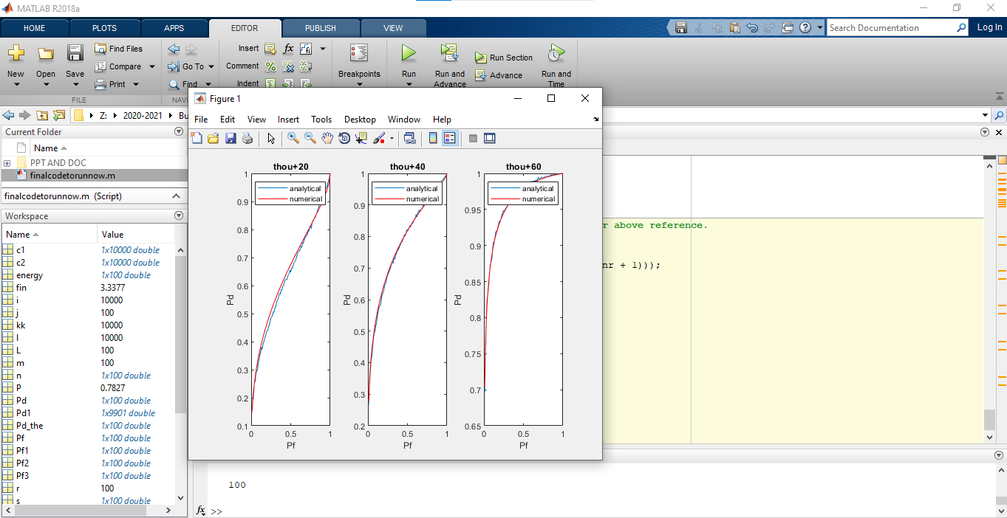

Figure:ROC curves for numerical and analytical simulations for SNR = -10 dB.

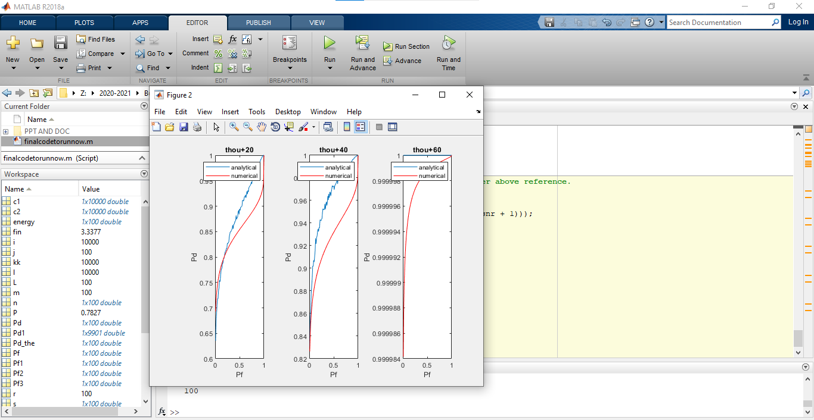

Figure:ROC curves for numerical and analytical simulations for SNR = 3 dB

Description:

Introduction: Radio and TV frequency bands are underutilized, mobile frequency band are over utilisied,so there is a spectrum scarcity, to overcome the problem of spectrum scarcity we go for cognitive radio ,CR is basically intelligent ,aware ,adaptive radio that senses the operating environment and changes its operating parameters according to the need of environment.

CR functions are as follows:

Spectrum sensing ,spectrum management, spectrum sharing, spectrum mobility.

spectrum sensing is the process of detecting unused portion of spectrum(or) spectrum holes.i.e detecting the presence or absence of the primary user.

Primary user:who purchased spectrum(authorized users) for their usage.

Secondary user:do not have license.

Block diagram description: The time is partitioned into frames of equal length. Each frame consists of a spectrum sensing phase and data transmission phase. the spectrum sensing phase is declared to be existence of the PU’s signal, the SU remains silent during the data transmission phase since the frame belongs to the PU. Otherwise, the SU starts to exploit the data transmission phase to transmit and receive its own data.

The spectrum sensing operation has two cases: A) Detection of the entrance of the PU’s signal; or

B) Detection of exiting of the PU user, i.e., empty spectrum frame.

Our goal (proposed method) is to detect the change in distribution (QCD)around the flipping point as quickly as possible.

Quickest Change detection:

If a primary user stops transmission, then a secondary user should detect this event quickly, in order to be able to start its own transmission quickly. A small detection delay will allow secondary users to take short transmission opportunities. On the other hand, if the primary user starts transmission, the cognitive user should detect this event as quickly as possible, in order to vacate the band for the primary user. A small detection delay will allow the design of a spectrum reuse scheme that has minimal impact on the licensed users. Of course, the desire to reduce the detection delay should be balanced with a certain false alarm constraint.

To check the performance how the proposed method is performing Pfa and Pd is defined;

Pfa is when there is no transmission, and we decide there is transmission ,Pd is when we decide PU is transmitting ,actual PU is transmitting.

Ideally Pfa(Probability of False alarm) is zero and probability of detection is one.

Proposed method:

Using CUSUM algorithm, after the spectrum status changes, as the number of collected samples increases, the probability of detection increases and, eventually, can reach its maximum value, i.e., 1., the total number of collected samples is bounded by the periodic sensing time. To this end, when applying CUSUM algorithm in cognitive radio applications where the size of the detection window is fixed, i.e., finite number of collected samples is used, the receiver operating characteristics (ROC), determined by the probability of false alarm and the probability of detection, are key performance metrics related to deciding on the status of the spectrum.

we derive closed-form expressions for the detection and false-alarm probabilities of the decision statistic of the CUSUM test.

( Refer formulae in base paper)

Results:

Plot between Pd and Pfa as the maximum number of collected samples during the spectrum

sensing phase changes(l =thou+20..), the pd approaches to the 1 and pfa is zero .

As expected, as the SNR level increases, Pd increases. Similarly, as l increases, Pd increases.

when the decision statistic exceeds the threshold, it is more likely that it is due to a detection of the PU’s entrance.

i.e as pd approaches to one and pfa is zero the PU signal is correctly detected.