Game Design Document

Fill up the following document

1. Write the title of your project.

Attacker Plane

1. What is the goal of the game?

Reach the high score.

1. Write a brief story of your game.

There will be rocket and it has to shoot the ufo’s by pressing space

key, save from the monsters and collect the stars and diamonds. If

we touch the stars and diamonds the score will increase and if we touch the ufo’s and monsters the game will end.

1. Which are the playing characters of this game?

* Playing characters are the ones who respond to the user based on the input from the user.
* Cars, monkeys, dinos, wizards, etc., are the playing characters in the game.

|  |  |  |
| --- | --- | --- |
| Number | Character Name | What can this character do? |
| 1 | Rocket | It can shoot |
| 2 |  |  |
| 3 |  |  |
| 4 |  |  |
| 5 |  |  |
| 6 |  |  |
| 7 |  |  |
| 8 |  |  |

1. Which are the Non-Playing Characters of this game?

* Non-Playing characters are the ones that don't have an action or behavior when the user interacts with the game.
* Hurdles, stones, bananas, coins, etc., are non-playing characters in the game.

|  |  |  |
| --- | --- | --- |
| Number | Character Name | What can this character do? |
| 1 | Monsters |  |
| 2 | UFO’s |  |
| 3 | Diamonds |  |
| 4 | Stars |  |
| 5 | Missile |  |
| 6 |  |  |
| 7 |  |  |
| 8 |  |  |

Draw your imagination of this game. What does this game look like?

* Draw the game either on your computer or on paper.
* Add images of the game scenes to show each of the playing and non-playing characters at least once.

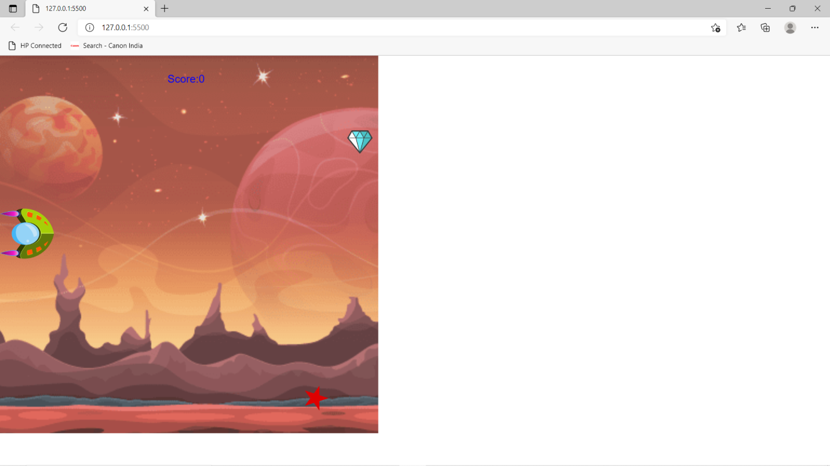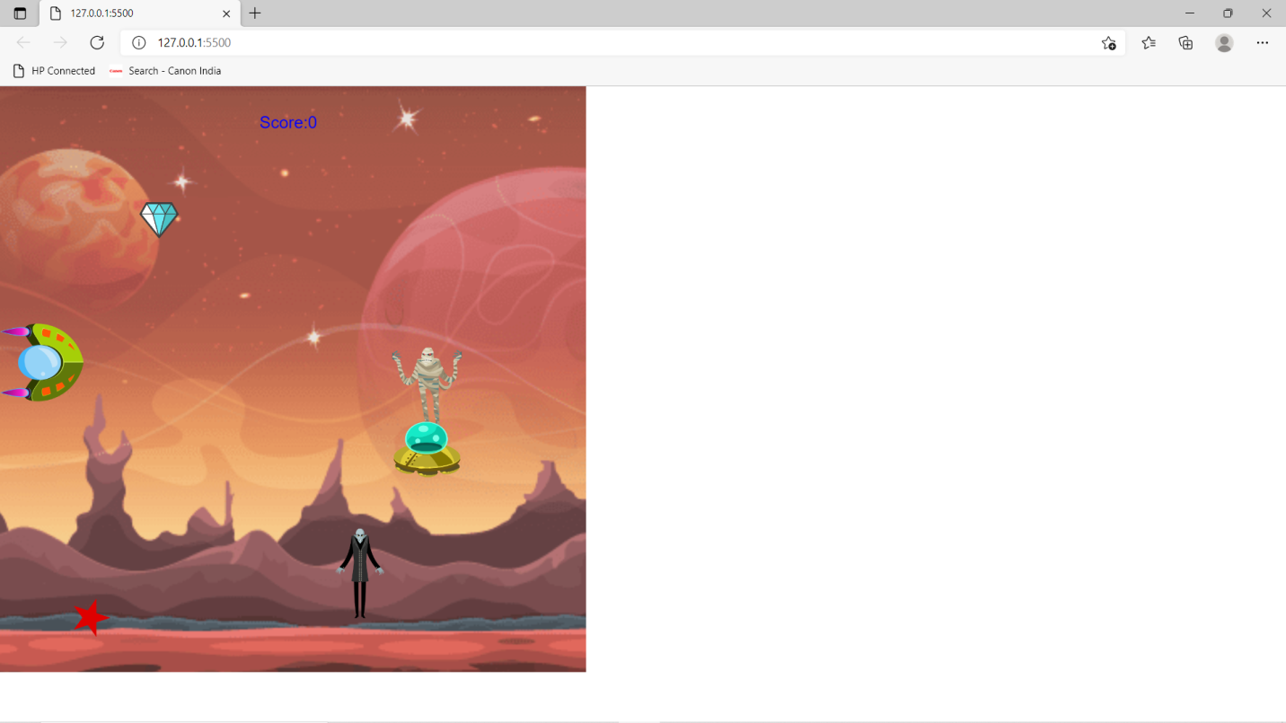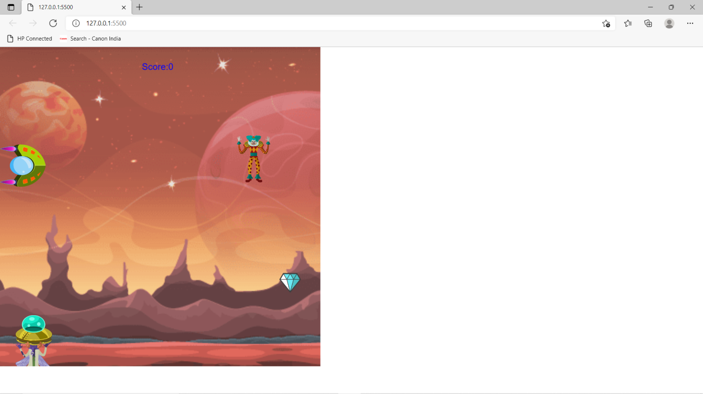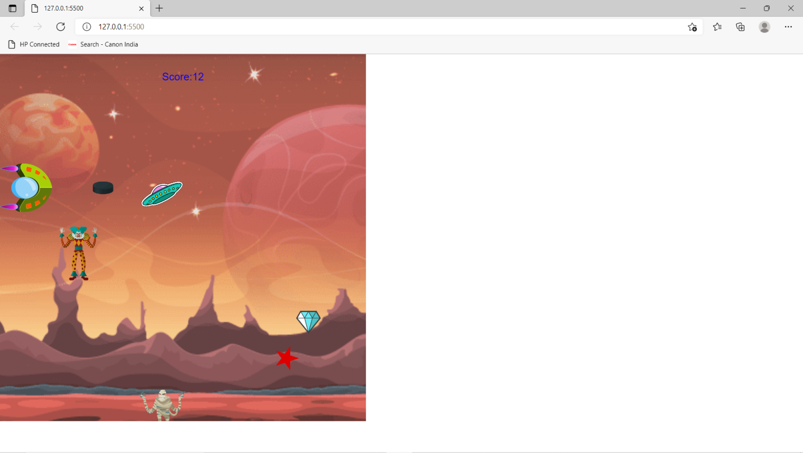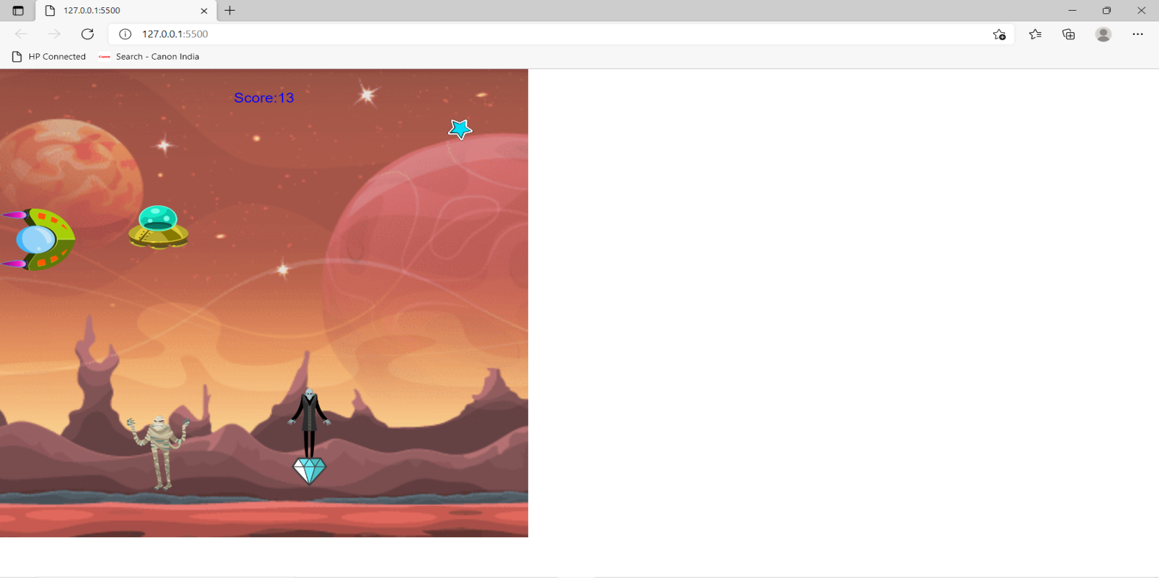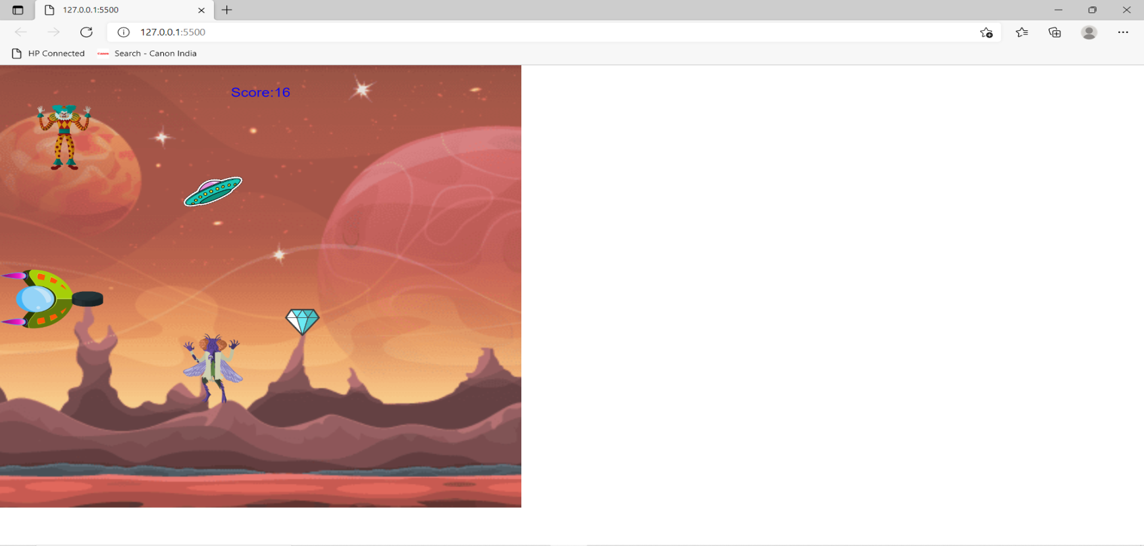

How do you plan to make your game engaging?

I have added monsters through which cannot be shooted and we have to be safe from them, there are diamonds and stars which we have to collect and we have to shoot the ufo’s.