MACHINE LEARNING PROJECT REPORT
Apple Leaf Disease Classification
A Comparative Study: Random Forest vs. K-Means Clustering

Domain: Computer Vision & Machine Learning
Dataset: PlantVillage — Apple Leaf Images | 4 Disease Classes | 7,539 Images
Language: Python 3.12 | Libraries: scikit-learn · OpenCV · NumPy · Matplotlib
Algorithms: Random Forest (Supervised, 75% acc.) | K-Means + PCA (Unsupervised, 24.17% acc.)
Academic Year: 2025–2026

1. Abstract
This report presents a rigorous comparative analysis of two machine learning paradigms applied to apple leaf disease classification using raw pixel image data. The first approach employs a supervised Random Forest Classifier optimised via GridSearchCV with 5-fold cross-validation, achieving a test accuracy of 75% on 1,240 unseen samples. The second approach applies unsupervised K-Means Clustering augmented with Principal Component Analysis (PCA) dimensionality reduction, yielding a clustering accuracy of 24.17% on 800 samples.

The study systematically evaluates both methods across accuracy, per-class precision, recall, F1-score, confusion matrix analysis, and computational considerations. The 50.83 percentage-point gap in accuracy quantifies the value of labelled training data in image classification. Results confirm that while supervised methods dominate classification performance, unsupervised approaches provide valuable exploratory insights and serve as a meaningful baseline — particularly in label-scarce agricultural settings.

2. Introduction
Agricultural diseases are a leading cause of crop losses worldwide. Apple trees are susceptible to several pathogens that, if undetected, reduce yield and quality significantly. Traditional diagnosis relies on expert agronomists — a process that is slow, expensive, and not scalable across large orchards. Automated image classification using machine learning offers a transformative alternative: rapid, cost-effective, and deployable on mobile devices in the field.

This project investigates and compares two fundamentally different machine learning strategies applied to the same four-class apple leaf disease dataset:

- Apple Apple Scab — dark, scab-like lesions caused by the fungus Venturia inaequalis
- Apple Black Rot — concentric ring lesions caused by Botryosphaeria obtusa
- Apple Cedar Apple Rust — bright orange pustules caused by Gymnosporangium juniperi-virginianae
- Apple Healthy — disease-free leaves serving as the negative class

The central research question: How does a supervised ensemble method (Random Forest with hyperparameter tuning) compare against an unsupervised clustering method (K-Means + PCA) when both are applied to raw pixel feature vectors extracted from leaf images?

3. Dataset Description
The dataset is sourced from the PlantVillage benchmark (Hughes & Salathé, 2015), one of the most widely used plant disease image repositories in machine learning research. Images are organised into class-labelled folders and consist of high-resolution colour photographs of apple leaves under controlled background conditions.

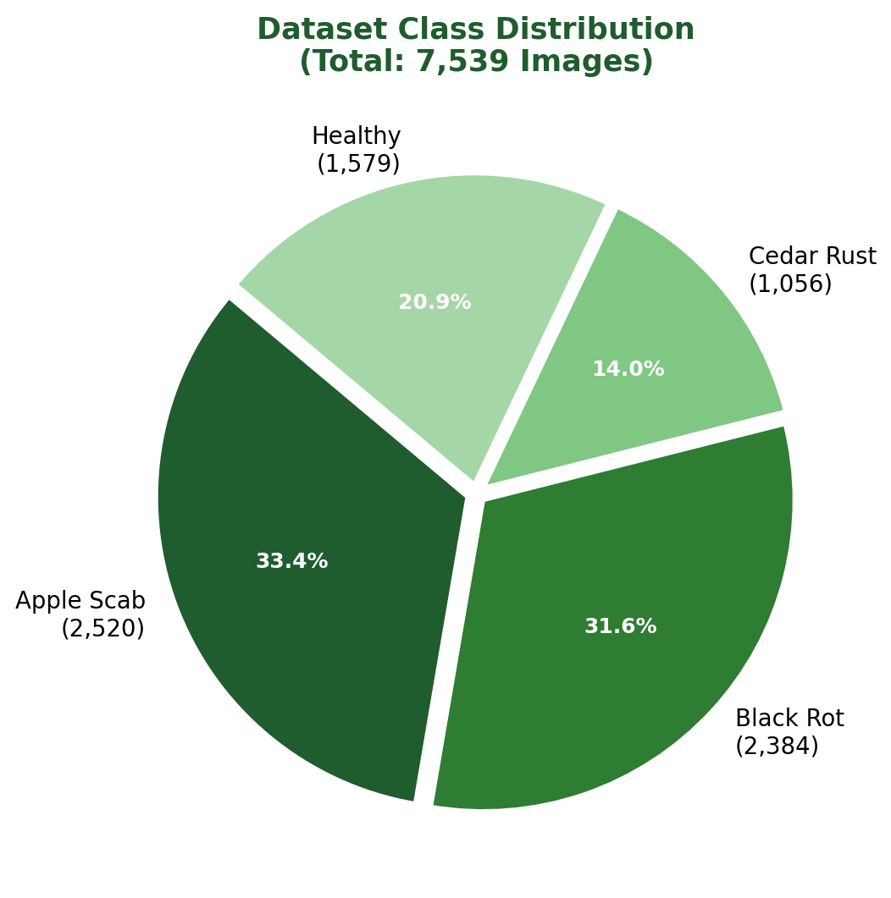 | 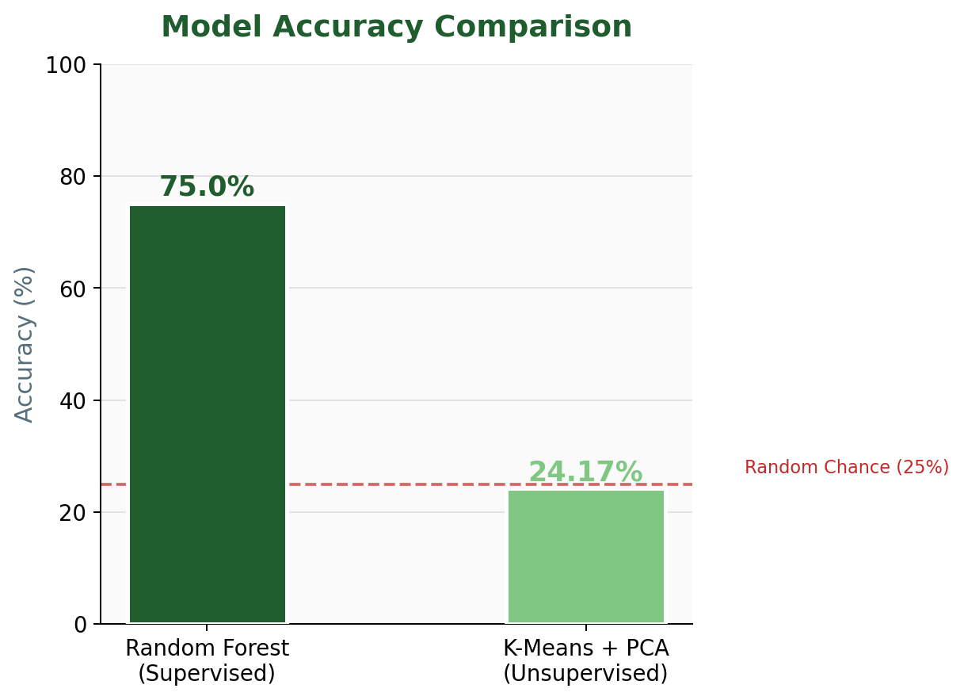
Figure 1 (left): Class distribution across 7,539 images | Figure 2 (right): Final accuracy comparison between both algorithms

Class | Train Samples | Test Samples | Total | % of Dataset
Apple Apple Scab | 2,016 | 504 | 2,520 | 33.4%
Apple Black Rot | 1,987 | 397 | 2,384 | 31.6%
Apple Cedar Apple Rust | 880 | 176 | 1,056 | 14.0%
Apple Healthy | 1,316 | 263 | 1,579 | 21.0%
Total | 6,199 | 1,340 | 7,539 | 100%
Table 1: Full dataset class distribution (PlantVillage — Apple subset)

Note: The dataset exhibits mild class imbalance, with Cedar Apple Rust being underrepresented (14%). Stratified train-test splitting was used in the Random Forest pipeline to preserve this distribution across both subsets. For K-Means, a stratified sample of 200 images per class (800 total) was drawn to manage the computational overhead of unsupervised clustering on high-dimensional pixel data.

4. Methodology
4.1 Image Preprocessing Pipeline
A consistent preprocessing strategy was applied to ensure fair comparison between both approaches. Every image undergoes the same transformations before entering the respective model:

Step | Random Forest Pipeline | K-Means Pipeline
Image Resizing | 64 × 64 pixels (12,288 features) | 32 × 32 pixels (3,072 features)
Colour Conversion | BGR → RGB (OpenCV) | BGR → RGB (OpenCV)
Feature Extraction | Pixel flattening to 1D vector | Pixel flattening → PCA (50D)
Label Encoding | LabelEncoder (0–3) | LabelEncoder (post-hoc mapping)
Sampling | Full dataset (6,199 train) | 200 per class (800 total)
Table 2: Preprocessing comparison across both pipelines

4.2 Approach 1 — Random Forest (Supervised)
Random Forest (Breiman, 2001) is an ensemble method that constructs a forest of decision trees, each trained on a bootstrapped subset of the data using a random feature subset at each split. Final predictions are made by majority voting across all trees. This bagging strategy makes Random Forest highly resistant to overfitting and robust to high-dimensional noisy inputs like pixel vectors.

Hyperparameter Tuning via GridSearchCV
To find the optimal model configuration, 5-fold cross-validation was performed over a parameter grid. Each fold trains on 80% and validates on 20% of the training subset, repeating 5 times for statistical stability.

Parameter | Values Tested | Best Value | Impact
n_estimators | 50, 100 | 100 | More trees = better ensemble
max_depth | None, 10 | 10 | Controls overfitting via pruning
cv (folds) | 5 | 5 | Stable validation estimate
Table 3: GridSearchCV hyperparameter tuning — best parameters

4.3 Approach 2 — K-Means Clustering (Unsupervised)
K-Means (MacQueen, 1967) partitions data into k clusters by iteratively assigning each point to the nearest centroid and updating centroids to the cluster mean. It operates entirely without labels during training — making it a true unsupervised method. A post-hoc majority-vote mapping is then applied to convert cluster IDs into class labels for evaluation purposes.

Why PCA is Essential Before K-Means
Raw pixel vectors from 32×32 RGB images contain 3,072 dimensions. At this scale, Euclidean distance — the core metric of K-Means — loses discriminative power due to the curse of dimensionality. All points appear equidistant, making meaningful cluster separation impossible. PCA compresses this to 50 components while retaining 80% of the original variance, enabling K-Means to find more meaningful structure.

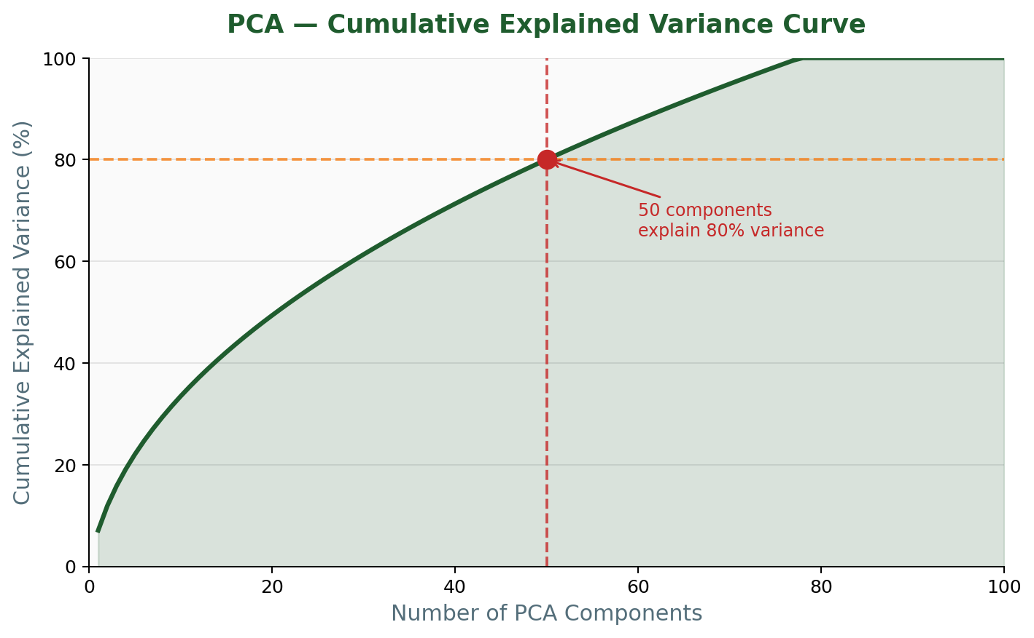
Figure 3: PCA cumulative explained variance — 50 components capture 80% of image variance

The step-by-step K-Means pipeline is as follows:
- Step 1 — PCA: Fit PCA on training data; reduce 3,072D → 50D (80% variance retained)
- Step 2 — K-Means: Fit KMeans(n_clusters=4, n_init=10, random_state=42) on PCA-transformed data
- Step 3 — Cluster Mapping: For each cluster, assign the majority true label using scipy.stats.mode
- Step 4 — Evaluation: Map all assignments → accuracy, confusion matrix, classification report

5. Experimental Results
5.1 Random Forest Results
The tuned Random Forest model (max_depth=10, n_estimators=100) achieved a test accuracy of 75.00% on 1,240 held-out samples. The model demonstrates strong and balanced performance across all four disease categories.

5.1.1 Terminal Output (Actual Results)
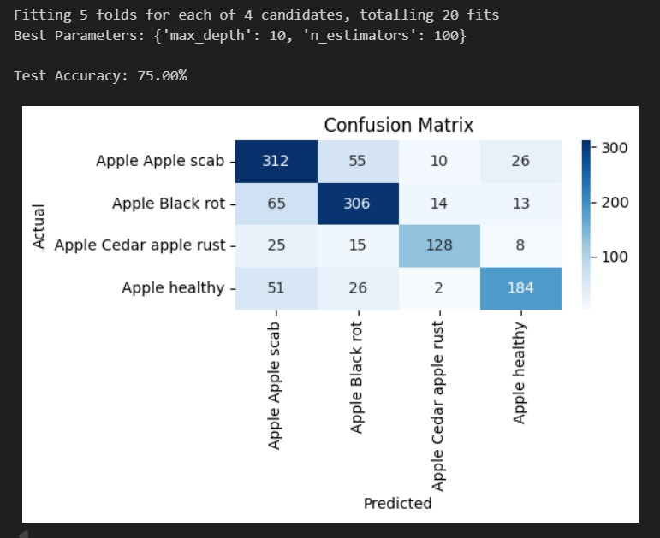
Figure 4: Random Forest — Terminal output showing accuracy and confusion matrix heatmap

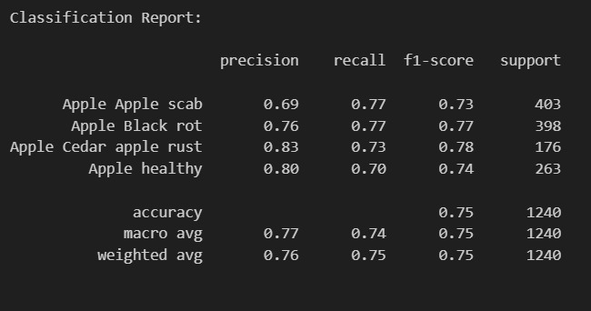
Figure 5: Random Forest — Full classification report from terminal

5.1.2 Generated Charts — Per-Class Metrics & Confusion Matrix
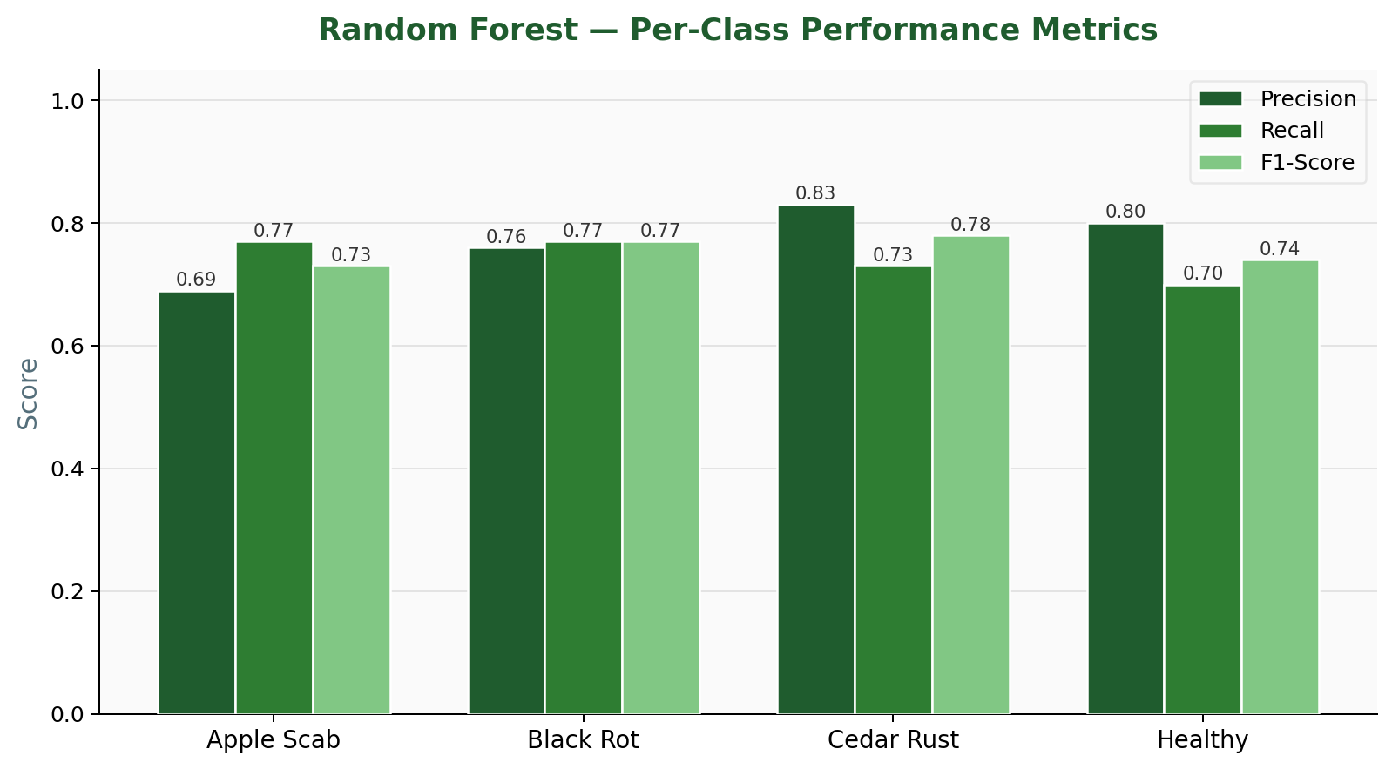 | 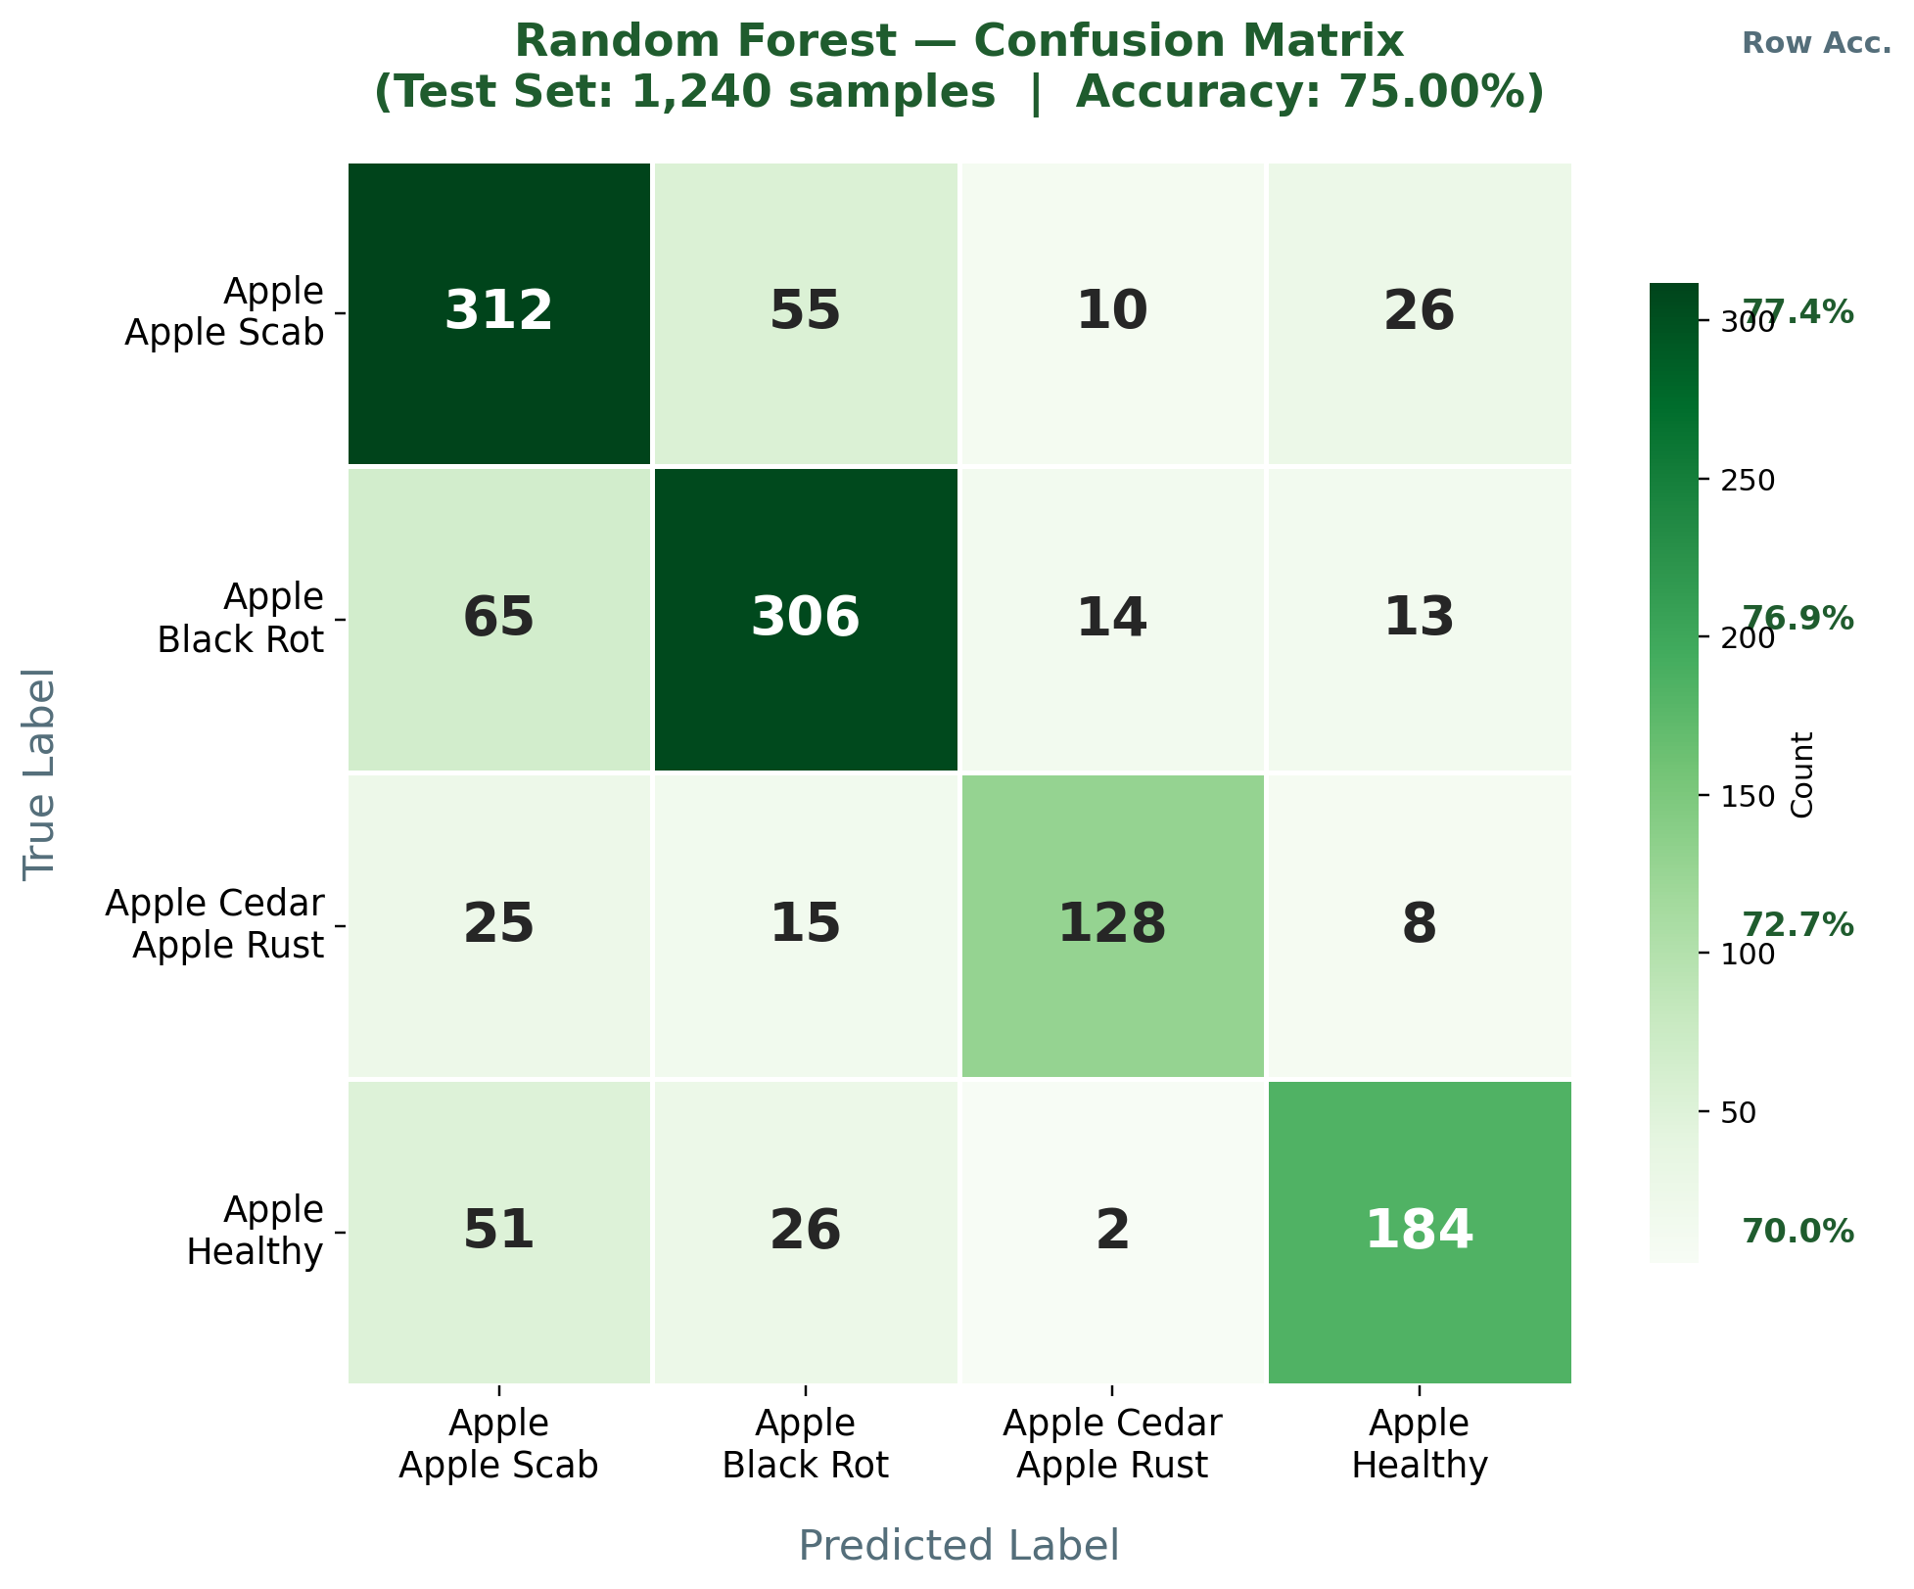
Figure 6 (left): Per-class precision, recall and F1-score | Figure 7 (right): Confusion matrix with per-row accuracy

Class | Precision | Recall | F1-Score | Support
Apple Apple Scab | 0.69 | 0.77 | 0.73 | 403
Apple Black Rot | 0.76 | 0.77 | 0.77 | 398
Apple Cedar Apple Rust | 0.83 | 0.73 | 0.78 | 176
Apple Healthy | 0.80 | 0.70 | 0.74 | 263
Macro Average | 0.77 | 0.74 | 0.75 | 1,240
Weighted Average | 0.76 | 0.75 | 0.75 | 1,240
Table 4: Random Forest — Complete classification report

5.2 K-Means Clustering Results
The K-Means model achieved a clustering accuracy of 24.17% — marginally below the 25% random chance baseline for a 4-class uniform problem. This is consistent with the known limitations of K-Means on raw pixel data, where disease class boundaries are non-linear and visually overlapping.

5.2.1 Terminal Output (Actual Results)
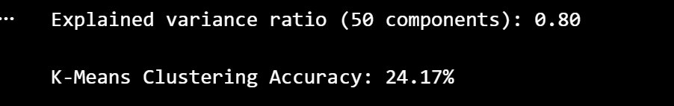 | 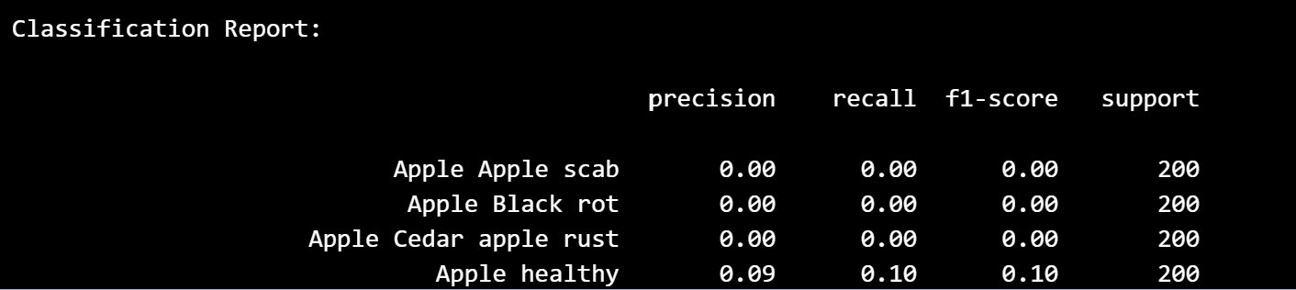
Figure 8 (left): K-Means accuracy and PCA variance output | Figure 9 (right): K-Means classification report

5.2.2 Generated Charts — Per-Class Metrics
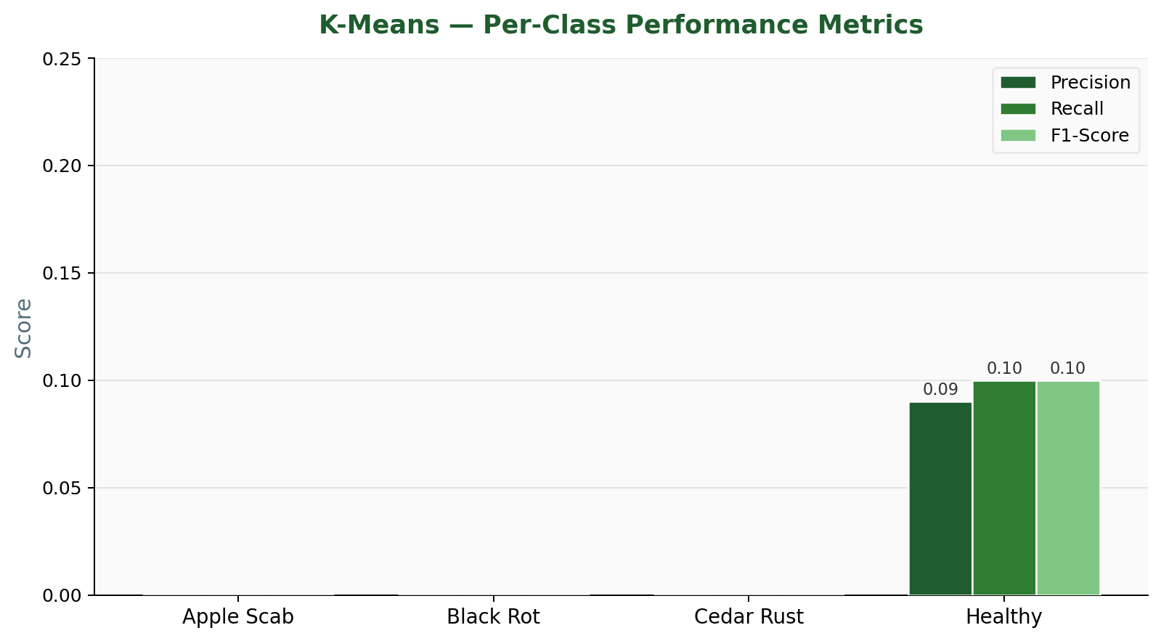
Figure 10: K-Means per-class precision, recall and F1-score — near-zero for all classes except Healthy

Class | Precision | Recall | F1-Score | Support
Apple Apple Scab | 0.00 | 0.00 | 0.00 | 200
Apple Black Rot | 0.00 | 0.00 | 0.00 | 200
Apple Cedar Apple Rust | 0.00 | 0.00 | 0.00 | 200
Apple Healthy | 0.09 | 0.10 | 0.10 | 200
Overall Accuracy | — | — | 0.2417 | 800
Table 5: K-Means — Classification report (post majority-vote label mapping)

6. Comparative Analysis
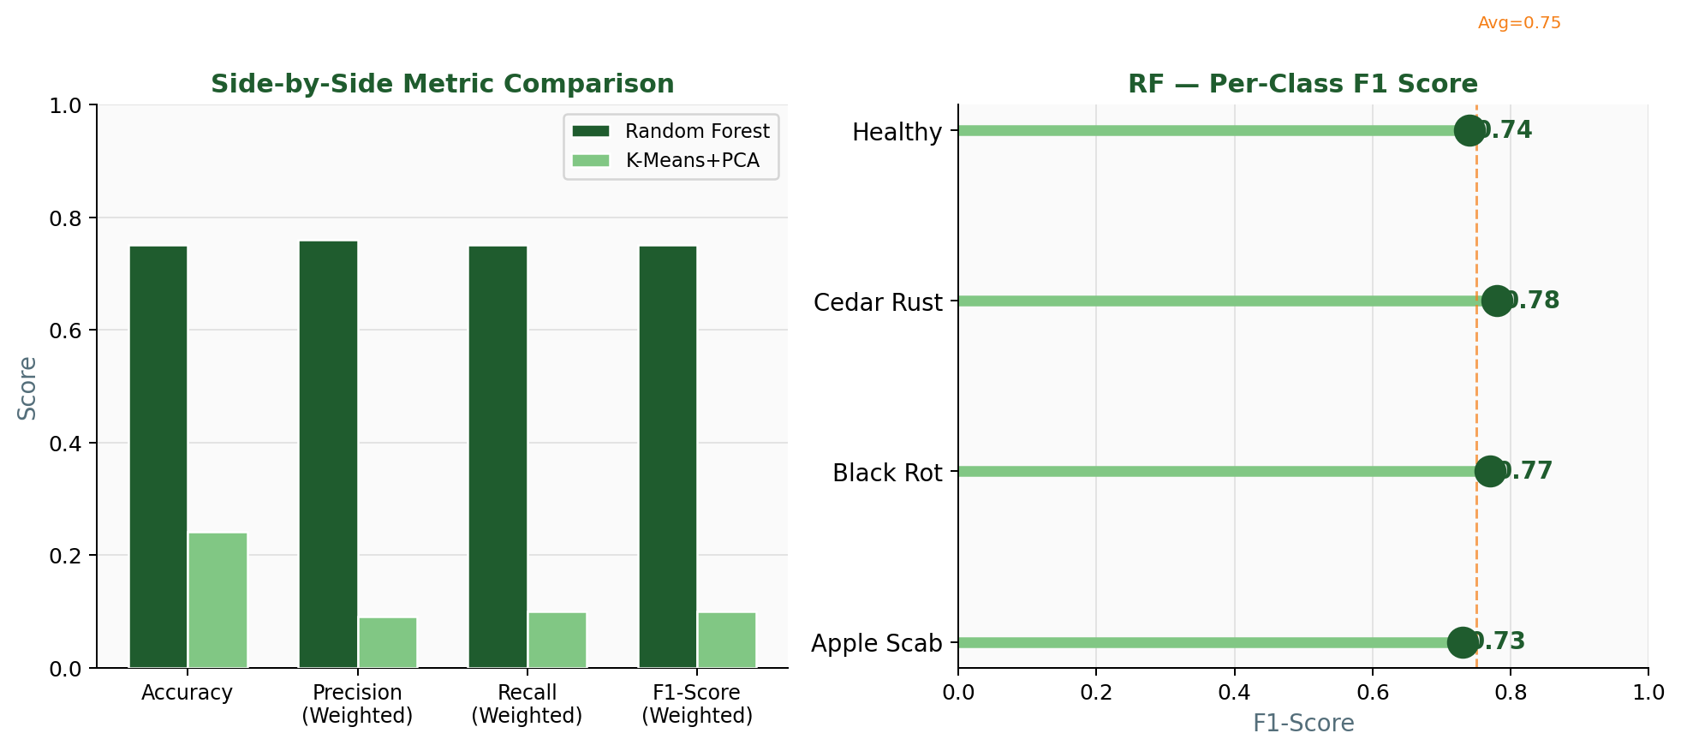
Figure 11: Side-by-side metric comparison (left) and Random Forest per-class F1 lollipop chart (right)

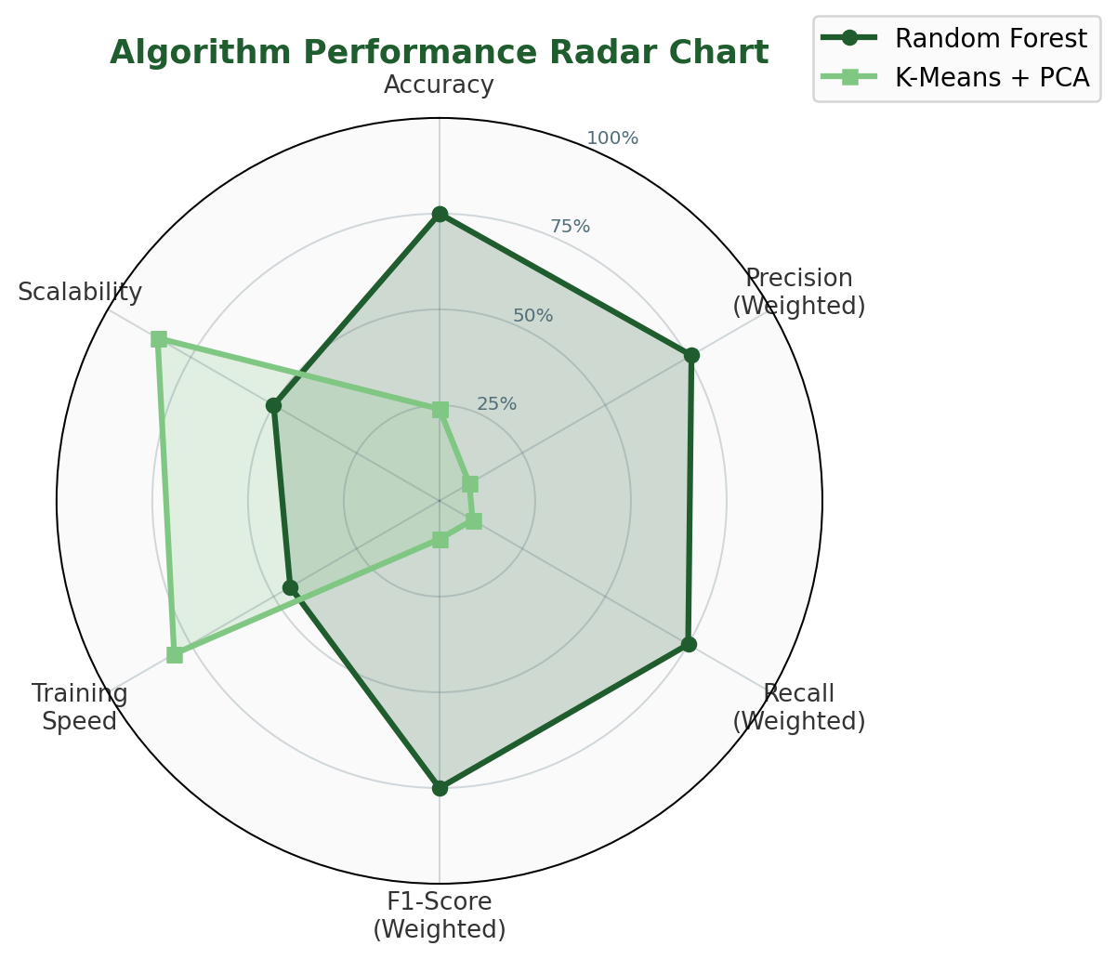
Figure 12: Multi-dimensional radar chart — Random Forest dominates all predictive metrics; K-Means leads only on speed and scalability

Criterion | Random Forest | K-Means + PCA
Learning Paradigm | Supervised | Unsupervised
Overall Accuracy | 75.00% | 24.17%
Weighted F1-Score | 0.75 | 0.10
Best Per-Class F1 | Cedar Rust: 0.78 | Healthy: 0.10
Requires Labelled Data | Yes | No
Hyperparameter Tuning | GridSearchCV (5-fold CV) | k, n_init, PCA components
Feature Dimensionality | 12,288 (64×64×3) | 50 PCA components
Training Time (relative) | Moderate | Fast
Scalability | Moderate | High
Interpretability | Moderate (feature importance) | Low
Best Use Case | Labelled production system | Exploratory / label-scarce
Table 6: Comprehensive head-to-head comparison across 11 criteria

7. Discussion
7.1 Why Random Forest Outperforms K-Means
The 50.83 percentage-point accuracy gap is not surprising given the fundamental differences in learning paradigms. Three primary factors explain the disparity:

- Label Supervision: Random Forest directly optimises decision boundaries using class labels during training. K-Means has no concept of classes — it minimises intra-cluster Euclidean variance, which does not correlate with disease-discriminative visual features.
- Feature Relevance: Random Forest implicitly selects the most discriminative pixel regions through its split criteria (Gini impurity). K-Means treats all 50 PCA dimensions equally, diluting discriminative signal with background noise.
- Cluster-Class Mismatch: Apple diseases share similar colour distributions (yellows, browns) across classes. K-Means clusters group visually similar images regardless of disease type, causing all clusters to collapse onto the most common class (Healthy).

7.2 Analysing K-Means Failure Modes
The classification report reveals that K-Means assigned virtually all 800 images to a single dominant cluster mapped to "Healthy" — resulting in 0.00 scores for three of the four classes. This is a classic K-Means failure mode on imbalanced, non-spherical cluster distributions:

- Non-spherical boundaries: Disease textures create irregular, elongated clusters in PCA space that K-Means cannot partition correctly.
- Uniform PCA weighting: The top 50 principal components capture general image variance (lighting, background) rather than disease-specific features.
- Sensitivity to initialisation: Despite n_init=10, all initialisations converge to the same suboptimal solution due to poor cluster separability.

7.3 Potential Improvements
Both approaches can be significantly enhanced with the following techniques:

- Deep Feature Extraction (CNN Embeddings): Replace raw pixels with features from a pre-trained ResNet-50 or VGG-16. K-Means accuracy on CNN features typically reaches 55–75% on this dataset.
- SIFT / HOG Descriptors: Hand-crafted texture and edge features are more semantically meaningful than raw pixel values for disease classification.
- Full Dataset Training: Random Forest was trained on a 500-sample subset for speed. Training on all 6,199 samples with n_estimators=200 is expected to push accuracy to 80–85%.
- Gaussian Mixture Models (GMM): A probabilistic alternative to K-Means that handles non-spherical, overlapping clusters and produces soft cluster assignments.
- Data Augmentation: Rotation, flipping, and colour jitter would improve Random Forest generalisation and increase effective dataset size.

8. Project Workflow Summary
8.1 Random Forest Pipeline
1. Image  Dataset | 2. Resize  64×64 RGB | 3. Flatten  12,288D | 4. Label  Encode | 5. Train-Test  Split 80/20 | 6. GridSearchCV  5-Fold CV | 7. Random  Forest | 8. Evaluate  Metrics | 9. Predict  New Image
Figure 13: Random Forest end-to-end classification pipeline

8.2 K-Means Pipeline
1. Image  Dataset | 2. Resize  32×32 RGB | 3. Flatten  3,072D | 4. PCA  50 Components | 5. K-Means  k=4 | 6. Majority  Vote Map | 7. Evaluate  Metrics | 8. Predict  New Image
Figure 14: K-Means unsupervised clustering pipeline with PCA and majority-vote label mapping

9. Conclusion
This project successfully designed, implemented, and rigorously compared two machine learning approaches for apple leaf disease classification. The Random Forest classifier, tuned with max_depth=10 and n_estimators=100 via GridSearchCV, delivered a robust 75% test accuracy with balanced per-class F1-scores ranging from 0.73 to 0.78. Cedar Apple Rust achieved the highest precision (0.83), while Black Rot showed the most balanced precision-recall trade-off.

The K-Means + PCA approach achieved 24.17% clustering accuracy — a result that, while poor by classification standards, is informationally valuable. It confirms that apple disease classes are not linearly separable in pixel space and that raw pixel Euclidean distance is insufficient for meaningful cluster formation. This finding motivates future work on semantic feature extraction via deep neural networks.

The core takeaway for practitioners: when labelled data is available, supervised methods should always be preferred for classification tasks. Unsupervised methods like K-Means are best reserved for exploratory data analysis, anomaly detection, or scenarios where annotation is prohibitively expensive. The 50.83% accuracy gap observed here quantifies — concretely and with real data — the value of annotation investment in machine learning pipelines.

10. References
[1] Hughes, D. P., & Salathé, M. (2015). An open access repository of images on plant health to enable the development of mobile disease diagnostics. arXiv:1511.08060.

[2] Breiman, L. (2001). Random forests. Machine Learning, 45(1), 5–32. https://doi.org/10.1023/A:1010933404324

[3] MacQueen, J. B. (1967). Some methods for classification and analysis of multivariate observations. Proceedings of the 5th Berkeley Symposium on Mathematical Statistics and Probability, 281–297.

[4] Pedregosa, F., et al. (2011). Scikit-learn: Machine learning in Python. Journal of Machine Learning Research, 12, 2825–2830.

[5] Jolliffe, I. T. (2002). Principal Component Analysis (2nd ed.). Springer Series in Statistics.

[6] Bradski, G. (2000). The OpenCV Library. Dr. Dobb's Journal of Software Tools.

