BirdVision AI: An Explainable Transfer-Learning System for Fine-Grained Bird Species Recognition with Location-Aware Species Discovery
Author Name(s) — to be supplied
Department / Program — to be supplied
Institution — to be supplied
Contact e-mail — to be supplied
Abstract—Automated bird species recognition can lower the expertise barrier for birdwatchers, students and biodiversity monitoring, but fine-grained classification among visually similar species remains difficult and a bare species label is of limited use without supporting context. We present BirdVision AI, an end-to-end system that pairs a trained convolutional neural network (CNN) with explainability and location-aware species discovery. The classifier is an EfficientNetB0 backbone, pre-trained on ImageNet and transfer-learned on the Caltech-UCSD Birds-200-2011 (CUB-200-2011) dataset (200 species; 5,194 training, 800 validation and 5,794 held-out test images). On the held-out test set the model attains a top-1 accuracy of 71.06%, top-5 accuracy of 92.44%, and a macro-averaged F1 of 0.715; per-class F1 ranges from 0.19 to 0.98 and the dominant errors occur between congeneric species (e.g. Chipping vs. Tree Sparrow). The CNN is the sole source of predictions and runs independently of two optional enrichment services: a Groq-hosted large language model (openai/gpt-oss-120b) that summarizes the identified species and answers questions, and the eBird API, which returns recent species-specific observations and nearby hotspots resolved through verified taxonomy. We integrate Grad-CAM for visual attribution and report its production behaviour. We emphasise that the softmax scores are uncalibrated, that a confidence threshold is a heuristic rather than an out-of-distribution detector, and that no independent field validation was performed. The system is a functional, reproducible reference implementation rather than a production-grade or scientifically validated identification tool.
Index Terms—bird species classification, EfficientNetB0, transfer learning, fine-grained recognition, explainable AI, Grad-CAM, convolutional neural networks, biodiversity informatics, eBird.

I. Introduction
Birdwatching and biodiversity monitoring depend on accurate species identification, a task that traditionally requires substantial expertise. Deep convolutional neural networks have driven large gains in image classification [1], [3], [4] and now underpin ecological applications such as camera-trap analysis [18] and large-scale species datasets [7]. Applied to birds, however, recognition is a fine-grained problem: hundreds of species share body plans and differ only in subtle plumage, bill or structural cues, and intra-class variation from pose, lighting and background frequently exceeds inter-class variation [6], [8].
A second limitation is that a species label alone is a thin user experience. A birdwatcher who learns that a photograph is a particular warbler usually also wants to know how confident the model is, why it reached that decision, what the species looks and behaves like, and where the bird might be observed nearby. Systems that return only a class name provide none of this and give users no basis for trusting or questioning the result.
BirdVision AI addresses both concerns with a modular system built around a genuinely trained classifier. A user uploads a photograph; a FastAPI backend validates and preprocesses it, runs EfficientNetB0 inference, maps output indices to the exact training class order, and returns ranked candidates with an explicit, uncalibrated-confidence disclaimer. Grad-CAM [11] produces an attribution heatmap. Two optional services enrich the result without ever participating in classification: a Groq-hosted large language model summarizes the identified species and answers follow-up questions, and the eBird API [16] returns recent, species-specific observations and nearby birding hotspots.
Research objectives. We set out to (i) train and honestly evaluate a transfer-learning classifier on CUB-200-2011; (ii) preserve exact class-index integrity from training to inference; (iii) provide production explainability; (iv) add language-model and citizen-science enrichment as strictly separated, fail-safe components; and (v) document limitations without inflating results.
Contributions. This paper makes the following implemented and verified contributions:
- A reproducible EfficientNetB0 transfer-learning classifier for 200 bird species with artifact-level integrity checks that validate the output-unit count against the stored class mapping before serving.
- An honest held-out evaluation (top-1 71.06%, top-5 92.44%, macro-F1 0.715) with per-class analysis and a confusion study that isolates congeneric failure modes; reported test metrics are independently recomputed from the saved confusion matrix and match the stored metrics exactly.
- A production Grad-CAM implementation that works with a nested Keras 3 backbone and includes degenerate-map validation.
- A clean architectural separation in which a Groq large language model and the eBird observation service enrich, but never perform, classification, each with classified error handling and graceful degradation.
We explicitly distinguish these from proposed future work (Section VII), which includes model calibration, out-of-distribution rejection and independent field validation; none of these is claimed as implemented.

II. Related Work
Deep and fine-grained classification. Modern image classification rests on deep CNNs trained on ImageNet [2], with residual connections [3] and compound-scaled architectures such as EfficientNet [4] improving the accuracy-efficiency trade-off; VGG-style networks [5] remain common feature extractors. Fine-grained recognition on datasets like CUB-200-2011 [6] motivated specialised methods, including bilinear pooling of two CNN feature extractors [8], which reaches 84.1% on CUB-200-2011 using higher-capacity backbones and domain-specific fine-tuning.
Transfer learning and ecological imagery. Transferring ImageNet-pretrained features to smaller target domains is effective because early layers learn general visual primitives [9]. This underpins ecological applications such as automated wildlife identification from camera traps [18] and large species benchmarks [7], where severe class imbalance and visual similarity depress accuracy.
Explainability, calibration and reliability. Grad-CAM [11] and its variants [12] visualise class-discriminative image regions via gradients of the class score with respect to convolutional feature maps. Separately, modern networks are often miscalibrated: softmax outputs do not match empirical correctness frequencies [13], and standard classifiers assign confident scores to out-of-distribution inputs, motivating dedicated detection baselines [14]. Dropout [10] is a common regulariser. These findings frame our deliberate refusal to present raw softmax scores as calibrated probabilities.
Birding information and citizen science. Acoustic monitoring models such as BirdNET [15] identify species from sound, a modality orthogonal to our image classifier. The eBird platform [16] aggregates hundreds of millions of citizen-science observations and exposes them through a public API, which we use for location-aware discovery.
Table I situates BirdVision AI among representative studies. Because datasets, modalities and evaluation protocols differ, the reported figures are not directly comparable and we make no ranking claim; the table clarifies scope and relevance rather than superiority.
TABLE I. COMPARISON WITH REPRESENTATIVE RELATED WORK (PROTOCOLS DIFFER; NOT DIRECTLY COMPARABLE)
Study | Data / modality | Architecture | Task | Reported
Lin et al. [8] | CUB-200-2011 (image) | Bilinear VGG | Fine-grained ID | 84.1% acc.
Van Horn [7] | iNaturalist (image) | Inception/ResNet | 5k-species ID | ~67% top-1
Tan&Le [4] | ImageNet (image) | EfficientNet-B0 | 1k-class ID | 77.1% top-1
Kahl et al. [15] | Audio recordings | CNN (spectrogram) | Acoustic ID | Audio (diff. modality)
This work | CUB-200-2011 (image) | EfficientNetB0 (TL) | 200-species ID + discovery | 71.06% top-1
Our aim is not a new state-of-the-art accuracy on CUB-200-2011; the lightweight EfficientNetB0 backbone and modest fine-tuning budget trail heavier fine-grained methods [8]. The contribution is an integrated, honestly-evaluated and explainable system with location-aware enrichment.

III. Dataset
The classifier is trained and evaluated on the Caltech-UCSD Birds-200-2011 (CUB-200-2011) dataset [6], which contains 11,788 images across 200 North-American-centric bird species. The project configuration records the data source as a Kaggle mirror listed as "200 Bird Species with 11,788 Images"; inspection of the class labels (CUB folder identifiers of the form 001.Black_footed_Albatross) confirms that this mirror is CUB-200-2011 and not a distinct dataset. We therefore report CUB-200-2011 throughout.
The pipeline uses the splits summarised in Table II: 5,194 training, 800 validation and 5,794 held-out test images, summing to the full 11,788. The held-out test set is used only for final evaluation. Per-class support in the test split is near-uniform (mean 29.0 images per class; range 11-30), so macro- and weighted-averaged metrics are close. The exact assignment procedure (random versus the official CUB train/test partition) is not recorded in the available artifacts and is marked for verification.
TABLE II. DATASET AND SPLIT SUMMARY (CUB-200-2011)
Partition | Images | Classes | Mean/class
Training | 5,194 | 200 | 26.0
Validation | 800 | 200 | 4.0
Test (held-out) | 5,794 | 200 | 29.0
Total | 11,788 | 200 | -
Input images are converted to RGB and resized to 224x224. Pixel values are kept in the 0-255 range: the EfficientNet backbone embeds its own rescaling and normalization layers, so no additional division by 255 is applied, avoiding a double-normalization error. Training-time augmentation, read directly from the saved model, comprises horizontal flips, small rotations (+/-0.08 rad), random zoom and mild random contrast (0.1). We did not run a dedicated duplicate-detection or split-leakage audit; this is noted as a limitation. CUB-200-2011 is distributed by Caltech for research use [6]; the raw images are not redistributed in this repository, which ships only the derived model and evaluation artifacts.

IV. Proposed Methodology

A. System Architecture
Figure 1 shows the end-to-end flow. The Next.js/TypeScript frontend sends an uploaded image to a Python FastAPI backend, which performs validation (size, MIME type and magic-byte checks), preprocessing, EfficientNetB0 inference, class-index mapping and ranking, and optional Grad-CAM. The identified species then conditions two independent services. The backend is the only component that performs classification; the Groq and eBird services are reached through separate, self-contained modules and neither receives the image for classification.
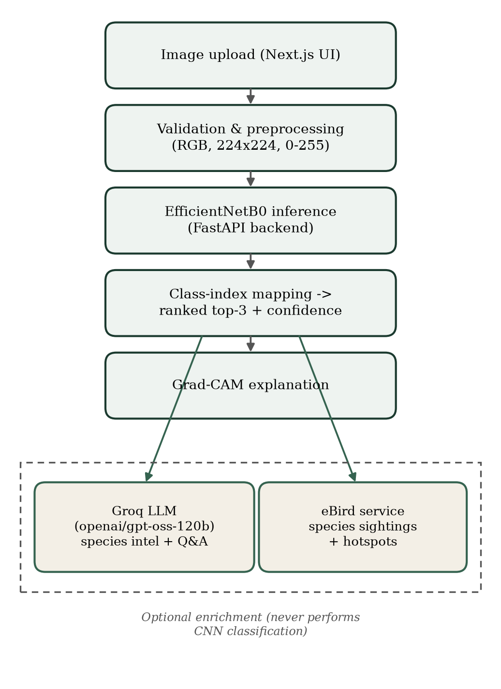
Fig. 1. End-to-end system architecture (illustrative). The CNN pipeline (top) is the sole classifier; the dashed region marks optional enrichment services that are conditioned on the identified species and never classify images.
Failure handling. Each boundary degrades independently. A readiness endpoint reports whether the model artifact is loaded and returns HTTP 503 rather than a fabricated prediction when it is not. Groq and eBird failures are classified and surfaced distinctly (Sections IV-F, IV-G) and never block classification.

B. Model Architecture
The classifier (Fig. 2) is an EfficientNetB0 backbone [4] pre-trained on ImageNet [2], followed by global average pooling, a dropout layer with rate 0.3 [10], and a dense softmax layer with 200 outputs. The saved model (Keras 3.13 / TensorFlow 2.21 [17]) has 4,305,771 total parameters, of which 2,293,720 are trainable and 2,012,051 are frozen; the partial trainable fraction indicates that fine-tuning extended into the upper backbone rather than the classification head alone. The serialized artifact is 36.4 MB. The exact set of unfrozen layers and the boundary between the head-training and fine-tuning phases are not separately labelled in the artifacts and are marked for verification.
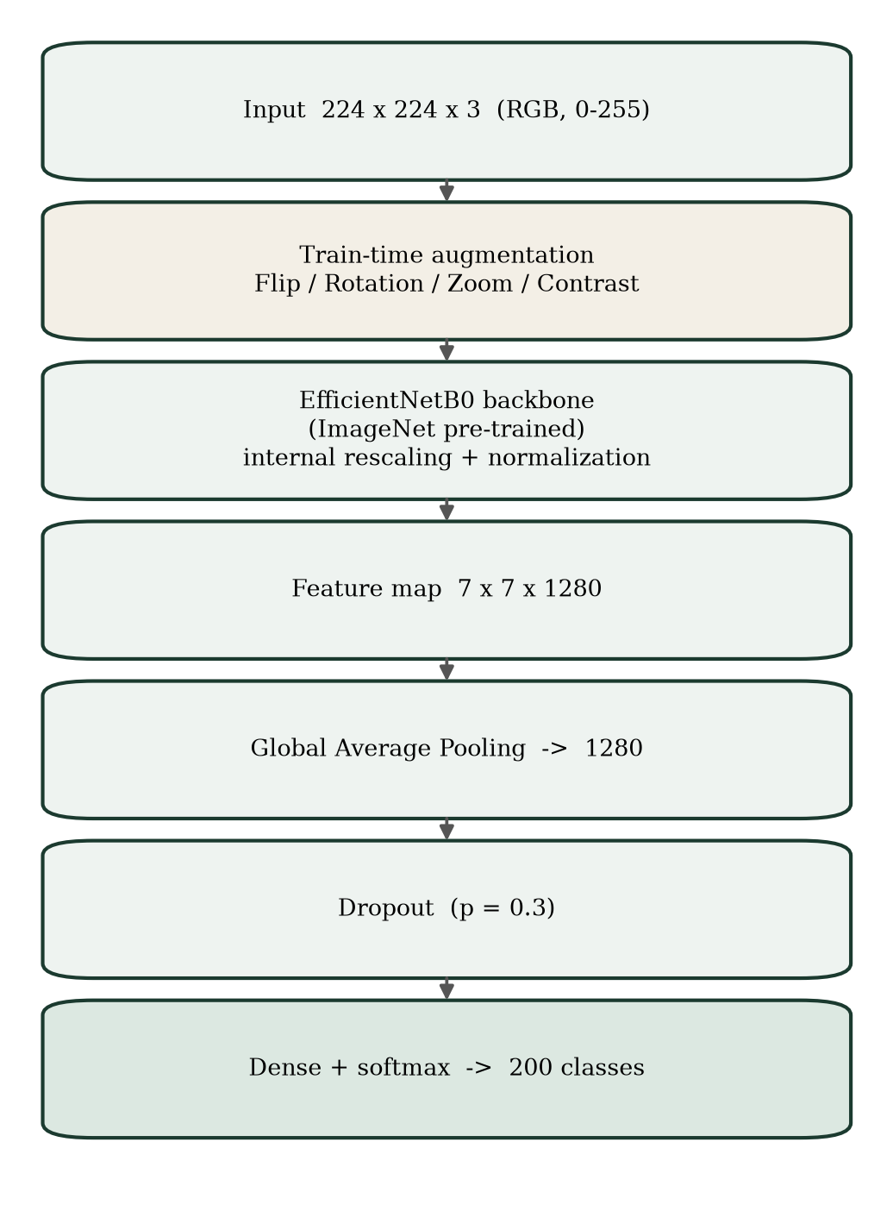
Fig. 2. Model architecture: an ImageNet-pretrained EfficientNetB0 backbone with a global-average-pooling, dropout (p=0.3) and 200-way softmax head.

C. Mathematical Formulation
For an input image x the network produces a logit vector z(x) over K=200 classes. The softmax transform yields a score vector p whose i-th entry is
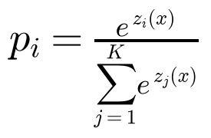 (1)
where z_i(x) is the logit for class i. The predicted label is the arg-max, and the top-k candidates are the k classes with the largest scores:
(2)
The supervised objective for this single-label softmax classifier is categorical cross-entropy,
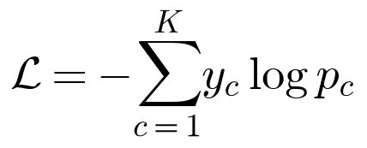 (3)
with y the one-hot target. We note that the exact loss and optimizer used during training are not recorded in the available artifacts; cross-entropy is the conventional and near-certain choice for this output layer and is stated as such rather than asserted from a training log. Crucially, the entries of p are uncalibrated scores, not empirical probabilities, and we present them accordingly.

D. Training and Preprocessing
Inputs are 224x224x3 RGB tensors in the 0-255 range (Section III). The stored training history spans 20 epochs and records train and validation top-1/top-5 accuracy, loss and the learning rate, which starts at 1e-3 and decays toward zero under a schedule. A fixed random seed (42) is recorded. The optimizer identity, batch size, precise learning-rate schedule and the training hardware are not present in the artifacts, since the Colab training notebook is not included in the repository; these are reported as requiring verification rather than inferred. Figure 3 plots the recorded curves: training top-1 accuracy reaches 0.936 while validation top-1 plateaus near 0.72, an approximately 21-point gap that indicates overfitting despite augmentation and dropout.
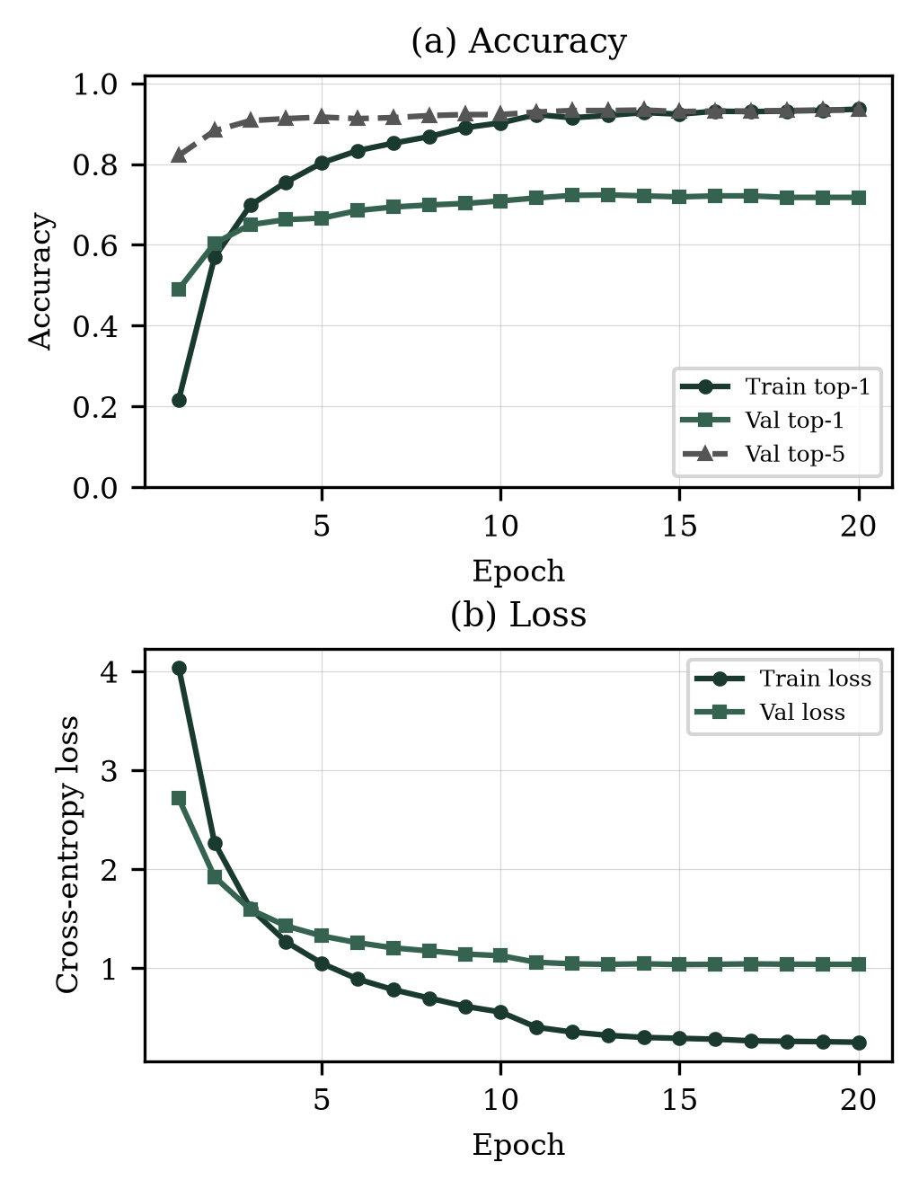
Fig. 3. Training dynamics over the 20 recorded epochs (from training_history.json). (a) Train/validation top-1 and validation top-5 accuracy; (b) train/validation cross-entropy loss. The widening train-validation gap is consistent with overfitting.

E. Explainability (Grad-CAM)
Grad-CAM [11] attributes a prediction to spatial regions of the final convolutional feature map. Let A^k be the k-th feature-map channel of the backbone's last convolutional block (7x7x1280) and y^c the score for class c. The channel importance weights and the localisation map are
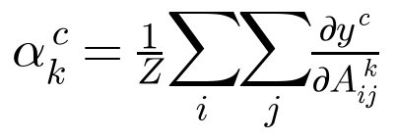 (8)
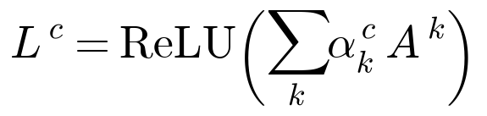 (9)
where Z is the number of spatial locations and ReLU keeps only positive contributions. Because the trained model nests the EfficientNetB0 backbone as a sub-model, the Keras 3 functional graph cannot be re-wired to tap the inner feature map directly; our implementation instead runs the forward pass eagerly under a gradient tape that watches the backbone output, then applies the backbone's remaining head layers. The raw map is validated for finiteness and a non-zero dynamic range before being normalized to [0,1]; a degenerate map raises a controlled error and the interface shows an "unavailable" state rather than a blank or misleading overlay. The map is bilinearly resized to 224x224, colour-mapped, and composited with a per-pixel alpha so that low-activation regions retain the original image. We stress that a heatmap indicates where activations influenced the score; it is an attribution aid, not evidence of causal reasoning or correctness [11], [12].
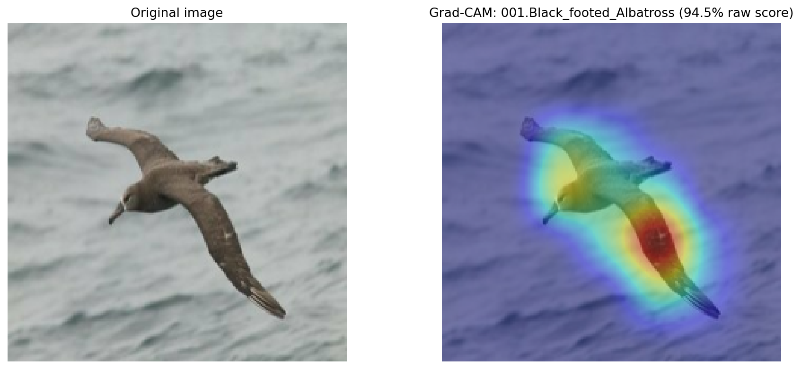
Fig. 6. Grad-CAM example from the training pipeline (gradcam_example.png): the original image (left) and the class-activation overlay (right). Warm regions mark the areas whose activations most influenced the predicted class score.

F. Species Intelligence (Groq)
After the CNN produces a label, an optional component queries a Groq-hosted large language model through its OpenAI-compatible chat API to generate a structured species summary (overview, habitat, diet, behaviour, notable facts, conservation note and suggested questions) and to answer free-form user questions. The configured model is openai/gpt-oss-120b with openai/gpt-oss-20b as a transient-failure fallback; both were verified available for the API key. The API key is read only from the backend environment and is never exposed to the client. Requests use JSON-mode responses that are schema-validated; failures are classified (rate-limited, temporarily unavailable, timeout, authentication, quota, configuration) and transient classes are retried at most twice with exponential backoff and jitter before the fallback model is tried. The language model is an enrichment layer only: it does not see the image for classification, and the classifier is fully functional when the service is unavailable. Generated text is explicitly labelled as AI-generated and is not an authoritative biological source; factual verification of model output is a known limitation.

G. Location-Aware Species Discovery (eBird)
The discovery component answers "where can I see this species near me?" using the eBird API 2.0 [16]. The predicted species is mapped to an eBird species code via its human-verified scientific name against the official eBird taxonomy, never by string-matching a common name; scientific names are verified for 128 of the 200 classes, and unresolved species are reported as such rather than guessed. The backend then requests recent species-specific observations near the supplied coordinates and nearby hotspots, using the exact coordinates from the request (bounded to a radius of at most 50 km and a look-back of at most 30 days). Observations are ranked nearest-first by great-circle distance,
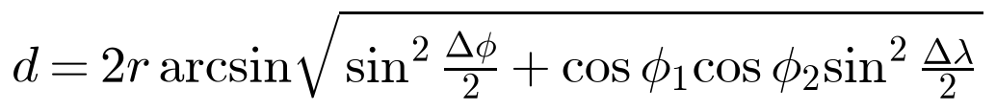 (10)
where r is the Earth radius and (phi, lambda) are latitudes and longitudes. Every response echoes the search centre, radius and time window so the interface can display exactly what was queried. An API error is reported distinctly from a genuine empty result, and browser geolocation is optional and requested only on explicit user action. We emphasise that recent reported sightings are community observations, not a guarantee of current presence, and are distinct from a species' range or abundance; sensitive-species handling follows eBird's own data policies.

V. Experimental Setup And Evaluation
Evaluation uses the 5,794-image held-out CUB-200-2011 test split (200 classes). We report top-1 and top-5 accuracy, macro and weighted precision, recall and F1, per-class F1, the confusion matrix, inference latency, and model size. For a per-class count TP_c, FP_c and FN_c, precision, recall and F1 are
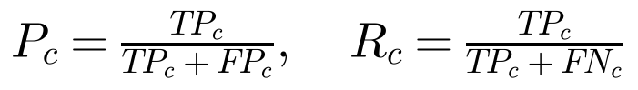 (4)
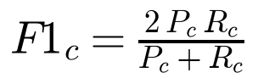 (6)
and the macro average is the unweighted mean over the K classes,
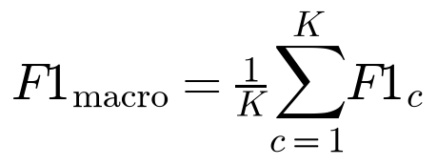 (7)
Top-1 accuracy alone is an inadequate summary for fine-grained classification with near-balanced support: it hides which species are systematically confused and treats a confident error the same as a near-miss. Macro-averaged F1 and the confusion matrix expose the per-class and congeneric structure of the errors, which is the behaviour that most affects a birdwatching user. All reported test metrics were additionally recomputed from the stored confusion matrix and agree with the saved metrics file to four decimal places, confirming class-index integrity between training and inference.
Calibration and OOD. We did not compute a calibration error or an out-of-distribution detection metric. Consistent with the literature [13], [14], we therefore make no calibration or robustness claim; the softmax scores are treated as uncalibrated and the confidence threshold described below is a heuristic.

VI. Results And Discussion
Table III reports the headline classification metrics on the held-out test set. The model attains 71.06% top-1 and 92.44% top-5 accuracy, with a macro-F1 of 0.715. The closeness of macro and weighted figures reflects the near-uniform class support.
TABLE III. CLASSIFICATION METRICS ON THE HELD-OUT TEST SET (5,794 IMAGES, 200 CLASSES)
Metric | Value
Top-1 accuracy | 71.06%
Top-5 accuracy | 92.44%
Macro precision | 0.7352
Macro recall | 0.7127
Macro F1 | 0.7146
Weighted F1 | 0.7127
The training curves (Fig. 3) and the roughly 21-point gap between training (0.936) and validation (~0.72) top-1 accuracy indicate overfitting; the held-out test top-1 (71.06%) is close to the best validation accuracy (72.37%), so the model generalises to the test split at the validation level but no better. We report the test figure, never the training or validation figure, as the headline result.
Per-class behaviour. Figure 5 shows the per-class F1 distribution and the weakest classes. Per-class F1 ranges from 0.19 to 0.98 (mean 0.715). The strongest classes are visually distinctive birds (e.g. Pileated Woodpecker 0.98, Horned Puffin 0.98, White Pelican 0.98), whereas the weakest are members of visually similar groups (Table V). This spread is the practical reason top-1 accuracy understates the difficulty for the hardest species.
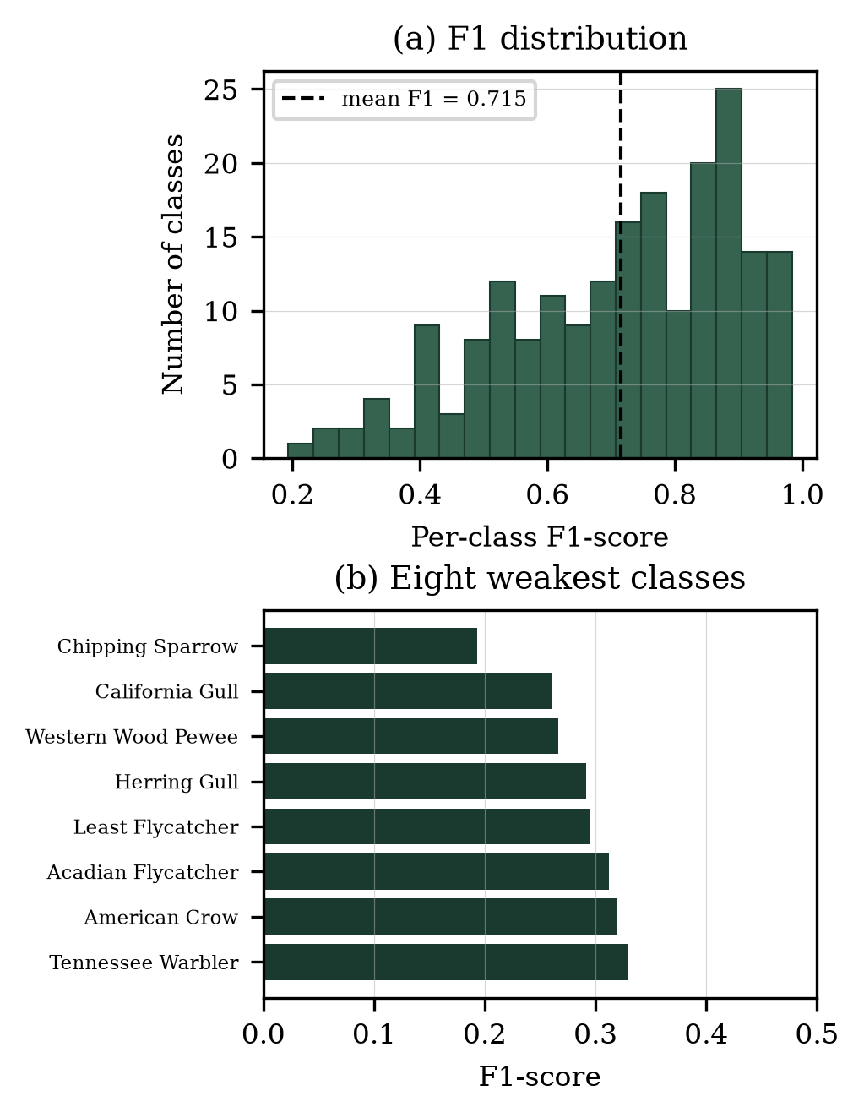
Fig. 5. Per-class performance on the held-out test set. (a) Distribution of per-class F1 (mean 0.715); (b) the eight weakest classes, all members of visually similar groups.
TABLE IV. BEST- AND WORST-PERFORMING CLASSES BY F1 (HELD-OUT TEST)
Class | P | R | F1 | n
Pileated Woodpecker | 0.97 | 1.00 | 0.98 | 30
Horned Puffin | 1.00 | 0.97 | 0.98 | 30
White Pelican | 0.95 | 1.00 | 0.98 | 20
Rose-breasted Grosbeak | 0.97 | 0.97 | 0.97 | 30
Least Flycatcher | 0.21 | 0.48 | 0.29 | 29
Herring Gull | 0.39 | 0.23 | 0.29 | 30
Western Wood-Pewee | 0.40 | 0.20 | 0.27 | 30
California Gull | 0.38 | 0.20 | 0.26 | 30
Chipping Sparrow | 0.19 | 0.20 | 0.19 | 30
Confusion structure. Figure 4 shows the row-normalized 200x200 confusion matrix; off-diagonal mass concentrates in small clusters of congeneric species. Table V lists the most frequent confusions, which are dominated by sparrows, gulls, terns, grebes, flycatchers, crows/ravens and cormorants - groups that experienced human observers also find difficult. These are genuine fine-grained errors rather than arbitrary mistakes.
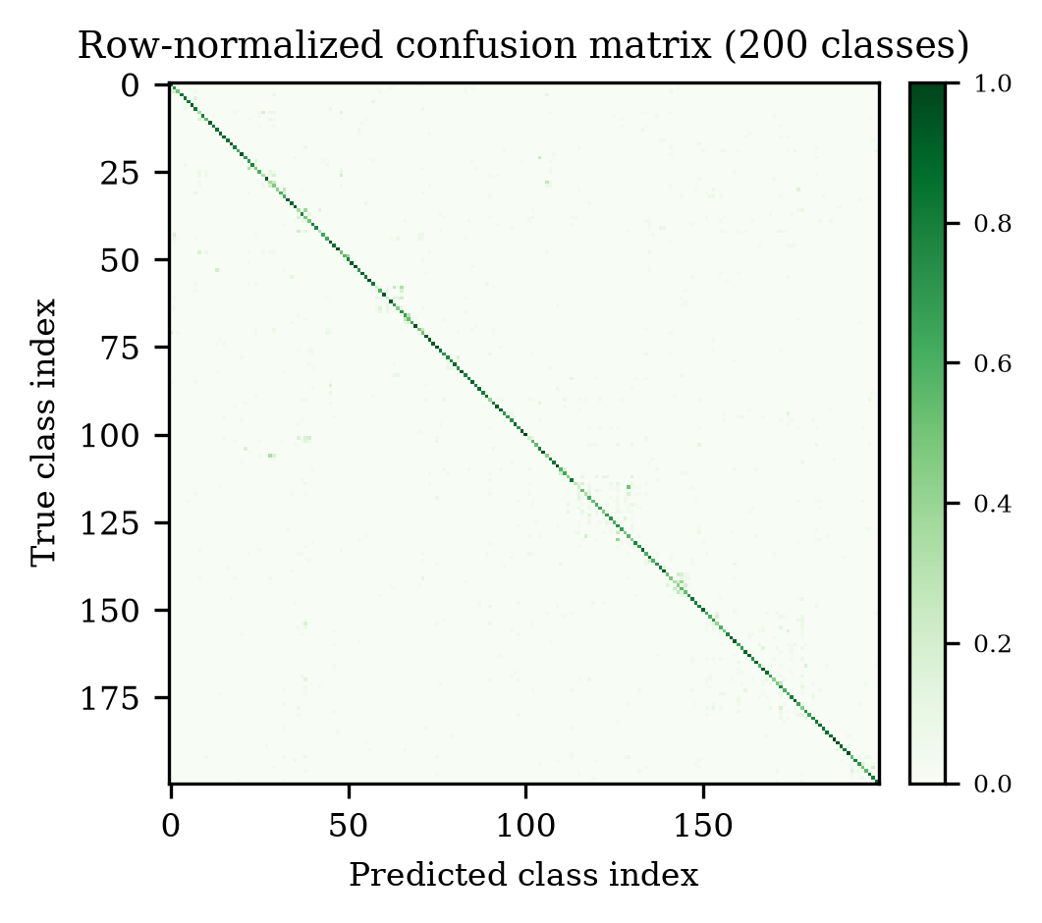
Fig. 4. Row-normalized confusion matrix over all 200 classes (from confusion_matrix.npy). A strong diagonal with sparse congeneric off-diagonal clusters is visible.
TABLE V. MOST FREQUENT TEST-SET CONFUSIONS (TRUE -> PREDICTED)
True species | Predicted species | Count
Chipping Sparrow | Tree Sparrow | 15
Vesper Sparrow | Savannah Sparrow | 12
Eared Grebe | Horned Grebe | 12
Caspian Tern | Elegant Tern | 12
Acadian Flycatcher | Least Flycatcher | 11
Common Raven | American Crow | 10
California Gull | Western Gull | 10
Pelagic Cormorant | Brandt Cormorant | 10
Computational characteristics. Table VI reports model size and latency. The stored evaluation recorded a mean single-image inference latency of 293 ms (p95 313 ms) on a GPU, as noted in the metrics artifact. On a CPU-only backend we observed a warm latency of roughly 130-290 ms per image and a one-off cold cost of several seconds on the first call due to graph tracing. Latency is therefore environment-dependent and we report both conditions.
TABLE VI. COMPUTATIONAL CHARACTERISTICS
Property | Value
Total parameters | 4,305,771
Trainable / frozen | 2,293,720 / 2,012,051
Serialized artifact size | 36.4 MB
Input resolution | 224 x 224 x 3
Latency (GPU, stored eval) | mean 293 ms, p95 313 ms
Latency (CPU, warm / cold) | ~130-290 ms / several s
Out-of-distribution behaviour. Because the softmax ranges over exactly 200 classes, the model cannot natively signal "not a supported species". Feeding clearly out-of-distribution inputs confirms this: uniform-noise and flat-grey images both produced low top scores (0.12 and 0.01) that fall below the system's heuristic abstention threshold (0.35) and are flagged as uncertain. This threshold reduces confident nonsense but is not a validated out-of-distribution detector [14]; genuinely unsupported species can still be mapped to the nearest known class with moderate confidence.
Functional verification of integrations. Table VII records the verification status of each component. Classification, Grad-CAM, the Groq enrichment and the eBird discovery service were exercised end-to-end; the backend test suite comprises 58 passing tests with external services mocked. We did not perform load testing, security penetration testing or any independent field validation of predictions.
TABLE VII. FUNCTIONAL VERIFICATION OF SYSTEM COMPONENTS
Component | Status | Evidence
CNN classification | Verified | Live inference; metrics recomputed
Class-index mapping | Verified | Startup guard + test
Grad-CAM | Verified | Live overlay; validation tests
Groq enrichment | Verified | Live 200 OK; 120b model
eBird discovery | Verified | Live species-specific sightings
Automated tests | Verified | 58 backend tests pass
Field validation | Not done | Out of scope
Benchmark versus real-world performance. All figures above are on curated CUB-200-2011 images. Real user uploads differ in framing, occlusion, background and image quality, and include species outside the 200 trained classes, so field accuracy is expected to be lower than the reported benchmark. We also observed that the external language-model service can be transiently rate-limited, in which case enrichment is withheld rather than fabricated. Previously reported qualitative screenshot cases (a sparrow-like, an eagle-like and a stork/crane-like bird) could not be re-evaluated here because the original image files are not present in the repository; they are noted as pending qualitative case studies and are not used as evidence.

VII. Limitations And Future Work
- Dataset coverage and shift. The model knows only 200 largely North-American species; inputs outside this set are necessarily misclassified, and curated-benchmark accuracy overstates field performance.
- Fine-grained confusion. Congeneric species (sparrows, gulls, terns, grebes, flycatchers) drive most errors and pull per-class F1 as low as 0.19.
- Uncalibrated confidence. Softmax scores are not calibrated and no calibration error was measured; the confidence threshold is heuristic.
- No OOD rejection. There is no validated out-of-distribution detector; unsupported species can be mapped to the nearest class.
- Explainability scope. Grad-CAM localises influence but does not verify correctness, and was not quantitatively validated against annotations.
- External-service dependence. Groq and eBird are subject to availability, rate limits and upstream data freshness; sightings are community reports, not guaranteed presence.
- Provenance gaps. The training notebook and raw images are absent, so optimizer, batch size, exact schedule, split methodology and leakage status remain unverified.
- No field validation. Predictions were not validated against expert-confirmed field observations.
Future work follows directly from these limitations and is not claimed as implemented: measuring and correcting calibration [13]; adding a validated out-of-distribution rejection mechanism [14]; stronger, quantitatively evaluated explainability [12]; a documented leakage and duplicate audit of the splits; broader taxonomic and geographic coverage; and an independent, expert-verified field evaluation of real user uploads.

VIII. Conclusion
We presented BirdVision AI, an explainable transfer-learning system for fine-grained bird species recognition with location-aware species discovery. A single EfficientNetB0 classifier, transfer-learned on CUB-200-2011, attains a verified held-out top-1 accuracy of 71.06% and a macro-F1 of 0.715, with errors concentrated among congeneric species, as an honest per-class and confusion analysis makes explicit. Around this classifier the system adds production Grad-CAM attribution and two strictly separated, fail-safe enrichment services - a Groq language model for species intelligence and the eBird API for species-specific nearby observations - without ever delegating classification to them. We have been deliberate about what is not claimed: the scores are uncalibrated, there is no out-of-distribution rejection, several training details remain unverified, and no independent field validation was performed. The result is a reproducible, defensible reference implementation of an explainable, context-rich bird-recognition system rather than a production-ready or scientifically validated identification tool.

Code Availability
The implementation (backend, frontend, evaluation artifacts and the scripts that regenerate this paper's figures) resides in the project repository. No public repository URL is asserted here; the code is available from the authors on request, subject to the dataset's research-use terms.

References
[1] Y. LeCun, Y. Bengio and G. Hinton, "Deep learning," Nature, vol. 521, no. 7553, pp. 436-444, 2015.
[2] J. Deng, W. Dong, R. Socher, L.-J. Li, K. Li and L. Fei-Fei, "ImageNet: A large-scale hierarchical image database," in Proc. IEEE CVPR, 2009, pp. 248-255.
[3] K. He, X. Zhang, S. Ren and J. Sun, "Deep residual learning for image recognition," in Proc. IEEE CVPR, 2016, pp. 770-778.
[4] M. Tan and Q. V. Le, "EfficientNet: Rethinking model scaling for convolutional neural networks," in Proc. ICML, 2019, pp. 6105-6114.
[5] K. Simonyan and A. Zisserman, "Very deep convolutional networks for large-scale image recognition," in Proc. ICLR, 2015.
[6] C. Wah, S. Branson, P. Welinder, P. Perona and S. Belongie, "The Caltech-UCSD Birds-200-2011 dataset," California Inst. Technol., Tech. Rep. CNS-TR-2011-001, 2011.
[7] G. Van Horn et al., "The iNaturalist species classification and detection dataset," in Proc. IEEE CVPR, 2018, pp. 8769-8778.
[8] T.-Y. Lin, A. RoyChowdhury and S. Maji, "Bilinear CNN models for fine-grained visual recognition," in Proc. IEEE ICCV, 2015, pp. 1449-1457.
[9] J. Yosinski, J. Clune, Y. Bengio and H. Lipson, "How transferable are features in deep neural networks?," in Proc. NeurIPS, 2014, pp. 3320-3328.
[10] N. Srivastava, G. Hinton, A. Krizhevsky, I. Sutskever and R. Salakhutdinov, "Dropout: A simple way to prevent neural networks from overfitting," J. Mach. Learn. Res., vol. 15, no. 1, pp. 1929-1958, 2014.
[11] R. R. Selvaraju, M. Cogswell, A. Das, R. Vedantam, D. Parikh and D. Batra, "Grad-CAM: Visual explanations from deep networks via gradient-based localization," in Proc. IEEE ICCV, 2017, pp. 618-626.
[12] A. Chattopadhay, A. Sarkar, P. Howlader and V. N. Balasubramanian, "Grad-CAM++: Generalized gradient-based visual explanations for deep convolutional networks," in Proc. IEEE WACV, 2018, pp. 839-847.
[13] C. Guo, G. Pleiss, Y. Sun and K. Q. Weinberger, "On calibration of modern neural networks," in Proc. ICML, 2017, pp. 1321-1330.
[14] D. Hendrycks and K. Gimpel, "A baseline for detecting misclassified and out-of-distribution examples in neural networks," in Proc. ICLR, 2017.
[15] S. Kahl, C. M. Wood, M. Eibl and H. Klinck, "BirdNET: A deep learning solution for avian diversity monitoring," Ecol. Informatics, vol. 61, art. 101236, 2021.
[16] B. L. Sullivan, C. L. Wood, M. J. Iliff, R. E. Bonney, D. Fink and S. Kelling, "eBird: A citizen-based bird observation network in the biological sciences," Biol. Conservation, vol. 142, no. 10, pp. 2282-2292, 2009.
[17] M. Abadi et al., "TensorFlow: A system for large-scale machine learning," in Proc. USENIX OSDI, 2016, pp. 265-283.
[18] M. S. Norouzzadeh et al., "Automatically identifying, counting, and describing wild animals in camera-trap images with deep learning," Proc. Nat. Acad. Sci. USA, vol. 115, no. 25, pp. E5716-E5725, 2018.

