SATQUERY AI — EARTH OBSERVATION WORKBENCH
Remote Sensing Inspection Report
Report ID | 19fd838e6bf7479c | Timestamp | 2026-09-07T17:12:10
Confidence | Medium (0.65) | Images | 2 scene(s)
Query | Analyze optical and SAR radar backscatter fusion for maritime vessels | Evidence | sar_fusion

Executive Summary & Findings
{
"summary": "The fused optical and SAR analysis reveals a bustling urban port environment with significant maritime activity. Optical imagery provides detailed land cover and vessel identification, while SAR backscatter corroborates structural features and uniquely highlights metallic vessels and calm water bodies, offering all-weather detection capabilities.",
"detailed_analysis": {
"scene_overview": "The scene captures a dense coastal city with an extensive port infrastructure. Optical multi-spectral reflectance clearly delineates urban blocks, road networks, and various vessels docked or in transit within the harbor and open water. SAR microwave backscatter strongly correlates with built-up areas and metallic structures, appearing as bright returns, while calm water bodies exhibit extremely low backscatter, appearing dark. This fusion provides a comprehensive view of both visible surface characteristics and dielectric/structural properties.",
"land_cover": "Urban areas, characterized by high optical albedo (concrete, buildings) and complex textures, exhibit very high SAR backscatter due to numerous corner reflectors and rough surfaces. Port infrastructure, including docks, cranes, and container yards, also shows high optical albedo and exceptionally high SAR backscatter. Water bodies, both the open ocean and the river, display low optical albedo (dark blue) and are consistently represented by extremely low SAR backscatter, indicative of specular reflection from smooth surfaces. Minimal vegetation is present, primarily within urban parks, showing moderate optical green signatures and less distinct SAR texture.",
"key_objects": [
"High-backscatter metallic / structural corner reflector: Multiple large vessels docked in the central-right harbor basin (Q2/Q4 boundary) and a vessel in motion in the central water body (Q2/Q4 boundary). Urban buildings throughout Q1, Q2, Q3 also act as strong corner reflectors.",
"Specular low-backscatter feature: The open ocean in the bottom-right (Q4) and the calm river flowing through the top-left (Q1/Q2) exhibit very low SAR backscatter, confirming smooth water surfaces.",
"Volume scattering canopy or rough terrain: While typical forest canopy volume scattering is absent, the dense urban fabric across Q1, Q2, and Q3 presents complex scattering from multiple surfaces and orientations, effectively acting as 'rough terrain' in the SAR context, distinct from specular water or isolated corner reflectors."
],
"spatial_patterns": "The SAR backscatter intensity forms a stark contrast between the bright, intricate patterns of the urban landscape and port facilities, and the uniformly dark expanse of the water bodies. Linear features like roads and bridges are discernible as bright lines within the urban

Visual Evidence Grounding
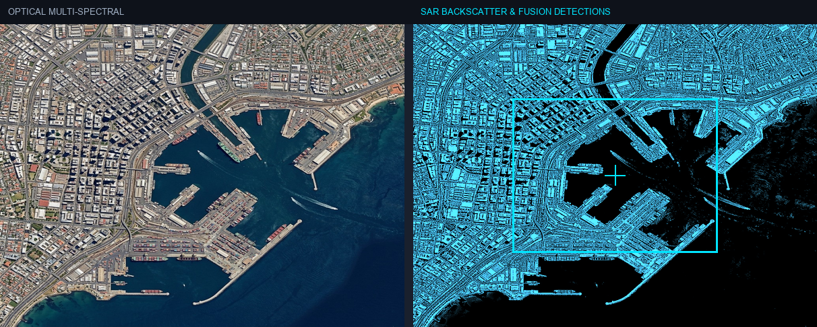
Figure: Orthorectified satellite scene with detected spatial features and evidence overlay.

Multi-Angle Satellite Telemetry
Scene Overview | {  "summary": "The fused optical and SAR analysis reveals a bustling urban port environment with significant maritime activity. Optical imagery provides detailed land cover and vessel identification, while SAR backscatter corroborates structural features and uniquely highlights metallic vessels and calm water bodies, offering all-weather detection capabilities.",  "detailed_analysis": {  "scene_overview": "The scene captures a dense coastal city with an extensive port infrastructure. Optical multi-spectral reflectance clearly delineates urban blocks, road networks, and various vessels docked or in transit within the harbor and open water. SAR microwave backscatter strongly correlates with built-up areas and metallic structures, appearing as bright returns, while calm water bodies exhibit extremely low backscatter, appearing dark. This fusion provides a comprehensive view of both visible surface characteristics and dielectric/structural properties.",  "land_cover": "Urban areas, characterized by high optical albedo (concrete, buildings) and complex textures, exhibit very high SAR backscatter due to numerous corner reflectors and rough surfaces. Port infrastructure, including docks, cranes, and container yards, also shows high optical albedo and exceptionally high SAR backscatter. Water bodies, both the open ocean and the river, display low optical albedo (dark blue) and are consistently represented by extremely low SAR backscatter, indicative of specular reflection from smooth surfaces. Minimal vegetation is present, primarily within urban parks, showing moderate optical green signatures and less distinct SAR texture.",  "key_objects": [  "High-backscatter metallic / structural corner reflector: Multiple large vessels docked in the central-right harbor basin (Q2/Q4 boundary) and a vessel in motion in the central water body (Q2/Q4 boundary). Urban buildings throughout Q1, Q2, Q3 also act as strong corner reflectors.",  "Specular low-backscatter feature: The open ocean in the bottom-right (Q4) and the calm river flowing through the top-left (Q1/Q2) exhibit very low SAR backscatter, confirming smooth water surfaces.",  "Volume scattering canopy or rough terrain: While typical forest canopy volume scattering is absent, the dense urban fabric across Q1, Q2, and Q3 presents complex scattering from multiple surfaces and orientations, effectively acting as 'rough terrain' in the SAR context, distinct from specular water or isolated corner reflectors."  ],  "spatial_patterns": "The SAR backscatter intensity forms a stark contrast between the bright, intricate patterns of the urban landscape and port facilities, and the uniformly dark expanse of the water bodies. Linear features like roads and bridges are discernible as bright lines within the urban
Land Cover (LULC) | General remote sensing scene
Key Spatial Features | N/A
Spatial Configuration | Standard geographic layout
Spectral Indicators | Visible optical spectrum
Risk Assessment | No critical hazards detected

