SATQUERY AI — EARTH OBSERVATION WORKBENCH
Remote Sensing Inspection Report
Report ID | 2b4c71b1ddbf4aaf | Timestamp | 2026-09-07T18:37:47
Confidence | Medium (0.65) | Images | 2 scene(s)
Query | Execute optical and SAR radar fusion to detect metallic vessels and corner-reflecting infrastructure. | Evidence | sar_fusion

Executive Summary & Findings
{
"summary": "The fused optical and SAR observations clearly delineate a bustling urban port environment, successfully identifying numerous metallic vessels and extensive corner-reflecting infrastructure. SAR backscatter strongly corroborates optical features, highlighting high-reflectivity objects against the specularly reflecting water bodies, enabling all-weather maritime and structural monitoring.",
"detailed_analysis": {
"scene_overview": "This multi-sensor capture presents a vibrant coastal city with a large, active port. The optical imagery provides detailed multi-spectral reflectance showing urban sprawl, dense building structures, roads, and numerous ships docked and in transit across the deep blue water. The SAR microwave backscatter image complements this by emphasizing dielectric properties and surface geometry, revealing strong returns from urban structures and metallic vessels, while water bodies appear as areas of low backscatter.",
"land_cover": "The fused LULC classification identifies dense urban built

Visual Evidence Grounding
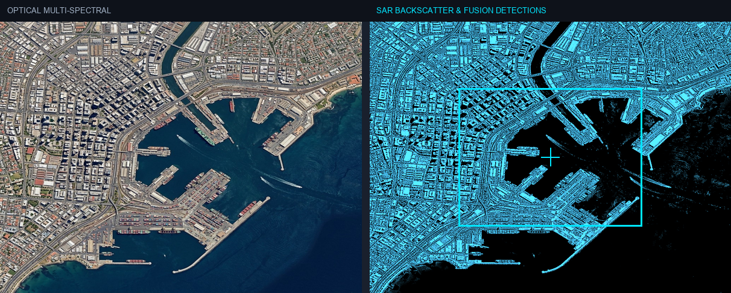
Figure: Orthorectified satellite scene with detected spatial features and evidence overlay.

Multi-Angle Satellite Telemetry
Scene Overview | {  "summary": "The fused optical and SAR observations clearly delineate a bustling urban port environment, successfully identifying numerous metallic vessels and extensive corner-reflecting infrastructure. SAR backscatter strongly corroborates optical features, highlighting high-reflectivity objects against the specularly reflecting water bodies, enabling all-weather maritime and structural monitoring.",  "detailed_analysis": {  "scene_overview": "This multi-sensor capture presents a vibrant coastal city with a large, active port. The optical imagery provides detailed multi-spectral reflectance showing urban sprawl, dense building structures, roads, and numerous ships docked and in transit across the deep blue water. The SAR microwave backscatter image complements this by emphasizing dielectric properties and surface geometry, revealing strong returns from urban structures and metallic vessels, while water bodies appear as areas of low backscatter.",  "land_cover": "The fused LULC classification identifies dense urban built
Land Cover (LULC) | General remote sensing scene
Key Spatial Features | N/A
Spatial Configuration | Standard geographic layout
Spectral Indicators | Visible optical spectrum
Risk Assessment | No critical hazards detected

