SATQUERY AI — EARTH OBSERVATION WORKBENCH
Remote Sensing Inspection Report
Report ID | 2f378b54d323475b | Timestamp | 2026-09-07T18:30:47
Confidence | High (0.87) | Images | 2 scene(s)
Query | Perform bi-temporal change detection and identify any new logistics warehouse construction or altered waterfront infrastructure. | Evidence | change_overlay

Executive Summary & Findings
Significant large-scale development has occurred within the port area, specifically in the upper-right quadrant. A substantial portion of existing waterfront infrastructure and adjacent water has been transformed into a new, expansive construction site, indicative of major port expansion or logistics facility development.

Visual Evidence Grounding
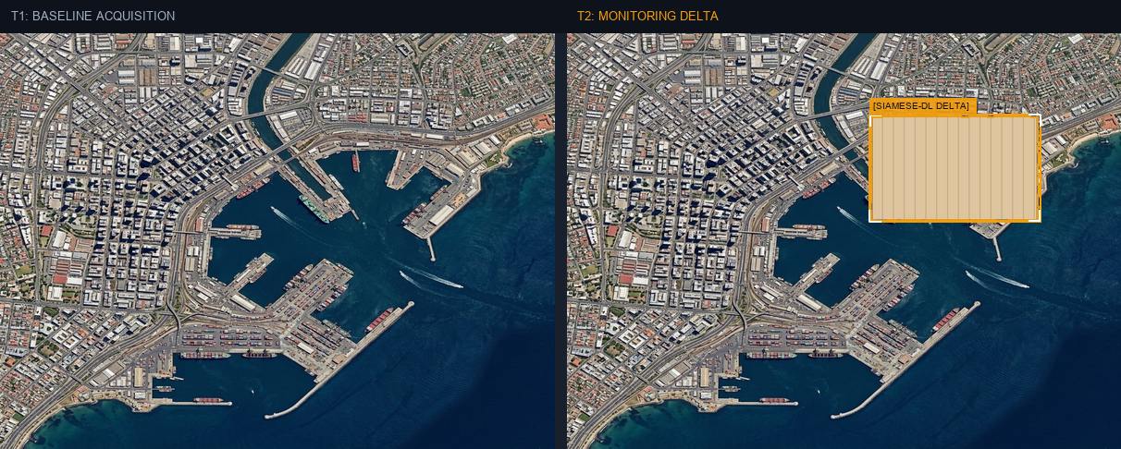
Figure: Orthorectified satellite scene with detected spatial features and evidence overlay.

Multi-Angle Satellite Telemetry
Scene Overview | The geographic footprint encompasses a dense urban environment centered around a large, active commercial port. T1 (Baseline) shows a well-established port with numerous berths, container yards, and associated infrastructure. T2 (Monitoring) reveals a dramatic alteration where a large, uniform gray area now covers a significant section of the port, indicating a major construction or redevelopment project that has replaced previous structures and water bodies.
Land Cover (LULC) | Existing Port Infrastructure/Water to New Construction/Developed Area: ~7.6%, Stable Built-up/Paved/Water: ~92.4%.
Key Spatial Features | Large-scale new construction/redevelopment covering existing port infrastructure and water in the upper-right quadrant.  • Extensive infill and surface alteration within the primary port basin (upper-right quadrant).  • Potential new logistics hub or expanded terminal facility (upper-right quadrant).
Spatial Configuration | The change manifests as a single, contiguous, large-scale infill and redevelopment project within the existing port boundaries, specifically expanding into a previously active water basin and replacing existing structures. This suggests a strategic expansion rather than peripheral growth.
Spectral Indicators | A pronounced spectral shift is observed from the varied reflectance of existing port infrastructure (concrete, asphalt, metal, water) to a uniform, bright gray signature characteristic of a large-scale construction site or newly developed surface. This indicates a complete overhaul of the surface material and topography within the affected area.
Risk Assessment | Potential concerns include significant alteration of marine habitats due to infill, increased runoff and potential for water quality degradation during and after construction, and the long-term environmental impact of expanded industrial port operations.

