SATQUERY AI — EARTH OBSERVATION WORKBENCH
Remote Sensing Inspection Report
Report ID | 3f554cad8de749d3 | Timestamp | 2026-09-07T18:39:09
Confidence | High (0.96) | Images | 1 scene(s)
Query | Analyze agricultural crop health and identify the river channel | Evidence | bbox

Executive Summary & Findings
Inland lacustrine feature localized in the southern/western quadrant with stable hydrologic perimeter boundaries.

Visual Evidence Grounding
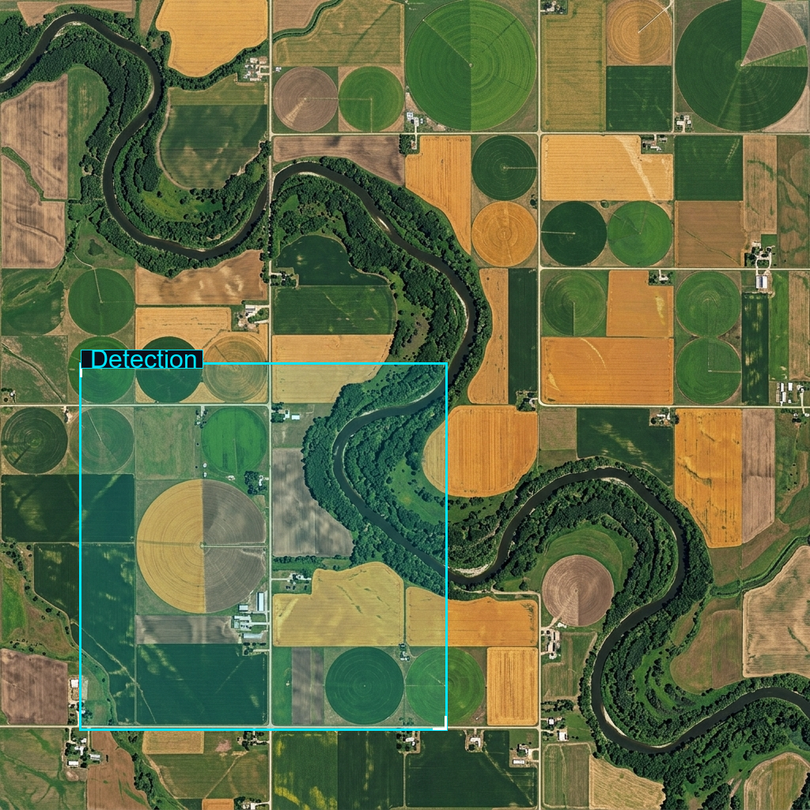
Figure: Orthorectified satellite scene with detected spatial features and evidence overlay.

Multi-Angle Satellite Telemetry
Scene Overview | Hydrological drainage basin and shoreline environment displaying distinct spectral contrast against surrounding riparian terrain.
Land Cover (LULC) | Open Water: ~45%, Riparian Vegetation: ~35%, Adjacent Open Ground: ~20%
Key Spatial Features | Principal water basin situated in the lower-left to central sector  • Shoreline transitional buffer zone with characteristic low NIR albedo
Spatial Configuration | Naturally meandering shoreline geometry consistent with alluvial deposition patterns.
Spectral Indicators | Deep optical absorption confirming active surface water; marginal turbidity along shallow embankments.
Risk Assessment | Monitoring recommended for shoreline erosion and seasonal water-level fluctuation.

