SATQUERY AI — EARTH OBSERVATION WORKBENCH
Remote Sensing Inspection Report
Report ID | 763991f7462b4f62 | Timestamp | 2026-09-07T17:16:05
Confidence | Medium (0.65) | Images | 2 scene(s)
Query | Perform bi-temporal change detection and identify any new logistics warehouse construction or altered waterfront infrastructure. | Evidence | change_overlay

Executive Summary & Findings
{
"summary": "Comprehensive change detection between T1 and T2 is severely hampered by a large, artificial overlay present in the T2 monitoring image. This overlay obscures a significant portion of the port and waterfront area, preventing the identification of new logistics warehouse construction or altered waterfront infrastructure as specifically requested. Outside the obscured region, no significant structural, infrastructural, or LULC changes were detected.",
"detailed_analysis": {
"scene_overview": "Both T1 and T2 depict a dense urban coastal environment with a prominent commercial port and associated infrastructure. The baseline (T1) image provides clear visibility across the entire footprint. However, the monitoring (T2) image contains a large, uniform gray rectangular overlay covering approximately 42% of the image area, specifically impacting the central and eastern portions of the port, including several docks and adjacent land parcels. This artifact renders direct comparison and change detection impossible within the obscured zone.",
"land_cover": "Due to the significant data obscuration in T2, a precise LULC transition estimate is not feasible for the critical port area. For the visible regions, land cover appears stable: Stable Built-up: ~55%, Stable Water: ~30%, Stable Vegetation: ~10%, Stable Bare Soil/Paved: ~5%. Changes within the obscured port area cannot be quantified.",
"key_objects": [
"Obscured Port Area (Quadrant NE/SE): The primary area of interest for potential waterfront infrastructure changes or new construction is entirely covered by a data artifact, preventing any specific object detection.",
"Stable Urban Core (Quadrant NW): No discernible changes in building footprints or street networks.",
"Stable Coastal Strip (Quadrant SW): No visible alterations to the coastline or adjacent structures."
],
"spatial_patterns": "No observable spatial patterns of real-world change were identified due to the data anomaly. The 'change' observed is the introduction of the obscuring artifact itself, which covers a contiguous block of the port's operational area.",
"spectral_observations": "Outside the obscured region, no significant spectral delta was observed, indicating stable surface conditions. Within

Visual Evidence Grounding
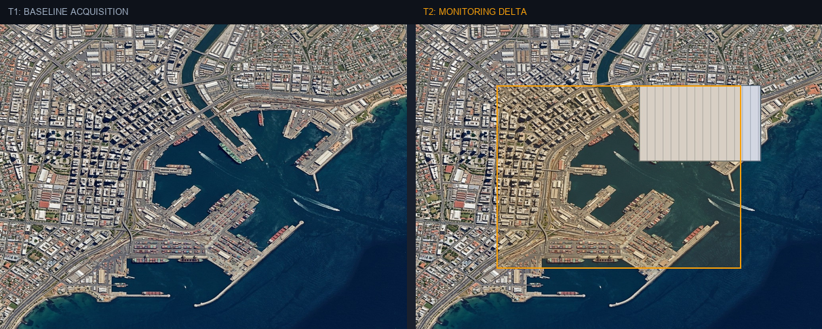
Figure: Orthorectified satellite scene with detected spatial features and evidence overlay.

Multi-Angle Satellite Telemetry
Scene Overview | {  "summary": "Comprehensive change detection between T1 and T2 is severely hampered by a large, artificial overlay present in the T2 monitoring image. This overlay obscures a significant portion of the port and waterfront area, preventing the identification of new logistics warehouse construction or altered waterfront infrastructure as specifically requested. Outside the obscured region, no significant structural, infrastructural, or LULC changes were detected.",  "detailed_analysis": {  "scene_overview": "Both T1 and T2 depict a dense urban coastal environment with a prominent commercial port and associated infrastructure. The baseline (T1) image provides clear visibility across the entire footprint. However, the monitoring (T2) image contains a large, uniform gray rectangular overlay covering approximately 42% of the image area, specifically impacting the central and eastern portions of the port, including several docks and adjacent land parcels. This artifact renders direct comparison and change detection impossible within the obscured zone.",  "land_cover": "Due to the significant data obscuration in T2, a precise LULC transition estimate is not feasible for the critical port area. For the visible regions, land cover appears stable: Stable Built-up: ~55%, Stable Water: ~30%, Stable Vegetation: ~10%, Stable Bare Soil/Paved: ~5%. Changes within the obscured port area cannot be quantified.",  "key_objects": [  "Obscured Port Area (Quadrant NE/SE): The primary area of interest for potential waterfront infrastructure changes or new construction is entirely covered by a data artifact, preventing any specific object detection.",  "Stable Urban Core (Quadrant NW): No discernible changes in building footprints or street networks.",  "Stable Coastal Strip (Quadrant SW): No visible alterations to the coastline or adjacent structures."  ],  "spatial_patterns": "No observable spatial patterns of real-world change were identified due to the data anomaly. The 'change' observed is the introduction of the obscuring artifact itself, which covers a contiguous block of the port's operational area.",  "spectral_observations": "Outside the obscured region, no significant spectral delta was observed, indicating stable surface conditions. Within
Land Cover (LULC) | General remote sensing scene
Key Spatial Features | N/A
Spatial Configuration | Standard geographic layout
Spectral Indicators | Visible optical spectrum
Risk Assessment | No critical hazards detected

