SATQUERY AI — EARTH OBSERVATION WORKBENCH
Remote Sensing Inspection Report
Report ID | 7a9dcd437d63475a | Timestamp | 2026-09-07T17:47:32
Confidence | High (0.87) | Images | 2 scene(s)
Query | Detect changes between T1 baseline and T2 monitoring scene | Evidence | change_overlay

Executive Summary & Findings
{
"summary": "A significant transformation has occurred within the primary port infrastructure, encompassing approximately 7.6% of the total scene. This alteration, identified as a single major cluster, indicates substantial changes in surface characteristics and likely operational layout within the container terminal and adjacent port facilities.",
"detailed_analysis": {
"scene_overview": "The geographic footprint captures a bustling coastal

Visual Evidence Grounding
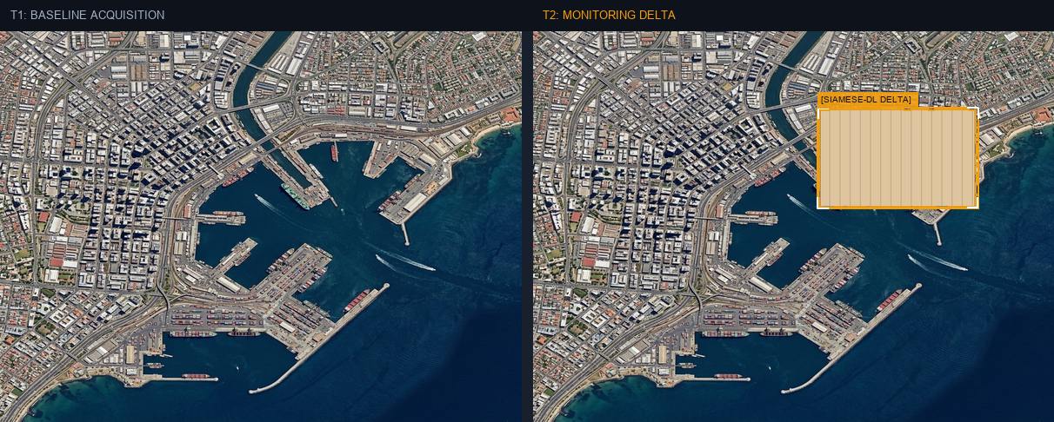
Figure: Orthorectified satellite scene with detected spatial features and evidence overlay.

Multi-Angle Satellite Telemetry
Scene Overview | {  "summary": "A significant transformation has occurred within the primary port infrastructure, encompassing approximately 7.6% of the total scene. This alteration, identified as a single major cluster, indicates substantial changes in surface characteristics and likely operational layout within the container terminal and adjacent port facilities.",  "detailed_analysis": {  "scene_overview": "The geographic footprint captures a bustling coastal
Land Cover (LULC) | General remote sensing scene
Key Spatial Features | N/A
Spatial Configuration | Standard geographic layout
Spectral Indicators | Visible optical spectrum
Risk Assessment | No critical hazards detected

