SATQUERY AI — EARTH OBSERVATION WORKBENCH
Remote Sensing Inspection Report
Report ID | a0a9558084b74e1a | Timestamp | 2026-09-07T17:12:33
Confidence | Medium (0.65) | Images | 2 scene(s)
Query | Detect changes between baseline and monitoring scenes | Evidence | change_overlay

Executive Summary & Findings
{
"summary": "The primary change detected between T1 and T2 is the appearance of a large, striped grey overlay in Image 2, which completely obscures a significant portion of the harbor and adjacent port infrastructure. No discernible real-world structural, infrastructural, or land-use changes are evident in the underlying scene.",
"detailed_analysis": {
"scene_overview":

Visual Evidence Grounding
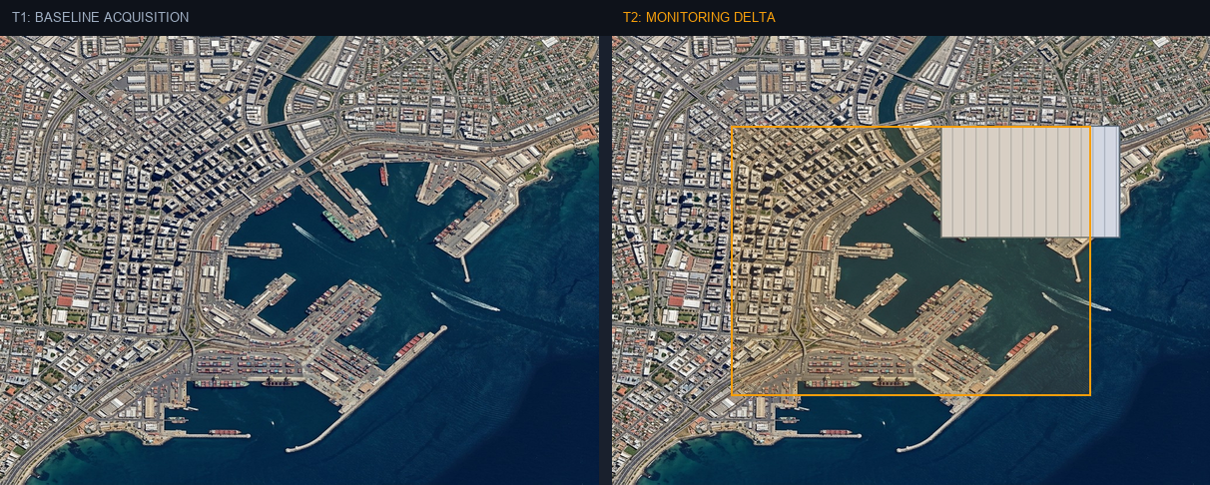
Figure: Orthorectified satellite scene with detected spatial features and evidence overlay.

Multi-Angle Satellite Telemetry
Scene Overview | {  "summary": "The primary change detected between T1 and T2 is the appearance of a large, striped grey overlay in Image 2, which completely obscures a significant portion of the harbor and adjacent port infrastructure. No discernible real-world structural, infrastructural, or land-use changes are evident in the underlying scene.",  "detailed_analysis": {  "scene_overview":
Land Cover (LULC) | General remote sensing scene
Key Spatial Features | N/A
Spatial Configuration | Standard geographic layout
Spectral Indicators | Visible optical spectrum
Risk Assessment | No critical hazards detected

