SATQUERY AI — EARTH OBSERVATION WORKBENCH
Remote Sensing Inspection Report
Report ID | b8f61c21b14647f4 | Timestamp | 2026-09-07T17:11:53
Confidence | Medium (0.65) | Images | 2 scene(s)
Query | Detect changes between baseline and monitoring scenes | Evidence | change_overlay

Executive Summary & Findings
{
"summary": "A significant data anomaly, specifically a large rectangular grey obscuration, has appeared in the monitoring scene (T2), covering a substantial portion of the harbor area. This artifact prevents the detection of any potential physical changes within the obscured region, while the unobscured areas show general stability.",
"detailed_analysis": {
"scene_overview": "Image 1 (T1) provides a clear baseline view of a bustling port city, featuring extensive urban infrastructure, a large commercial harbor with numerous vessels, and surrounding residential areas. Image 2 (T2) captures the same geographic footprint but is significantly compromised by a large, uniform grey rectangular block that completely obscures a major part of the harbor and

Visual Evidence Grounding
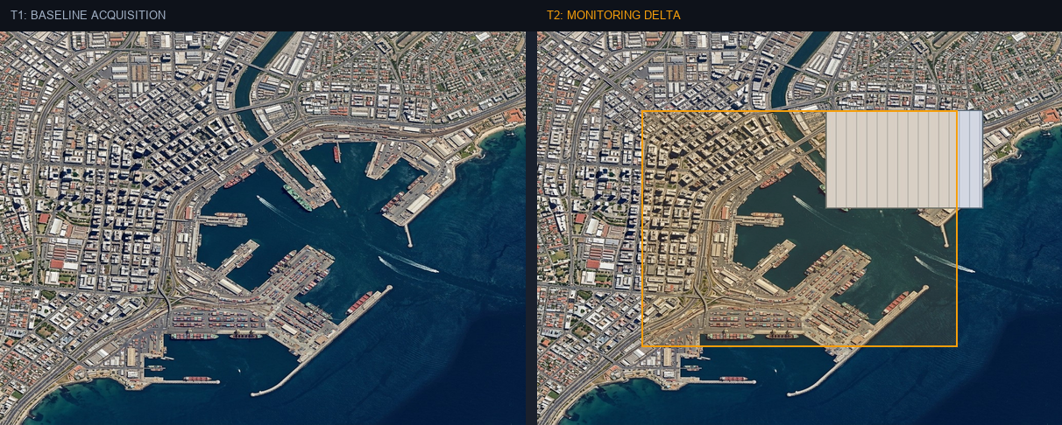
Figure: Orthorectified satellite scene with detected spatial features and evidence overlay.

Multi-Angle Satellite Telemetry
Scene Overview | {  "summary": "A significant data anomaly, specifically a large rectangular grey obscuration, has appeared in the monitoring scene (T2), covering a substantial portion of the harbor area. This artifact prevents the detection of any potential physical changes within the obscured region, while the unobscured areas show general stability.",  "detailed_analysis": {  "scene_overview": "Image 1 (T1) provides a clear baseline view of a bustling port city, featuring extensive urban infrastructure, a large commercial harbor with numerous vessels, and surrounding residential areas. Image 2 (T2) captures the same geographic footprint but is significantly compromised by a large, uniform grey rectangular block that completely obscures a major part of the harbor and
Land Cover (LULC) | General remote sensing scene
Key Spatial Features | N/A
Spatial Configuration | Standard geographic layout
Spectral Indicators | Visible optical spectrum
Risk Assessment | No critical hazards detected

