SATQUERY AI — EARTH OBSERVATION WORKBENCH
Remote Sensing Inspection Report
Report ID | ff3e30de2e5d4e76 | Timestamp | 2026-09-07T17:17:36
Confidence | Medium (0.65) | Images | 2 scene(s)
Query | Execute optical and SAR radar fusion to detect metallic vessels and corner-reflecting infrastructure. | Evidence | sar_fusion

Executive Summary & Findings
{
"summary": "The fused optical and SAR observations provide a comprehensive view of a major coastal city and its active port. Optical imagery details urban infrastructure and numerous vessels, while SAR backscatter strongly corroborates these features, highlighting metallic structures and ships as high backscatter points against the specularly reflecting water. This multi-sensor intelligence confirms extensive built-up areas and dynamic maritime traffic, enabling robust detection

Visual Evidence Grounding
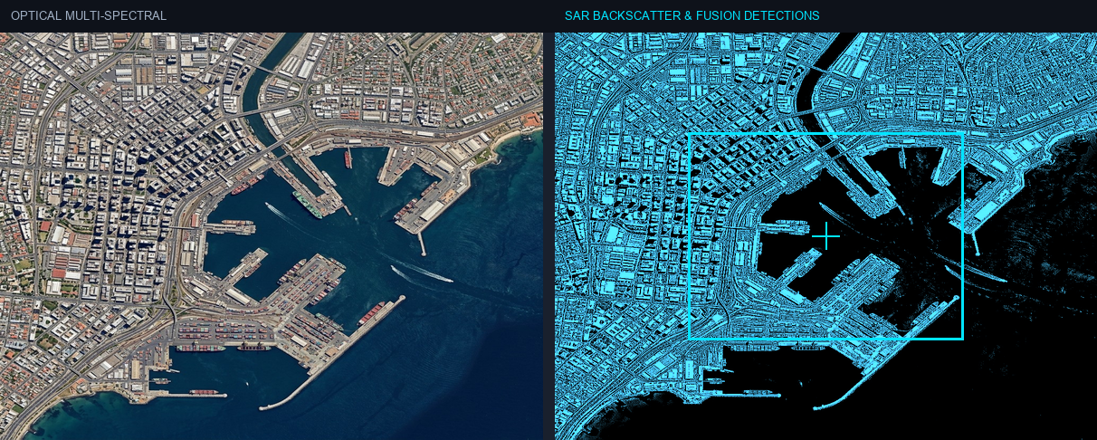
Figure: Orthorectified satellite scene with detected spatial features and evidence overlay.

Multi-Angle Satellite Telemetry
Scene Overview | {  "summary": "The fused optical and SAR observations provide a comprehensive view of a major coastal city and its active port. Optical imagery details urban infrastructure and numerous vessels, while SAR backscatter strongly corroborates these features, highlighting metallic structures and ships as high backscatter points against the specularly reflecting water. This multi-sensor intelligence confirms extensive built-up areas and dynamic maritime traffic, enabling robust detection
Land Cover (LULC) | General remote sensing scene
Key Spatial Features | N/A
Spatial Configuration | Standard geographic layout
Spectral Indicators | Visible optical spectrum
Risk Assessment | No critical hazards detected

