SMART HOME ENVIRONMENT SENSOR
Requirements Analysis and Block Diagram Design

1. Introduction
This report presents a conceptual design for a Smart Home Environment Sensor. The device monitors room temperature and humidity and provides a local alert when conditions cross user-defined limits. It is intended as a student prototype for understanding embedded-system requirements, hardware interfaces, power management, and system interactions. It is not a certified safety device.

2. Objective and Scope
The objective is to define the functional and non-functional requirements of a small embedded device and show how its components communicate. The prototype reads a digital temperature-and-humidity sensor, processes readings using a microcontroller, displays basic status, and activates an LED or buzzer alert when a threshold is exceeded. Optional Wi-Fi reporting may be added later; the core design does not depend on internet connectivity.

3. System Requirements
Functional requirements: measure temperature and humidity at a configurable interval; validate sensor readings; compare valid readings with configured thresholds; display current status; activate a warning LED or buzzer when a threshold is crossed; clear the alert after readings return to the normal range. Non-functional requirements: operate reliably indoors; use low-voltage DC power; keep firmware modular and testable; indicate sensor disconnection or invalid readings.

4. Proposed Components
ESP32 or Arduino-compatible microcontroller (processing and GPIO); DHT22 or equivalent digital sensor (temperature and humidity); LED and buzzer (local warning); optional OLED/LCD (display); USB 5 V supply with appropriate regulation; optional push button (acknowledge alert or change mode).

5. Block Diagram
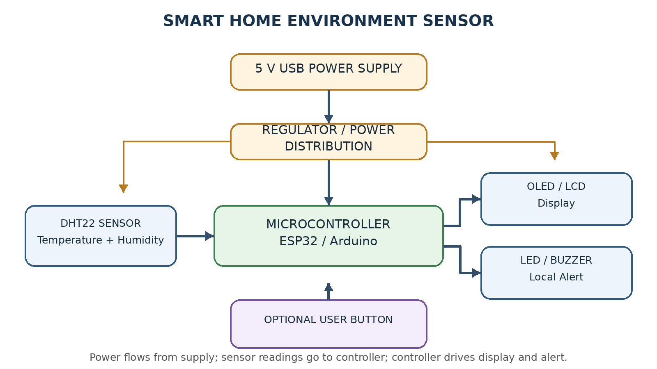

6. Operating Method
1) Power on and initialize sensor, display, and GPIO. 2) Read temperature and humidity at a fixed interval, for example every 2 seconds. 3) Validate the sensor response; if invalid, show an error and do not use the value. 4) Compare valid readings with configured limits. 5) Update display/status and activate the buzzer if a limit is crossed. 6) Continue monitoring and clear the alert when readings return to normal.

7. Design Choices and Limitations
A digital sensor reduces analog signal-conditioning needs and is straightforward for a student prototype. An ESP32 provides GPIO and common interfaces, with Wi-Fi available as a future extension. A local alert remains useful without a network. Accuracy and response time depend on sensor quality and placement. This design is educational and must not replace certified fire, gas, or medical alarms.

8. Testing Plan
Power-up: confirm initialization. Sensor test: compare readings with a reference thermometer/hygrometer. Threshold test: set a low limit and verify warning output. Sensor-failure test: disconnect the sensor and check for an error. Recovery test: restore normal readings and verify alert clearing.

9. Conclusion
The Smart Home Environment Sensor demonstrates sensing, processing, decision-making, and notification. The requirements and block diagram provide a starting point for implementation and testing. Add actual implementation details and test results after building or simulating the prototype.

10. Report Description (minimum 200 words)
This report describes the requirements analysis and conceptual block diagram for a Smart Home Environment Sensor. The proposed device measures room temperature and relative humidity using a digital sensor and sends readings to a microcontroller such as an ESP32 or Arduino-compatible board. The controller validates the readings, compares them with configurable limits, and updates a display or status indicator. If a temperature or humidity limit is crossed, the controller activates an LED or buzzer to provide a local warning. The report identifies functional and non-functional requirements, lists the main hardware components and their interfaces, and explains the power, sensing, processing, and output paths in the block diagram. It outlines a basic operating sequence, design choices, limitations, and a testing plan covering startup, sensor readings, threshold alerts, sensor failure, and recovery. This is a conceptual student design intended for learning and prototyping; it is not a certified safety or monitoring product. Actual implementation details and test results should be added after the hardware or simulation is completed.

Note: This is a conceptual block diagram. Update the component names and connections to match the design you actually implement.

