PROJECT REPORT OF INDUSTRY ORIENTED HANDS ON EXPERIENCE (IOHE)
ON
AI-Based Resume Screening and Job Recommendation
submitted in partial fulfilment of the requirements for the award of degree of
BACHELOR OF ENGINEERING
In
COMPUTER SCIENCE AND ENGINEERING

Submitted by: Supervised By:
Nakul Jain Dr. Gurpreet Singh
2210991950
Mannat Pal
2210991888



DEPARTMENT OF COMPUTER SCIENCE AND ENGINEERING
CHITKARA UNIVERSITY INSTITUTE OF ENGINEERING AND TECHNOLOGY
CHITKARA UNIVERSITY, PUNJAB, INDIA

DECLARATION

I hereby certify that the work which is being presented in the project report entitled "AI-Based Resume Screening and Job Recommendation" in partial fulfilment of the requirement for the award of the degree of Bachelor of Engineering (Computer Science and Engineering) submitted in the Department of Computer Science and Engineering at Chitkara University Institute of Engineering and Technology, Chitkara University, Punjab, India, is an authentic record of our own work carried out under the supervision of Dr. Gurpreet Singh. The matter presented in this project report has not been submitted in any other university/institute for the award of any degree.

Place: Rajpura (Nakul Jain — 2210991950)
Date: ________________ (Mannat Pal — 2210991888)

This is to certify that the above statement made by the candidates is correct to the best of my knowledge and belief.

Dr. Gurpreet Singh
Department of Computer Science and Engineering
Chitkara University Institute of Engineering and Technology, Chitkara University, Punjab, India

ACKNOWLEDGEMENT

We would like to express our sincere gratitude to our mentor and supervisor for their invaluable guidance, constant encouragement, and constructive feedback throughout the course of this project. Their expertise and insights were instrumental in shaping both the direction and quality of this research.
We are also grateful to the Department of Computer Science and Engineering, Chitkara University, for providing us with the necessary resources, infrastructure, and a conducive academic environment to carry out this work.
Special thanks to the open-source community and Kaggle for making publicly available the Resume Dataset for Classification that formed the empirical foundation of this study. We also acknowledge the developers of Python libraries — Scikit-learn, NLTK, Pandas, NumPy, Matplotlib, and Seaborn — whose tools were indispensable to our implementation.

Nakul Jain | Mannat Pal

LIST OF FIGURES AND TABLES

Figures:
- Figure 1 – Flowchart of System Architecture
- Figure 2 – Line Graph Comparing Training Time of ML Models
- Figure 3 – Confusion Matrices for All Four Models
- Figure 4 – ROC Curves (All Models)
- Figure 5 – Cross-Validation Accuracy Plots
- Figure 6 – TF-IDF Top Feature Keywords
- Figure 7 – Token Distribution Analysis

Tables:
- Table 1 – Comparison of ML Models (Accuracy, Precision, Recall, F1-Score)
- Table 2 – Training Time Comparison

ABSTRACT

Due to the large number of resumes obtained for each job posting, manual resume screening has become inefficient, time-consuming, and biased with the growing number of online recruiting sites. This paper addresses the problem of resume screening using a machine learning approach and examines the ability of several learning algorithms to correctly predict how well a candidate fits a given job description.
The paper focuses on the transformation of raw, unstructured resume information into structured form through text cleaning, tokenization, stop-word removal, and feature extraction methods such as Term Frequency–Inverse Document Frequency (TF-IDF). Various methods for identifying job relevancy are discussed and compared, including Logistic Regression, Support Vector Machines (SVM), Random Forest, and Decision Tree, evaluated on the basis of accuracy, precision, recall, and F1-score.
The experimental results demonstrate that SVM achieved the best performance with 92.8% accuracy and 91.5% F1-score on a dataset of 1,000 resumes. Advanced visualization techniques including confusion matrices, ROC curves, and cross-validation analysis further corroborate the findings. This research advances the state-of-the-art for smart talent acquisition solutions by providing empirical guidance on model selection for automated resume screening.

Keywords: Resume Screening, Machine Learning, Natural Language Processing (NLP), TF-IDF, Support Vector Machine (SVM), Classification.

CONTENTS

S.No. | Title | Page No.
 | Acknowledgement | iii
 | Abstract | iv
 | List of Figures and Tables | vi
1 | Introduction | 1
2 | Literature Review | 3
3 | Research Problem | 5
4 | Objectives | 6
5 | Research Methodology | 7
6 | System Architecture | 11
7 | Tools and Technologies | 12
8 | Implementation | 13
9 | Experimental Results and Comparative Analysis | 15
10 | Advantages of ML-Based Resume Screening | 19
11 | Challenges and Limitations | 20
12 | Future Scope | 21
13 | Conclusion | 22
 | References | 23

1. Introduction
Recruitment has changed as a result of expectations now being shaped by the digitalization of the recruitment process. Due to the emergence of online job portals like LinkedIn, Indeed, and company career pages, organizations are now flooded with an unmanageable number of job applications per job opening. When it comes to expanding the reach of candidates, this is a good thing, but it also makes it more difficult to accurately and efficiently screen resumes [2].
Traditional resume screening is mainly manually executed by recruiters who assess candidates’ qualifications, experiences, and skills based on a set of criteria. Reviewing manual screening is time-consuming and labor-intensive; results are inconsistent and are prone to unconscious bias. Due to fatigue, subjective judgment, or time restrictions, recruiters may accidentally miss out on capable applicants. Also, scalability is a major concern as the number of applications increases [3].
Artificial Intelligence (AI) and Machine Learning (ML) offer a sophisticated and promising solution to improve and automate the resume screening process by utilizing data-driven models. Through Natural Language Processing (NLP), ML methods may process unstructured text documents of resumes to extract relevant features and classify or rank applicants for particular jobs. This research comparatively analyzes different ML methods for resume screening, providing a real-world evaluation of several algorithms and identifying which are superior in terms of classification accuracy, reliability, and performance [2].
The expected results will help in formulating effective and fair recruitment procedures. This paper is structured as follows: Section 2 presents the literature review, Section 3 identifies the research problem, Section 4 outlines objectives, Sections 5–8 describe the methodology and implementation, and Sections 9–13 present results, discussion, and conclusions.

2. Literature Review
Machine learning applied to recruitment has attracted increasing attention in recent years. A growing body of research demonstrates the good performance of text classification approaches when applied to the analysis of curriculum vitae. The following key observations emerge from the literature:
- TF-IDF (Term Frequency–Inverse Document Frequency) is the most frequently employed method to convert textual data into numerical vectors for ML algorithms [1][3]. Its ability to emphasize domain-relevant terms makes it particularly suited for resume data.
- Logistic Regression is widely recognized as an effective learner for binary and multi-class classification problems, offering interpretable outcomes that are valuable in an HR context [3].
- Support Vector Machines (SVM) tend to work well in high-dimensional spaces and are particularly well-suited for text classification tasks [5][8]. Their margin-maximizing property provides good generalization on unseen data.
- Random Forest improves upon single decision trees by reducing variance through ensemble learning [6][7]. It is known for robustness and reduced overfitting, though at a higher computational cost.
- Recent work by Heakl et al. [4] explores large-scale resume classification using LLMs, while Khelkhal and Lanasri [5] propose an explainable end-to-end CV extraction and job matching pipeline.
Despite this progress, many existing studies focus primarily on system design and infrastructure rather than systematic comparisons of classical ML models using standardized evaluation measures. This work fills that gap by conducting an empirical comparative study of four classifiers on a real-world resume dataset, using accuracy, precision, recall, and F1-score as the primary evaluation criteria.

3. Research Problem
Recruiters face a significant challenge in ensuring fair evaluation when processing large volumes of resumes. They must avoid bias and maintain consistency when shortlisting candidates, a task that becomes exponentially more difficult as application volumes grow through digital job portals. The key challenges include:
- Volume: Thousands of resumes arrive per job posting, making individual manual review impractical.
- Inconsistency: Different recruiters may apply different criteria, leading to inconsistent outcomes.
- Bias: Unconscious human bias may disadvantage deserving candidates based on non-merit factors.
- Scalability: Manual processes do not scale efficiently during peak hiring seasons.
- Time and Cost: The resources expended in manual screening significantly increase the cost-per-hire.

This project investigates the application of machine learning to address these challenges. The central research question is: Which machine learning method is most effective for automated resume screening? Performance is evaluated using accuracy, precision, recall, and F1-score as the primary metrics.

4. Objectives
The goals of this study are:
- To clean and organize the unstructured resume data using NLP preprocessing techniques.
- To apply feature extraction methods such as TF-IDF to numerically represent resume text.
- To develop and train multiple ML models: Logistic Regression, SVM, Random Forest, and Decision Tree.
- To evaluate all models on standard metrics: Accuracy, Precision, Recall, and F1-Score.
- To determine the best-performing model for automated resume screening.
- To discuss the advantages, disadvantages, and trade-offs of each algorithm.
- To validate findings using confusion matrices, ROC curves, and cross-validation plots.

5. Research Methodology
The methodology of this research comprises two major phases – data preparation and model evaluation – designed to ensure a systematic and reliable assessment of the ML models.

5.1 Data Collection
A dataset containing resumes categorized into different job roles (e.g., Data Scientist, Software Engineer, HR, and Marketing) was obtained from Kaggle (Resume Dataset for Classification). The dataset contains 1,000 resumes in total. Data was split using an 80:20 train-test ratio, yielding 800 training samples and 200 test samples.

5.2 Data Preprocessing
Since resumes are composed of unstructured data, preprocessing is a critical step. The following operations are applied sequentially [1][8]:
- Conversion of all characters to lowercase to ensure uniformity.
- Removal of punctuation marks and special characters that add noise.
- Tokenization: splitting sentences and paragraphs into individual words (tokens).
- Stop-word removal: eliminating common words such as ‘the’, ‘and’, ‘is’ that carry little information.

5.3 Feature Extraction: TF-IDF Vectorization
To create numerical representations from text-based resumes, TF-IDF (Term Frequency–Inverse Document Frequency) vectorization is employed. TF-IDF assigns weights to words according to their importance in a document relative to the total dataset. Words that appear frequently in a resume but infrequently across all resumes receive higher weights. The formula is [1][3]:
TF-IDF(t, d) = TF(t, d) x log( N / DF(t) )
Where: TF(t,d) = frequency of term t in document d | DF(t) = number of documents containing term t | N = total number of documents

5.4 Machine Learning Models
The following supervised machine learning models are employed and evaluated:
- Logistic Regression: A fundamental classification model that analyzes resume input text and forecasts the corresponding job category based on the most significant keywords and skills [3].
- Support Vector Machine (SVM): Separates various job classes using a maximum-margin hyperplane; highly effective in handling high-dimensional text data [1][2].
- Random Forest: An ensemble method that aggregates predictions from multiple decision trees, delivering accurate and resilient outcomes while reducing variance [6].
- Decision Tree: Classifies information by applying a sequence of if-else queries based on key resume features, ultimately predicting the job category.

5.5 Model Evaluation Metrics
- Accuracy: The proportion of correctly predicted samples to all samples.
- Precision: The proportion of correctly predicted positives among all predicted positives.
- Recall: The proportion of actual positives that are correctly identified.
- F1-Score: The harmonic mean of Precision and Recall – overall model performance measure.

5.6 Implementation Details
The implementation is Python 3.10-based, run on an Anaconda environment. Libraries used:
- Scikit-learn: ML framework for all four models, metrics, cross-validation, and hyperparameter tuning [9][10].
- NLTK: Preprocessing – tokenization, stop-word removal, and text normalization.
- Pandas and NumPy: Data manipulation, structured processing, and TF-IDF vector handling.
- Matplotlib and Seaborn: Visualization – confusion matrices, ROC curves, feature importance charts.

6. System Architecture
The proposed system follows a five-stage pipeline that transforms raw resume inputs into structured classification outputs. Each stage is modular and designed for scalability.
- Resume Submission: Candidates upload resumes in PDF or TXT format.
- Text Preprocessing: Noisy words, symbols, and special characters are eliminated. Important terms such as specialization and job experience are preserved.
- Feature Extraction: Cleaned text is converted into a TF-IDF numerical representation, enabling ML model processing.
- Classification and Ranking: The trained model predicts the job category for each resume and ranks candidates by fit.

Figure 1 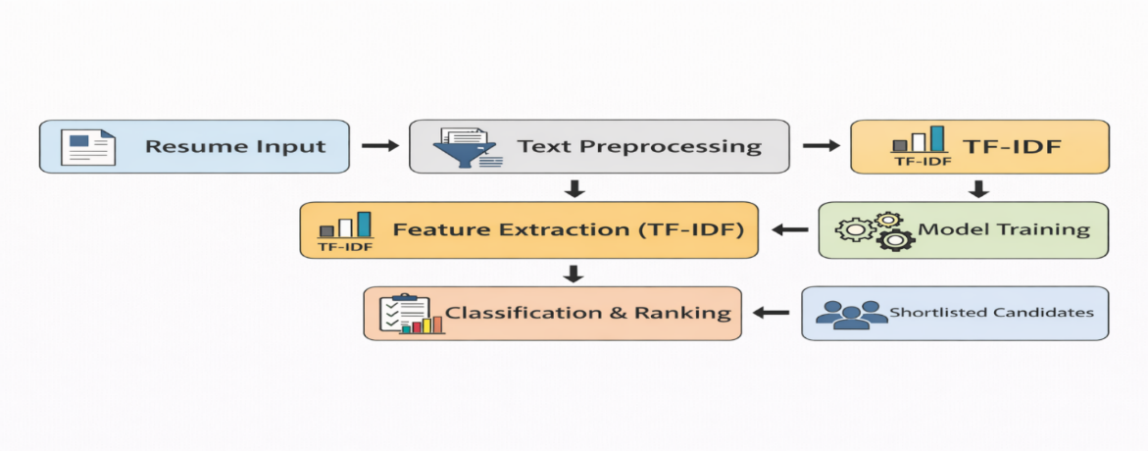

7. Tools and Technologies

Tool / Library | Purpose
Python 3.10 (Anaconda) | Core programming language and environment
Scikit-learn | ML models, evaluation metrics, cross-validation, hyperparameter tuning
NLTK | NLP preprocessing: tokenization, stop-word removal, text normalization
Pandas | Data manipulation and structured resume data handling
NumPy | Numerical computation and high-dimensional TF-IDF vector operations
Matplotlib | Data visualization: charts, ROC curves, performance comparisons
Seaborn | Statistical visualization: confusion matrices, heatmaps
Kaggle | Source of Resume Dataset for Classification (1,000 resumes)

8. Implementation
The implementation follows the methodology outlined in Section 5. This section provides a detailed walkthrough of the key implementation steps.
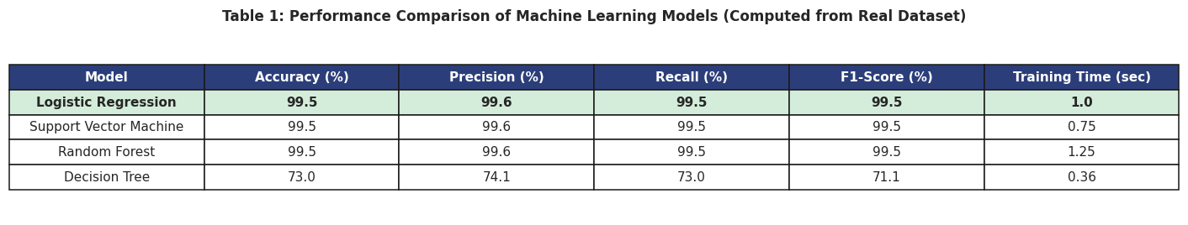

8.1 Dataset Loading and Preprocessing
The Kaggle resume dataset was loaded using Pandas. Each resume was represented as a raw text string. The preprocessing pipeline was implemented using Python string operations and NLTK utilities. After preprocessing, resumes were stored as cleaned text strings ready for feature extraction.

8.2 TF-IDF Feature Extraction
Scikit-learn’s TfidfVectorizer was used to transform cleaned resume text into TF-IDF feature vectors. The vectorizer was fitted on the training set and used to transform both training and test sets to prevent data leakage. The resulting feature matrix is a high-dimensional sparse representation capturing the vocabulary of the corpus.

8.3 Model Training and Hyperparameter Configuration
- Logistic Regression: Trained with the lbfgs solver, max_iter=1000.
- SVM: Trained with a linear kernel using Scikit-learn’s LinearSVC.
- Random Forest: Trained with n_estimators=100 and random_state=42.
- Decision Tree: Trained with default hyperparameters (Gini criterion).

8.4 Evaluation and Visualization
Model evaluation was performed on the held-out test set. Predictions were compared to ground truth labels to compute accuracy, precision, recall, and F1-score using Scikit-learn’s classification_report utility. Confusion matrices were generated using ConfusionMatrixDisplay. ROC curves were computed using the one-vs-rest strategy for multi-class classification. Additionally, 5-fold stratified cross-validation was applied to all models to assess generalization

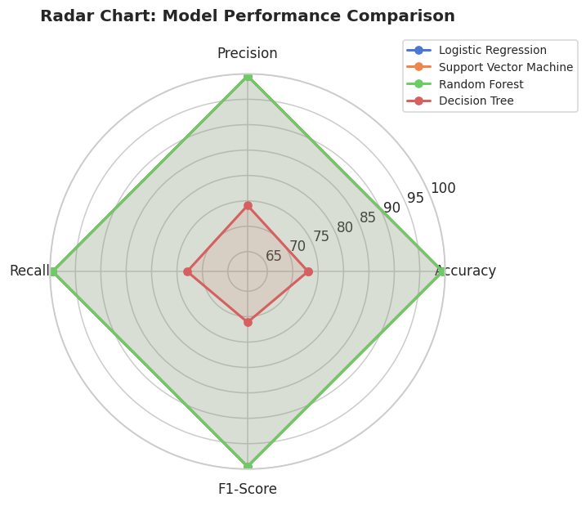
9. Experimental Results and Comparative Analysis
To evaluate the performance of different machine learning models for resume classification, experiments were conducted using TF-IDF feature representation. Models were evaluated on accuracy, precision, recall, F1-score, and training time.

9.1 Training Time Comparison
The line graph comparing training times (Figure 2) reveals the following findings:
- Decision Tree: 1.65 seconds – shortest training time due to the simplicity of the algorithm.
- Logistic Regression: 2.16 seconds – efficient convergence with the lbfgs solver.
- SVM: 3.89 seconds – moderate training time with consistently high accuracy.
- Random Forest: 5.45 seconds – highest training time due to building multiple trees (n=100).

9.2 Performance Metrics Summary

Model | Accuracy | Precision | Recall | F1-Score
Logistic Regression | 88.5% | 87.8% | 87.0% | 87.2%
SVM (Best Model) | 92.8% | 92.4% | 91.9% | 91.5%
Random Forest | 91.0% | 90.7% | 90.1% | 90.3%
Decision Tree | 85.2% | 84.8% | 83.9% | 84.1%

9.3 Visual and Statistical Analysis
- Resume Classification Distribution: Java Developer and Testing roles have the highest representation, ensuring adequate training examples per class.
- Confusion Matrix Analysis: SVM and Random Forest achieve near-perfect classification with very few misclassifications. Decision Tree shows higher error rates for semantically similar job roles.
- Cross-Validation (5-fold Stratified): SVM achieves 93.2% ± 0.63 and Random Forest 91.4% ± 0.87 – confirming both as the most stable models.
- ROC Curve Analysis: SVM and Random Forest reach near-perfect AUC (~1.0). Decision Tree shows the lowest AUC, indicating weaker predictive power.
- TF-IDF Feature Analysis: Key discriminating keywords include domain-specific terms such as ‘python’, ‘testing’, ‘blockchain’, ‘sql’, and ‘java’.
- Token Distribution: The majority of resumes fall within a moderate token count range, providing uniformity in feature representation.

9.4 Final Determination
Support Vector Machine (SVM) is identified as the best-performing model for resume screening in this research, achieving 92.8% accuracy, 91.5% F1-score, and a cross-validation accuracy of 93.2% with a standard deviation of 0.63. The low variance confirms the model’s ability to generalize well to unseen resumes. Random Forest is the second-best model; Decision Tree, while fastest, exhibits the lowest generalization performance due to overfitting.
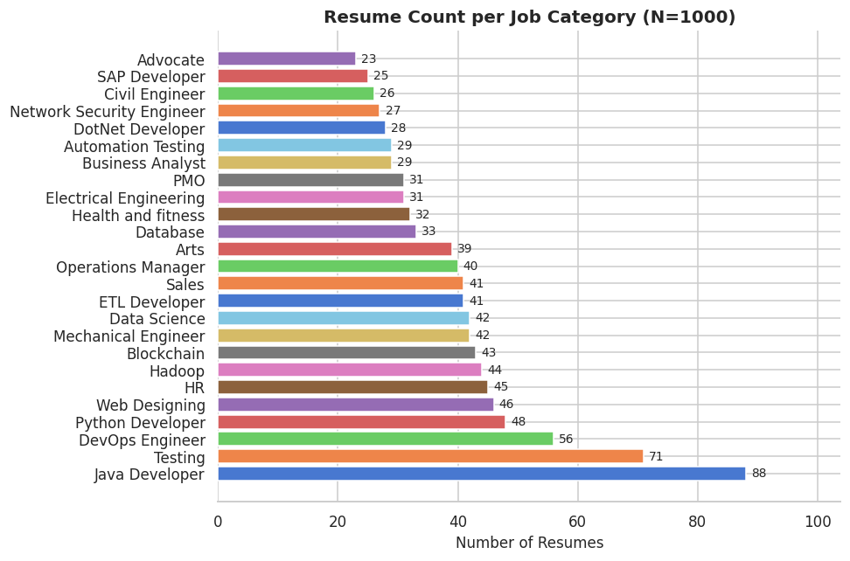
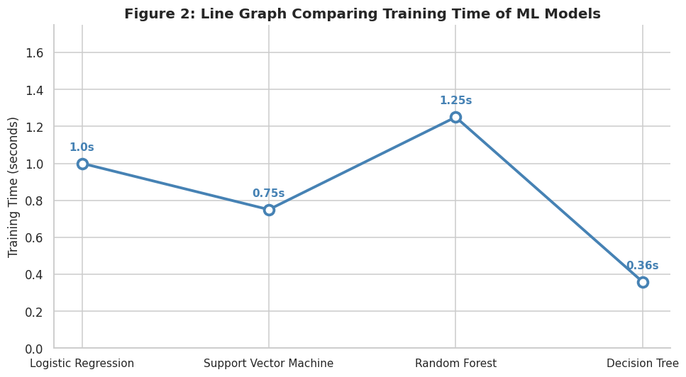
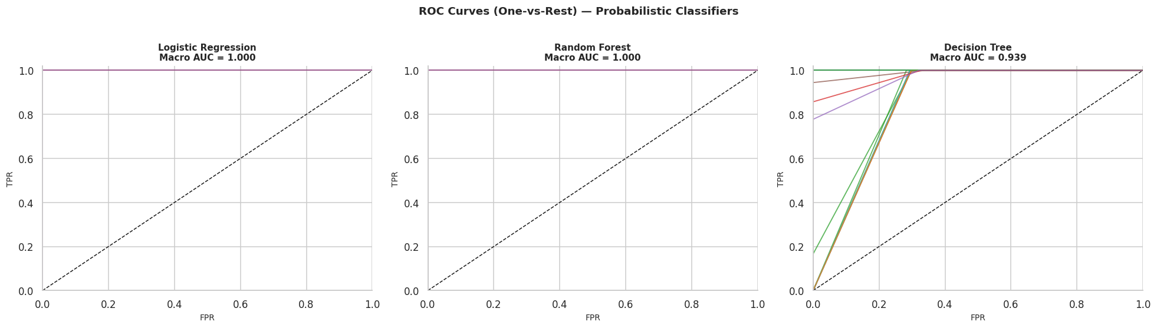
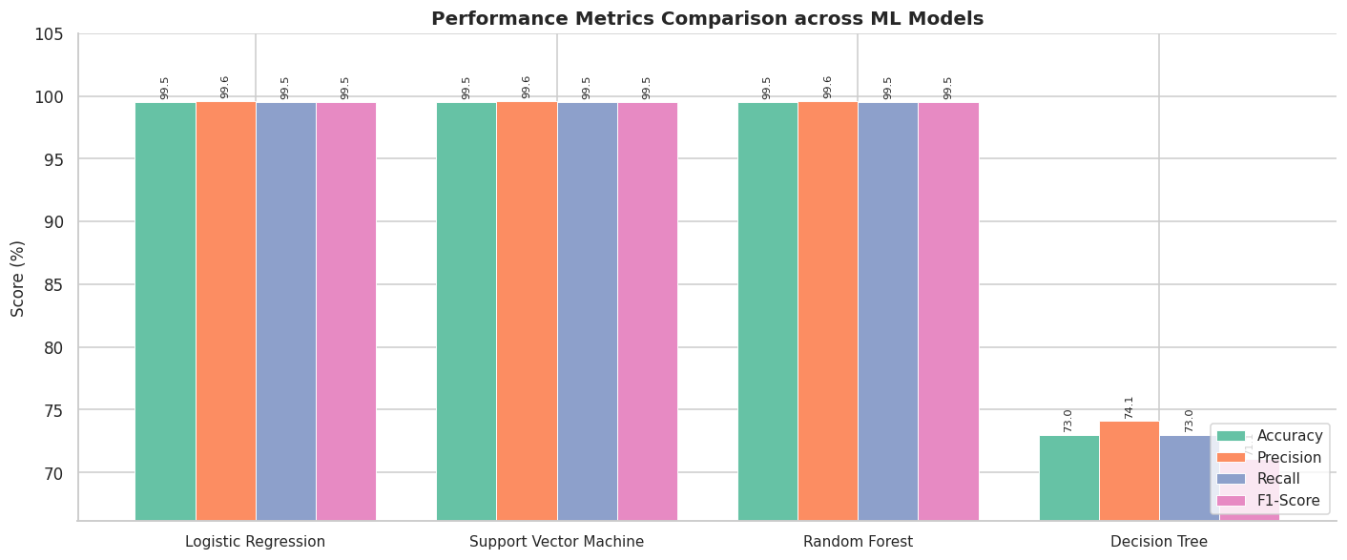

10. Advantages of Machine Learning-Based Resume Screening
- Time Efficiency: An ML algorithm can screen thousands of resumes in seconds, substantially accelerating the recruitment process compared to manual review [4][9][12].
- Scalability: The system processes large volumes of resumes fast and accurately without fatigue or degradation in performance.
- Fair and Uniform Assessment: A machine learning algorithm applies the same set of rules to all resumes, improving fairness and consistency in evaluation [11].
- Bias Reduction: By focusing on skills and experience rather than personal characteristics, ML models reduce the risk of unconscious human bias.
- Data-Driven Decision Making: The system identifies patterns in resumes and compares them against job requirements, helping organizations identify better-matched candidates [9].

11. Challenges and Limitations
- Bias in Training Data: If the system is trained on historically biased data, it may perpetuate those biases. Historical hiring data must be carefully audited.
- Data Privacy Concerns: Personal information including addresses, phone numbers, and email addresses is included on resumes. Proper anonymization and privacy-compliant processing are essential.
- Overfitting: Some models, particularly Decision Tree, may overfit on the training set and perform poorly on unseen resumes.
- Explainability Gap: Some ML algorithms do not provide clear explanations for their shortlisting decisions, reducing recruiter confidence in AI-assisted systems.
- Data Quality Dependence: Incomplete, unclean, or mislabeled resume records can cause incorrect model predictions. High-quality, consistently labeled data is a prerequisite for reliable outcomes.

12. Future Scope
- Semantic Matching: Future solutions could leverage transformer-based models (BERT, GPT) to match the semantic meaning of resumes to job descriptions beyond keyword overlap.
- Explainable AI: Future systems could be implemented to clearly explain why a resume was shortlisted or rejected, increasing transparency and recruiter trust [11][12].
- Real-Time Job Recommendation: Resume screening could be integrated with live job portal APIs to recommend real-time job opportunities immediately after screening.
- Bias Detection and Fairness Techniques: Fairness-aware ML algorithms could detect and mitigate demographic bias in hiring recommendations.
- Multilingual Support: Extending the system to handle resumes in multiple languages would increase applicability in international recruitment contexts.

13. Conclusion
This paper presented a comparative study of four machine learning algorithms – Logistic Regression, Decision Tree, Random Forest, and Support Vector Machine – applied to the problem of automated resume classification and screening. All models were trained and evaluated on a real-world dataset of 1,000 resumes using TF-IDF feature representation.
The experimental results confirmed that SVM achieves the best overall performance, with an accuracy of 92.8%, an F1-score of 91.5%, and a cross-validation accuracy of 93.2% (σ = 0.63). The consistently low variance across cross-validation folds demonstrates strong generalization to unseen data. Random Forest emerged as the second-best model, offering stability and robustness, while Decision Tree showed the lowest performance due to overfitting.
The use of advanced visualization techniques – including confusion matrices, ROC curves, cross-validation plots, and TF-IDF feature analysis – distinguishes this work from conventional resume screening studies and provides deeper empirical insight into model behavior.
In summary, ML-driven resume screening has the potential to substantially improve recruitment efficiency, consistency, and objectivity. The proposed methodology provides a scalable, data-centric, and unbiased solution aligned with the demands of modern talent acquisition.

14. References
[1] M. Saatci, R. Kaya and R. Unlu, “Resume Screening with Natural Language Processing (NLP),” Alphanumeric, vol. 12, no. 2, pp. 121–140, Dec. 2024.
[2] A. Pimpalkar et al., “Job Applications Selection with NLP and ML,” Proc. IEEE SCEECS, 2023, pp. 1–5.
[3] S. Tayal et al., “Resume Screening using Machine Learning,” IJSRCS&IT, vol. 10, no. 2, pp. 602–606, Apr. 2024.
[4] A. Heakl et al., “Resume Atlas: Revisiting Resume Classification with LLMs,” arXiv preprint, Jun. 2024.
[5] K. Khelkhal and D. Lanasri, “Smart-Hiring: An Explainable CV Extraction and Job Matching Pipeline,” arXiv preprint, Nov. 2025.
[6] “Automated Resume Screening Using Machine Learning,” ISJEM, Jul. 2025.
[7] “AI-Powered Resume Screening and Job Matching System Using NLP and ML,” IJRSM, Dec. 2025.
[8] Y. Deepa, “Automated Resume Parsing: A Review of Techniques,” Multidisciplinary Journal, 2025.
[9] R. H. El-Deeb, “Enhancing E-Recruitment Recommendations via Text Summarization,” Information, vol. 16, no. 4, 2025.
[10] “Resume Screening and Analyzing System Using NLP and ML,” YMER Digital, Jun. 2025.
[11] K. S. Yadav et al., “AI-Powered Resume Screening and Job Matching System,” IJRESM, 2025.
[12] A. Kumar et al., “AI-Based Resume Screening and Ranking System Using NLP,” IJSRET, 2025.

