4

Covid-19 X-ray Image Classification
Maneesh Kumar Singh
University of Illinois at Urbana-Champaign
mksingh4@illinois.edu Raman Walwyn-Venugopal
University of Illinois at Urbana-Champaign
rsw2@illinois.edu Satish Reddy Asi
University of Illinois at Urbana-Champaign
sasi2@illinois.edu Srikanth Bharadwaz Samudrala
University of Illinois at Urbana-Champaign
sbs7@illinois.edu
28 March 2021
Abstract
As part of CS598 Deep Learning for Healthcare course, we have decided to reproduce and improve FLANNEL model[5] for COVID-19 classification using X-ray images.

1 Introduction and Motivation
COVID-19 pandemic has ravaged the world on an unprecedented scale. It has caused loss of millions of lives and long lasting damages on surviving patients. X-ray imaging is very important part of diagnosis of COVID-19 and other pneumonia and is often the first-line diagnosis in many cases. Using deep learning for X-ray classification is an ongoing research area. There are some useful model proposed for COVID-19 classification using X-rays. FLANNEL is one such model proposed by Zhi Qiao et al. [5]. FLANNEL has shown to accurately detect COVID-19 using X-ray images even when trained with only 100 available COVID-19 x-ray images. From the FLANNEL paper, we identified poor performance by base models is due to less number of COVID 19 CXR images. In this paper, we wanted to improve performance of base models by performing classification on K-patches for each segmented CXR image which shows performance improvement on limited dataset [4].

2 Literature Survey

2.1 FLANNEL for COVID-19 detection
FLANNEL model [5] is a classification model proposed for detection of COVID-19 from other pneumonia types and normal x-ray images. In this paper, Zhi Qiao et al. has shown that with ensemble learning FLANNEL can detect and diagnose COVID-19 from pneumonia x-ray images with high accuracy, even when trained on only 100 available COVID-19 x-ray images.
FLANNEL model introduces two stage classification, where first stage involves using state of the art CNN models to classify dataset into 4 classes: COVID, Pneumonia virus, Pneumonia bacteria, Normal. As train dataset is very small, pre-trained models using ImageNet are utilized. Due to limited number of COVID-19 images, each model suffers from poor performance and high variance. In order to solve this issue, in stage-2 an ensemble method is proposed, where instead of traditional voting such as bagging[6], a neural weight module is used is used to learn weights for all five predictions in Stage-1. For ensemble model training, instead of using cross-entropy loss, focal loss [3] is extended to handle multi-class classification. Focal loss function allows to down weight well-classified classes, so that model can focus on learning poorly classified classes.

2.2 COVID-19 classification using chest CT
X. Bai and Wang [1] were able to create an AI system that could differentiate COVID-19 and other pneumonia using a chest CT scan. They approached this as a classification problem and used the EfficientNet B4 architecture which was a CNN based network. They were able to achieve results of 96% accuracy, 95% sensitivity, 96% specificity, and an area under receiver operating characteristic curve of 0.95 and an area under the precision recall curve of 0.90. When compared with radiologists on the same test dataset, the AI system performed better. This study concluded that the AI can support radiologists in detection of COVID-19 in Chest CT images.

2.3 Focal loss for dense object detection
Lin T, Goyal P, Girshick R propose Focal loss [3], a modification to the standard cross entropy criterion that focuses weights for loss on hard examples versus well classified examples. This is accomplished by adding a factor to the standard cross entropy criterion where setting γ>0 reduces the relative loss for well-classified examples . This results in achieving higher accuracy than using the standard cross entropy loss and surpassed speed and accuracy when compared with state of the art two stage detectors; Faster R CNN Variants.

2.4 Ensemble Models
FLANNEL model applies ensemble approach to combine multiple base learners to get classification from each model. As shown by Larse Kai Hansen and Peter Salamon [2] compared to individual model, a better classification can be achieved by training an ensemble of neural networks on same data and then using a consensus scheme to decide the collective classification by vote.
Modular ensemble models have also been shown to perform better and reduce training time in several researches [6]. It has been also shown to reduce model complexity and making the overall system easier to understand.

2.5 Deep learning COVID-19 features on CXR using limited training data sets
The authors of this paper [4], proposed a patch-based convolutional neural network approach with a relatively small number of trainable parameters for COVID-19 diagnosis. The architecture contains first pre-processed data that are fed into a segmentation network [FC-DenseNet] to extract lung areas. From this segmented lung area, classification network is used to classify the corresponding diseases using a patch-by-patch training and inferences [ResNet-18 (pre-trained) and many ResNet-18 models are used for K patches], final decision is made based on the majority voting from previous layers. A Grad-CAM saliency map is calculated to provide an interpretable result. This method has an accuracy of 91.9%, compared to that of 92.4% for COVID-Net.

2.6 COVID19-Net Deep Convolutional Neural Network
This is the first open source network design for COVID-19 detection from CXR images, our final research paper also considers this as its baseline for experiments. This paper considered COVIDx dataset which contains 13,975 CXR images for training and experiments. COVID-Net architecture makes heavy use of a lightweight residual â€˜projection expansion projection extensionâ€™ (PPEX) design pattern that contains multiple levels of convolution layers with fully connected layers and a softmax at the end. COVID-Net achieved higher test accuracy than other architectures such as VGG-19 and ResNet-50.

2.7 Noise-robust segmentation of COVID-19 from CT images
This is a CNN model [7] developed to be effective with detection of COVID-19 lesions from CT images that have a lot of noise. This paper discusses how Wang et al developed a novel noise-robust learning framework based on self-ensembling of CNNs. To better deal with the complex lesions, a novel COVID-19 Pneumonia Lesion segmentation network (COPLE-Net) was proposed that uses a combination of max-pooling and average pooling to reduce information loss during downsampling, and employs bridge layers to alleviate the semantic gap between features in the encoder and decoder. Experimental results with CT images of 558 COVID-19 patients showed the effectiveness of the noise-robust Dice loss function, COPLE-Net and adaptive self-ensembling in learning from noisy labels for COVID-19 pneumonia lesion segmentation. To make the training process robust against noisy labels, a novel noise-robust Dice loss function was proposed and integrated into a self-ensembling framework, where an adaptive teacher and an adaptive student are introduced to further improve the performance in dealing with noisy labels.

3 Data
We will use same data source as used in original paper. COVID Chest X-ray (CCX) dataset: This dataset contains COVID-19 pneumonia images as well few X-ray images from other classes. The dataset can be obtained from https://github.com/ieee8023/covid-chestxray-datasetGitHub. Kaggle Chest X-ray (KCX) dataset: This dataset contains normal, bacterial pneumonia, and nov-COVID-19 viral pneumonia. The dataset can be obtained from https://www.kaggle.com/paultimothymooney/chest-xray-pneumoniaKaggle. These public datasets contain 6410 chest x-ray images across 3015 patient. The initial statistics are shown in Table 1.
Our data preprocessing steps are same as in original paper. We will apply horizontal flips and random noise to convert PA view into AP view, so that model can be trained on same view. We will use train-test ratio of 4:1 to randomly generate train test split. We will apply 5 fold cross validation on training to get 5 models. This is done to maximize limited sample size. For Image preprocessing, we will resize the original input image from 256 x 256 to 224 x 224 by randomly cropping them in center. The original x-ray has some labels which will be masked by the crop.

Table 1: Experimental data description

Source |  | Total | COVID-19 | Viral | Bacterial | Normal
2* Original data | CCX data | 554 | 478 | 16 | 42 | 18
 | KCX data | 5856 | 0 | 1493 | 2780 | 1583
2* View Distribution | AP view | 6163 | 282 | 1501 | 2789 | 1591
 | PA view | 247 | 196 | 8 | 33 | 10

AP: anteroposterior; CCX: COVID Chest X-ray; COVID-19: coronavirus disease 2019; KCX: Kaggle Chest X-ray; PA: posteroanterior.

4 Approach
We will use updated data to reproduce FLANNEL and our proposed improvement.

4.1 Reproduce FLANNEL

4.1.1 Stage-1: Base Learner Training
As done in the original paper, we would use CNN models InceptionV3, Vgg19_bn, ResNeXt101, Resnet152 and Densenet161 as base learners. Due to limited data for training, we will utilize pre-trained models on ImageNet and fine-tune each model for COVID-19 classification.

4.1.2 Stage-2: Ensemble model learning
We would feed the predictions from base learners to FLANNEL neural weight module to learn base learner weights. For learning, we use the Focal loss function modified for multi-class classification. To compare the advantage of FLANNEL model on ensemble learning, we would also train FLANNEL with traditional ensemble methods voting and stacking, training FLANNEL with cross-entropy loss replacing focal loss and training FLANNEL with re-sampling and without focal loss.

4.2 Improvement Discussion
Based on the performance of the novel FLANNEL architecture, our team is motivated to improve the performance further. With inspiration from the approach of Oh Y., and Park S. [4], a primary improvement that we are proposing is to extract the lung contours from the CXR images prior to classification. The motivation behind this is to have the classifier focus on the specific lung regions versus the whole CXR image. In addition, another improvement we propose is to modify each base model in the ensemble to process the segmented CXR image in K patches as shown in Figure 1.
To accomplish this, the steps we will follow are
1. Extract the lung contours from the CXR images using Segment Model.
2. Train k-patch classifiers by starting with pre-trained model from ImageNet. Divide extracted lung contours into k-patches. Run each patch through model to generate classification, prediction is calculated based on majority voting. Update shared weights for each of the k models.
3. Construct improved FLANNEL architecture by using extracted lung contours as input and k-patch classifiers used as the base models.
4. Train Improved FLANNEL architecture. From input CXR images, extract the lung contours using Segment Model. Create k-patches of segmented CXR. Each k-patch classifier processes k-patches and produces predictions. Calculate weighted ensemble through neural weighting module. Compute prediction based on k-patch model predictions and weights. Compute focal loss and update neural weighting module weights. Continuously calculate metrics to measure performance such as but not limited to: accuracy, recall, precision, F1 and ROC.
5. Perform ensemble (combining multiple K patch classifiers) to calculate the weighted ensemble.
6. Get the prediction and compare with the ground truth.
7. Apply Focal Loss to train the model (improve weights).
8. Test the model on the â€˜testâ€™ dataset to calculate accuracy, precision, F1 measure, ROC and other metrics.
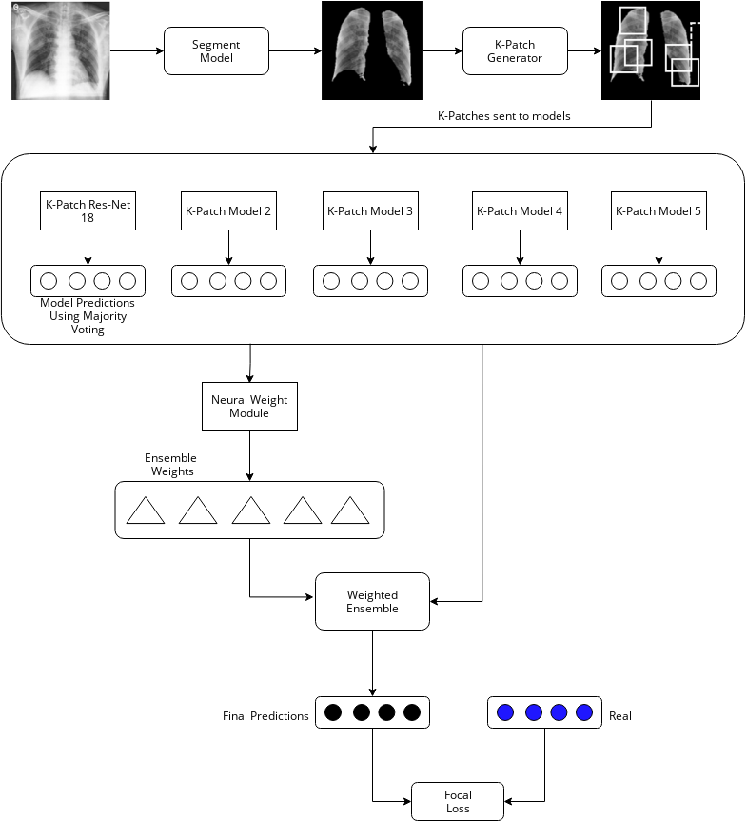
Figure 1: FLANNEL Improvement

4.3 Performance Analysis
We will record the classification accuracy for 4 classes using F1-score. We compare the F1-score accuracy for COVID-19 vs other classes for five base learners, FLANNEL with ensemble strategies voting and stacking, FLANNEL with cross entropy loss, FLANNEL with re-sampling and FLANNEL with k-patch improvement. We use receiving operating characteristic (ROC) curve and precision-recall (PR) curve to display classification performance against threshold. Finally we will provide visual description of FLANNEL and proposed improvement performance using confusion matrix.

5 Experimental Setup
We are planning to use https://github.com/qxiaobu/FLANNEL FLANNEL source code as our baseline and enhance on top of it. Our codebase would be using below software/python packages as shown in Table 2

Table 2: Software/Tools used

Software/Tool | Version
Python | 3.8.5
numpy | 1.20.2
torch | 1.8.1
torchvision | 0.9.1
matplotlib | 3.4.0
scikit-learn | 0.24.1
pandas | 1.2.3

As FLANNEL model requires significant compute and GPU resources (3 NVIDIA Tesla P100 GPUs). We would be utilizing AWS EC2 service with instance type p3.8xlarge which provides 4 NVIDIA Tesla V100 GPUs along with 32 core CPU and 64GB RAM.
For data analysis and exploration, we are going to use Google Colab.

6 Timeline

Table 3: Project Timeline

Task | Planned Due Date
Research, Planning and proposal | 03/30/2021
Data Cleaning and Preprocessing | 04/02/2021
Extract the lung contours | 04/09/2021
Apply classifier on each patch | 04/09/2021
Ensemble the results from each classifier | 04/16/2021
Calculate weights | 04/23/2021
Run the training data to get the prediction | 04/23/2021
Apply Focal Loss | 04/23/2021
Model Training | 04/23/2021
Performance Evaluation | 04/23/2021
Documentation and Video presentation | 05/07/2021
Code and Report Submission | 05/08/2021

References
[1] H. X. Bai, R. Wang, Z. Xiong, B. Hsieh, K. Chang, K. Halsey, T. M. L. Tran, J. W. Choi, D. C. Wang, L. B. Shi, J. Mei, X. L. Jiang, I. Pan, Q. H. Zeng, P. F. Hu, Y. H. Li, F. X. Fu, R. Y. Huang, R. Sebro, Q. Z. Yu, M. K. Atalay, and W. H. Liao. Artificial Intelligence Augmentation of Radiologist Performance in Distinguishing COVID-19 from Pneumonia of Other Origin at Chest CT. Radiology, 296(3):E156–E165, 09 2020.
[2] L. K. Hansen and P. Salamon. Neural network ensembles. IEEE Transactions on Pattern Analysis and Machine Intelligence, 12(10):993–1001, 1990.
[3] T.-Y. Lin, P. Goyal, R. Girshick, K. He, and P. DollÃ¡r. Focal loss for dense object detection, 2018.
[4] Y. Oh, S. Park, and J. C. Ye. Deep Learning COVID-19 Features on CXR Using Limited Training Data Sets. IEEE Trans Med Imaging, 39(8):2688–2700, 08 2020.
[5] Z. Qiao, A. Bae, L. M. Glass, C. Xiao, and J. Sun. FLANNEL (Focal Loss bAsed Neural Network EnsembLe) for COVID-19 detection. Journal of the American Medical Informatics Association, 28(3):444–452, 10 2020.
[6] A. Sharkey. On combining artificial neural nets. Connect. Sci., 8:299–314, 12 1996.
[7] L. Wang and A. Wong. Covid-net: A tailored deep convolutional neural network design for detection of covid-19 cases from chest x-ray images, 2020.

http://www.image-net.org/challenges/LSVRC/index

