Activity 9.1: Polls Missing the Mark
  - Intro to Observational Studies
 Warning
- Submit via Gradescope, don’t forget to assign pages to the questions in the outline!
- Delete any extraneous instructions (like this box) before submission. You will be deducted points from now on if you do not follow this instruction!
- There is no coding required for this activity! I would recommend you complete it using the Word version, but you are still welcome to use the .qmd template: .

The 1936 campaign concluded with the Literary Digest (1936) publishing survey results forecasting a landslide victory for the Republican presidential candidate, Alf Landon. The actual election was, of course, won by the incumbent, Franklin Roosevelt, by a large margin. Thus the Literary Digest poll gained an infamous place in the history of survey research. Almost every book on presidential elections or survey methodology contains some scathing reference to the poll and gives reasons why it failed to forecast the correct results.
This was the introduction to an article (Squire 1988), written 50 years after the election and poll in question. Franklin D. Roosevelt was up for re-election to president of the US, and the republican candidate running was Alf Landon. You probably have not heard of Alf Landon because he did not win the election, contrary to what was predicted as a major margin in favor of Landon by the Literary Digest right before the election:
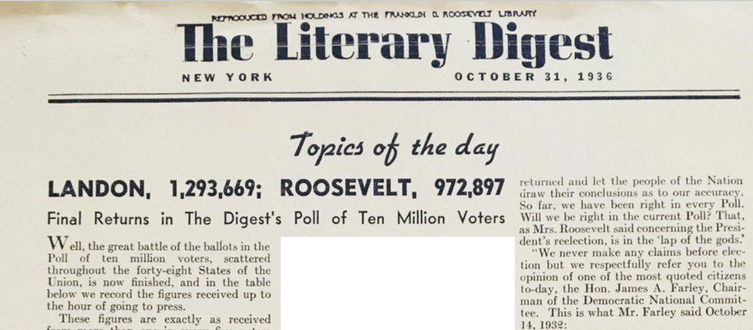
Let’s follow along with Squire’s investigation to think about what might have happened here.

Literary Digest Poll
The Literary Digest boasted that they polled 10 million voters across the 48 states in the US at the time. For each voter polled, they sent out a “straw ballot” and asked that it be mailed back once completed. Out of the 2.3 million ballots returned, 1,293,699 said they planned to vote for for Landon, and 972,897 for Roosevelt.
- What is the standard error on the estimate of 55% votes for Landon? Would you consider that to be a precise estimate (i.e. very small standard error)?
- What was the response rate for the survey? (What proportion of people returned the ballot). What do you think about that response rate – does it seem high or low?
- It turns out that the sample of 10 million voters primary came from car registration lists and telephone books. Who might have been missing from this sample? Who might have been over-represented?
- Roosevelt actually won the election with 61% of the popular vote. At this point, what do you hypothesize could be some potential reasons for how wrong the poll was??

Gallup’s Follow-Up Survey
Because it was such an embarrassment to polling, George Gallup (this name should sound familiar!) followed up on the Literary Digest poll with his own survey between May 19-24, 1937 asking about whether people received and completed the Literary Digest straw ballot, who they actually voted for, and some demographic questions.
Squire (1988) analyzed this follow-up survey to investigate hypotheses that had developed over the previous 50 years about what “went wrong.”
The first hypothesis most people had was that poorer voters (who would be more likely to support Roosevelt) were under-sampled because these voters may not own cars or telephones. The plot below shows the results from Gallup’s follow-up survey about the relationship between car / phone ownership and presidential support.
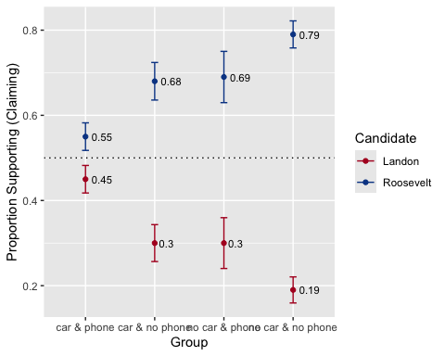
Figure representation of data presented in Table 1 of Squire. Error bars indicate two standard errors (based on the estimate and sample size).
- Does there appear to be a relationship between owning cars or phones and supporting Landon vs. Roosevelt? Is there evidence that people who owned cars and phones supported Landon over Roosevelt based on this survey?
- It turns out that it is common, as with Gallup’s survey, that voters will misremember (or report) voting for the winner of a political race. Gallup’s follow-up survey overall overestimated the vote for Roosevelt by 5%. Does that impact or change your thoughts from in Q5?
The second hypothesis was that Landon voters were just more likely to respond to the poll.
Here is data regarding the question
Did you receive a Literary Digest straw vote ballot in the Presidential campaign last fall?
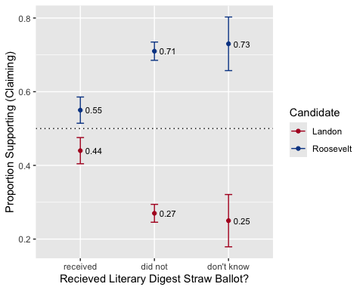
Figure representation of data presented in Table 2 of Squire. Error bars indicate two standard errors (based on the estimate and sample size).
Here is data regarding the question
Did you send it in?
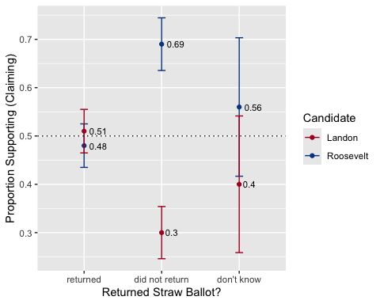
Figure representation of data presented in Table 3 of Squire. Error bars indicate two standard errors (based on the estimate and sample size).
- Does there appear to be evidence that Landon voters were more likely to respond to the poll?
Here is a table version of the responses:
ballot | landon | roosevelt | n
returned | 251 | 237 | 493
did not return | 86 | 199 | 288
don’t know | 19 | 27 | 48
- What do you notice about the % of people who claimed that they sent the straw vote ballot back?

Reflection
- One of the big claims of the potential accuracy of the Literary Digest polls when they originally published their article was that they had surveyed 10 million people and that the results were based on 2.3 million responses! How did it go so wrong even with such a big sample size?
- Based on this example, what do you think are some of the large challenges facing pollsters (statistically and logistically) who want to try to predict election results?
Gallup, George, and Claude Robinson. 1938. “American Institute of Public Opinion-Surveys, 1935-38.” The Public Opinion Quarterly 2 (3): 373–98. https://www.jstor.org/stable/2744825.
Squire, Peverill. 1988. “Why the 1936 Literary Digest Poll Failed.” The Public Opinion Quarterly 52 (1): 125–33. https://www.jstor.org/stable/2749114.

I couldn’t find the actual data, as it is not included in the official polls from Gallup and Robinson (1938). But the results were produced in Squire (1988)

