Activity 8.1: Causal Inference and Comparing Assumptions
  - Schools Revisited
 Warning
- Submit via Gradescope, don’t forget to assign pages to the questions in the outline!
- Delete any extraneous instructions (like this box) before submission (unless you are using the PDF template). You will be deducted points from now on if you do not follow this instruction!
- There is no coding required for this activity! I would recommend you complete it using the Word version, but you are still welcome to use the .qmd template: 08.1-activity-causal-inference.qmd

Study: We are interested in testing a novel tutoring strategy with 7th grade students in English. We recruit 10 middle schools and randomly assign 5 to implement the new strategy and 5 to use no tutoring in their 7th grade English classes. At the end of the year, we get the passing rate for each school on a standardized reading test.
- Describe the treatment and experimental structure for this study.

Estimating ATE under Potential Outcomes
- I am magic and actually know both potential outcome passing rates for every school. Fill in the table with the individual treatment effects and the observed outcomes.
School | $y_{i}^{t}$ | $y_{i}^{c}$ | $τ_{i}$ | $T_{i}$ | $Y_{i}$
1 | 80 | 73 |  | 1
2 | 89 | 88 |  | 0
3 | 70 | 66 |  | 1
4 | 60 | 55 |  | 0
5 | 75 | 75 |  | 0
6 | 80 | 70 |  | 1
7 | 72 | 66 |  | 0
8 | 78 | 76 |  | 1
9 | 86 | 75 |  | 0
10 | 68 | 65 |  | 1
- Calculate the ATE ($\overset{‾}{τ}$) based on the table. Why do we usually not know the ATE?
- Calculate the observed difference in means ($\hat{τ}$) in this study.
- Calculate the difference in means for a different treatment permutation between the schools. Use the treatment permutation of your choosing and fill out the table below to help you out.
School | $T_{i}$ | $Y_{i}$
1
2
3
4
5
6
7
8
9
10
- To create the distribution below, for every possible permutation of 5 schools among 10 being assigned treatment (225 permutations), I calculated what the observed difference in means would be ($\hat{τ}$), and then plotted all of them.
- Why does it make sense that the center of the distribution is 4.9?
- What does the SD value of this distribution mean?
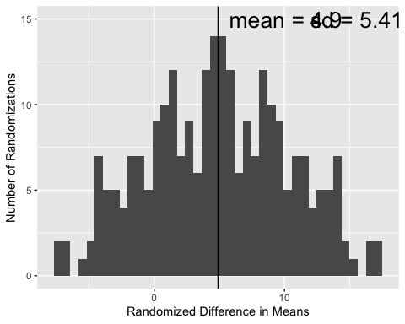

Assumptions
- Write out the model and assumptions we used to estimate the ATE in Q4.
- Write out the model and assumptions we would use to estimate the ATE using ANOVA.

