Activity 5.1: Reducing Variability with Blocking
  - Advertising Strategies
 Warning
- Submit via Gradescope, don’t forget to assign pages to the questions in the outline!
- Delete any extraneous instructions (like this box) before submission. You will be deducted points from now on if you do not follow this instruction!
- Delete anything like \vspace{}
- Remember that it’s okay if you cannot get the .qmd to render to submit this!! I will help you but you can also use any of the other formats.
- You should follow the qmd template for coding: 05.1-activity-reducing-variability-with-blocking.qmd
- You can download the data on Canvas or here: 05-advertising_sales_data.csv)

A marketing team for a regional grocery chain wants to compare the impact of four advertising strategies on sales.
The four strategies are:
- (Discount) Discount-Driven Ads – highlight weekly price specials.
- (Storytelling) Brand Storytelling – focus on local farms and family ownership.
- (Digital) Digital-Only – social media and email ads only.
- (Events) Community Events – in-person promotions like pop-up tastings.
There are 16 cities interested in participating in the study. Each city will use one advertising strategy for a 6-week campaign, and overall sales volume during that period will be recorded. However, cities differ greatly in their population size and baseline sales. Larger cities naturally have higher sales, regardless of the advertising strategy.

Part A: Setup

1. How would you create blocks for this experiment?

2. Sketch a design blueprint
Clearly draw the blocks, show the experimental units, and how treatments are randomly assigned.

3. Describe the treatment structure

4. Describe the experimental structure

Part B: Incorrect Analysis
 STOP!
Before you proceed to read in the data, make sure that you have moved the .qmd template AND the data to your STAT 3540 folder (and whatever sub-folder you choose). You will need to add the relative file path to the code below to the data!

INCORRECT ANALYSIS!

5. Run a one-way ANOVA CRD analysis (ignoring block) and record the numeric values below
$$y_{im}=μ+τ_{i}+ϵ_{im}\text{ with }ϵ_{im}\overset{\text{iid}}{∼}N(0,σ^{2})$$
for $i=1,2,3,4$ and $m=1,2,3,4$
- SST = ________________
- SSTrt = ______________
- SSE = ________________ $→$ MSE = ${\hat{σ}}^{2}$ = _________

Part C: Treatment and Block Means
The observed sales volumes (in thousands of dollars) are shown below.

Original Sales
Advertising Strategy | Block m = 1 (Smallest) | Block m = 2 | Block m = 3 | Block m = 4 (Largest) | Treatment Mean Sales ${\overset{‾}{y}}_{i⋅}$ |
Digital | 136 | 153 | 203 | 200
Discount | 147 | 146 | 217 | 225
Events | 162 | 189 | 231 | 228
Storytelling | 184 | 208 | 251 | 257
Block Mean Sales (${\overset{‾}{y}}_{⋅m}$) |  |  |  |  | ${\overset{‾}{y}}_{⋅⋅}=$
Block Effects (${\hat{ρ}}_{m}={\overset{‾}{y}}_{⋅m}−{\overset{‾}{y}}_{⋅⋅}$)

 Computations in R
You can either do this computations with the data itself OR just using the numbers provided in the table above. You can use R as a calculator or any calculator your prefer… I would recommend using R as a calculator so that you can track exactly what you did and catch mistakes!
I included one for you below. Putting the parethesis around the whole line prints the output as well as saving the object ybar1. for use in a later calculation!
Delete the R chunks if you don’t use them

6. Compute the treatment mean sales ${\overset{‾}{y}}_{i⋅}$ for each advertising strategy. Record in the table above.

7. Compute the block mean sales ${\overset{‾}{y}}_{⋅m}$ for each city size block. Record in the table above.

8. Compute the overall mean sales volume ${\overset{‾}{y}}_{⋅⋅}$ . Record in the table above.

Part C: Block Effects

9. Compute the block effect for each block. Record in the table above.
$${\hat{ρ}}_{m}={\overset{‾}{y}}_{⋅m}−{\overset{‾}{y}}_{⋅⋅}$$

10. Use the block effects to compute SSBlk
Notice: the $({\overset{‾}{y}}_{⋅m}−{\overset{‾}{y}}_{⋅⋅})$ inside the parentheses is the ${\hat{ρ}}_{m}$ you computed in (9).
SSBlk=tm​(y⋅m−y⋅⋅)2=
Note
Recall, the purpose of the block design is to “remove” the variation explained by the blocking variable from the SSE, thus reducing the experimental error variation (MSE).

Part D: Block Adjusted Sales

11. Using the block effects from the table above, adjust each observed sales volume value by the associated block effect $(y_{im}−ρ_{m})$. Record in the table below.
Note, you are essentially “removing” the effect of city from the sales.

Block-adjusted Sales
Advertising Strategy | Block m = 1 (Smallest) | Block m = 2 | Block m = 3 | Block m = 4 (Largest) | Block-adjusted  Treatment Mean  Sales
Digital
Discount
Events
Storytelling

12. Calculate the block adjusted mean sales. Record in the table above.
- What do you notice about the block-adjusted mean sales compared to the original mean sales?
- Would the SSTrt change when using the block-adjusted mean sales? Recall SSTrt=Mi​(yi⋅−y⋅⋅)2. ## 13. What do you notice about the variability of the block-adjusted sales within each advertising strategy compared to the original variability of sales (without block-adjusted sales)?
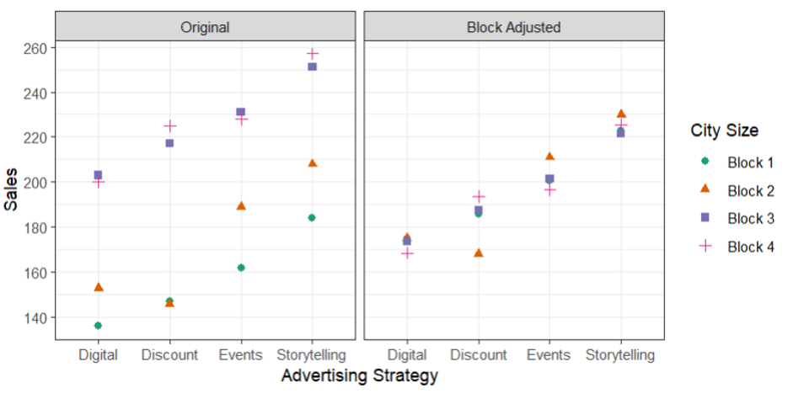

Part E: RCBD Analysis
Consider the statistical effects model that accounts for the block effect.
$$y_{im}=μ+τ_{i}+ρ_{m}+ϵ_{im}\text{ with }ϵ_{im}\overset{\text{iid}}{∼}N(0,σ^{2})$$
for $i=1,2,3,4$ and $m=1,2,3,4$

14. Complete the skeleton ANOVA below
Source of Variation | DF: Total = _________

15. Use R to fit the statistical effects model specified above. Record the following:
- SSE = __________
- MSE = ${\hat{σ}}^{2}$ = __________

16. How does your experimental error in (15) using the statistical effects model to account for the block effect compare to the experimental error calculated in (5) ignoring the effect of block?

