FOUNDING PRODUCT BIBLE

COOL CRYPTO GAMES
  - Games first. Crypto native.
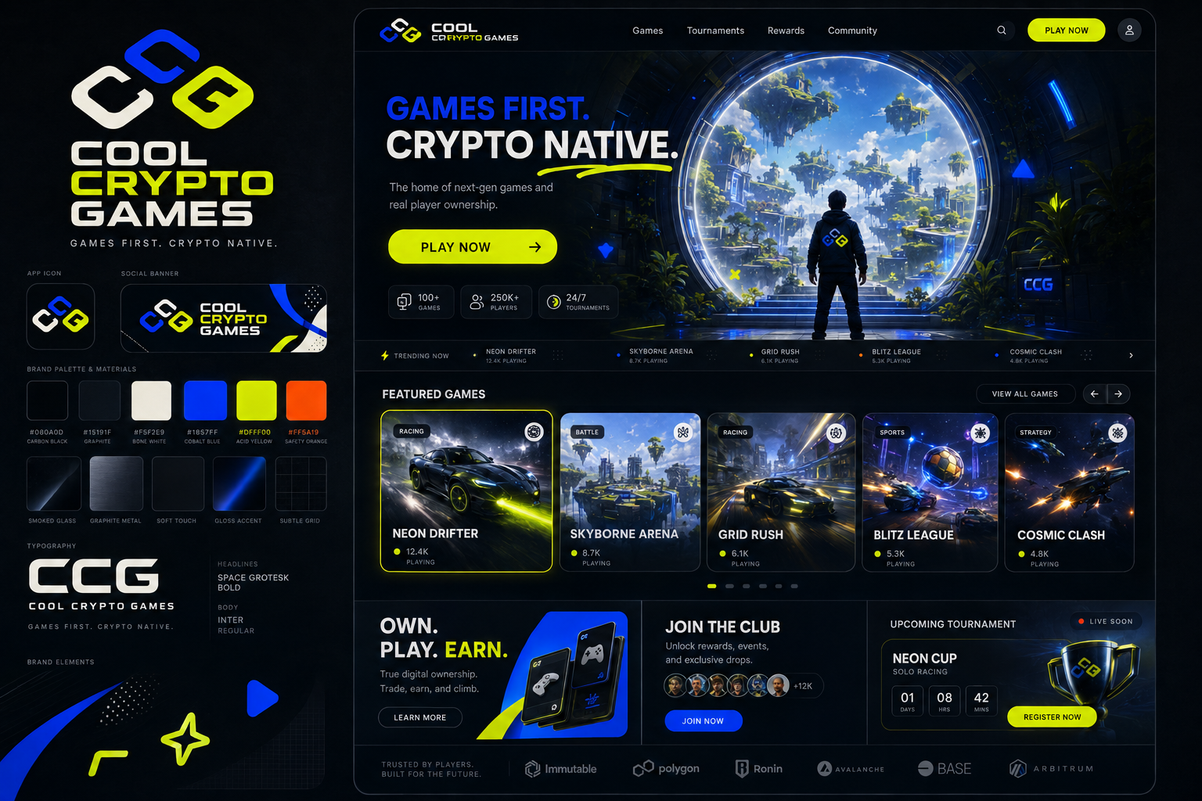
NORTH STAR Build the game platform WEBCADE was reaching for: excellent games, fair developer economics, trusted competition, live community, and optional crypto infrastructure that never gets in the way of fun.

Version 0.1 | September 4, 2026 | Founding working draft
This document defines the intended product and operating model. Legal, tax, payments, privacy, promotion, and gaming counsel must review implementation before launch.
CONTENTS

The CCG operating system
01 North star and positioning
02 Player experience
03 Wallet-gated play and security
04 Game catalog and quality bar
05 Developer platform and economics
06 CCG revenue engine
07 Tournaments, prizes and competitive integrity
08 Live streams and community
09 Product map and functional requirements
10 Technical architecture
11 Trust, safety and legal-risk boundaries
12 Launch strategy and first five games
13 Roadmap
14 Metrics and operating cadence
15 Non-negotiables and first 30 days
Appendix A CCG game SDK contract
Appendix B Launch readiness checklist
Appendix C Sources and policy references

Executive decision
CCG will launch as a curated, web-first gaming network. Anybody can browse the catalog, watch streams, inspect leaderboards, discover developers, and view tournament schedules without a wallet. A wallet connection and free message signature are required only when a player starts a game, submits a score, enters a tournament, or claims a prize.
POSITIONING Browse freely. Watch freely. Connect to play. Never pay to play.

CCG is not a crypto casino, a token launchpad, an uncurated upload portal, or a collection of shallow promotional games. It is a place where people come because the games are worth playing. Wallets provide persistent identity and security. Money flows toward developers, production, prizes, and the platform - not toward player-funded wagering.
01

North star and positioning
A total gamer paradise must earn that description through the quality and density of the experience. The home page should feel alive: games launching, tournaments counting down, creators streaming, players climbing leaderboards, new updates arriving, and developers visibly earning from successful work.

Mission
Make internet-native games easier to discover, more rewarding to build, and more exciting to compete in.

Brand promise
Audience | CCG promise
Players | Instant fun, trusted competition, meaningful identity, and prizes without pay-to-win mechanics.
Developers | Distribution, monetization, analytics, community, tournament infrastructure, and transparent payouts.
Sponsors | Brand-safe access to engaged gaming communities and measurable event activations.
CCG | A durable platform business built on revenue share, memberships, sponsorships, and services.

Positioning sentence
Cool Crypto Games is a curated browser gaming network where players connect a wallet to play, developers earn from the audiences they build, and free-entry skill tournaments turn great games into live events.

Experience principles
- Games are the product. Crypto is infrastructure.
- The first playable moment matters more than the first purchase.
- Every economic rule must be understandable in one screen.
- Competition is verified, observable, and appealable.
- Developers can see how revenue is calculated.
- Mobile is a primary platform, not a reduced desktop layout.
- CCG launches fewer games and makes each one matter.

Brand system
The visual identity combines a dark graphite product shell with bone-white surfaces, cobalt structural accents, acid-yellow action states, and rare safety-orange alerts. The interface is sleek and gamer-forward without retro nostalgia, casino imagery, market charts, or excessive cyberpunk effects.
Role | Specification | Usage
Foundation | #080A0D / #15191F | Navigation, page shell, game theater, streaming surfaces
Primary | #1857FF cobalt | Links, selected states, navigation, developer identity
Action | #DFFF00 acid | Play, register, live status, verified result
Surface | #F5F2E9 bone | Readable contrast, editorial cards, announcements
Alert | #FF5A19 orange | Limited events, warnings, expiring states

02

Player experience
CCG should turn discovery into play with as little ceremony as possible. A visitor can understand the platform, inspect games, watch broadcasts, and explore community activity before connecting anything. The wallet gate appears only at the moment of play and clearly explains why it exists.

Core player loop
- Discover a game through the home feed, creator page, live event, friend activity, or tournament.
- Open a rich game page and understand the fantasy, controls, session length, and competitive mode.
- Tap Play, connect a supported wallet, and sign a free authentication message.
- Play immediately inside a focused game theater.
- Receive a verified result, XP, achievements, progression, and leaderboard movement.
- Follow the game or developer, share a clip or scorecard, and enter the next relevant event.

Access rules
Activity | Wallet | Account/session rule
Browse games and developers | No | Public
Watch streams and clips | No | Public; chat may require account
View leaderboards and events | No | Public
Play any game | Required | Signature creates verified play session
Submit score or achievement | Required | Bound to active wallet session
Enter tournament | Required | Eligibility and rules acceptance required
Claim prize | Required | Same wallet plus additional verification when required

Mobile-first home
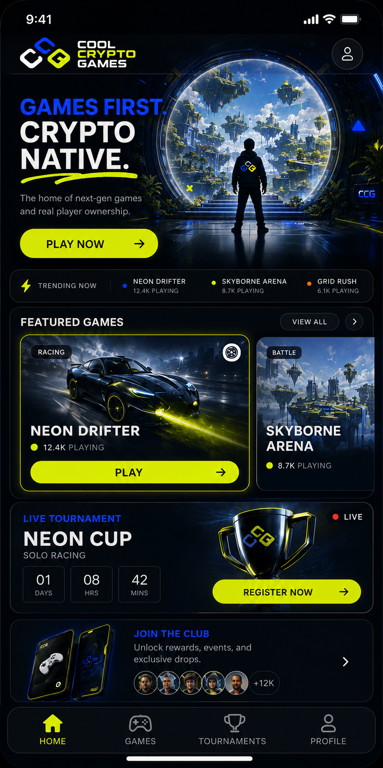
Direction reference: compact hero, thumb-sized play action, swipeable game cards, live tournament module, and persistent bottom navigation.

Required primary navigation
- Home - personalized discovery and live activity
- Games - curated catalog and filters
- Tournaments - current, upcoming, and completed events
- Live - official broadcasts and approved creator streams
- Developers - studios, updates, and follow graph
- Profile - identity, achievements, history, rewards, and settings

Game page anatomy
Zone | Required content
Above the fold | Title, key art, Play, live status, players online, tournament status
Game theater | Responsive runtime, controls, fullscreen, performance and report controls
Competition | Leaderboards, verified badges, current events, personal best
Creator | Developer identity, follow, updates, support and revenue-bearing items
Community | Approved streams, clips, reviews, friends playing and report tools

03

Wallet-gated play and security
LOCKED RULE A wallet is required to play. It is an authentication and accountability requirement, not a payment requirement.

Wallet connection requirements
- Any supported, valid wallet can play, including an empty wallet.
- No token holding, balance, NFT, transaction, gas payment, approval, or asset permission is required.
- The user signs a human-readable authentication message containing domain, nonce, issued time, expiration, and requested capability.
- The signed message is verified server-side before a session is issued.
- The wallet is never asked to sign every input, frame, or round.
- The interface explains that signing does not create a blockchain transaction or grant access to assets.

Secure play-session flow
- Play request: client requests a one-time nonce from CCG.
- Wallet proof: wallet signs the scoped authentication message.
- Risk evaluation: service evaluates wallet, device, IP/network, rate limits, history, and active sanctions.
- Authorization: server issues a short-lived, game-specific play token bound to wallet, device risk state, game version, and match ID.
- Game launch: isolated runtime receives only the minimum scoped token it needs.
- Telemetry: game records required input and event evidence during the run.
- Result submission: backend validates token, chronology, score model, replay evidence, and duplicate state.
- Decision: result becomes verified, held for review, or rejected with an auditable reason code.

Security model
Layer | Purpose | Important limitation
Wallet signature | Cryptographic control of player identity | Wallets are inexpensive to create; not sufficient alone
Device risk | Detect repeat abuse and automation clusters | Probabilistic; shared devices exist
IP/network risk | Rate limits and anomaly context | Never use IP alone for permanent bans
Server match ID | Stops replay and duplicate submissions | Requires strict expiration and single-use rules
Event/replay evidence | Supports score verification and appeals | Collection must be proportionate and disclosed
Manual review | Protects high-value finals | Needs trained reviewers and consistent procedures

Tournament integrity controls
- Delayed publication for suspicious top scores
- Server-authoritative logic where technically feasible
- Deterministic replays or compact input logs
- Impossible-state and velocity checks
- Wallet, device, and behavior graphing
- Rate limits and cool-downs
- Manual verification for finalists
- Appeal window and documented reviewer decision

Privacy boundary
Security signals should be used to protect games, not to create an undisclosed surveillance product. Publish the categories of data collected, retention periods, decision uses, appeal path, and deletion controls. Hash or minimize identifiers where possible. Do not promise that the system is unbeatable; promise that high-value results are verified through layered evidence.
04

Game catalog and quality bar
CCG begins as a curated platform. Open submissions may be accepted for review, but nothing is published automatically. The catalog should feel edited, alive, and intentional.

Founding catalog shape
Slot | Purpose | Required strength
Flagship competition | Creates the identity of CCG | Deep mastery, spectator clarity, fair scoring
Instant score chase | Fast repeat sessions | Under 10 seconds to understand; strong one-more-run loop
PvP duel | Social rivalry and live events | Short matches, stable networking, readable outcomes
Progression game | Longer retention | Meaningful unlocks without pay-to-win
External standout | Proves developer platform value | Distinct voice and creator-led community

Release gates
- Originality and intellectual-property attestation
- Stable launch on target mobile and desktop browsers
- Defined performance budget and loading target
- Touch, keyboard, and controller behavior where applicable
- Responsive game theater and safe-area support
- Save and resume behavior
- Crash, error, and telemetry instrumentation
- Clear controls and onboarding
- Tournament-compatible deterministic rules when applicable
- Age/content rating and moderation classification
- No undisclosed wallet actions or external transaction prompts

Catalog tiers
Tier | Meaning | Visibility
Featured | CCG-certified flagship quality | Home, campaigns, tournaments, live programming
Arcade | Released and supported | Catalog, search, recommendations
Labs | Early access with visible status | Opt-in discovery; feedback tools
Archived | No longer actively supported | Profile history and direct links; no promotion

What CCG rejects
- Reskins created only to promote a token
- Broken or unfinished prototypes presented as releases
- Copied characters, maps, audio, branding, or mechanics presented deceptively
- Casino-first experiences or disguised wagering
- Games that require external purchases to be competitive
- Games whose primary loop is watching advertisements
- Apps that request wallet permissions unrelated to play authentication
05

Developer platform and economics
Developers should experience CCG as a distribution, monetization, competition, and community partner. The platform earns trust through clear contracts, fast payouts, usable analytics, human support, and public economic rules.

CCG Developer Studio
- Game upload, versioning, staged rollout, rollback, and release notes
- SDK configuration for wallet identity, sessions, saves, scores, achievements, purchases, and telemetry
- Device and browser compatibility reporting
- Store items, cosmetics, season content, and pricing controls
- Tournament creation proposals and event operations
- Revenue ledger showing gross receipts, deductions, net receipts, split, and payout status
- Retention, funnel, session, crash, purchase, and tournament analytics
- Community updates, stream scheduling, clips, reviews, and moderation queue

Recommended economic rules
Revenue source | Developer share | CCG share | Basis
Game cosmetics / passes | 80% | 20% | Net receipts attributable to the game
Advertising in game | 70% | 30% | Net advertising receipts
Direct player support | 90% | 10% | Net receipts after payment costs
CCG-sourced sponsor activation | 70% | 30% | Net campaign revenue after approved direct costs
CCG membership | 50% pool | 50% | Net subscription revenue; pool allocated by quality engagement

All contracts must define net receipts plainly: money actually received minus disclosed taxes, payment processing, refunds, chargebacks, and agreed direct campaign costs. CCG should publish a worked example and never change a split retroactively.

Founding Developers Program
Recruit a small founding class and give them white-glove support. Recommended offer: enhanced launch placement, direct integration help, co-produced tournament, founder badge, featured stream, and an introductory 90/10 game-revenue split for a defined period. In exchange, founding developers commit to quality milestones, telemetry, update cadence, player support, and promotional participation.

Developer rights
- Developer retains ownership of the game and pre-existing IP.
- CCG receives only the distribution and promotion licenses required by the agreement.
- Developer can inspect revenue calculations and export performance data.
- Removal, suspension, chargeback, moderation, and dispute procedures are documented.
- Exclusivity is optional, narrow, compensated, and time-limited.
06

CCG revenue engine
The platform should make money because it improves distribution, payments, events, community, and production. It should not make money from players losing wagers.

Revenue pillars
Pillar | Player value | CCG value
Membership | Ad-free experience, cloud benefits, identity customization, early playtests | Recurring revenue
Game commerce | Cosmetics, expansions, season content | Revenue share
Sponsorships | Bigger events, prizes, broadcasts, limited cosmetics | Campaign and production margin
Advertising | Free access when used with restraint | Scaled catalog monetization
Developer services | Optional QA, porting, live ops, art, analytics | Service revenue without tax on all creators

Membership boundaries
A membership may provide ad-free browsing, profile themes, cloud saves, private lobbies, early playtests, expanded social features, and non-cash XP boosts. It must not improve prize odds, buy tournament placement, provide extra attempts in a prize event, or create a gameplay advantage in competitive modes.

Sponsor package anatomy
- Named event or season with clear sponsor labeling
- Fixed prize commitment held before promotion
- Developer production allocation
- CCG broadcast and operations allocation
- Optional non-pay-to-win cosmetic integration
- Stream overlays and approved placements
- Performance report covering reach, qualified players, playtime, stream viewers, and conversion

Commerce rules
- No dark patterns, hidden recurring charges, or fake scarcity.
- Prices and developer shares are visible before purchase.
- Competitive power is never sold.
- Refund and chargeback behavior is defined.
- Sponsored placements are labeled.
- Randomized paid rewards are excluded from the founding product.
07

Tournaments, prizes and competitive integrity
FOUNDING FORMAT Free entry. Predetermined sponsor- or platform-funded prizes. Objective skill. Published rules. Verified results.

Event types
Format | Best use | Result model
Open leaderboard | Broad weekly participation | Highest verified score during event window
Qualifier + final | High-value featured event | Open qualifying followed by live verified final
Head-to-head bracket | PvP games and broadcasts | Match result advances player
Developer challenge | Launch or update activation | Game-specific objective and judging/scoring rules
Community cup | Teams, clubs, partner communities | Aggregate verified performance

Required official-rule fields
- Sponsor and administrator
- Eligibility, age, and geography
- No-purchase entry statement
- Opening and closing timestamps
- Game version and permitted devices
- Scoring method and tie-breakers
- Prohibited conduct and anti-cheat evidence
- Prize description and approximate retail value
- Winner verification, notification, taxes, and claim deadline
- Disqualification and appeal process
- Publicity and data-use terms
- Platform-store disclaimer where applicable

Prize policy
CCG should begin with physical gaming gear, sponsor products, merchandise, gift cards, travel support where appropriate, and fixed cash prizes administered through compliant payout processes. Token prizes, tradable prize tickets, and onchain prize pools should wait for jurisdiction-specific review.

Hard prohibitions
- Player-funded prize pools or peer-to-peer wagers
- Paid entry or purchased tournament attempts
- Purchased items that affect score or odds
- Stake-to-enter or deposit-to-compete
- Random winner selection inside a paid gameplay loop
- Changing rules after an event begins
- Publishing unverified high-value results as final

Competition operations
Every material event needs an event owner, rules owner, integrity reviewer, support path, incident channel, prize ledger, final verification record, and post-event report. High-value finals should be streamed when practical and use enhanced verification.
08

Live streams and community
Live programming is the heartbeat that turns a catalog into a destination. CCG should not attempt to replicate a universal streaming platform at launch. It should produce and curate streams that make its games and developers matter.

Launch programming
- Weekly CCG tournament broadcast
- Developer launch premiere and Q&A
- Verified high-score attempts
- Speedrun and challenge nights
- Patch preview and playtest streams
- Community cups and creator exhibitions

Streaming rollout
Phase | Capability | Moderation level
1 - Curated | Official channel plus approved embedded creators | Pre-approved accounts; monitored chat
2 - Partner | Developer and verified creator channels | Identity, reporting, filtering, human escalation
3 - Platform | Broader native streaming, clips, subscriptions and tips | Full trust-and-safety operation

Community architecture
- Follow games, developers, players, clubs, and tournaments
- Activity feed built around scores, releases, streams, events, and achievements
- Comments or chat only where moderation coverage exists
- Clips live on the related game page rather than in an unrelated content feed
- Block, mute, report, appeal, and enforcement-history tools
- Verified developer and tournament-official identities

Creator monetization
Approved streamers can earn through direct support, channel membership, sponsorship activations, affiliate game commerce, and event production fees. CCG should publish creator splits and prohibit misleading prize, token, or investment claims.
09

Product map and functional requirements
Surface | Primary job | MVP requirements
Home | Convert attention into play | Hero, trending, featured games, live event, tournaments, updates
Games | Catalog discovery | Categories, filters, search, compatibility, sort, editorial collections
Game page | Play and deepen engagement | Theater, wallet gate, details, leaderboards, creator, streams, store
Tournaments | Organize competition | Schedule, rules, eligibility, entry, standings, results, history
Live | Create appointment viewing | Featured stream, schedule, approved channels, clips
Developers | Build creator identity | Studio pages, games, updates, streams, follows, support
Profile | Represent player history | Wallet, achievements, scores, follows, cosmetics, privacy
Developer Studio | Publish and earn | Builds, SDK, analytics, commerce, payouts, events, support
Admin | Operate trust and quality | Review queues, sanctions, prize ledger, moderation, releases, incidents

Homepage hierarchy
- Live or timely platform story
- Immediate Play action
- Featured games
- Trending now
- Active tournament
- Live stream
- New and updated games
- Developer spotlight
- Community activity

Search and discovery signals
Recommendations should balance explicit follows, device compatibility, genres, recent play, friend activity, editorial curation, quality score, update freshness, and verified retention. Paid placement must be labeled and may not override minimum quality requirements.

Accessibility and compatibility
- Keyboard navigation for the shell
- Visible focus states and semantic controls
- Captions for official video
- Color is never the only status indicator
- Reduced-motion support
- Controller and touch mapping disclosure
- Safe-area handling on mobile
- Performance profiles for lower-end devices
10

Technical architecture
CCG should be web-first and installable as a progressive web app. The platform shell and game runtimes are separate trust zones. Games receive narrowly scoped capabilities through the CCG SDK rather than direct access to platform sessions.

Core services
Service | Responsibility | MVP note
Web application | Discovery, profiles, tournaments, streams, commerce | Responsive server-rendered shell
Identity | Wallet challenge, signature verification, sessions, recovery links | No asset approvals
Game runtime gateway | Versioned game launch and isolation | Sandboxed origin / iframe policies
Game SDK API | Saves, scores, achievements, telemetry, commerce | Capability-scoped tokens
Competition service | Events, entries, rules, standings, verification | Immutable event version after start
Integrity service | Risk signals, anomaly detection, replay review | Reason-coded decisions
Media service | Streams, VOD, clips, schedules | Curated providers first
Commerce and payout | Orders, ledger, refunds, developer splits | Marketplace payment provider
Admin console | Moderation, publishing, sanctions, prizes, incidents | Role-based access and audit log

Isolation requirements
- Each game build runs on a separate restricted origin or equivalent isolated container.
- Game code cannot read platform cookies, wallet provider objects, or another game's storage.
- The shell passes only short-lived, audience-bound capabilities through an allow-listed message protocol.
- Network destinations and requested permissions are declared in the game manifest.
- Build files are scanned, hashed, versioned, and immutable after tournament start.
- Content Security Policy and cross-origin protections are treated as release gates.

Reliability targets
Measure | Founding target
Shell availability | 99.9% monthly target after public launch
Crash-free game sessions | At least 99.0% per released title; higher for featured events
Median time from Play to interactive | Under 5 seconds on supported broadband; game-specific budgets disclosed
Score submission durability | Idempotent; no duplicate award on retry
Incident ownership | Named on-call owner during promoted tournaments

Data model minimums
Wallet, user profile, consent record, device-risk pseudonym, game, build, manifest, play session, match, event log, score, verification decision, achievement, tournament, entry, standing, prize, order, ledger line, developer account, revenue share, payout, stream, clip, report, sanction, appeal, and audit event.
11

Trust, safety and legal-risk boundaries
This section defines product constraints, not legal conclusions. Before launch, qualified counsel must review the exact tournament, prize, payment, privacy, intellectual-property, streaming, and age-access implementation for every jurisdiction served.

Required policy set
- Terms of Service
- Privacy Policy and state/country notices
- Cookie and tracking controls
- Developer Distribution Agreement
- Tournament and Prize Policy
- Official Rules template
- Community Standards
- Streaming and Creator Policy
- Acceptable Use Policy
- DMCA notice, designated agent, takedown, and repeat-infringer policy
- Refund Policy
- Security and vulnerability reporting policy
- Law-enforcement and data-request procedure

Lower-risk founding boundaries
Area | Founding position | Escalation trigger
Wallet | Authentication only; no payment or holding required | Token gating, staking, asset approvals
Competition | Free entry and objective skill | Entry fees, paid attempts, chance
Prizes | Fixed and sponsor/platform funded | Player-funded pools or tradable prize currency
Commerce | Cosmetics and content; no competitive power | Cash-out, secondary-market promises
Crypto | Optional collectibles and supported payouts later | Platform token, investment language
Streaming | Curated and moderated | Open broadcasting or anonymous chat
Age | 18+ founding account/competition policy | Expansion to children or mixed-age social features

Moderation requirements
- Pre-publication game review
- Automated and human content filtering where applicable
- In-product reporting
- Blocking and muting
- Published contact channel
- Response-time targets by severity
- Transparent enforcement reasons
- Appeal path
- Evidence retention rules
- Emergency stream and chat shutdown controls

Legal review gates
Counsel approval is required before introducing paid competition, random prizes, token rewards, tradable assets tied to play, international prize events, travel prizes, under-18 participation, open live streaming, peer-to-peer transfers, custodial balances, or any marketing that implies profit or investment return.
12

Launch strategy and first five games
LAUNCH PHILOSOPHY Do not fill the site. Make five games feel like an entire world.

Founding content slate
Game role | Session | Launch programming
Flagship competitive original | 3-8 minutes | Launch championship and weekly ranked event
Endless score chase | 30 seconds-3 minutes | Daily challenge and creator record attempts
PvP duel | 2-5 minutes | Bracket nights and community rivalry
Progression title | 10-30 minutes | Seasonal goals and developer streams
Founding indie partner | Varies | Developer premiere and sponsored challenge

Launch-week rhythm
Day | Programming
Monday | Platform opening, founder message, five-game showcase
Tuesday | Developer spotlight and behind-the-scenes stream
Wednesday | Open qualifier begins
Thursday | Community challenge and clips
Friday | Live final and prize verification
Weekend | Open play, featured creator streams, recap and next-event reveal

Founding developer acquisition
- Recruit directly rather than opening a public marketplace.
- Show the revenue contract and SDK before asking for exclusivity or integration work.
- Offer a funded polish milestone where budget allows.
- Give every launch developer a page, premiere, tournament, and measurable campaign.
- Publish developer success stories with real numbers only after permission.

Go-to-market message
Lead with the games and the people making them. Avoid claims about earning money as a player. The clean launch message is: "Five games. One live competition network. Developers share in what they create. Connect a wallet to play - no purchase required."
13

Roadmap
Phase | Outcome | Included | Explicitly excluded
0 - Foundation | Rules and architecture locked | Brand, product bible, counsel review, SDK spec, founding slate | Public launch
1 - Closed alpha | End-to-end verified play | Wallet auth, 2 games, scores, profiles, admin review | Prizes and open social
2 - Founding beta | Playable platform | 5 games, catalog, tournaments, developer pages, official stream | Open uploads and native streaming
3 - Revenue launch | Developers and CCG earn | Commerce, membership, sponsor operations, payout ledger | Platform token
4 - Creator network | Community scales | Approved channels, clips, clubs, richer social, developer self-service | Anonymous open broadcast
5 - Expansion | Platform distribution grows | PWA maturity, selective native app, additional regions and genres | Unreviewed real-money mechanics

Suggested timing
A credible founding beta is likely a multi-month build, not a weekend website. Timing depends heavily on whether the five games already exist, how tournament-authoritative they are, and whether streaming is embedded or native. Stage gates should be based on quality and integrity evidence rather than calendar promises.

Release gates by phase
- Foundation exit: economics, wallet gate, prize boundaries, policy owners, and architecture approved.
- Alpha exit: wallet signature, game isolation, score verification, telemetry, and admin review work end to end.
- Beta exit: five games meet quality bar; support and event operations are staffed.
- Revenue exit: ledger reconciles; refunds, chargebacks, developer statements, and payouts are tested.
- Creator exit: reporting, blocking, filtering, takedown, moderation, and appeals are operational.
14

Metrics and operating cadence

North-star metric
WEEKLY VERIFIED PLAYERS Unique wallets that complete at least one valid, human-quality game session during the week. This rejects empty traffic and keeps attention on actual play.

Player metrics
Metric | Why it matters
Play conversion | Percent of game-page visitors who connect and begin a session
Time to interactive | Friction from Play tap to control
D1 / D7 / D30 retention | Whether fun persists beyond prize events
Sessions per verified player | Strength of the game loop
Organic vs. incentivized return | Whether CCG survives without rewards
Tournament repeat rate | Competition health

Developer metrics
- Monthly active earning developers
- Median earnings per 1,000 verified play hours
- Time from approved build to release
- Payout accuracy and timeliness
- Developer retention
- Share of plays outside sponsored events

Quality and integrity metrics
- Crash-free session rate
- P50 and P95 load time
- Held-score rate
- False-positive appeal rate
- Tournament incident rate
- Moderation response time
- Prize verification and payout time

Operating cadence
Cadence | Meeting / review
Daily during launch | Reliability, fraud, support, event readiness
Weekly | Game health, player retention, content calendar, developer pipeline
Per tournament | Rules sign-off, integrity readiness, live operations, postmortem
Monthly | Revenue reconciliation, developer statements, trust-and-safety trends
Quarterly | Catalog strategy, economic splits, policy review, roadmap reset

15

Non-negotiables and first 30 days

CCG will always
- Require a wallet signature before game play.
- Allow empty wallets to play without a transaction.
- Prioritize game quality over catalog count.
- Publish tournament rules before entry opens.
- Separate purchased Credits, non-cash XP, and predetermined prizes.
- Show developers how earnings are calculated.
- Verify high-value competitive results.
- Label sponsorships and early-access games.
- Provide reporting, blocking, appeals, and human escalation where community content exists.

CCG will not launch with
- A platform token
- Pay-to-play prize tournaments
- Player-funded prize pools
- Purchased score advantages
- Random paid rewards with real-world value
- Open anonymous streaming
- Unreviewed game uploads
- Promises that anti-cheat is impossible to defeat
- A catalog full of low-quality promotional reskins

First 30 days
- Form the company and retain gaming/promotions, privacy, payments, and IP counsel.
- Approve the founding economic model, wallet-auth message, prize boundaries, and age/geography position.
- Define the first five game roles and select the first two alpha titles.
- Write the CCG SDK specification and game manifest schema.
- Prototype the desktop and mobile shell around one real game runtime.
- Implement wallet signature, expiring play token, match ID, score submission, and admin review.
- Draft the Developer Distribution Agreement and official tournament-rules template.
- Recruit three to five founding developers and one launch sponsor candidate.
- Run a closed internal tournament with no public prize and document every failure.
- Set the beta launch gate from evidence, not excitement.
DECISION FOR THE FOUNDER Build the smallest version that proves three things: players return for the games, developers trust the economics, and tournament results can be verified.

APPENDIX A

CCG game SDK contract

Founding SDK capabilities
Capability | Game can request | Game cannot access
Identity | Scoped player ID and display profile | Wallet keys, asset permissions, unrelated wallet history
Session | Match ID, game/build version, expiration | Platform cookies or other game sessions
Save | Namespaced cloud state | Another title's save data
Score | Submit typed result and evidence reference | Write directly to public leaderboard
Achievement | Request unlock with evidence | Grant platform XP without validation
Commerce | Display approved product and confirm entitlement | Initiate undisclosed wallet transaction
Telemetry | Declared gameplay and performance events | Undeclared cross-site tracking

Example manifest fields
- game_id and developer_id
- semantic version and immutable build hash
- supported viewport/orientation
- input methods and accessibility capabilities
- network allow-list
- requested SDK capabilities
- save schema version
- score schema and verification mode
- telemetry declaration
- content rating and regional restrictions
- privacy contact and support URL

Message protocol
The initial protocol should cover ready, resize, pause, resume, end-session, save, load, submit-score, achievement-request, purchase-request, entitlement-query, telemetry-batch, and report-error. Every message includes protocol version, game ID, session ID, timestamp, request ID, and capability scope. The shell validates origin and schema before processing.

Build immutability
A tournament references an exact game build hash and rules version. Once the event opens, neither changes. Emergency shutdown is allowed, but silent replacement is not. If a material defect changes competitive outcomes, the event owner follows the published cancellation, restart, or remediation rule.
APPENDIX B

Launch readiness checklist

Product and games
- [ ] Five-game slate approved
- [ ] All releases pass performance and compatibility gates
- [ ] Wallet-to-play disclosure is clear
- [ ] Guest browsing and viewing work without wallet
- [ ] Mobile safe areas and touch controls verified
- [ ] Support and report paths visible

Competition and prizes
- [ ] Official rules approved
- [ ] Prize inventory or funds committed
- [ ] Eligibility and geography enforced
- [ ] Anti-cheat and finalist review rehearsed
- [ ] Appeal and support owners assigned
- [ ] Prize claim and tax workflow tested

Developer and commerce
- [ ] Developer agreements executed
- [ ] Revenue splits configured
- [ ] Ledger reconciled against test transactions
- [ ] Refund and chargeback paths tested
- [ ] Payout onboarding complete
- [ ] Sponsor placements labeled

Trust, safety and operations
- [ ] Policies published
- [ ] DMCA agent and workflow established
- [ ] Moderation queue staffed
- [ ] Block/report/appeal tools tested
- [ ] Incident runbook rehearsed
- [ ] Backups and rollback verified
- [ ] Privacy disclosures match actual collection
APPENDIX C

Sources and policy references
These sources support the founding risk boundaries and should be rechecked before launch because platform rules and regulatory interpretations change.
Apple App Review Guidelines
https://developer.apple.com/app-store/review/guidelines/
Sections on creator content, user-generated content, payments, contests, sweepstakes, and real-money gaming.
Google Play Real-Money Gambling, Games, and Contests
https://support.google.com/googleplay/android-developer/answer/9877032?hl=en
Restrictions on money, purchased items, contests, tournaments, loyalty programs, and prizes.
FTC: Fake Prize, Sweepstakes, and Lottery Scams
https://consumer.ftc.gov/articles/fake-prize-sweepstakes-and-lottery-scams
Consumer-facing explanation that sweepstakes are free and purchases cannot improve odds.
FTC COPPA Compliance Plan
https://www.ftc.gov/business-guidance/resources/childrens-online-privacy-protection-rule-six-step-compliance-plan-your-business
Requirements when covered services collect personal information from children under 13.
U.S. Copyright Office: Section 512
https://www.copyright.gov/512/
DMCA safe-harbor conditions for qualifying online service providers.
Stripe Connect documentation
https://docs.stripe.com/connect
Marketplace payments and connected-account payouts.

Open founder decisions
- Company entity and launch jurisdictions
- Exact domain and public brand lockup
- Supported wallets at alpha
- Founding age policy and verification vendor
- First five games and ownership status
- Launch prize budget and sponsor target
- Membership price and benefits
- Developer payout countries and methods
- Streaming provider and moderation staffing
- Data retention and device-risk implementation
END OF FOUNDING PRODUCT BIBLE | VERSION 0.1

