**WebDriver (Introduction, Downloading, Configuring and WebDriver API Commands - Part 1)**

**What is Selenium WebDriver?**

Selenium WebDriver is the main component of Selenium and requires Core Java knowledge for using it.

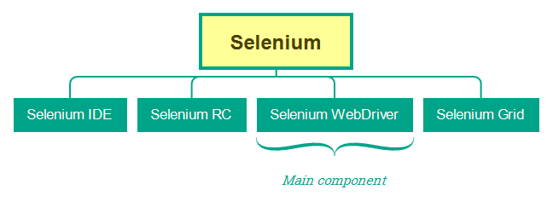

**Downloading and configuring Selenium WebDriver in Java Projects**

Follow the below steps for downloading and configuring the Selenium WebDriver in a Java Project:

1. Create a new Java Project
2. Create a new Class say Demo having main() method
3. Create an object for ChromeDriver and assign to the variable of WebDriver interface
4. Create a new folder say 'library' inside the Project workspace
5. Go to mvnrepository and find the latest stable version of Selenium
6. Download latest stable version of Selenium from Selenium.dev > Previous releases
7. Extract the folder and Paste the available jar files into the library folder and configure the Project
8. Create a new folder 'drivers' and copy the compatible chrome driver
9. Setting the Chrome Driver -

System.*setProperty* ("webdriver.chrome.driver" ,"D:\\SeleniumTrainingWorkspace\\Demo\\drivers\\chromedriver.exe" );

1. Run the code to see the Chrome Browser launching.
2. How to run the code on other browsers will be explained in the upcoming sessions

**Selenium WebDriver API Commands**

Selenium WebDriver is an API, which contains a set of predefined library of commands / methods.

* Google Search "Selenium Java WebDriver API" and find the predefined methods of WebDriver interface

Lets start using the Predefined methods of Selenium WebDriver.

* **get()** - Used to open the specified URL's web page - Demonstrate [here](https://drive.google.com/file/d/17tIGIH5O78w-8t-jxZ4bTsqaXo4yrjmJ/view?usp=sharing)
  + **http://** needs to be provided, otherwise the specified URL wont get opened
* **manage().window().maximize() -**Used to maximize the current web page - Demonstrate [here](https://drive.google.com/file/d/1R8SMDaJxQP7MYY7eMvNTj4mqXmHGRMHe/view?usp=sharing)
* **findElement()**, **By** **class and its predefined methods, WebElement interface and its predefined methods**
  + findElement() is a predefined method of WebDriver and it needs to be used with By Class and its predefined methods for locating and performing the operations on UI elements
  + View the 'By' Class and its predefined methods in Selenium API Pages - The purpose of the By class and its predefined methods is to locate the UI elements with the help of the locators
  + **id()  - By.id("confirm")**
  + **name() - By.name("q")**
  + **className() - By.className("classone")**
  + **linkText() - By.linkText("compendiumdev")**
  + **partialLinkText() - By.partialLinkText("compendium")**
  + **cssSelector() - By.cssSelector("#confirm")**
  + **xpath() - By.xpath("//input[@id='confirm']")**
  + Store the UI element located by the findElement() to reference variable of **WebElement** interface
* **click()** - Used to perform click operation on different UI elements like Button, link, checkbox option and radio option etc
* **sendKeys() -**Used to enter text into the text fields like text box, text area, password fields etc. - [Demonstrate here](https://drive.google.com/file/d/1_xlaMADhncaEuy_O-FV3NgHpla3SxrHN/view?usp=sharing)
* **clear() -**Used to clear the text available in the text box or text area fields - [Demonstrate here](https://drive.google.com/file/d/1W13czuuIdX9xHLe9uROdGwQWmQatb_p1/view?usp=sharing)
* **getText()** - Used to retrieve the elements text (i.e. The text between the starting and ending tags of HTML elements) - [Demonstrate here](https://drive.google.com/file/d/1dsqFexQbJWa4kifrIHP65H_AFWuCH5cE/view?usp=sharing)