Instruction for building the Novac system with the Axiomtek computer

Date | Changed by | Comment
2018-10-18 | manne@kedu.se | First version.
2019-01-11 | manne@kedu.se | Adapted for Avantes spectrometer with USB communication

Required parts

Nr of units | Part ID | Description | Provider
1 | Axiomtek IFB122  E26V122100 | Rugged embedded computer | mouser.com  martinsson.se
1 | Taskit RS232-ADC16  (542869) | Analog converter and digital I/O interface. | taskit.de  conrad.com
1 | Trinamic TMCM-1070 | Stepper motor controller | farnell.com  elfa.se
1 | Trinamic TMCM-1070-Cable | Cable to motor controller | farnell.com  elfa.se
1 | Any  For example LogiLink UA 0136 | A USB-hub with at least 2 USB ports. | conrad.com or similar
1 | Any  For example Phoenix Contact VS-09-DSUB-20-LI-1,0 | Serial cable with 9 pin DSUB Male in one end and 9 pin DSUB female in other end. | conrad.com or similar
1 | Any | USB cable to spectrometer
1 | For example  MCMF006FF1803A50 | 180 Kohm resistor 1% | Farnell.se or similar
1 | For example  MCMF006FF2002A50 | 20 Kohm resistor 1% | Farnell.se or similar
1 | MCP9701A-E/TO | Temperature sensor | Farnell.se or similar
1 | For example Multicomp 5502-25SA-01-F1 | 25 pin DSUB female connector with soldering sockets. | Farnell.se or similar
1 | For example Multicomp  5502-09PA-01-F1 | 9 pin DSUB male connector with soldering sockets. | Farnell.se or similar
1 | Globalsat BU-353S4 | USB connected GPS | dustin.se or similar

Building the system
You need equipment for solering, some cables and a computer with ethernet connector to setup the Axiomtek computer.

Connect a serial cable between port 2 on the Axiomtek computer to the Taskit ADC16.
Connect the USB-hub to the USB connector on the Axiomtek computer.
Connect a USB_cable between any output on the USB-hub to the USB connector on the spectrometer.
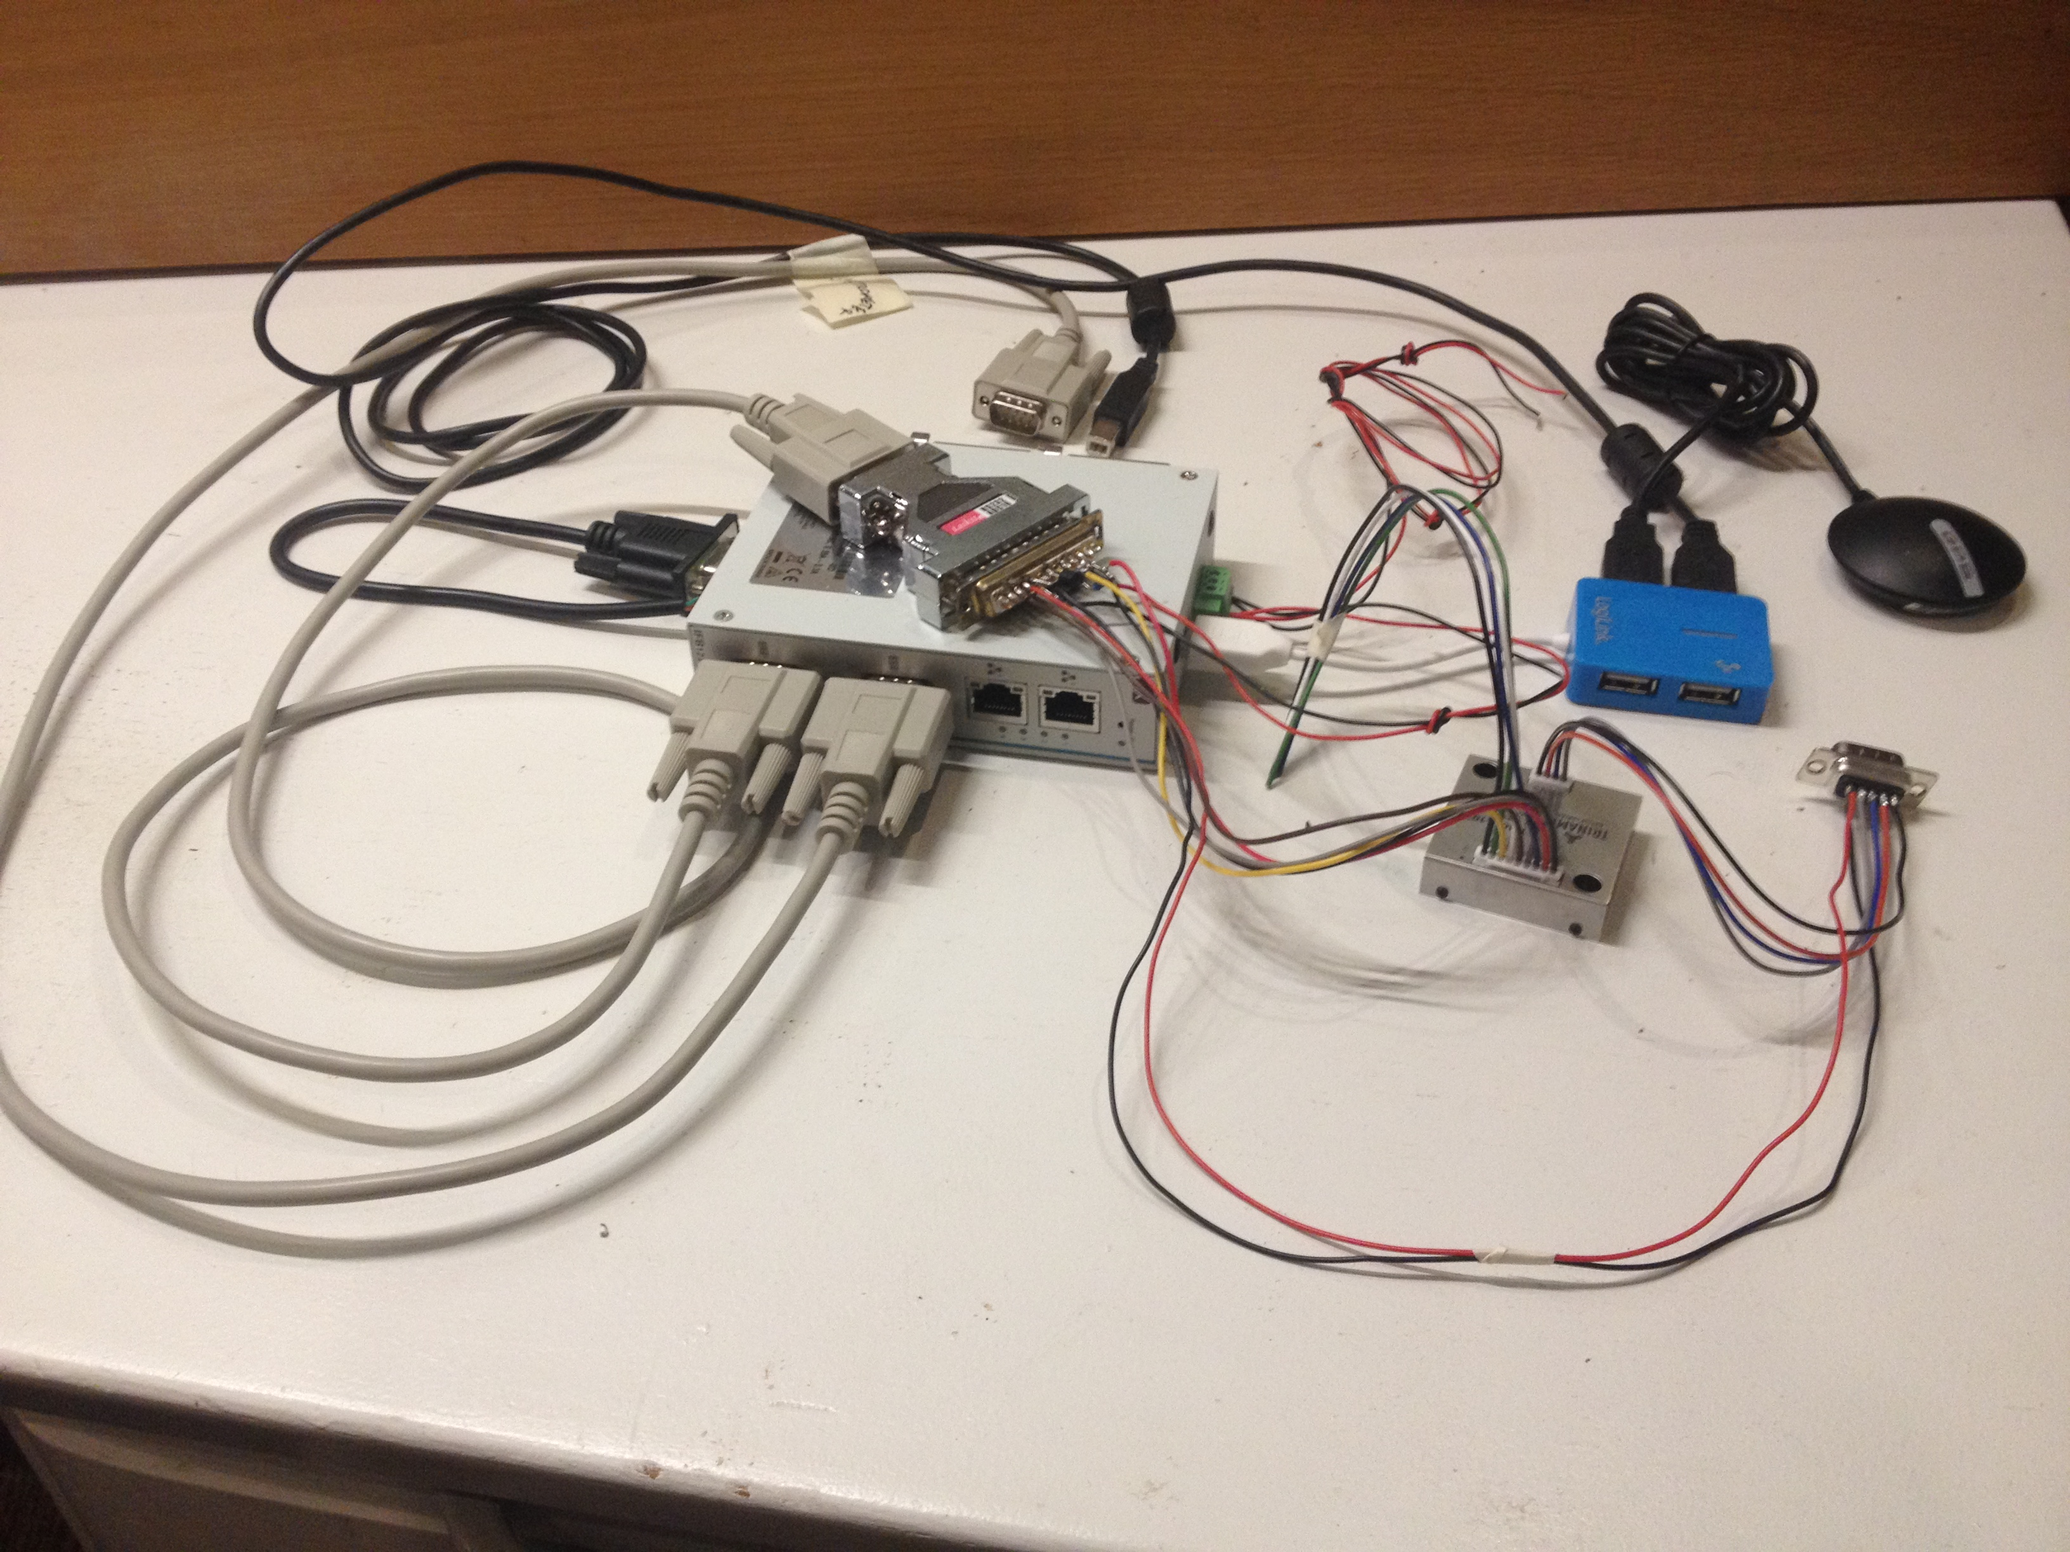
Connect the GPS to any output on the USB-hub.
Connect the 4 pin and the 9 -pin cables from the cable kit to the motorcontroller.
Connect the DSUB25 connector to the Taskit ADC16.

Soldering connections to the DSUB25

Solder the center pin (output on the MCP9701A) to pin 7 (A0 input)
Solder pin 3 (GND) on MCP9701A to pin 11 (AGND)
Solder pin 1 (VDD) on MCP9701A to pin 5 (D7 digital input/output)
Solder 180 Kohm resistor between pin 24 (Vin) and pin 21 (A3 analog input)
Solder 20 Kohm resistor between pin 21 and 18 (GND).
Solder 2 wires to pin 24 and 18 (preferrably black and red). Connect the other ends to the power connector on the Axiomtek computer. These wires provide power to the Taskit ADC16.
Connect pin 5 on the 9 pin DSUB to pin 4 on DSUB25 (D5 digital input/output)
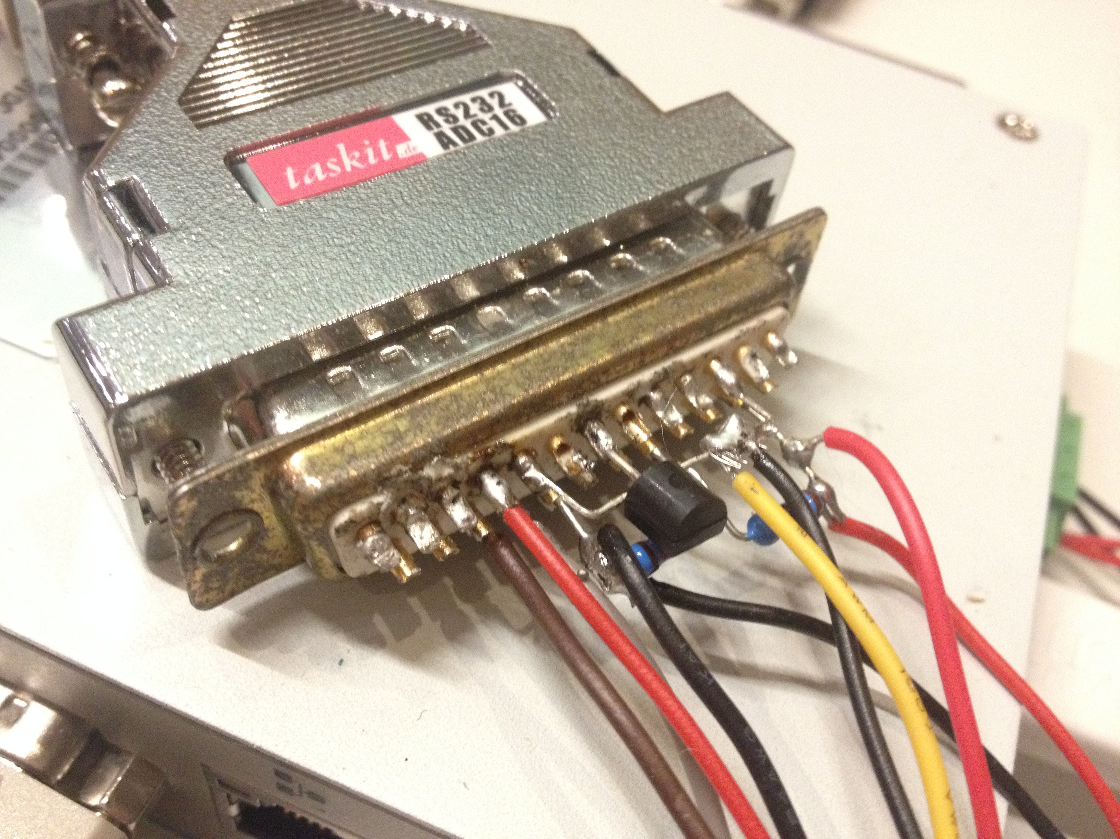
Connect pin 9 on the 9 pin DSUB to pin 11 on DSUB 25 (AGND).

Motor controller
Connect yellow cable (COMM) from motor controller to pin 11 (AGND) on DSUB25.
Connect brown cable (EN) to pin 16 (D4 digital input/output)
Connect grey cable (STEP) to pin 17 (D6 digital input/output)
Connect red cable (V+) to pin 24 (VIN)
Connect black cable (GND) to pin 18 (GND)
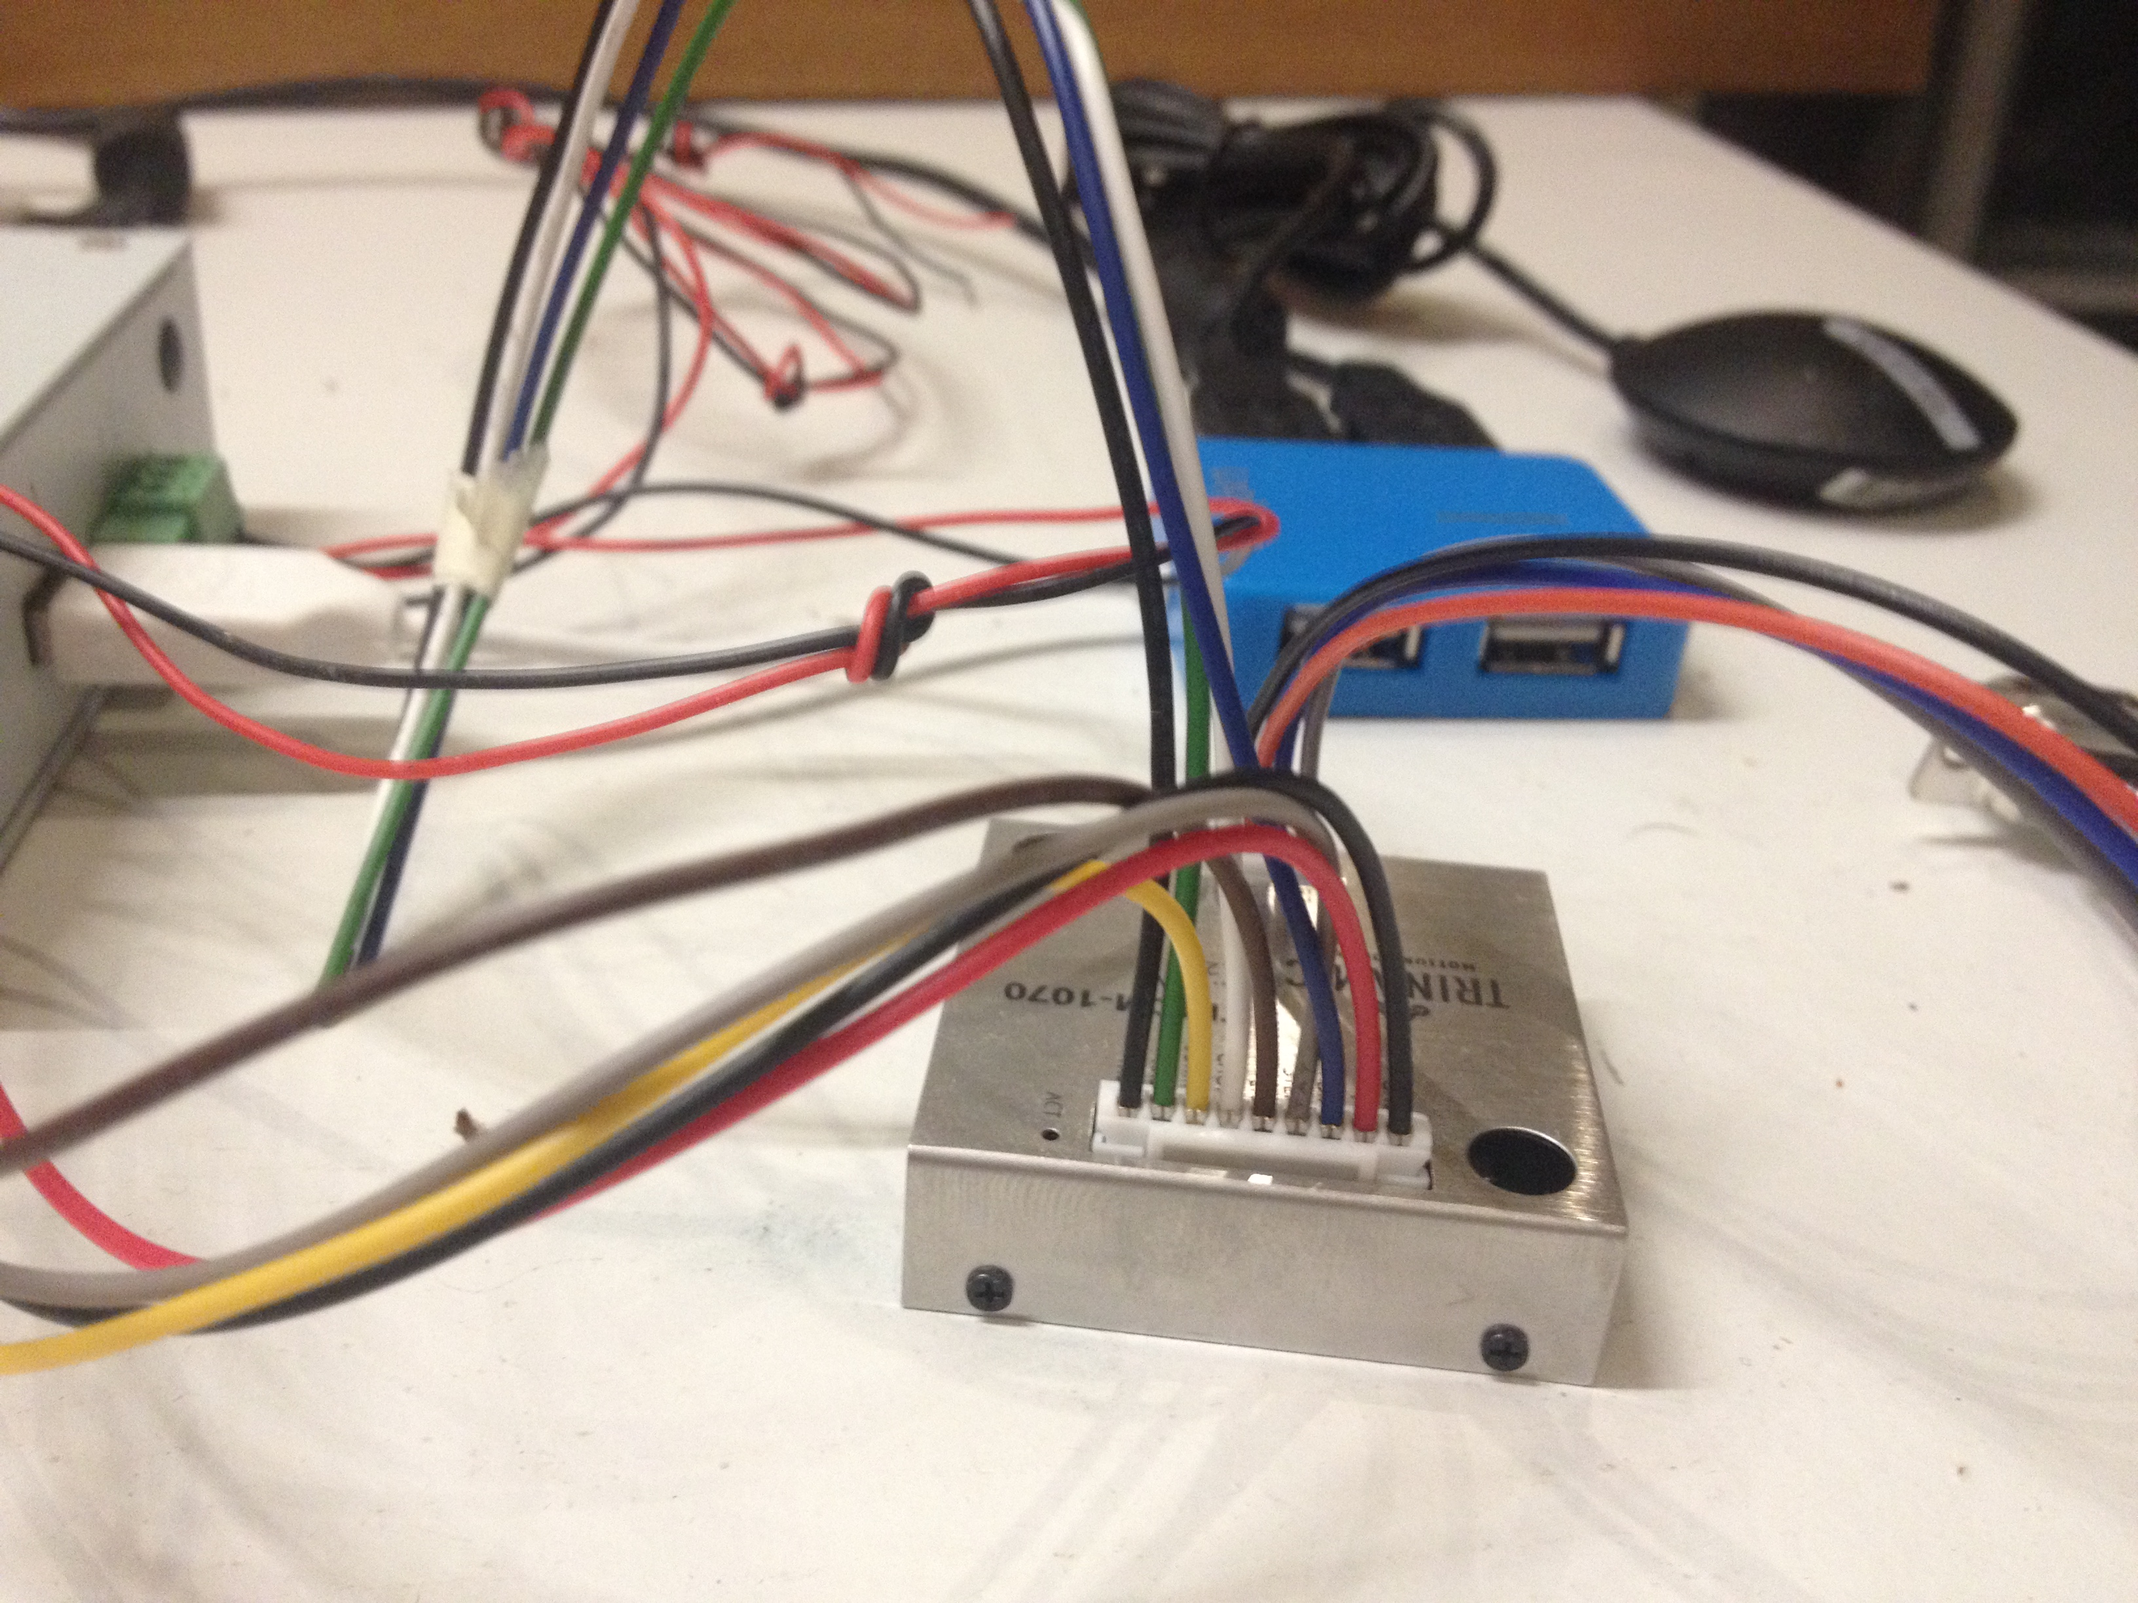

Motor controller to motor
The motor is connected to the 9 pin male DSUB and is compatible with the old system.
Connect black cable (A1) from motor controller to pin 1 on DSUB9.
Connect red cable (A2) from motor controller to pin 2 on DSUB9.
Connect blue cable (B1) from motor controller to pin 3 on DSUB9.
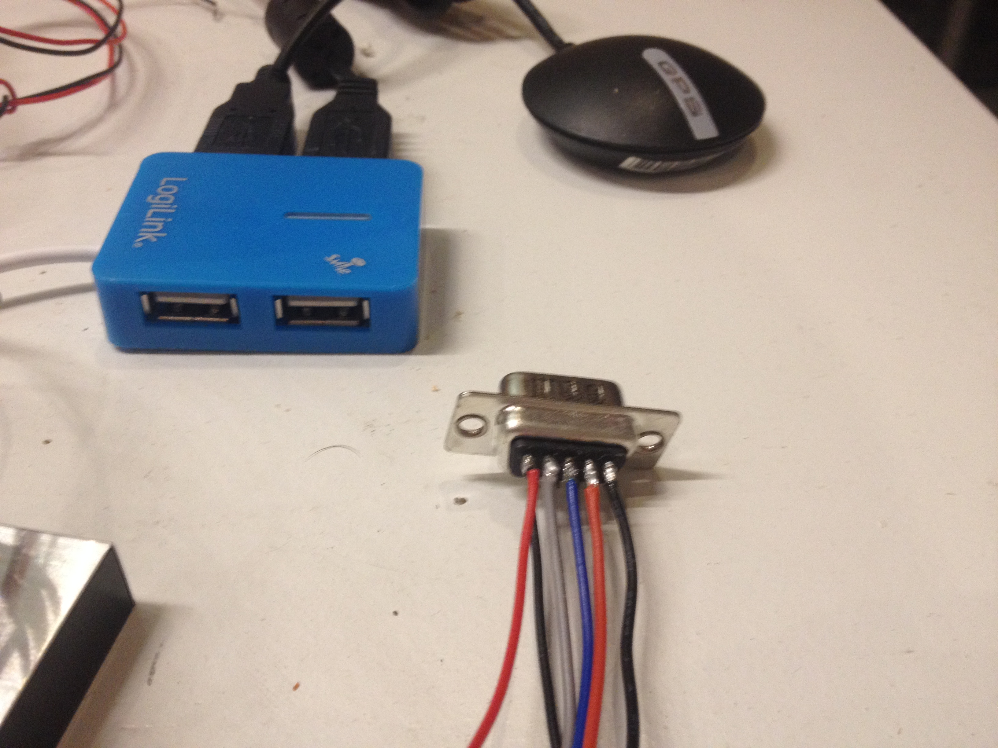
Connect grey cable (B2) from motor controller to pin 4 on DSUB9.

Power
Power is applied to the PWR connector on the Axiomtek computer. Any voltage between 9 and 15V will work. At start 200 mA will be consumed by the system. When running motor 300 mA is consumed.

Installing the Axiomtek computer
The computer is administered using ssh or serial port terminal (115200 baud 8 bits no parity, no flow control). Telnet is not supported. Filetransfer using ftp and scp is supported.

The first ethernet port is default setup for dynamic IP address, i.e. it lets the switch it is connected to decide the IP number. The second ethernet port is default setup to have IP number 192.168.0.254.
When fresh from factory use login as user root and no password.
Upload the file install181014.tar to /home/root using ftp or scp.
Log in to the computer as root and execute the command:
tar -xvf install190111.tar
cd install190111
./runme.sh
This will install everything. Enter the command reboot or power-cycle the computer.
After the computer has restarted it is possible to log in to the computer with username novac and password 1225.
When the computer starts again, the kongo program will automatically start. It will move the motor until the reference switch is found and then retrieves GPS information and start measurements.
Position the GPS so that it receives signal from satellites.
Log into the computer and Display the output from kongo with the showlog command (nolog to turn off).
Wait until the program has eastablished time and date from the GPS. Then execute the following command:
hwclock -w
This will store the time to the bettery backed up RTC clock.
Now the installation is finished.

MICROSTEPS=
The Trinamic motor controller is from factory configured to use 16 microsteps for each normal step. This can be changed by a special configuration program provided for free from Trinamic. In order to avoid such time consuming procedures at installation, the new system default uses 16 microsteps. Thus, for each normal step, 16 pulses are generated to the STEP signal. In case this behavior need to be changed it can be configured with a MICROSTEPS=1 parameter in the cfg.txt file. Note that the default value for this parameter is 16.

