A

Mini Project On

**RECOGNITION OF DIABETIC RETINOPATHY BASED ON TRANSFER LEARNING**

(Submitted in partial fulfillment of the requirements for the award of Degree)

BACHELOR OF TECHNOLOGY

In

COMPUTER SCIENCE AND ENGINEERING

By

M. RAVI TEJA (197R1A0587)

SK. IRFAN HASAN (197R1A05A7)

P.VAISHNAVI REDDY (197R1A05B5)

Under the Guidance of

## NAJEEMA AFRIN

(Associate Professor)

## DEPARTMENT OF COMPUTER SCIENCE AND ENGINEERING

**CMR TECHNICAL CAMPUS UGC AUTONOMOUS**

(Accredited by NAAC, NBA, Permanently Affiliated to JNTUH, Approved by AICTE, New Delhi) Recognized Under Section 2(f) & 12(B) of the UGCAct.1956, Kandlakoya (V), Medchal Road, Hyderabad-501401.

**2019-2023**

# ABSTRACT:

Diabetic retinopathy is a disease caused by uncontrolled chronic diabetes and it can cause complete blindness if not timely treated. Therefore early medical diagnosis of diabetic retinopathy and it medical cure is essential to prevent the severe side effects of diabetic retinopathy. Manual detection of diabetic retinopathy by ophthalmologist take plenty of time and patients need to suffer a lot at this time. An automated system can help detect diabetic retinopathy quickly and we can easily follow-up treatment to avoid further effects to the eye. This study proposes a machine learning method for extracting three features like exudates, hemorrhages, and micro aneurysms and classification using hybrid classifier which is a combination of support vector machine, k nearest neighbor, random forest, logistic regression, multilayer perceptron network. From the results of the experiments, the highest accuracy values 82%. Hybrid approach produced a precision score of 0.8119,Recall score of 0.8116 and f-measure score of 0.8028.

Keywords-Diabetic Retinopathy, KNN, SVM, Random Forest, Retinal Fundus Images.

# EXISTING SYSTEM:

Described a system for diabetic retinopathy grade classification based on fractal analysis and random forest using MESSIDOR dataset. Their system segmented the images, then computed the fractal dimensions as features. They failed to distinguish mild diabetic retinopathy to severe diabetic retinopathy. [Qomariah 2019] proffered an automated system for classification of Diabetic Retinopathy and normal retinal images using concurrent neural network (CNN) and support vector machine (SVM). Features comprised of exudates, Haemorrhage and Microaneurysm.

# DISADVANTAGES:

* They failed to distinguish mild diabetic retinopathy to severe diabetic retinopathy.
* Needed the Fractal analysis of dataset.

# PROPOSED SYSTEM:

We proposed system software in which it detects the disease according to the given input images of the eyes. The software checks the given input data with the system data and analyze the information whether the given image matches or not . If the image matches with the system data then it shows the stages of the diabetic retinopathy disease( i.e no disease, mild,moderate, severe) .Otherwise, it will show the there is no disease.

# ADVANTAGES:

* The system needs the Only Images of the eyes as input.
* Detects all stages of the disease (i. e, no disease, mild, moderate, severe).
* Displays the result in short interval.

# SYSTEM SPECIFICATIONS:

**SOFTWARE REQUIREMENTS:**

**Operating system** : Windows 11 .**Coding Language** : Python.**Front-End**  : Python console.

**HARDWARE REQUIREMENTS:**

**System** : Pentium IV 2.4 GHz. **Hard Disk** : 40 GB. **Floppy Drive** : 1.44 Mb. **Monitor**  : 14’ Colour Monitor. **Mouse**  : Optical Mouse. **Ram**  : 512 Mb.

# SYSTEM ARCHITECTURE:

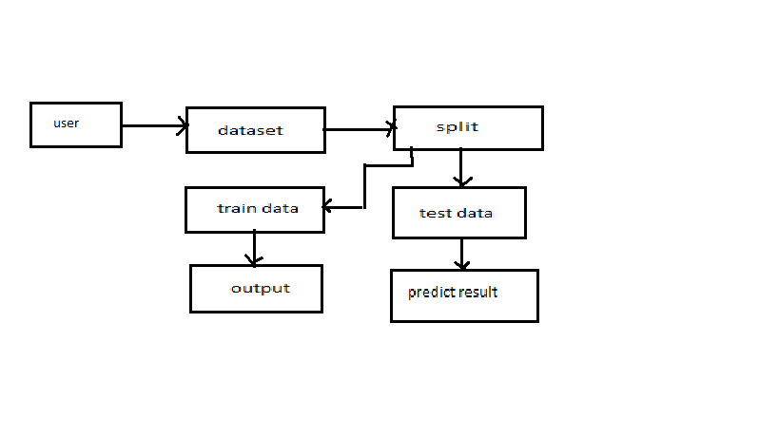

# FLOW CHART:

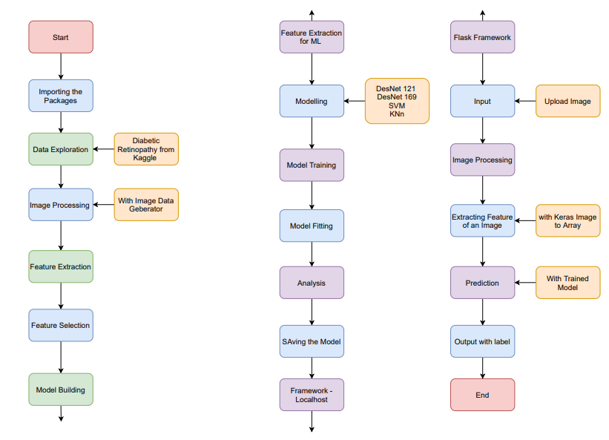

# CONCLUSION:

In this proposed method hemorrhages, exudates and micro-aneurysms are detected. For exudate detection green channel extraction, masking, smoothing, bitwise AND are done which results in better calculation and extraction of exudates. For detection of hemorrhages and microaneurysms, morphological operations are performed like opening. Dilation and erosion operators are performed here. For diabetic retinopathy detection, count the number for MA occurred, count the number of hemorrhages occurred and count the number of exudates occurred in the image so we can decide the condition of image. Then features are calculated and feed to both SVM, KNN, Random Forest classifier. Voting of three classifiers are chosen as final prediction . So from the extracted feature it directly concludes the disease grade as normal or abnormal. So earlier detection and diagnosis of diabetic retinopathy help the patients from blindness and also the severe effects of disease can be decreases.