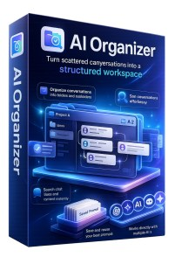

AI Organizer Setup Guide

Step-by-Step Installation & Activation Instructions
Important Note

Your License Key will be sent separately via email from browsx.com

Please check your inbox (and spam folder) for email from BrowsX.com

Step 1: Download the Extension

Download the AI Organizer extension ZIP file: https://www.mediafire.com/file_premium/04lzgctxnv8i012/AI_Organizer.zip/file

Step 2: Extract the ZIP File

Unzip the downloaded file on your computer to a location you can easily find.

Step 3: Install in Chrome

* Open Chrome, go to Extensions (chrome://extensions/) * Enable Developer Mode (toggle in top right corner)
* Click "Load unpacked"
* Select the extracted AI Organizer folder

Step 4: Login

Open the extension and sign in using:
* Your License Key (from the separate email) * Your purchase email address
* Your password

If you are not registered on https://browsx.com/, please register first.

Video Tutorial

Watch the step-by-step setup video here

Additional Resources

A complete AI Organizer User Guide PDF is also available for download on your ThankYou page.

Need Help?

Send an email to support@aibizapps.com

