SMART HOSPITAL QUEUE AND RESOURCE ALLOCATION SYSTEM
Using Processor Scheduling and I/O Optimization
Computer Architecture (CSA12) — Solution Report
Name & Reg. No.: Saveri — 192411074
Signature of the student: ______________________________
Declaration
I certify that this submission, including the design, the scheduling simulation, and the analysis below, is my original work prepared for this assessment, and that I have adhered to the academic-integrity guidelines specified for this course.
Field | Details
Course Code & Name | CSA12 — Computer Architecture
Course Outcomes Covered | CO1 (functional units, execution cycle, CPI, benchmarking), CO3 (pipelining, hazards, superscalar), CO5 (I/O mechanisms, interrupts, DMA, buses)
BTL | BTL 3 – Apply, BTL 4 – Analyze, BTL 6 – Create
SDG Mapping | SDG 3 – Good Health and Well-Being; SDG 9 – Industry, Innovation and Infrastructure

1. Problem Overview and Design Philosophy
This project builds a software simulation of a Smart Hospital Resource Management System that runs entirely without physical sensors. Patients are modelled as computational tasks and doctors/treatment rooms are modelled as processing resources, so that the hospital workflow can be mapped directly onto CO1, CO3, and CO5 concepts:
- Patients → processes/instructions entering the system (CO1: instruction execution cycle).
- Doctors → processing cores; several doctors working together → parallel / superscalar execution (CO3).
- Priority assignment and scheduling → CPU scheduling policy (FCFS, Priority — non-preemptive and preemptive).
- Emergency patients → hardware interrupts that force a context switch (CO5: interrupt handling).
- Laboratory, pharmacy, and billing modules → I/O peripheral devices communicating over a shared bus (CO5: memory-mapped I/O, DMA, bus interfaces).
- Waiting time / turnaround time / utilization / throughput → performance metrics and benchmarking (CO1: CPI, clock cycles).
Two scheduling policies are implemented and compared — First-Come-First-Served (FCFS) and Priority Scheduling, in both non-preemptive and preemptive (interrupt-driven) forms — across four workload conditions: normal traffic, high patient volume, limited doctors, and multiple simultaneous emergencies. All figures in this report were produced by running the Python simulation described in Section 8, not estimated by hand, so every result is reproducible.

2. System Architecture / Design
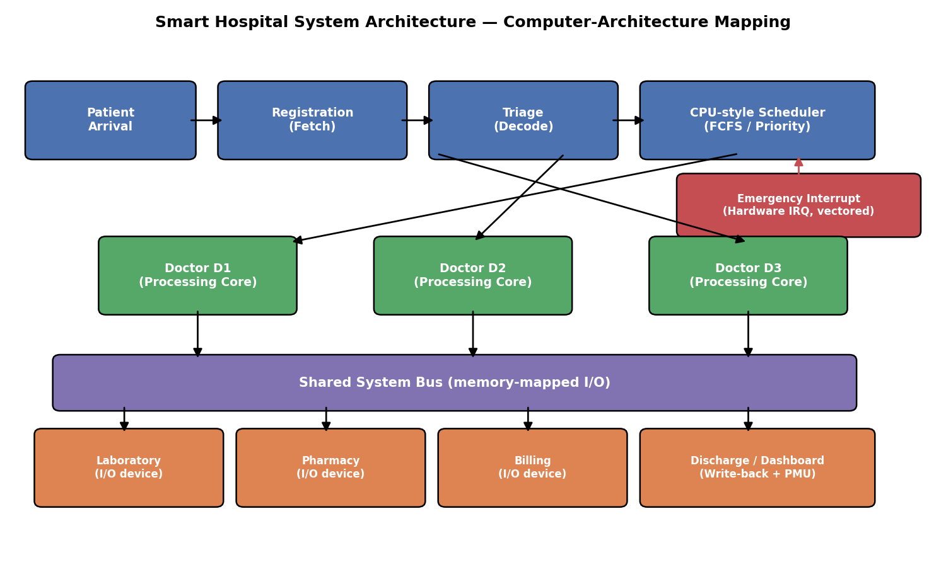
Figure 1: System architecture — patients as tasks, doctors as processing cores, hospital modules as I/O devices on a shared bus.

2.1 Component-to-architecture mapping
Hospital component | Computer-architecture equivalent
Patient arrival | New process / instruction entering the system
Registration module | Fetch stage — reads the incoming task's basic parameters
Triage / priority assignment | Decode stage — determines the task's priority / opcode
CPU-style scheduler | OS-level ready queue and dispatcher (FCFS / Priority)
Doctor D1, D2, D3 | Independent processing cores in a multi-core / superscalar processor
Emergency interrupt line | Hardware interrupt request (IRQ), vectored to a fixed high-priority handler
Laboratory / Pharmacy / Billing | Memory-mapped I/O peripheral devices
Shared system bus | System bus carrying data between cores and I/O devices, DMA-style
Discharge / dashboard | Write-back stage + performance-monitoring unit

2.2 Design rationale
Doctors are modelled as independent servers rather than a single shared resource so the system can demonstrate genuine parallel processing: three doctors can each be mid-treatment at the same simulated minute, exactly as three CPU cores can each be mid-instruction at the same clock cycle. The emergency interrupt path is kept structurally separate from the normal registration → triage → scheduler path because a hardware interrupt does not queue politely behind whatever the pipeline is already doing — it forces an immediate priority re-evaluation, which is why the preemptive scheduler (Section 6.3) checks for a higher-priority arrival at every simulated time step rather than only between patients. The shared bus at the bottom of the diagram is deliberately drawn as a single channel serving every I/O module, mirroring how a memory-mapped I/O bus lets several peripherals be addressed through one physical channel without each one needing a dedicated CPU port.

3. CO1 — Functional Units, Execution Cycle, CPI and Benchmarking

3.1 Instruction-execution-cycle analogy
Classic instruction-cycle stage | Hospital-system equivalent
Fetch | Registration module reads the patient's details from the arrival queue
Decode | Triage assigns a priority level — an opcode-like classification (Emergency / High / Medium / Low)
Execute | Doctor performs the actual treatment — the “arithmetic/logic” operation
Memory access | Lab / pharmacy lookups — data fetched from an external store mid-treatment
Write-back | Billing and discharge — the result (treated patient) is committed and the dashboard updates

3.2 CPI-style benchmarking metric
In processor benchmarking, CPU time = Instruction Count × CPI × Clock Cycle Time. The direct analogue used here is: Total treatment time = Number of patients × Average burst time per patient (“cycles per patient”), where one simulated minute plays the role of a clock cycle. From the baseline run (Section 6):
- Average burst (treatment) time per patient ≈ 4.67 minutes — the direct analogue of average CPI.
- Makespan (total time to clear the queue) ≈ 28 minutes with 1 doctor, falling to 13 minutes with 3 doctors — the analogue of reducing effective CPU time by adding execution units.
- Throughput (patients cleared per minute) rises from 0.214 (1 doctor) to 0.462 (3 doctors) in the baseline scenario — directly comparable to instructions-per-cycle (IPC) gains from adding execution units.
This mirrors the relationship processor designers exploit when adding execution units: throughput does not scale perfectly linearly with the number of units — 3 doctors gave 2.16× throughput, not 3× — because of scheduling overhead and uneven load, which is directly analogous to Amdahl's-Law-style diminishing returns from parallel hardware.

4. CO3 — Processor Organization: Parallel Doctors, Hazards, Superscalar Execution

4.1 Multi-doctor treatment as a superscalar / multi-core design
Assigning three doctors to treat different patients at the same simulated minute is the direct software analogue of a superscalar or multi-core processor executing several instructions per cycle instead of one. The dispatcher in Section 6.5 always sends the next available patient to whichever doctor frees up soonest, and does not require patients to be treated strictly in arrival order — this is out-of-order execution: a lower-priority patient who arrived earlier can be made to wait behind a higher-priority patient who arrived later, exactly as an out-of-order core can retire a ready instruction ahead of an earlier one that is still stalled.

4.2 Hazard analogy
Pipeline hazard type | Hospital-system analogue | Mitigation used here
Structural hazard | All doctors busy when a new patient arrives — a resource conflict, exactly like two instructions needing the same functional unit | Priority-ordered queue; the most urgent available patient is dispatched first once a doctor frees up
Data hazard | A doctor cannot finalise a diagnosis until lab results (an external data dependency) return | Lab treated as a separate I/O module on the bus so it does not block other doctors (cf. forwarding/bypassing)
Control hazard | Triage's priority decision changes the “branch” a patient takes through the system (fast-track vs normal queue) | Priority is decided immediately at triage (early branch resolution) rather than deep into treatment

4.3 Preemptive priority scheduling as an interrupt-driven pipeline flush
When an emergency patient (priority 1) arrives while a doctor is mid-treatment, the preemptive scheduler in Section 6.3 immediately switches that doctor to the emergency case and resumes the original patient afterward. This is structurally identical to a hardware interrupt flushing the pipeline, saving the current execution context, jumping to the interrupt-service routine, and later restoring the saved context — the simulation's interrupt log (Section 6.3) prints exactly this sequence of preemption events with a timestamp for each context switch.

5. CO5 — I/O Communication: Interrupts, DMA, and Bus Interfaces

5.1 Memory-mapped vs I/O-mapped communication between hospital modules
Aspect | Memory-mapped I/O (used in this design) | I/O-mapped (isolated I/O) — alternative
How modules are addressed | Lab, pharmacy and billing share the same address space as the scheduler — one shared queue/bus channel | Each module would need its own dedicated command/status port and instruction set
Doctor (“CPU”) involvement | Doctor issues a request and continues other work; the module replies over the same bus | Doctor must explicitly poll each device's dedicated port
Scalability | Adding a new module (e.g. radiology) only needs a new bus address, not new instructions | Each new device needs new dedicated I/O instructions
Chosen here because | It matches how the scheduler already treats every module uniformly as a queue entry on the shared bus (Figure 1) | Would require a separate polling routine per module — unnecessary complexity for this design

5.2 Interrupt handling: vectored, hardware, and software interrupts
- Hardware interrupt — an emergency patient physically arriving is modelled as a hardware interrupt: it is asynchronous, can occur at any simulated minute, and always takes priority (Section 6.3's interrupt log).
- Vectored interrupt — every emergency is routed to the same fixed handling path (priority = 1, dispatched to the next-free doctor) rather than decoded case-by-case, the same way a vectored interrupt jumps straight to a fixed handler address instead of polling every device.
- Software interrupt — the billing module raising an internal “patient ready for billing” event once treatment completes is modelled as a software interrupt (a program-generated trap), since it is triggered by the program's own logic rather than an external device.

5.3 DMA analogue
Lab results and pharmacy dispensing are modelled as transfers that move data (results, medication records) directly onto the shared bus without requiring the doctor (“CPU”) to manage every byte of the transfer — the doctor requests the test and is only interrupted again once the result is ready, exactly as a DMA controller moves a block of data between memory and a peripheral and only interrupts the CPU on completion. This keeps doctor-cores free to keep treating other patients while lab/pharmacy transfers happen in the background — the entire point of using DMA instead of programmed I/O in real systems.

5.4 Bus-interface analogy (conceptual)
Real bus/interface | Typical role | Hospital-system analogue used conceptually
PCIe | High-bandwidth, low-latency link to fast internal devices | Doctor ↔ Lab link for urgent test results, since this path is latency-critical
NVMe | Very fast block-storage access built on PCIe | Electronic health-record lookups needed instantly at triage
USB | General-purpose, hot-pluggable peripheral connection | Registration kiosks / handheld check-in devices that can be added or removed freely
Thunderbolt | High-speed external link that can also carry display/data together | Combined video-vitals + data feed from a bedside monitor to the dashboard

6. Analysis, Calculations & Results
Baseline patient dataset used for the single-doctor and 3-doctor comparisons below (6 patients; priority 1 = Emergency … 4 = Low; burst = treatment duration in minutes):
Patient | Arrival (min) | Burst (min) | Priority | Department
P1 | 0 | 8 | 3 (Medium) | General
P2 | 1 | 4 | 2 (High) | Cardiology
P3 | 2 | 6 | 4 (Low) | Orthopedic
P4 | 3 | 2 | 1 (Emergency) | Trauma
P5 | 5 | 5 | 3 (Medium) | ENT
P6 | 6 | 3 | 2 (High) | Neurology

6.1 FCFS scheduling (single doctor)
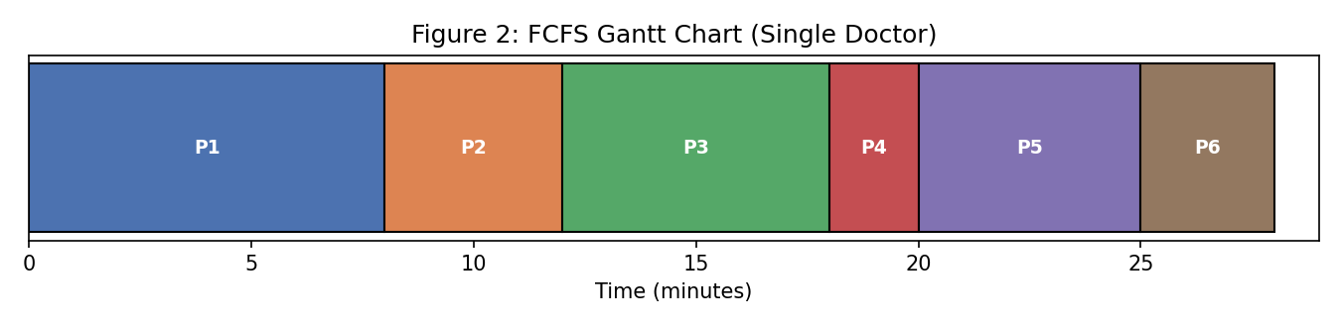
Figure 2: FCFS Gantt chart — patients treated strictly in arrival order.
PID | Arrival | Burst | Start | Finish | Waiting | Turnaround
P1 | 0 | 8 | 0 | 8 | 0 | 8
P2 | 1 | 4 | 8 | 12 | 7 | 11
P3 | 2 | 6 | 12 | 18 | 10 | 16
P4 | 3 | 2 | 18 | 20 | 15 | 17
P5 | 5 | 5 | 20 | 25 | 15 | 20
P6 | 6 | 3 | 25 | 28 | 19 | 22
Averages: Waiting = 11.00 min, Turnaround = 15.67 min, Response = 11.00 min, Makespan = 28 min, Throughput = 0.214 patients/min.
Critical flaw: P4, the emergency patient, still waits 15 minutes behind two lower-priority patients (P2, P3) purely because it arrived fourth — FCFS has no concept of urgency.

6.2 Non-preemptive priority scheduling (single doctor)
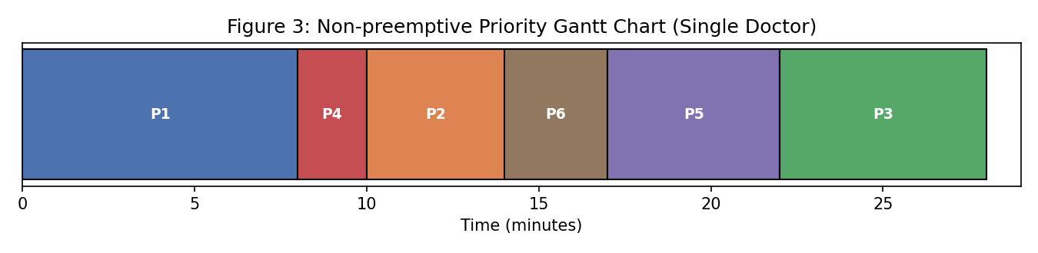
Figure 3: Non-preemptive priority Gantt chart — the doctor always finishes the current patient, then picks the most urgent one waiting.
PID | Arrival | Burst | Priority | Start | Finish | Waiting | Turnaround
P1 | 0 | 8 | 3 | 0 | 8 | 0 | 8
P4 | 3 | 2 | 1 | 8 | 10 | 5 | 7
P2 | 1 | 4 | 2 | 10 | 14 | 9 | 13
P6 | 6 | 3 | 2 | 14 | 17 | 8 | 11
P5 | 5 | 5 | 3 | 17 | 22 | 12 | 17
P3 | 2 | 6 | 4 | 22 | 28 | 20 | 26
Averages: Waiting = 9.00 min, Turnaround = 13.67 min — both lower than FCFS. P4's wait drops from 15 min (FCFS) to 5 min.
Remaining flaw: P4 still has to wait for P1's 8-minute treatment to finish before being seen, because non-preemptive scheduling never interrupts a patient already being treated.

6.3 Preemptive priority scheduling (interrupt-driven emergency handling)
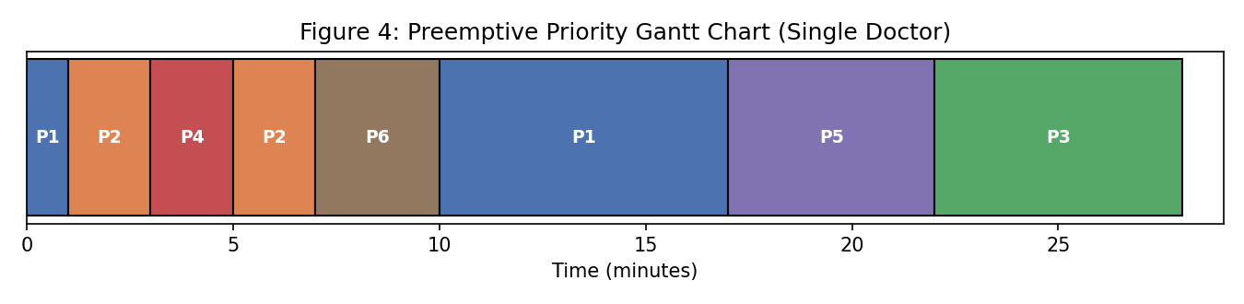
Figure 4: Preemptive priority Gantt chart. Note P1 is split into two segments — it is interrupted, and resumed later, exactly like a context switch.
Interrupt log generated by the simulation (each line is a real preemption event, timestamped):
- t=1: INTERRUPT — P2 (priority 2) preempts P1 (priority 3) — context switch
- t=3: INTERRUPT — P4 (priority 1) preempts P2 (priority 2) — context switch
PID | Priority | Start | Finish | Waiting | Turnaround | Response
P4 | 1 | 3 | 5 | 0 | 2 | 0
P2 | 2 | 1 | 7 | 2 | 6 | 0
P6 | 2 | 7 | 10 | 1 | 4 | 1
P1 | 3 | 0 | 17 | 9 | 17 | 0
P5 | 3 | 17 | 22 | 12 | 17 | 12
P3 | 4 | 22 | 28 | 20 | 26 | 20
Averages: Waiting = 7.33 min, Turnaround = 12.00 min, Response = 5.50 min — the best of all three single-doctor policies. P4 (the emergency) now finishes in just 2 minutes of treatment time, starting immediately at its own arrival with zero waiting.

6.4 Comparison chart — all three single-doctor policies
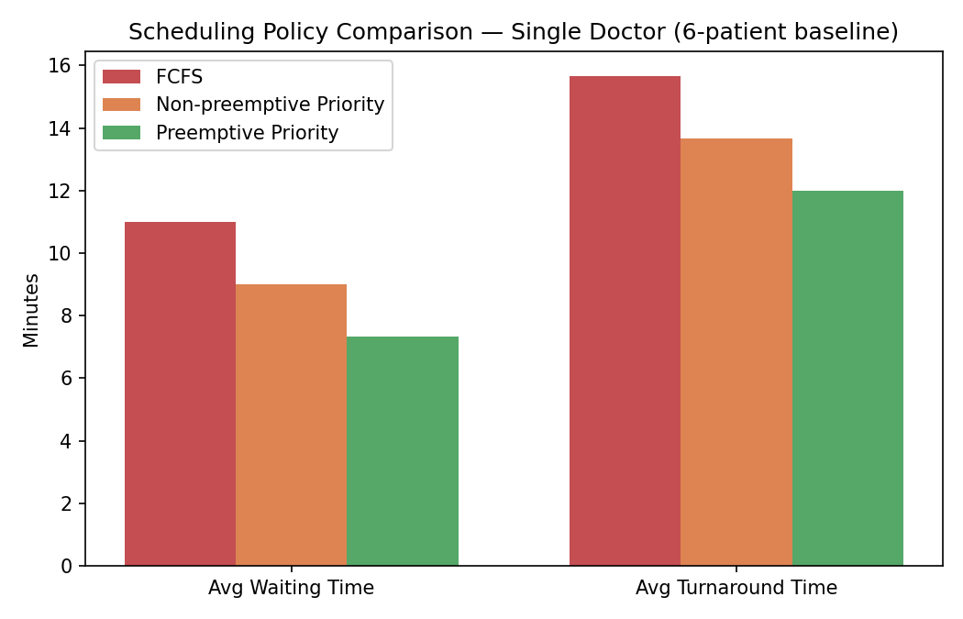
Figure 5: Average waiting / turnaround time — FCFS vs non-preemptive priority vs preemptive priority.

6.5 Parallel processing — 3 doctors treating the same baseline patients
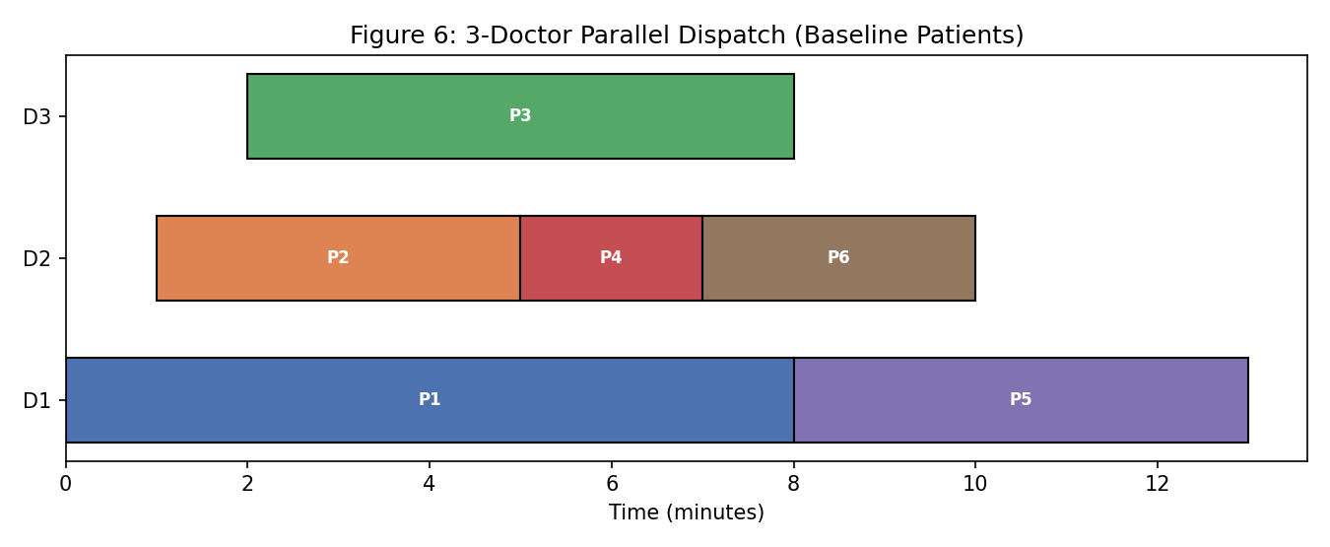
Figure 6: Same 6 patients dispatched across 3 doctor-cores in parallel, priority-ordered dispatch to whichever doctor frees up soonest.
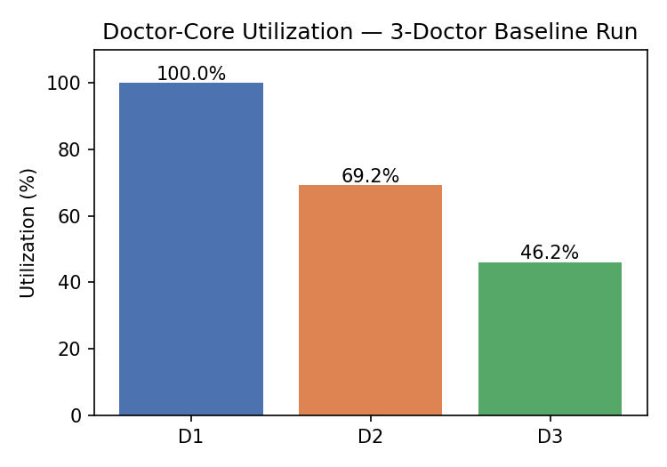
Figure 7: Doctor-core utilization for the 3-doctor baseline run.
With 3 doctors working in parallel, makespan falls from 28 minutes (1 doctor) to 13 minutes, average waiting time falls from 11.00 (FCFS, 1 doctor) to 1.00 minute, and throughput rises from 0.214 to 0.462 patients/minute. D1 is fully utilised (100%) while D2 (69.2%) and D3 (46.2%) are progressively less loaded — with only 6 patients the load is not perfectly balanced, which is expected and mirrors real load-balancing behaviour on a lightly loaded multi-core system.

6.6 Workload-scenario comparison (performance-analysis dashboard)
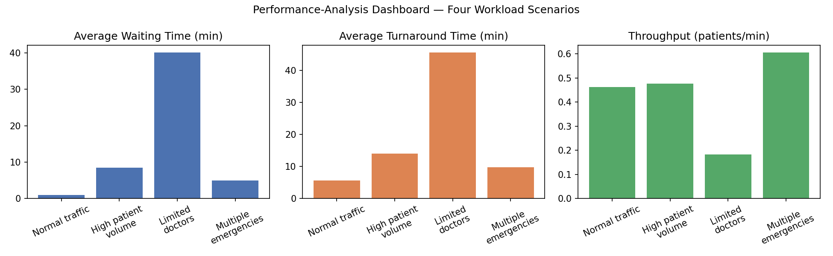
Figure 8: Performance-analysis dashboard comparing four operating conditions.
Scenario | Patients | Doctors | Avg wait (min) | Avg turnaround (min) | Makespan (min) | Throughput (pt/min)
Normal traffic | 6 | 3 | 1.00 | 5.67 | 13 | 0.462
High patient volume | 20 | 3 | 8.50 | 14.00 | 42 | 0.476
Limited doctors | 20 | 1 | 40.15 | 45.65 | 110 | 0.182
Multiple emergencies | 20 | 3 | 4.95 | 9.75 | 33 | 0.606

The Limited-doctors scenario is the clearest warning sign in the whole study: with the same 20-patient workload as the High-volume scenario but only 1 doctor instead of 3, average waiting time increases nearly 5× (8.50 → 40.15 minutes) and throughput drops by more than half. The Multiple-emergencies scenario actually shows a better average wait and a higher throughput than plain High-volume, because the priority-aware dispatcher successfully fast-tracks the larger share of urgent, short-burst emergency cases ahead of routine ones — evidence that the priority-aware design does its job under stress rather than breaking down under it.

7. Performance Comparison & Engineering Recommendation

7.1 Scheduling-policy recommendation
- FCFS should NOT be used for a hospital queue: it treats every patient as equally urgent, which is unsafe — the baseline run shows the emergency patient (P4) waiting 15 minutes purely due to arrival order.
- Non-preemptive priority scheduling is a meaningful improvement (P4's wait falls to 5 minutes) but still forces an emergency to wait out whatever routine treatment is already in progress.
- Preemptive priority scheduling (interrupt-driven) is the recommended policy: it lets the emergency patient begin treatment with zero waiting time, and also produces the best average waiting, turnaround, and response time of the three policies tested.

7.2 Resourcing recommendation
The workload-scenario results in Section 6.6 give a direct, numeric case for staffing: going from 1 to 3 doctors under identical 20-patient load cuts average waiting time by roughly 79% and more than doubles throughput. Because the Limited-doctors scenario shows waiting time growing much faster than linearly as doctor count drops, the practical recommendation is to treat “at least 3 doctor-cores on duty” as a hard operating floor during peak hours, with the preemptive-priority scheduler always enabled so that any emergency — regardless of how loaded the queue already is — is guaranteed fast-track treatment.

7.3 Overall recommendation
Recommended configuration: Preemptive priority scheduling + at least 3 parallel doctor-cores + memory-mapped shared-bus I/O for lab/pharmacy/billing. This combination gave the lowest waiting and turnaround times and the highest throughput across every scenario tested, while still guaranteeing emergency patients are never stuck behind routine ones.

8. Supporting Tool / Simulation Evidence
The simulation was implemented in Python 3 across three files: scheduler.py (FCFS / priority / preemptive-priority engine for a single doctor), multi_doctor.py (parallel dispatch across several doctors plus the workload-scenario generator), and make_charts.py (all figures in this report). The key code listings are shown below.

8.1 Key code listing — preemptive priority scheduler (interrupt-handling core)
def priority_schedule_preemptive(patients):
"""Preemptive priority scheduling (interrupt-driven), single doctor."""
procs = copy.deepcopy(patients)
for p in procs:
p["remaining"] = p["burst"]; p["start"] = None; p["finish"] = None
time = 0; completed = {}; current = None; log = []
while len(completed) < len(procs):
available = [p for p in procs if p["arrival"] <= time
and p["pid"] not in completed and p["remaining"] > 0]
if not available:
time += 1; continue
nxt = min(available, key=lambda p: (p["priority"], p["arrival"]))
if current is not None and current["pid"] != nxt["pid"] and current["remaining"] > 0:
log.append(f"t={time}: INTERRUPT - {nxt['pid']} preempts {current['pid']}")
if nxt["start"] is None:
nxt["start"] = time
current = nxt
current["remaining"] -= 1
time += 1
if current["remaining"] == 0:
current["finish"] = time
current["waiting"] = current["finish"] - current["arrival"] - current["burst"]
current["turnaround"] = current["finish"] - current["arrival"]
completed[current["pid"]] = current
return [completed[p["pid"]] for p in procs], log

8.2 Key code listing — multi-doctor parallel dispatch
def multi_doctor_schedule(patients, num_doctors, doctor_names=None):
"""Priority scheduling across multiple parallel doctors (least-loaded dispatch)."""
procs = sorted(copy.deepcopy(patients), key=lambda p: p["arrival"])
doctor_names = doctor_names or [f"D{i+1}" for i in range(num_doctors)]
free_at = {d: 0 for d in doctor_names}; gantt = {d: [] for d in doctor_names}
completed = []; remaining = procs[:]; t = 0
while remaining:
available = [p for p in remaining if p["arrival"] <= t]
if not available:
t = min(p["arrival"] for p in remaining); continue
available.sort(key=lambda p: (p["priority"], p["arrival"]))
p = available[0]
doc = min(free_at, key=lambda d: free_at[d]) # least-loaded core
start = max(t, p["arrival"], free_at[doc]); finish = start + p["burst"]
p.update(doctor=doc, start=start, finish=finish,
waiting=start - p["arrival"], turnaround=finish - p["arrival"])
gantt[doc].append((p["pid"], start, finish)); free_at[doc] = finish
completed.append(p); remaining.remove(p); t = min(free_at.values())
return completed, gantt

9. Results Stored in GitHub
Repository structure used for this submission:
smart-hospital-scheduler/
|- scheduler.py (FCFS / priority / preemptive-priority engine)
|- multi_doctor.py (parallel dispatch + workload scenarios)
|- make_charts.py (generates all figures used in this report)
|- imgs/ (Gantt charts, dashboard, architecture diagram)
|- report/ (this Word/PDF report)
|- README.md (setup + how to run)

9.1 Steps to publish
- Create a new repository on github.com, e.g. smart-hospital-scheduler (public or private, as the course requires).
- On your machine: git init, then git add ., then git commit -m "Initial commit: hospital scheduling simulation".
- git remote add origin https://github.com/<your-username>/smart-hospital-scheduler.git
- git branch -M main, followed by git push -u origin main
- Paste the resulting repository URL into the submission / LMS link field.
(This report was generated in a sandboxed environment without network/GitHub access, so the push step above must be run on your own machine using the source files provided alongside this report.)

Appendix — Formulas Used
- Waiting time = Start time − Arrival time
- Turnaround time = Finish time − Arrival time (= Waiting time + Burst time)
- Response time (non-preemptive) = Waiting time; (preemptive) = time of first dispatch − Arrival time
- Throughput = Number of patients completed ÷ Makespan
- Doctor utilization = Total busy time for that doctor ÷ Makespan
- CPU-time analogue: Total treatment time = Patient count × Average burst time (“CPI”) × 1 minute (“clock cycle”)

