R Assignment 4: Creating Phylogenetic Trees using Genbank data

#### Motivation

Add section…

#### Prerequisites

Before starting this week’s tutorial you will have:

1. completed some pre-assignment reading on DNA barcoding, multiple sequence alignment, phylogenetics, and their role in plant taxonomy,
2. completed some pre-assignment reading on why/how Genbank is used by plant taxonomists,
3. navigated through the Genbank website and understand what it is and why it exists.
4. **MB** Get students to read (for example, something like) Majure et al (2012), Am. J. Bot. if we end up using *Opuntia* as an example…

#### Outcomes

By the end of this tutorial you will have:

1. experience using Genbank, CLUSTAL, and the most common phylogenetics packages in R
2. familiarity with Genbank and the types of data that can be obtained,
3. the tools and knowledge needed to create your own phylogenetic tree as part of a taxonomic research programme,
4. …more

#### Activity 1: Downloading, Aligning, and Graphing DNA Sequences from Genbank

In previous Assignments we familiarized ourselves with GBIF, R, RStudio Cloud, and the R packages that allow us to connect to databases. Today, we’ll learn how to use our newfound R skills to download and align nucleotide sequences from [GenBank](https://www.ncbi.nlm.nih.gov/nuccore), a repository of DNA sequences hosted by the National Center for Biotechnology Information (NCBI). We’ll then use the aligned sequences to create a phylogenetic tree that will organize species based on their relatedness.

In this lab, we’ll explore further the genus *Opuntia*:

*Opuntia basilaris* (Mojave, Colorado, Utah) *Opuntia fragilis* (Northwestern) *Opuntia humifusa* (Eastern) *Opuntia oricola* (Coastal sage and chaparral of S. California) *Opuntia polyacantha* (Great Plains, foothills of Rocky Mtns)

**MB** Could add in some natural history background to better motivate this activity.

Open this week’s .R file (‘324_Phylogenetics.R’) and navigate to the source pane. Install and attach the necessary packages using install.packages() and library(). By highlighting and running lines 38-111, we can run the script that searches Genbank for *matK* and *rbcL* sequences from our five *Opuntia* species.

Selecting and running lines 120-167 will generate three phylogenetic trees. The first tree illustrates the relationships between species based only on the nucleotide sequences of the *matK* gene. The second tree does the same thing, but for the *rbcL* gene. The third tree considers both sequences. Since this tree has the most information, it is often considered a better estimate of the true relationships between species.

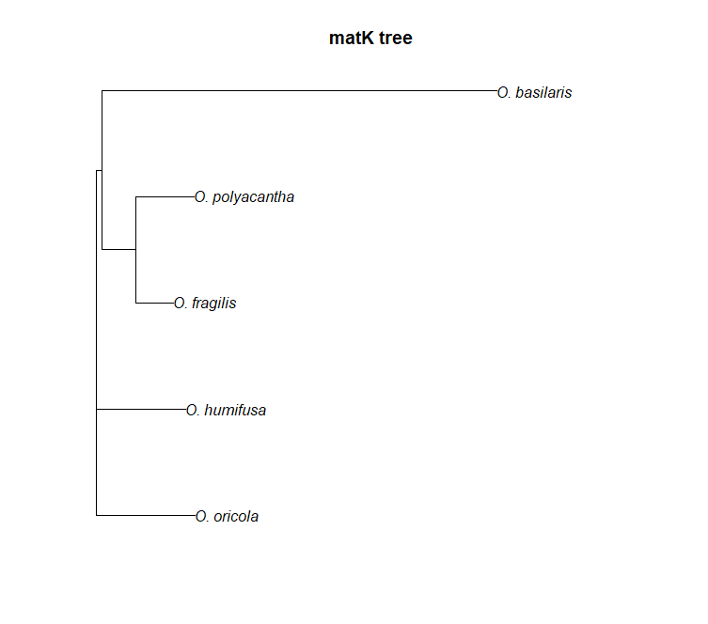

Figure 1: Phylogenetic tree for *Opuntia* constructed from aligned *matK* sequences.

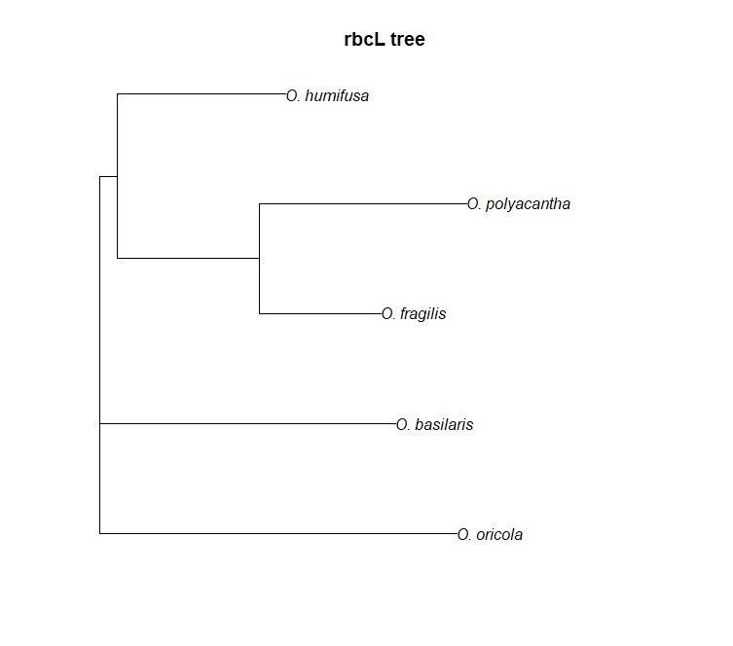

Figure 2: Phylogenetic tree for *Opuntia* constructed from aligned *rbcL* sequences.

**MB** Could add in some discussion here about why different genes produce different trees.

#### Activity 2: Dechyphering some code

Let’s step through the script in order to understand what is happening here.

**Lines 14-18**: The library() function loads various packages designed specifically for connecting with the Genbank database (ape), filtering and organizing our data (tidyverse), aligning sequences (msa), concatenating sequences (seqinr), and constructing phylogenetic trees (ape).

**Lines 38-40**: The c() concatenates the elements specified inside the brackets () into an object. For example, the species object contains five elements - each one is the name of an *Opuntia* species that we are interested in. The matK_acc object contains the Genbank accession numbers for each species. These were found by searching Genbank like so:

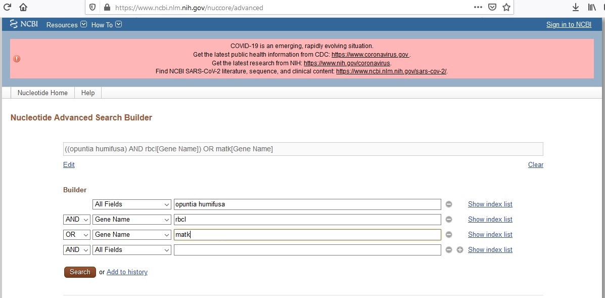

Figure 3: Searching Genbank for accession numbers.

**Line 42**: From our three objects created above, we will merge them together into a dataframe. The purpose of this dataframe is to keep our accession numbers and species names organized - it will come in handy later!

function searches GBIF for taxon IDs associated with your search query. The <- function stores the results in an object that we named group1_ids. By storing the results in an object we can later return to the object and inspect it, subset it, and feed it to other functions.

**Lines 50-56**: The read.Genbank() function searches Genbank for nucleotide sequences associated with our search query. In this case, we are giving read.Genbank() our accession numbers for the *matK* that we collected earlier.

**Line 59**: Because Genbank returns the nucleotide sequences with accession numbers, we want to re-name them with English names for easier reading later on.

**Lines 70-79**: Here, we’re collecting sequence information from Genbank, but for the *rbcL* gene.

**Lines 93-98**: Now that we have some DNA sequences, we need to align them. The msa() function takes our sequences and uses the CLUSTAL algorithm to make an optimal alignment (you could also do this by eye, but this becomes difficult with many sequences).

**Line 100**: The print() function allows us to inspect the alignment.

**Lines 103-111**: Here, we’ll go through the same alignment procedure for the *rbcL* sequences.

**Line 124**: In addition to constructing phylogenies for each gene separately, we’ll also construct a phylogeny using both sequences concatenated together. The paste0() function allows us to string the *matK* and *rbcL* sequences together.

**Lines 128-135**: With our concatenated sequences, we’ll re-align with CLUSTAL once more using the msa() function.

**Lines 148-150**: To construct a phylogeny, we first need to know how similar or dissimlar each species’ DNA sequence is from another. The dist.alignment() function calculates a ‘distance matrix’ that describes these similarities.

**Lines 154-156**: With our distance matrices, we can now construct a phylogenetic tree. The nj() function creates a certain type of tree called a ’neighbour joining tree`

**MB**: Perhaps need to explain this terminology (distance matrix, neighbour joining) in pre-assingment reading, or lectures.

**Line 159-161**: Now it’s time to plot our trees! The *matK* and *rbcL* trees were shown earlier, below is the consensus tree:

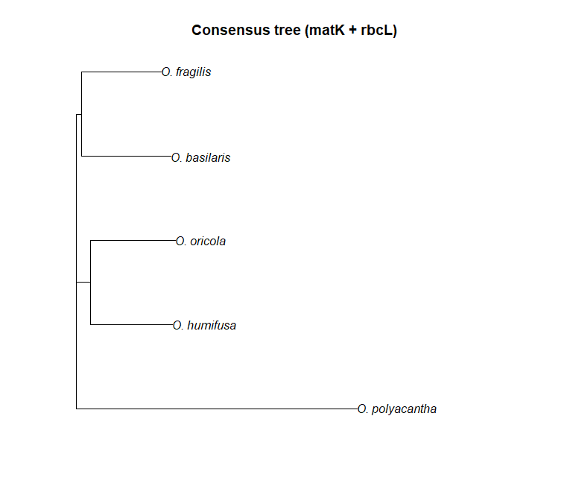

Figure 4: Phylogenetic tree for *Opuntia* constructed from concatenated and aligned *matK* and *rbcL* sequences.