Field Notes, San Pedro 2017

**16 de Agosto**

I currently see 8 stages of the *Centropogon* flower lifecycle:

Stage 1. Flower primordia appears above bracts. No curvature and red-orange pigmentation is not continuous around the base. Flower up to 9 mm tall (as measured from the top of the bracts). Basal diameter up to 4 mm.

Stage 2. Initiation of curvature, creating 90 degree angle. Red-orange pigmentation is continuous around the base. Flower up to 10 mm tall. Basal diameter up to 6 mm.

Stage 3. Growth phase. 180 degree angle formed. Red-orange pigmentation outweighs yellow. Flower 14 to 20 mm tall. Basal diameter 6 – 8 mm.

Stage 4. Pre-anthesis. >180 degree angle formed. Flower 30 mm tall. Basal diameter 7 – 8 mm.

Stage 5. Anthesis. Mature male-phase flower. Flower 34 -36 mm tall. Basal diameter 7 – 8 mm.

Stage 6. Female-phase flower. Pistil grows overtop of the pollen trap. Flower up to 36 mm tall. Basal diameter up to 10 mm.

Stage 7. Senescing flower. Petals wilting but retained. Basal diameter 8 – 10 mm.

Stage 8. Berry development. Petals senesced and lost. Basal diameter grows from 11 – 17 mm.

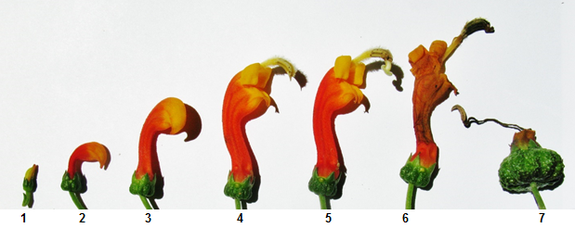

To study these phases, tag flower primordia at very early, pre-phase 1 stage and take morphological and temporal measurements (development).

The *Centropogon* fruit is a berry with many seeds:

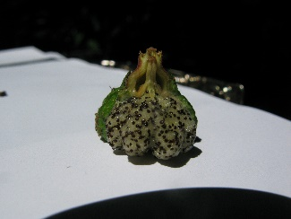

Pollination experiment started 16th of August.

|  |  |  |  |
| --- | --- | --- | --- |
| **Treatment** | **Location** | **Location** | **Location** |
| No treatment | Patch 1, inflor 1 | Patch 1, inflor 4 |  |
| No treatment + bag | Patch 1, inflor 6 | Patch 1, inflor 10 |  |
| Cross pollination | Patch 1, inflor 5 | Adventure trail head, inflor 1 |  |
| Cross pollination + bag | Patch 1, inflor 7 |  |  |
| Self pollination + bag | Patch 1, inflor 3 | Patch 1, inflor 9 |  |
| Bird exclusion cage | Patch 1, inflor 2 | Patch 1, inflor 8 |  |

Any flowers with bags or cages had all post-anthesis flowers removed. Cross pollinated flowers had pollen transferred from different patches. Inflorescences within patches are likely to be one genetic individual.

18 de Agosto: *Eutoxeres condamini* is a visitor of *Centropogon granulosus*

19 de Agosto: How does *Centropogon* prevent self pollination?Or is this a failsafe mechanism? Idea: If a flower has most of its pollen taken by a pollinator, the ratio of self:cross pollination will be low. If no pollinator comes, the self:cross ratio will be high. In this scenario *some* self-pollination is inevitable, but it guarantees pollination regardless of visitors.

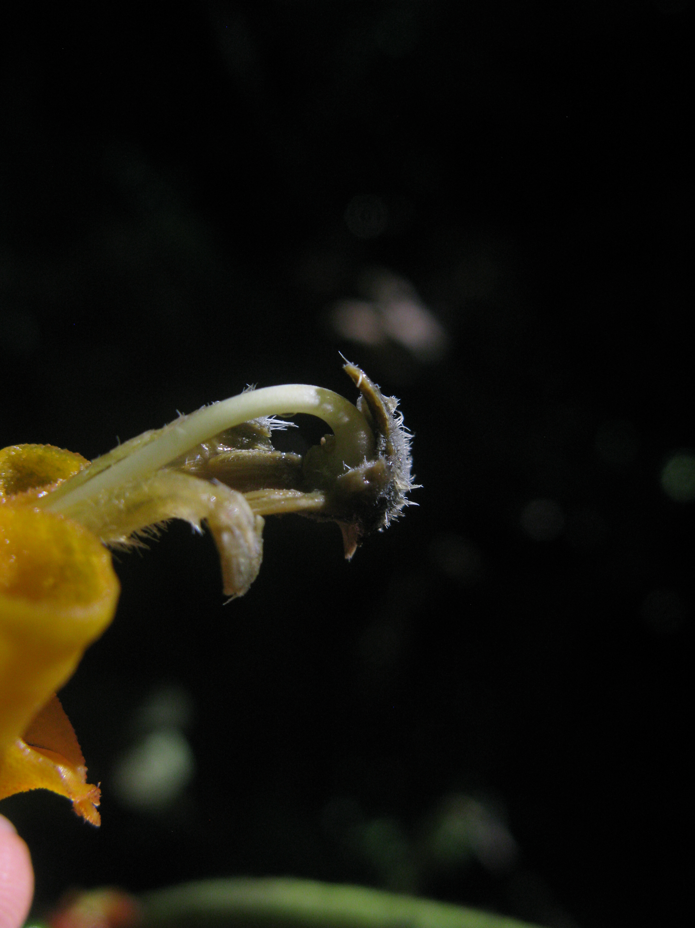

Something eats *Centropogon* berries

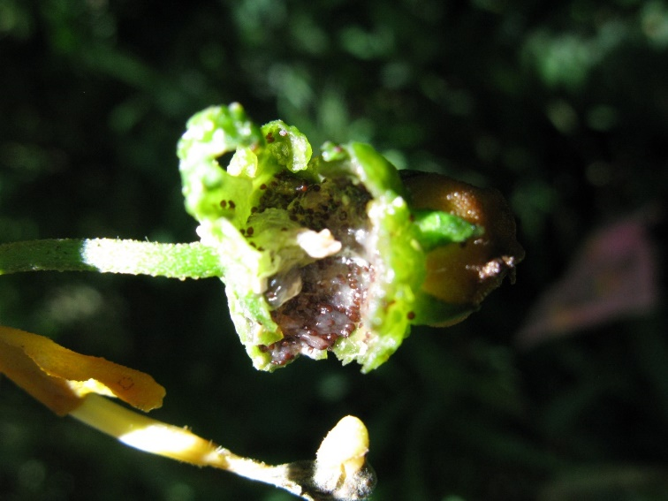

25 de Agosoto: It seems unlikely that the lignified inflorescence is used as a perch by hummingbirds. This could be demonstrated using a 8 gram weight tied to the inflorescence. It would surely sag too much to be of use. Instead I think the lignified inflorescence is used to hold the flowers in an upright configuration – especially during anthesis. On that note, I think that post-anthesis flowers are purposefully ‘drooped’ as they are no longer needed to be upright. Observation will tell.

3 de Septiembre: Inflorescences protected by a cage do not produce berries. Instead, the unfertilized flower droops and is excised in 4-5 days following the female phase. Untreated inflorescences do produce berries. About half reach maturity. It can take up to 10 days for a berry to reach a diameter of 20 mm. Such berries contain 150-230 seeds.