**Plant-pollinator specialization: Origin and measurement of curvature.**

Mannfred M.A. Boehm, Jill E. Jankowski, Quentin C.B. Cronk

Biodiversity Research Centre, University of British Columbia

Proposal for a **Syntheses and Perspectives** article in *The American Naturalist*

**Summary**

* The curvature of flowers and pollinator mouthparts (e.g. hummingbird bills) along the dorsiventral plane is a widespread, convergent trait, and is generally viewed as indicative of plant-pollinator co-evolution.
* We propose to synthesize the current state of knowledge on the role of curvature in plant-pollinator systems, advocate for a standardized metric for quantifying curvature, and integrate this curvature metric with geometric morphometrics.
* We review the literature focusing on the ecological and evolutionary importance of curvature in flowers and pollinator mouthparts. While floral curvature may have originated as a response to developmental constraints, it persists as a mechanism to mediate plant-pollinator interaction strength. Mouthpart curvature in pollinators (e.g. in birds) is not always indicative of reciprocal selection.
* In reviewing and summarising these works, we note a disparity in the conceptualization of curvature. We describe five different curvature metrics from the literature, and their relationship to the mathematical definition of curvature (*K)*, which is not currently used in evolutionary ecology.
* We draw from the differential geometry literature and present key concepts that help clarify the definition of curvature (*K*). This definition not only is more precise but integrates readily with geometric morphometrics (GM), the *de facto* standard for quantifying biological shape.
* Curvature, as newly defined, is integrated into a typical GM protocol. This is demonstrated on a novel dataset of floral development in *Epimedium* (Berberidaceae).
* A decisive definition of curvature rooted in long-standing geometric concepts will improve crosstalk among the sub-fields of organismal biology, and naturally integrates into the well-established framework of GM.

**Proposal**

The role of plant-pollinator morphology in the speciation process is central to our understanding of the generation of biodiversity. The idea that reciprocal selection between plants and pollinators can reinforce morphological divergence, and ultimately reproductive isolation, has been framed as a special case of ecological speciation (Althoff et al. 2014). This has reaffirmed plant-pollinator diversification as a model system in speciation research.

Although floral and pollinator mouthpart shape are widely recognized as important phenotypes mediating interaction strength, there is a notable gap in the literature where aspects of shape are defined – ‘curvature’ is one of them. Because curvature represents one of the three spatial axes through which biological shape can evolve, a clear definition of its meaning and measurement is foundational to understanding morphological and biological diversity.

We are proposing an article with three main goals. **(1)** A review of the current state of knowledge of the role of curvature in plant-pollinator systems. There are over 40 plant-pollinator studies focused on curvature, beginning in the 1970’s, but no overview of the results yet exists. **(2)** A discussion of the various methods used to measure curvature, and a proposal to improve these methods by first understanding what curvature is in a geometric sense. We propose to draw from the differential geometry literature and define curvature as the instantaneous rate of angular change of the tangent (*d*ϕ). We will relate this definition of curvature with related concepts in geometric morphometrics (GM), the quantitative study of shape. **(3)** An analysis of a novel floral development dataset using the proposed curvature metric, and a demonstration of its integration with GM. In the discussion we will emphasize the importance of integrating univariate metrics (e.g. curvature) with GM, which is the authoritative method for the quantitative study of shape.

In the following section, we outline a proposed structure for the manuscript, followed by proposed figures and tables.

**Proposed Outline**

Main text

* *Section 1: Origins and consequences of curvature*
  + The curvature of flowers and pollinator mouthparts (e.g. hummingbird bills) is a widespread, convergent trait, and is frequently the focus of studies testing the theory of co-evolutionary diversification.
  + In plants, floral curvature might originate from developmental constraints while in bud, but persists when vestigial floral curvature improves pollination (i.e. fitness).
  + The evolution of floral curvature can involve reciprocal adaptation with a pollinator. This can reinforce morphological divergence leading to the evolution of an obligate mutualism and reproductive isolation. The latter is more likely in plants where flowers are a ‘magic trait’ (under divergent selection and also contribute to assortative mating).
  + In pollinators, curvature (e.g. of hummingbird bills) appears to serve multiple ecological functions. Bill curvature mediates resource partitioning in competitive (i.e. species-rich) habitats, and thus this trait has a predictable geographic distribution. Sexual dimorphism in foraging behaviours, male-male competition, and the biomechanics of foraging also mediate bill curvature outside of reciprocal selection with plants.
* *Section 2:* *History of measuring curvature in pollination ecology*
  + Conduct a systematic literature search for studies focused on the role of curvature in plant-pollinator systems.
  + A brief chronology of measuring curvature in pollination ecology.
  + A summary and review of the most common methods used to measure curvature. A discussion of their advantages, pitfalls, mathematical interpretation (i.e. what they really measure), and interchangeability.
  + An introduction to geometric morphometrics (GM), its use in quantifying shape, and current limitations in quantifying curvature.
* *Section 3: Curvature and concepts from differential geometry*
  + The literature search reveals a lack of consensus of what curvature and its associated units mean. This largely stems from multiple independent metrics invented in the 1970’s that do not reference the mathematical definition of curvature.
  + By turning to the field of differential geometry, we can find that curvature has a long-standing definition that is easily adapted to the study of dorsiventral curvature of flowers and pollinator mouthparts.
  + Borrowing from geometry, we define curvature as a point-wise property of a curve, representing the instantaneous rate of angular change of the tangent (*d*ϕ). By integrating point-wise curvature across a specimen, we can also derive *total curvature* (*K*tot), which is the metric most comparable to those reviewed in Section 2.
  + This definition of curvature closely resembles the tangent angle function (Zahn and Roskies 1972) that is implemented in modern geometric morphometric analyses of outlines. For this reason, integrating the analysis curvature (as defined above) into the field of geometric morphometrics is the likely next step for pollination ecology and comparative morphology at large.
* *Section 4: A proposed protocol for measuring curvature*
  + Given the new definition of curvature, we suggest practical ways to implement this metric using existing algorithms in the R environment.
  + The protocol begins with landmarking a biological specimen, as is typical for a geometric morphometrics protocol.
  + A curve is fitted to the landmarks. We present various options, but for simplicity, use a polynomial curve in this example.
  + From the fitted function, derivatives, and therefore point-wise curvature can be estimated. The above steps can be conducted using existing packages in R.
  + We re-emphasize that the tangent angle function (Zahn and Roskies 1972), is the likely way forward for improving pre-existing algorithms to compute curvature as part of an integrated morphometrics pipeline (though not currently possible with existing R packages).
* *Section 5: Demonstration of concepts*
* We implement the above protocol using a novel dataset of nectar spur development in *Epimedium* (Berberidaceae).
* A standard GM analysis suggests that the first principal component (PC1) of shape variation is related to curvature.
* To test this, we measure curvature explicitly and regress against PC1.
* We re-measure curvature using the historic methods and compare results to the new method.
* This demonstration illustrates the improved ease of discussion of curvature with a clear definition of the concept and units of measurement.
* We conclude with an outlook on the applicability of this curvature metric to the study of the biodiversity of shape, and its further integration with geometric morphometrics.

**Proposed Outline (Continued)**

Tables

* *Table 1: Summary of literature reviewed for metrics of floral or mouthpart curvature in plant-pollinator systems.* 
  + Each row in this table is a study reviewed from the literature search. For each entry we include a column briefly describing the study system and another column indicating the metric used to quantify curvature.

Figures

* *Figure 1: Overview of most commonly used curvature metrics within pollination ecology.* 
  + Illustrates the four most common metrics used to represent ‘curvature’. This is a visual accompaniment to the literature review (Section 2).
* *Figure 2: A visual representation of the mathematical definition of curvature.* 
  + Central to this figure is a curve fitted to landmarks. We use this curve to illustrate geometric concepts such as arc length, tangent vectors, tangent angles, and their rate of change across the curve (derived in Section 3).
* *Figure 3: A proposed protocol for measuring curvature [included on following page]*
  + This figure illustrates the step-by-step protocol described in Section 4. This includes landmarking a biological specimen, fitting a curve to the landmarks, computing step-wise derivatives, and estimating tangent rotations from the derivative.
* *Figure 4: Geometric morphometric principal components plot.* 
  + In Section 5 we test the utility of the new curvature metric on a novel dataset of *Epimedium* nectar spur development. We also perform a typical geometric morphometrics analysis to demonstrate how these protocols are complimentary. This figure illustrates two PCs of shape space with deformation grids that aid in visualizing the components of shape that vary along PC1 and PC2.
* *Figure 5: Scatterplot of total curvature and PC1 from PCA of geometric morphometric shape space.* 
  + The deformation grids in Figure 4 suggest that curvature is a shape component driving variation in PC1 of shape space.
  + We measure curvature separately and regress against PC1 from the GM analysis to show that an explicit analysis of curvature can test these sorts of hypotheses.

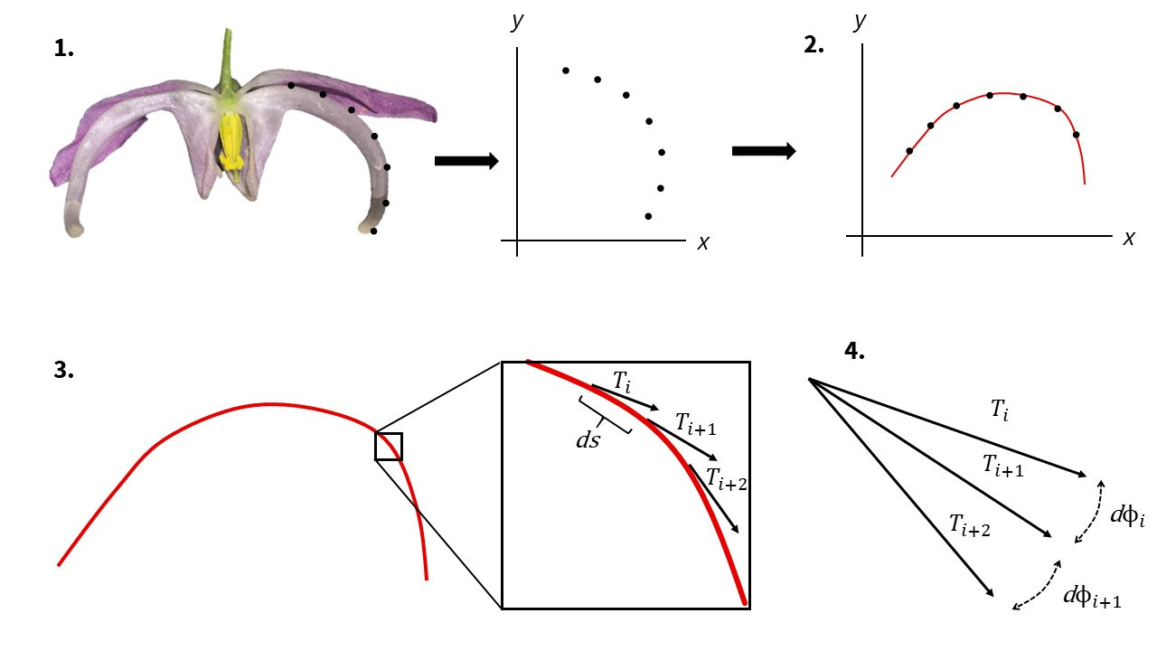

*Figure 3.* Proposed protocol for measuring curvature. **1.** A specimen (in this case *Epimedium violaceum*) is landmarked, semi-landmarked and assigned *xy* coordinates within a Cartesian plane. **2.** The *xy* coordinates are rotated so that a single-valued function can be fitted to the landmarks (this step is not necessary for all cases). **3.** The tangent vector **T** is calculated at an arbitrarily large number of increments, *ds*, along the curve. **4.** Curvature is calculated as the rate of change of the tangent angle (ϕ) point-wise along the curve.

**References**

Althoff, D. M., Segraves, K. A., & Johnson, M. T. (2014). Testing for coevolutionary diversification: linking pattern with process. *Trends in Ecology & Evolution*, 29(2), 82-89.

Zahn, C. T., & Roskies, R. Z. (1972). Fourier descriptors for plane closed curves. *IEEE Transactions on Computers*, 100(3), 269-281.