The inside curve: geometry and pollination ecology of curved flowers

#### Abstract

The curvature of a flower along the lateral plane (‘floral curvature’) is a widespread, convergent trait with important ecological and evolutionary implications. This review summarizes the methods used to measure floral curvature, suggests a clarification of the definition of curvature and a translation into a field-portable methodology. Intuitively, curvature is the degree to which a line is not straight. In plane geometry curvature is defined as the rate at which the unit derivative changes direction with respect to arc length. To apply this definition we suggest a protocol wherein a line is regressed against landmarks placed on a lateral image of an organism, then computing curvature at many points along the fitted line and taking the sum. The utility of this metric was tested by studying the development of nectar spur curvature in *Epimedium* (Berberidaceae). We found *Epimedium koreanum* to have an order of magnitude greater curvature than the closely related *E. grandiflorum* and *E. violaceum*. The suite of functions used to quantify floral curvature in this study are available as an open-source R package ‘curvy’. The major advantages of this method are 1) precision of measurement is increased without introducing expensive field equipment or computing power, 2) precision of terminology within pollination ecology is improved by adopting from the existing mathematical tools for studying line-curves, and 3) the opportunity is opened for investigating the genetic basis of (lateral plane) curvature measured at the cellular scale (not sure if this is worth commenting on.. cut if manuscript is too long?)

#### 1. The ecology of floral curvature

“We are beginning to understand why some hummingbird bills are long, whereas others are short, and why some hummingbird flowers are wide, whereas others are narrow. Now, why are bills of some hummingbirds and the tubes of the flowers they visit curved?” – Temeles (1996).

At the center of plant-pollinator diversification is a remarkable variety of floral form. The notion that plant communities are under selection to reduce interspecific mating (“floral isolation”, Grant, 1949), points to the importance of floral diversity in initiating and reinforcing reproductive isolation (Armbruster and Muchhala, 2009). For example, in the rapid radiation of Andean *Centropogon* (Campanulaceae), competition for pollination led to the divergence of floral traits associated with bat and hummingbird pollination (Lagomarsino and Muchhala, 2019). Meanwhile, in South African *Lapeirousia* (Iridaceae), geographic variation in floral tube length has initiated reproductive isolation between morphs with short and long flower tubes, despite sharing the same fly pollinator (Minnaar et al., 2019). Thus, floral morphology is a key phenotypic feature underlying the diversification of plants and pollinators (Kay and Sargent, 2009; Ollerton, 2017).

Flower-pollinator curvature as viewed from the side (lateral plane), has been a trait of special interest since the post-Darwin era of pollination ecology. In making pollinator observations of the Cape flora, Scott-Elliott (1890) noticed that the flowers of *Leonotis ocymifolia* (Lamiaceae) visited by *Nectarinia* sunbirds were “curved with the same curvature as that of the bird’s beak.” (p. 272). Robertson (1889) insightfully notes that the curved nectar spurs of *Viola* spp. (Violaceae) “serves to limit the insect visits much more than the mere length of the spur.” (p. 172). From these early observations curvature has been synonymous with specialization; we expect curvature to limit the range of functional taxa in a plant-pollinator mutualism and strengthen interactions between the existing participants. And these expectations have largely been supported: Stiles (1975) first posited that neotropical *Heliconia* partition hummingbird visitation by flower-bill curvature, and that specialization by curve-billed hummingbirds allow co-existence within the species-rich *Heliconia* clade. Subsequent research supports this hypothesis (Maglianesi et al., 2014): along the slopes of the Central Cordillera (Costa Rica), the degree of flower-hummingbird bill curvature is proportional to plant-pollinator interaction strength (Dehling et al., 2014) and extent of specialization (*d’*, (Blüthgen et al., 2006). More recently the scope of plant-pollinator research has expanded to address the biogeography of curvature. As predicted by Stiles (2004), Maglianesi (2015a) and Sonne (2019) find curvature to be most prevalent in the lowland environments of the neotropics. Explanations for this pattern range from heightened competition at lower elevations to environmental filtering in the Andean highlands (Stiles, 2004; Graham et al., 2009). Because the neotropical hummingbird subfamily Phaethornithinae comprises the majority of species with curved bills, we might expect plant-hummingbird curvature to have a predictable global distribution.

Pollinator specialization has major effects on macroevolutionary and biogeographic patterns (Kay and Sargent, 2009; Armbruster and Muchhala, 2009; Vamosi et al., 2018), and curvature is a component, but widespread feature of specialist systems. Therefore, to synthesize our knowledge of curved plant-pollinator systems, curvature is a concept that needs an exact definition and method of measurement. In this review we summarize the approaches to measuring curvature within the field of plant-hummingbird pollination, identify strengths and shortcomings, and offer a solution with the aim of standardizing how curvature is studied within the field of pollination ecology. Although this review is motivated by the problem of measuring curvature in plant-hummingbird systems, the solution is general to any biological form modelled as a line curve: this case is hopefully made in the demonstration to follow.

#### 2. Summary of the literature

We searched the scientific literature for studies focusing on or considering floral curvature - a common measurement used in pollination ecology as a proxy for specialization. We make the distinction between measuring curvature in the lateral plane versus measuring curvature of surfaces (e.g. of petals). The methods for handling surface (Gaussian) curvature are relatively developed and well-defined (Nath et al., 2003; Coen and Rebocho, 2016). The literature was sourced by querying Google Scholar for the terms “corolla curvature”, “flower curvature”, and “hummingbird curvature”. Results are summarized in Table 1. 25 studies of hummingbird-plant systems were found using some form of curvature metric (Table 1). An additional 10 studies of other plant, insect, and passerine bird systems were found (Table S1). There were numerous studies of plant-pollinator shape that did not address curvature - these were omitted.

The discussion of lateral curvature in plant-hummingbird interactions begins with Hainsworth (1973) and is first empirically studied by Stiles (1975), though methods for measuring curvature of bird bills outside of a pollination context can be found much earlier (Baldwin et al., 1931). We identified six common approaches to measuring curvature. First, there are qualitative descriptions, e.g. “very curved”, “less curved”, but these have generally been out of use since the 1970s. Second, the *arc:chord* method wherein curvature is a ratio of two lines: a straight line (chord) from tip to base (of the flower or bill) and a line that traverses a path along the arc of the flower/bill ([Figure 1](Figures/Figure_1.jpg)). Third, the *orthogonal length* method which defines curvature as a ratio of two lines: a straight line from base to tip and a perpendicular line that measures the width of the flower/bill. This method is another form of the *arc:chord* method because for a given chord length, the length of the perpendicular line will be proportional to the arc length. Fourth, the *angle of deflection* method which considers curvature as the angle between the base of the flower/bill and its tip. This is another form of the *inverse radius* method which approximates the entire length of the flower/bill as a segment of a circle. These methods are interchangeable because the radius of a circle can be calculated from the length and angle of a line that passes through it (Bell, 1956; Temeles et al., 2009), see: [Figure S1](Figures/Figure_S1.jpg). Sixth, geometric morphometrics, which quantifies shape as a configuration of homologous points (landmarks) existing on a coordinate plane ([Figure 2](Figures/Figure_2.jpg)).

The strength of methods 2 and 3 are their portability and accessibility. These measurements can be taken in the field, or soon after from photographs. The methods are intuitive and in the simplest case, require only a ruler, string, and protractor. However, even if the measurements are made using imaging software these methods have some shortcomings (discussed in Berns and Adams, 2010), principally that there are many shapes that could produce the same curvature value. For the *inverse radius* method, a curve is approximated with the segment of a circle. This method is insufficient for any flower and bill shapes that deviate from having constant curvature (*e.g.* nectar spurs of *Delphinium* ). Similarly, the *angle of deflection* is not sensitive to local features along the length of the flower/bill - only the start and end points are considered in the calculation.

Starting in 2010, geometric morphometrics (GM) emerges in the pollination literature. GM has since steadily gained in popularity in this field due to its statistical rigour, reproducibility, and the intuitive visual results presented as transformations of shape (*e.g.* illustrations of geographic variation in flower shape Gómez et al. (2009)). We briefly outline the reasoning of a GM protocol to introduce relevant concepts, but recommend the authoritative introduction to the topic written by Webster and Sheets (2010). A GM protocol for a 2-D object begins by placing the specimens on an *xy* grid and assigning landmarks to locations on the specimen that are topologically or biologically homologous - a landmark is defined so that its location can be reproduced within and between samples. The set of landmarks representing the shape of an organism is a ‘landmark configuration’. In a comparative study, the samples must first be optimally aligned and their shape information isolated from their orientation, location, and size. This is done using a least-squares type protocol, most commonly the Generalized Procrustes Analysis (GPA). GPA-adjusted landmark configurations hereafter exist in a multidimensional shape space defined by the number of landmarks and spatial dimensions implemented. Each landmark configuration contains unique information about the specimen’s shape, and as such, occupies a unique position in the corresponding shape space. These configurations are then “projected” onto a simpler Euclidian space, similar to the reduction of a spherical Earth onto a two-dimensional map (Webster and Sheets, 2010). From here, familiar statistical procedures (*e.g.* PCA) can be performed to quantify variation in landmark configurations (shape) between samples.

This is giant leap forward for morphological studies because GM is a complete protocol for measuring, quantifying, and comparing shapes with high precision, as well as the covariation of these shapes with ecological variables of interest. The limitation of GM in quantifying curvature is that this method is concerned with analyzing configurations of landmarks, *i.e.* the entirety of a shape summarized as a set of *xy* coordinates. Once the specimen has been reduced to a landmark configuration, it exists as a point in shape space. Parsing segments of landmark configurations for separate analyses (*e.g.* for curvature) is not currently part of the geometric morphometrics toolkit. Therefore, studies that have used this technique to analyse biological forms are able to compare shapes in their entirety, but are ultimately limited to making descriptive statements about how segments of shapes appear to have different curvatures (*e.g.* Berns and Adams, 2013).

#### 3. What is curvature?

Reviewing the literature leads us to ask, “what is curvature?”. There exists several distinct but related definitions, resulting from a history of independent mathematical derivations (reviewed in Coolidge, 1952; Bardini and Gianella, 2016). Here, we follow the conventions of Casey (1996) and Rutter (2000). In a two-dimensional, flat (Euclidian) space (Heath, 1956), a straight line is traced when a particle moves without changing direction. A curve is traced when a particle moves from its origin and does not maintain its original heading as it moves. At every step along its path, the particle has a measure of direction and speed. The degree to which the direction of a particle changes from one position to the next is its curvature ([Figure 3](Figures/Figure_3.jpg)). Intuitively, a particle that traces a straight line will not change its direction and will have zero curvature. A particle that traces a turning line will have relatively greater curvature.

In order to formalize this concept of curvature, we first introduce the concept of a vector-valued function. Physically, a vector can be thought of as an arrow-like object with length and direction [Figure 4](Figures/Figure_4.jpg). A vector that exists in a coordinate plane “points” to an $(x,y)$ location and is called a *position vector*. The $x$ and $y$ components of a position vector can be handled separately as scaled *unit vectors* of length 1. Therefore, the length of a position vector is computed as the Euclidian distance (hypotenuse) between its rectangular $x$ and $y$ unit vector components (Figure 4). A vector’s direction is determined by its relative orientation to an arbitrarily chosen fixed line (*e.g.* the $x$-axis). Because vectors can “point” to a location on a coordinate plane, an $(x,y)$ coordinate can can be rewritten as a position vector

$r=xi+yj$,

Where $i$ and $j$ are orthogonal unit vectors fixed on the $x$ and $y$ axes, respectively, and $r$ is the resultant position vector pointing to some point ([Figure 4](Figures/Figure_4.jpg)).

Now, instead of the typical $f(x)=y$ notation for a function, consider a curve as the path traced by a moving particle that passes through a set of $(x,y)$ points, described by two time-dependent functions

$x=\hat{x}(t)$, $y=\hat{y}(t)$,

where $\hat{x}$ and $\hat{y}$ denote that $x$ and $y$ are functions of time $t$. This parameterization is convenient because we would like to treat position vectors as composites of the unit vectors $i$ and $j$. Consequently, we can combine the concepts of eqs 1 and 2 to produce a *vector-valued function*

$\hat{r}(t)=\hat{x}(t)i+\hat{y}(t)j$,

where $\hat{r}(t)$ is a function that produces a position vector $r=xi+yj$ determined by $t$.

Extending this concept, if we have general curve with an arc length $s$, this curve can also be paramtertized its arc length, instead of time

$\overline{r}(s)=\overline{x}(s)i+\overline{y}(s)j$.

Where $\overline{r}(s)$ indicates that the position vector $r$ is determined by its arc length $s$. When a curve is parameterized by its arc length, for every increment of $s$ that we move along the curve ($ds$), we generate a position vector $r$ indicating our $(x,y)$ location in the coordinate plane.

If we are interested in the derivative properties of a vector-valued function, we can differentiate a position vector $r$ with respect to arc length $s$ as

$\frac{dr}{ds}=\lim_{Δs→0}\frac{Δr}{Δs}=T$.

The resultant tangent vector $T$ not only indicates the direction of the curve at position $r(s)$ but also has a length of 1. This is because as $Δs→0$, the length of the tangent vector ($dr$) and the length of the arc segment ($ds$) become equal. In this case, the tangent vector is called the *unit tangent vector*.

At the beginning of this section we defined curvature ($K$) as the degree to which the direction of a particle changes from one position to the next. More formally this could be stated as *the degree to which the direction of the unit tangent vector changes with respect to arc length*. By “degree” we mean the angle $ϕ$ formed between the tangent vector and the $x$-axis or some other arbitrary reference ([Figure 4](Figure_4.jpg)).

$K=\frac{dϕ}{ds}$.

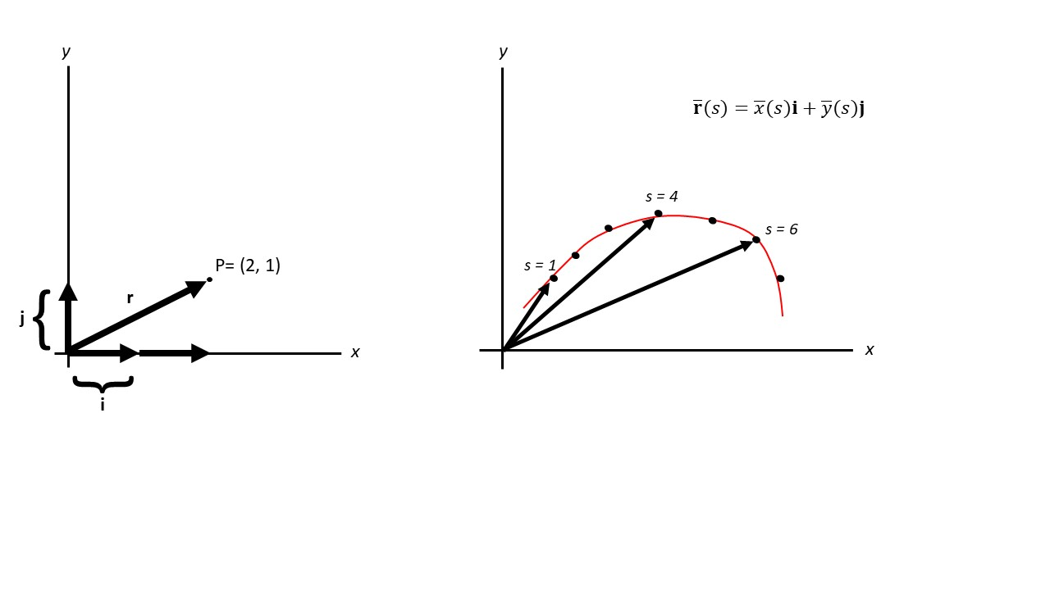

Figure 4. Illustrations of vectors. Left: On the x and y axis are the unit vectors i and j, respectively, of length 1. The point P = (2,1) can be rewritten as a position vector r, that is made of two i unit vectors and one j unit vector, r = 2i + j. The length of r is ||r|| = sqrt 2^2 + 1^2. Right: A vector valued function describing a curve, parameterized by arc length.

#### 4. A proposed protocol for measuring curvature

In order to apply the above definition of curvature, a biological organ or tissue needs to be reduced to a continuous function. We propose a workflow as illustrated in [Figure 3](Figures/Figure_3.jpg). Cosgrove (1990) uses an analogous approach to study the development of cucumber hypocotyls. By fitting cubic splines to hand-marked seedlings, curvature was computed using the same definition as above. Since Cosgrove (1990), the entire field of landmark-based geometric morphometrics has unfolded (reviewed in Adams et al., 2013). This rigorous, reproducible toolkit has been used extensively in pollination ecology, but has not yet been leveraged to calculate curvature ([Table 1](Tables/Table_1.csv)). Terral et al (2004) use these tools to digitally landmark olive stones and fit polynomials to the landmarks: synthesizing the concepts of Cosgrove (1990) and Terral (2004) produces a modernized method for fitting curves and computing curvature from biological forms (Figure 3)

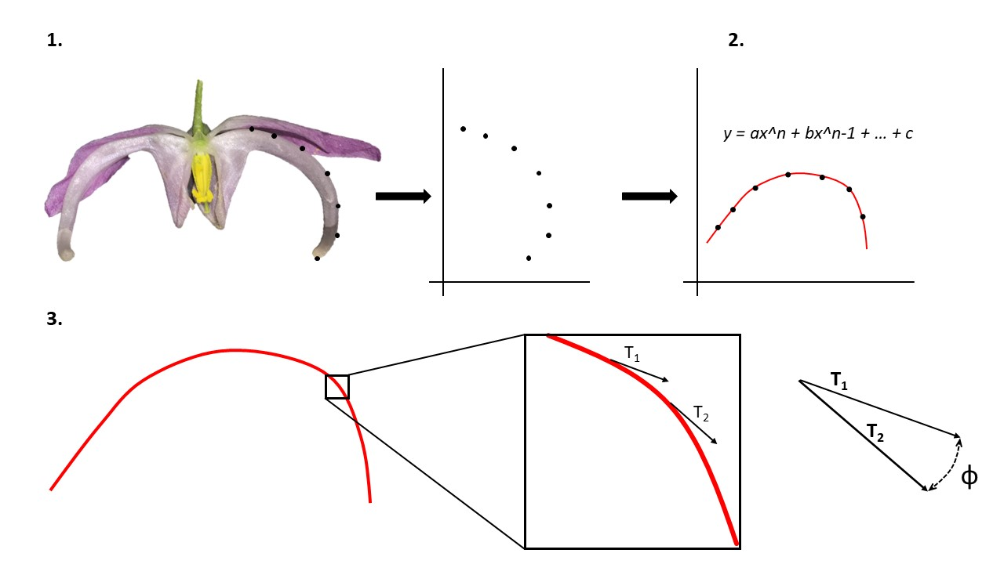

Figure 3: Proposed protocol for measuring curvature. 1. A petal of Epimedium violaceum is landmarked and rotated. 2. A polynomial curve is fitted to the landmarks. 3. Curvature is calculated as the rate of change of the tangent vector at every point along the curve.

Comment on why using the simplest case (polynomials) and not splines, fourier, etc.

#### 5. Proof of concept: A study of the development of curvature in *Epimedium*

We tested the utility of this curvature metric by studying floral development in *Epimedium grandiflorum* C.Morren, *Epimedium koreanum* Nakai, and *Epimedium violaceum* C.Morren. (Berberidaceae, Table 2 - sample sizes). The latter two ‘species’ are generally considered forms of *E. grandiflorum sensu lato* (Stearn, 2002), but we considered them separate for comparitive purposes.

Flower size was measured daily from April 9 to May 2, 2019 at the UBC Botanical Garden (Supp Mat 1). Size was defined as the length between the apex of the two outer sepals lying on the major axis of the flower - aestivation is imbricate. Length was measured to the nearest 0.1 mm using an SPI Polymid Dial Caliper. By correlating changes in flower size to developmental landmarks (Figure 5), we were able to define 3 discrete stages of flower development in *E. grandiflorum* and 4 stages in *E. koreanum* and *E. violaceum* (Table 2, & will include figure with photographs of the stages).

Flowering stage data was fragmented and staggered because of censoring, i.e. due to tracking flowers after their initial budding stage, or flowers that had succumb to herbivory or weather after several days of measurement. Therefore, stage data was aligned by using a multiple sequence alignment protocol (ClustalW implemented in msa v.3.9) with a neutral (identity) substitution matrix. Gap opening was prohibited. By aligning phenological data within species, a consensus stage sequence was calculated and used to estimate flower age where observations were censored. Once aligned, these data represent the ‘developmental dataset’.

To measure curvature, a separate set of flowers were sampled haphazardly and preserved in 70% ethanol. Preserved flowers were later transferred to a glass slide and imaged in the lateral view using a stereo microscope at 0.63x (Zeiss Stemi 508 with Axiocam 301). Specimens that did not fit within the field of view were imaged in halves and the images joined using the Stitching Plugin in the Fiji distribution of ImageJ2 (Preibisch et al., 2009; Rueden et al., 2017).

Photographed specimens were landmarked digitally using tpsDig (Rohlf, 2015). We placed landmarks along the edge of dorsal petals (in lateral view) as an approximation of the flower’s total shape (see discussion of geometric morphometrics above). Landmarks used to measure the dorsal arc were 1) the farthest point on the apex of the spur before the inflection point where either the spur diminishes to a tip (*E. violaceum*) or widens into a saccate reservoir (*E. koreanum*), and 2) the inflection point at which the spur widens to become an attachment for the petal to the stem (anatomical name?). 13 semi-landmarks (defined in Webster and Sheets, 2010) were placed between landmarks 1 and 2 (illustrated in Figure S2).

Landmark files (.tps) were imported into R using Momocs v.1.3.0 (Bonhomme et al., 2014). Polynomial functions were regressed to the landmark coordinates for each specimen using Momocs - we chose polynomials of the third degree based on the recommendations of Rolhf (1990). Arc length was calculated from bounded polynomial functions using pracma v.2.2.5 (Borchers, 2019). Curvature, as defined in the previous section, was computed using a custom function modified from the maxcurv() function of the soilphysics package v.3.1 (Silva and Lima, 2017). All custom functions used in this analysis are available as an R package curvy hosted at github.com/mannfred/curvy. R scripts used in this analysis are hosted at github.com/mannfred/epidmedium. These data represent the ‘curvature dataset’.

Because the second set of flowers were sampled opportunistically after the developmental study, age was inferred by outer sepal size. First, the developmental data was used to model size and age as a logistic function using the `drc v.3.0.1 package in R (Ritz et al., 2015). Then, age was inferred for the curvature data by inputing size information into the logistic model.

Results:

In *E. grandiflorum* we identified three distinct stages of development (Tukey’s HSD: p<0.01). The first stage (“G”) is defined as the initiation and growth of the bud until the petals begin to separate (“T” stage). At the “T” stage nectar begins accumilating in the spurs. Anthesis takes place during the “A” stage at which point the flower opening may increase in size and anthers dehisce. In *E. koreanum* and *E. violaceum* we detected another distinct “C” stage in the early stage of bud development. At this stage the petals are shorter in length than the sepals that envelop them - the “G” stage begins when the petals overtake the surrounding sepals in length.

-insert table with mean +/- 95%CI of sizes (mm) for all three species.

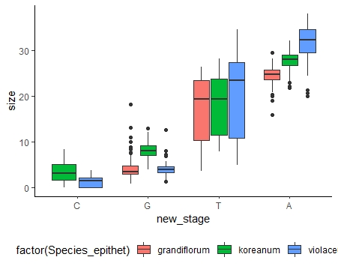

Figure 5: Comparison of developmental stages. Size is in mm. Tukey’s HSD: p<0.01 for all within-species comparisons

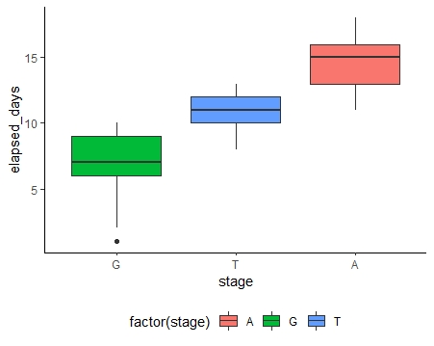

Figure 6: Days elapsed per stage in E. grandiflorum

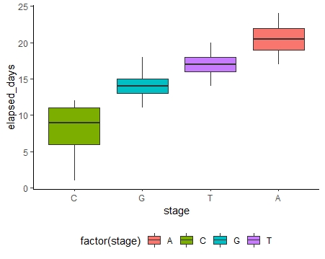

Figure 7: Days elapsed per stage in E. koreanum

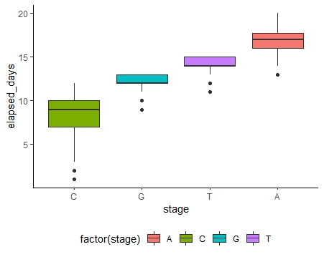

Figure 8: Days elapsed per stage in E. violaceum

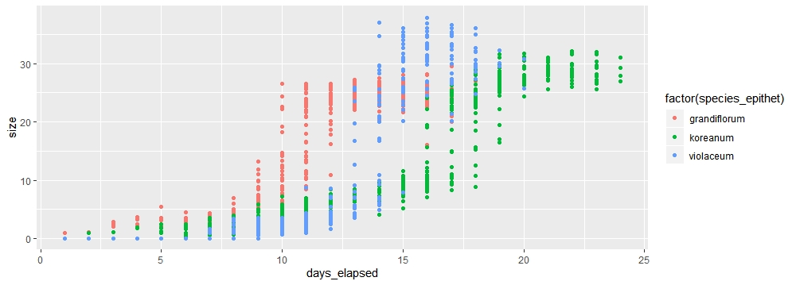

Figure 9: Logistic growth of Epimedium flowers

*E. koreanum* is more curved at initial stages of development:

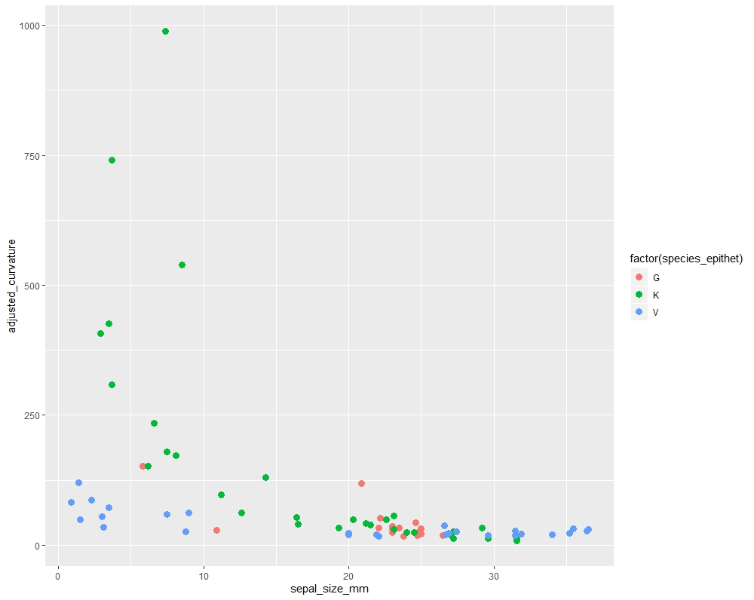

Figure 10: size vs curvature

*E. koreanum* is more curved at initial stages of development:

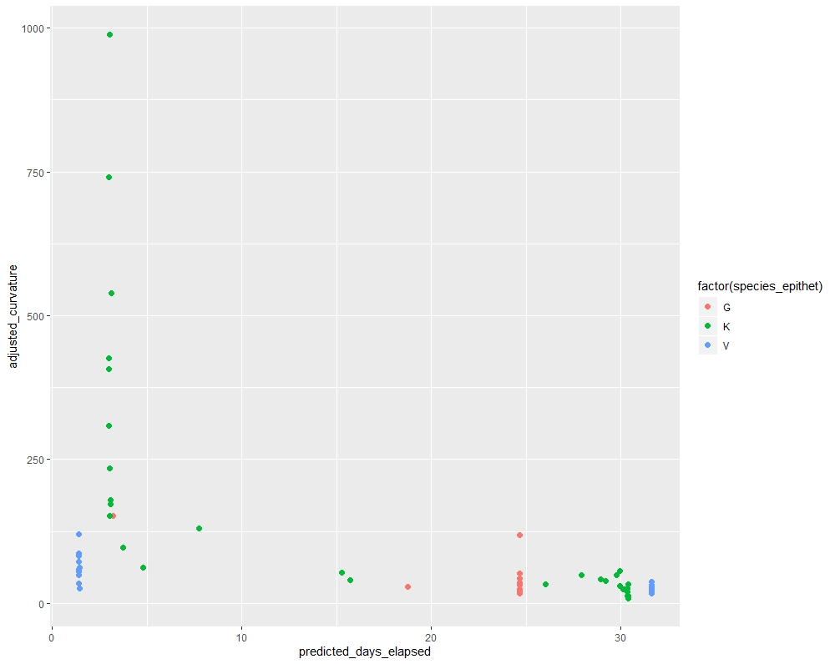

Figure 11: elapsed days vs curvature

Table 1: Summary of literature reviewed for the role of curvature in plant-pollinator systems.

|  |  |  |
| --- | --- | --- |
| Citation | System | Method |
| Stiles (1975) | Corolla morphology of Heliconia and bill morphology of nine hummingbird species at La Selva, Costa Rica. | Qualitative (e.g. ‘strongly curved, moderately curved, etc.). |
| Buttrose et al. (1977) | Significance of curvature of style branches in Hibiscus trionum for pollination | Qualitative |
| Gill and Wolf (1978) | Sunbird bill diversity and abilities to extract nectar from Kenyan Leonotis nepetifolia (Lamiaceae). | Mandibular index: Curvature is “the ratio x/y, where x is the bill length measured from the anterior edge of the nostril and y is the maximum height above the longest chord of the bill.” |
| Paton and Collins (1989) | Correlates (Geography, Age, Sex, Tongue structure, foraging mode) of bill morphology on nectar extraction 198 hummers (and other birds). | Mandibular index: “Bill curvatures were defined as the maximum perpendicular height of the bottom edge of the culmen above the chord from the gape to the tip of the bill, divided by the length of this chord”. |
| Stiles (1995) | Effects of bill morphology on insect foraging strategy by 11 species of hummingbirds at La Selva, Costa Rica. | Arc:chord ratio of exposed culmen (aka maxillary index) – silhouette projected onto a screen |
| Mclntyre and Browne (1996) | Phototropism in Helianthus and effects on cotyledon curvature | Protractor |
| Cotton (1998) | Survey and description of 16 hummingbird species occurring at Amacayacu National Park, Colombia. | Qualitative |
| Temeles et al. (2000) | Sexual dimorphism of bill shape in Purple-throated caribs (Eulampis jugularis), pollinatiors of Heliconia at Quilesse Reserve, Saint Lucia. | Not described, but presumably the same method as Temeles 2009, Temeles 2010. |
| Borgella Jr et al. (2001) | Effects of bill morphology (21 hummingbird spp.) on pollen loads (35 plant spp.) at Coto Brus, Costa Rica. | For species with decurved bills, we also used a ruler to measure a few bills along the curve to calculate a correction factor. (Not reproducible) |
| Temeles et al. (2005) | Sexual dimorphism of bill shape in Purple-throated caribs (Eulampis jugularis), pollinatiors of Heliconia at Quilesse Reserve, Saint Lucia. | Not described, but presumably the same method as Temeles 2010, Temeles 2009. |
| Collins (2008) | Foraging efficiency from artificial and natural (15 spp.) flowers by 4 species of hummingbirds at Monteverde, Costa Rica | Paton and Collins 1989 |
| Stiles (2008) | Correlations of bill morphology to the elevational distributions of 150 spp. of hummingbirds in the Andes. | Arc:chord ratio of exposed culmen |
| Martén-Rodrı́guez et al. (2009) | Testing the pollination syndrome hypothesis in Antillean Gesneriaceae. | Protractor aligned with the dorsal side of the corolla tube. (Angle of deflection) |
| Temeles et al. (2009) | Effects of natural (Heliconia) and artificial flower morphologies on foraging performance of Purple-throated caribs (Eulampis jugularis) at Saint Lucia. | K=1/R ‘Inverse radius’/angle of declension method. |
| Temeles et al. (2010) | Sexual dimorphism of bill shape in 21 species of Central and South American hummingbirds. | K=1/R ‘Inverse radius’/angle of declension method. |
| Berns and Adams (2010) | Sexual dimorphism of bill shape in Black-chinned hummingbird (Archilochus alexandri) and Ruby-throated hummingbird (Archilochus colubris). | Comparison of 3 methods: Paton and Collins 1989 (maxilla), Stiles 1975 (mandible), Temeles 2009 (inverse radius). |
| Berns and Adams (2013) | Sexual dimorphism of bill shape in 219 hummingbird spp. | Geometric morphometrics (” Thin-plate spline deformation grids revealed that in these species, females have longer, more curved bills at both the tip and main body of the bill relative to the mean, while males have straighter and shorter bills and M. minima has the largest magnitude of sexual shape dimorphism” – used GeoMorphometrics but in the end resort to just saying that the deformations of the spline ‘look different’.) |
| Maglianesi et al. (2014) | Trait matching and resource use in a plant-hummingbird network, La Selva, Costa Rica. | Angle of deflection |
| Rico-Guevara and Araya-Salas (2014) | Bills as weapons in lekking Phaethornis longirostris at La Selva, Costa Rica. | Arc:chord ratio of exposed culmen. |
| Maglianesi et al. (2015a) | Differential preferences of artificial and natural (65 spp.) flower populations visited by 3 species of hummingbird in Braulio Carrillo National Park, Costa Rica. | Angle of deflection |
| Maglianesi et al. (2015b) | Plant-pollinator specialization along an elevational gradient at Braulio Carrillo National Park, Costa Rica. 21 hummingbird spp. and 208 plant species examined. | Angle of deflection |
| Lagomarsino et al. (2017) | Evolution of pollination syndromes in Andean Campanulaceae. | Arc:chord ratio of corolla midline and base-to-opening line. |
| Hadley et al. (2018) | Effects of forest fragmentation on hummingbird bill morphologies (19 spp.) representative of specialization. Coto Brus, Costa Rica. | Bill curvature was calculated as the angle between a horizontal line across the top of the bill and a line running the length of the bill. (Arc:chord ratio) |
| Sonne et al. (2019) | Distribution of morphological specialization along an elevational gradientin Ecuador. | Arc:chord ratio of exposed culmen. |

Table 3: Elapsed days per stage for three Epimedium species.

|  |  |  |  |  |
| --- | --- | --- | --- | --- |
| Species | C.Stage | G.Stage | T.Stage | A.Stage |
| E. grandiflorum | NA | 7.01 +/- 0.45 days | 10.9 +/- 0.20 days | 14.7 +/- 0.20 days |
| E. koreanum | 8.31 +/- 0.40 days | 14.3 +/- 0.20 days | 17.1 +/- 0.20 days | 20.6 +/- 0.30 days |
| E. violaceum | 8.27 +/- 0.40 days | 12.0 +/- 0.20 days | 14.1 +/- 0.20 days | 16.7 +/- 0.30 days |

Table S1: Additional studies of curvature outside of hummingbird pollination

|  |  |  |
| --- | --- | --- |
| Citation | System | Method |
| Hamilton 1975 | Comparative Behavior of the American Avocet and the Black-Necked Stilt(Recurvirostridae) | Radius of curvature |
| Kawabata et al 2009 | Quantitative analysis of corolla shapes and petal contours in single-flower cultivars of Lisianthus. | Something like geomorph?? |
| Pour et al 2018 | Curvature-based pattern recognition for cultivar classification of Anthurium (Araceae) flowers. | Calculated k (the rate of change in the direction of the tangent line at that point with respect to arc length) for n points along the flower. |
| Dellinger et al 2018 | Floral trait changes correlated with the repeated shifts away from buzz?pollination in the Melastomataceae. | Qualitative |
| Joly et al 2017 | Analysis of polliation syndromes in Antillean Gesneriaceae. | Geometric morphometrics. “PC2 represents variation in corolla curvature” (descriptive). |
| Berger et al 2017 | Quantifying morphological modifications to floral form in gene knockdowns in Fedia graciliflora. | Landmark-based geometric morphometrics |
| Alexandre et al 2015 | QTL analysis comparing hummingbird pollinated and generalist Rhytidophyllum flowers (Gesneriaceae). | Angle between flower opening and flower base. |
| Campos et al 2015 | Generating 3D printed flowers to test efficacy of moth pollination | “Curvature parameter” |
| Travers et al 2003 | Nectar spurs of Impatiens spp. and Ruby-throated hummingbird (Archilochus colubris) at Franklin County, Massachusetts. | “Angle at which the spur deviates from an arbitrary line drawn through the flower.” (Angle of deflection) |
| Baldwin et al 1931 | Measurements of birds | Inverse radius method |
| Dalayap et al 2011 | Petal, sepal, and labellum shapes in Mokara orchids | Outline morphometrics |

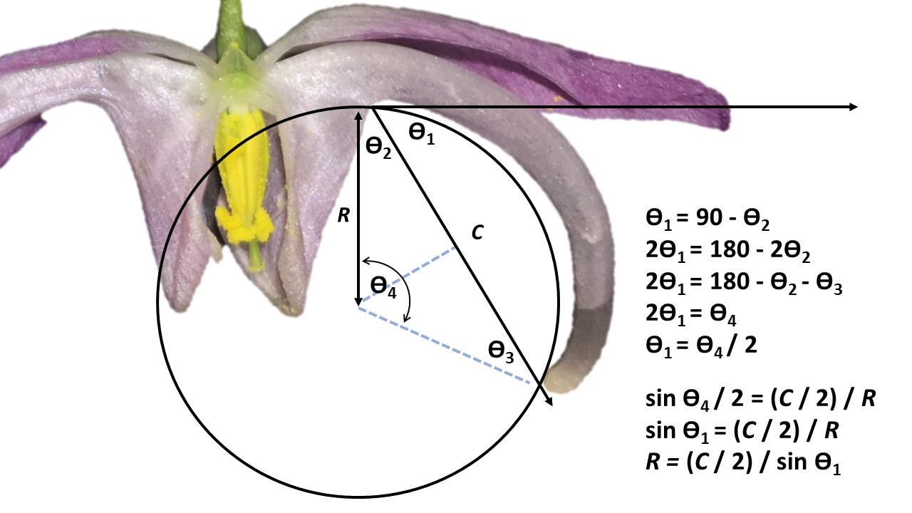

Figure S1: Demonstration that the ‘inverse radius’ and ‘angle of deflection’ methods are equivalent.

# References

Adams, D.C., Rohlf, F.J., and Slice, D.E. (2013). A field comes of age: Geometric morphometrics in the 21st century. Hystrix *24*, 7.

Armbruster, W.S., and Muchhala, N. (2009). Associations between floral specialization and species diversity: Cause, effect, or correlation? Evolutionary Ecology *23*, 159.

Baldwin, S.P., Oberholser, H.C., and Worley, L.G. (1931). Measurements of birds (Cleveland Museum of Natural History).

Bardini, G., and Gianella, G.M. (2016). A historical walk along the idea of curvature, from Newton to Gauss passing from Euler. International Mathematical Forum *11*, 259–278.

Bell, J. (1956). 2619. Tangent, chord theorem. The Mathematical Gazette *40*, 211–212.

Berns, C.M., and Adams, D.C. (2010). Bill shape and sexual shape dimorphism between two species of temperate hummingbirds: Black-Chinned hummingbird (*Archilochus alexandri*) and Ruby-Throated hummingbird (*Archilochus colubris*). The Auk *127*, 626–635.

Berns, C.M., and Adams, D.C. (2013). Becoming different but staying alike: Patterns of sexual size and shape dimorphism in bills of hummingbirds. Evolutionary Biology *40*, 246–260.

Blüthgen, N., Menzel, F., and Blüthgen, N. (2006). Measuring specialization in species interaction networks. BMC Ecology *6*, 9.

Bonhomme, V., Picq, S., Gaucherel, C., and Claude, J. (2014). Momocs: Outline analysis using r. Journal of Statistical Software *56*, 1–24.

Borchers, H.W. (2019). Pracma: Practical numerical math functions. R package version 2.2.5.

Borgella Jr, R., Snow, A.A., and Gavin, T.A. (2001). Species richness and pollen loads of hummingbirds using forest fragments in southern costa rica. Biotropica *33*, 90–109.

Buttrose, M., Grant, W., and Lott, J. (1977). Reversible curvature of style branches of *Hibiscus trionum* L., A pollination mechanism. Australian Journal of Botany *25*, 567–570.

Casey, J. (1996). Exploring curvature (Braunschweig, Germany: Friedr. Vieweg & Sohn Verlagsgesellschaft mbH).

Coen, E., and Rebocho, A.B. (2016). Resolving conflicts: Modeling genetic control of plant morphogenesis. Developmental Cell *38*, 579–583.

Collins, B.G. (2008). Nectar intake and foraging efficiency: Responses of honeyeaters and hummingbirds to variations in floral environments. The Auk *125*, 574–587.

Coolidge, J.L. (1952). The unsatisfactory story of curvature. The American Mathematical Monthly *59*, 375–379.

Cosgrove, D.J. (1990). Rapid, bilateral changes in growth rate and curvature during gravitropism of cucumber hypocotyls: Implications for mechanism of growth control. Plant, Cell & Environment *13*, 227–234.

Cotton, P.A. (1998). Temporal partitioning of a floral resource by territorial hummingbirds. Ibis *140*, 647–653.

Dehling, D.M., Töpfer, T., Schaefer, H.M., Jordano, P., Böhning-Gaese, K., and Schleuning, M. (2014). Functional relationships beyond species richness patterns: Trait matching in plant–bird mutualisms across scales. Global Ecology and Biogeography *23*, 1085–1093.

Gill, F.B., and Wolf, L.L. (1978). Comparative foraging efficiencies of some montane sunbirds in kenya. The Condor *80*, 391–400.

Gómez, J., Perfectti, F., Bosch, J., and Camacho, J. (2009). A geographic selection mosaic in a generalized plant–pollinator–herbivore system. Ecological Monographs *79*, 245–263.

Graham, C.H., Parra, J.L., Rahbek, C., and McGuire, J.A. (2009). Phylogenetic structure in tropical hummingbird communities. Proceedings of the National Academy of Sciences *106*, 19673–19678.

Grant, V. (1949). Pollination systems as isolating mechanisms in angiosperms. Evolution *3*, 82–97.

Hadley, A.S., Frey, S.J., Robinson, W.D., and Betts, M.G. (2018). Forest fragmentation and loss reduce richness, availability, and specialization in tropical hummingbird communities. Biotropica *50*, 74–83.

Hainsworth, F.R. (1973). On the tongue of a hummingbird: Its role in the rate and energetics of feeding. Comparative Biochemistry and Physiology Part A: Physiology *46*, 65–78.

Heath, T.L. (1956). The thirteen books of euclid’s elements (Dover Publications, Inc.).

Kay, K.M., and Sargent, R.D. (2009). The role of animal pollination in plant speciation: Integrating ecology, geography, and genetics. Annual Review of Ecology, Evolution, and Systematics *40*, 637–656.

Lagomarsino, L.P., and Muchhala, N. (2019). A gradient of pollination specialization in three species of bolivian centropogon. American Journal of Botany *106*, 633–642.

Lagomarsino, L.P., Forrestel, E.J., Muchhala, N., and Davis, C.C. (2017). Repeated evolution of vertebrate pollination syndromes in a recently diverged Andean plant clade. Evolution *71*, 1970–1985.

Maglianesi, M.A., Blüthgen, N., Böhning-Gaese, K., and Schleuning, M. (2014). Morphological traits determine specialization and resource use in plant–hummingbird networks in the neotropics. Ecology *95*, 3325–3334.

Maglianesi, M.A., Böhning-Gaese, K., and Schleuning, M. (2015a). Different foraging preferences of hummingbirds on artificial and natural flowers reveal mechanisms structuring plant–pollinator interactions. Journal of Animal Ecology *84*, 655–664.

Maglianesi, M.A., Blüthgen, N., Böhning-Gaese, K., and Schleuning, M. (2015b). Functional structure and specialization in three tropical plant–hummingbird interaction networks across an elevational gradient in costa rica. Ecography *38*, 1119–1128.

Martén-Rodrı́guez, S., Almarales-Castro, A., and Fenster, C.B. (2009). Evaluation of pollination syndromes in Antillean Gesneriaceae: Evidence for bat, hummingbird and generalized flowers. Journal of Ecology *97*, 348–359.

Mclntyre, G., and Browne, K. (1996). Effect of darkening the cotyledons on the growth and curvature of the sunflower hypocotyl: Evidence of hydraulic signalling. Journal of Experimental Botany *47*, 1561–1566.

Minnaar, C., Jager, M. de, and Anderson, B. (2019). Intraspecific divergence in floral-tube length promotes asymmetric pollen movement and reproductive isolation. New Phytologist.

Nath, U., Crawford, B.C., Carpenter, R., and Coen, E. (2003). Genetic control of surface curvature. Science *299*, 1404–1407.

Ollerton, J. (2017). Pollinator diversity: Distribution, ecological function, and conservation. Annual Review of Ecology, Evolution, and Systematics *48*, 353–376.

Paton, D., and Collins, B. (1989). Bills and tongues of nectar-feeding birds: A review of morphology, function and performance, with intercontinental comparisons. Australian Journal of Ecology *14*, 473–506.

Preibisch, S., Saalfeld, S., and Tomancak, P. (2009). Globally optimal stitching of tiled 3D microscopic image acquisitions. Bioinformatics *25*, 1463–1465.

Rico-Guevara, A., and Araya-Salas, M. (2014). Bills as daggers? A test for sexually dimorphic weapons in a lekking hummingbird. Behavioral Ecology *26*, 21–29.

Ritz, C., Baty, F., Streibig, J.C., and Gerhard, D. (2015). Dose-response analysis using R. PloS One *10*, e0146021.

Robertson, C. (1889). Flowers and insects. II. Botanical Gazette *14*, 172–178.

Rohlf, F.J. (2015). The tps series of software. Hystrix *26*.

Rolhf, F.J. (1990). Fitting curves to outlines. In Proceedings of the Michigan Morphometrics Workshop, F.J. Rolhf, and F.L. Bookstein, eds. (Ann Arbor, MI: University of Michigan Museum of Zoology), pp. 177–188.

Rueden, C.T., Schindelin, J., Hiner, M.C., DeZonia, B.E., Walter, A.E., Arena, E.T., and Eliceiri, K.W. (2017). ImageJ2: ImageJ for the next generation of scientific image data. BMC Bioinformatics *18*, 529.

Rutter, J.W. (2000). Geometry of curves (Boca Raton, FL: CRC Press, Taylor; Francis Group).

Scott-Elliot, G. (1890). Ornithophilous flowers in south africa. Annals of Botany *4*, 265–280.

Silva, A.R. da, and Lima, R.P. de (2017). Determination of maximum curvature point with the r package soilphysics. International Journal of Current Research *9*, 45241–45245.

Sonne, J., Zanata, T.B., Martı́n González, A.M., Cumbicus Torres, N.L., Fjeldså, J., Colwell, R.K., Tinoco, B.A., Rahbek, C., and Dalsgaard, B. (2019). The distributions of morphologically specialized hummingbirds coincide with floral trait matching across an andean elevational gradient. Biotropica *51*, 205–218.

Stearn, W.T. (2002). The genus *Epimedium* and other herbacious Berberidaceae including the genus *Podophyllum* (Portland, OR: Timber Press, Inc.).

Stiles, F.G. (1975). Ecology, flowering phenology, and hummingbird pollination of some costa rican heliconia species. Ecology *56*, 285–301.

Stiles, F.G. (1995). Behavioral, ecological and morphological correlates of foraging for arthropods by the hummingbirds of a tropical wet forest. Condor 853–878.

Stiles, F.G. (2004). Phylogenetic constraints upon morphological and ecological adaptation in hummingbirds (trochilidae): Why are there no hermits in the paramo. Ornitologia Neotropical *15*, 191–198.

Stiles, F.G. (2008). Ecomorphology and phylogeny of hummingbirds: Divergence and convergence in adaptations to high elevations. Ornitologia Neotropical *19*, 511–519.

Temeles, E.J. (1996). A new dimension to hummingbird-flower relationships. Oecologia *105*, 517–523.

Temeles, E.J., Pan, I.L., Brennan, J.L., and Horwitt, J.N. (2000). Evidence for ecological causation of sexual dimorphism in a hummingbird. Science *289*, 441–443.

Temeles, E.J., Goldman, R.S., and Kudla, A.U. (2005). Foraging and territory economics of sexually dimorphic Purple-Throated Caribs (*Eulampis jugularis*) on three *Heliconia* morphs. The Auk *122*, 187–204.

Temeles, E.J., Koulouris, C.R., Sander, S.E., and Kress, W.J. (2009). Effect of flower shape and size on foraging performance and trade-offs in a tropical hummingbird. Ecology *90*, 1147–1161.

Temeles, E.J., Miller, J.S., and Rifkin, J.L. (2010). Evolution of sexual dimorphism in bill size and shape of hermit hummingbirds (Phaethornithinae): A role for ecological causation. Philosophical Transactions of the Royal Society B: Biological Sciences *365*, 1053–1063.

Terral, J.-F., Alonso, N., Capdevila, R.B. i, Chatti, N., Fabre, L., Fiorentino, G., Marinval, P., Jordá, G.P., Pradat, B., Rovira, N., et al. (2004). Historical biogeography of olive domestication (olea europaea l.) as revealed by geometrical morphometry applied to biological and archaeological material. Journal of Biogeography *31*, 63–77.

Vamosi, J.C., Magallón, S., Mayrose, I., Otto, S.P., and Sauquet, H. (2018). Macroevolutionary patterns of flowering plant speciation and extinction. Annual Review of Plant Biology *69*, 685–706.

Webster, M., and Sheets, H.D. (2010). A practical introduction to landmark-based geometric morphometrics. The Paleontological Society Papers *16*, 163–188.