Plant-pollinator specialization: Origin and measurement of curvature

Author Names

Author affiliations: Department of Botany, University of British Columbia

3156 - 6270 University Boulevard, Vancouver, BC, Canada, V6T 1Z4

Submission Type: Synthesis and Perspective

Abstract: 286 Words (Max 250 for AmNat)

Main Body: 4673 Words (Max 5500 for AmNat)

Figures: 6 (colour)

Keywords:

#### TO DO

* ref: Rudall and Bateman (2004) in Section 5
* table s2, sample sizes
* reformat table s3
* units for Fig 6: K vs size
* pair geomorph analysis with curvature data?
* compare previous methods to proposed method
* Results and Discussion: heterochrony in *E. koreanum* and *E. violaceum*.

#### Acknowledgements

Sections 2 and 3 were generously reviewed and improved by A. MacPherson and J.S. Légaré, respectively. M. Boehm was funded by The University of British Columbia, and the Natural Sciences and Engineering Research Council of Canada (NSERC, Ref# GC-2017-Q4-00199) + additional authors…

#### Abstract

A feature of biodiversity is the abundance of curves displayed by organs and organisms. An example is the curvature of flowers and pollinator mouthparts (e.g. hummingbird bills) along the dorsiventral plane. This is a widespread, convergent trait with important ecological and evolutionary implications. Pollination ecologists are concerned with flower-pollinator curvature because it appears to be a derived trait associated with specialization, competition, and species co-existence. In this review we summarize and evaluate the four methods historically used to measure curvature in pollination systems and suggest a clarification of its general definition using concepts of differential geometry. Intuitively, curvature is the degree to which a line is not straight, or more formally, the rate at which the unit derivative changes direction with respect to arc length. To apply this definition we suggest a protocol wherein a line is regressed against landmarks placed on an image of a curved organ or organism, then curvature is computed at many points along the fitted line and the sum taken. The protocol is demonstrated by studying the development of nectar spur curvature in *Epimedium* (Berberidaceae). By clarifying the definition of curvature, the language of comparative morphology is made more precise. In this study we found *Epimedium koreanum* to have an order of magnitude greater curvature than the closely related *E. violaceum* at the early stages of flower development. That is, *E. koreanum* had greater total degrees of rotation along the arc of the nectar spur. The functions used to quantify floral curvature in this study are available as an R package ‘curvy’. The major advantages of this method are 1) increased precision of measurement, and 2) improved precision of terminology in biology by adopting the existing mathematical terms for studying line-curves.

#### 1. The ecology of flower-pollinator curvature

*“We are beginning to understand why some hummingbird bills are long, whereas others are short, and why some hummingbird flowers are wide, whereas others are narrow. Now, why are bills of some hummingbirds and the tubes of the flowers they visit curved?”* – Temeles (1996).

At the center of plant-pollinator diversification is a remarkable variety of floral form. The notion that plant communities experience selection to reduce interspecific mating (“floral isolation”, Grant, 1949) points to the importance of floral diversity in initiating and reinforcing reproductive isolation (Armbruster and Muchhala, 2009). For example, in the rapid radiation of Andean *Centropogon* C.Presl (Campanulaceae), competition for pollination led to the divergence of floral traits associated with bat and hummingbird pollination (Lagomarsino and Muchhala, 2019). In the case of South African *Lapeirousia* Pourr. (Iridaceae), geographic variation in floral tube length has initiated reproductive isolation between morphs with short and long corolla tubes, despite sharing the same fly pollinator (Minnaar et al., 2019 ). While patterns of plant-pollinator evolution point to both contemporaneous and asymmetrical co-adaptation (Cardinal and Danforth, 2013; Tripp and McDade, 2013), floral morphology can both be the cause and result of plant-pollinator diversification (Kay and Sargent, 2009; Niet and Johnson, 2012; Ollerton, 2017).

Flower-pollinator curvature as viewed from the side (dorsiventral plane), has been a trait of special interest since the post-Darwin era of pollination ecology. However, floral curvature has origins that likely precede any particular ecological function. Instead, curved flowers (e.g. nectar spurs) might develop within buds when constrained for space. That is, during bud development nectar spurs elongate and curve when met with resistance from the enclosing bud tissue. Following bud opening flowers may straighten but retain some degree of curvature at maturity. Consequently, like floral tube length (e.g. Nilsson, 1988; Hodges and Arnold, 1995), there can be positive selection for curvature when it increases the complexity of nectar extraction and mechanical interaction between the anthers and the body of the pollinator (Young, 2008; Collins, 2008).

A further consequence of floral curvature is pollinator partitioning. In making pollinator observations of the Cape flora, Scott-Elliott (1890) noticed that the flowers of *Leonotis ocymifolia* (Burm.f.) Iwarsson (Lamiaceae) visited by *Nectarinia* Illiger (Nectariniidae) sunbirds were “curved with the same curvature as that of the bird’s beak.” (p. 272). Robertson (1889) insightfully notes that the curved nectar spurs of *Viola* L. (Violaceae) “serves to limit the insect visits much more than the mere length of the spur.” (p. 172). From these early observations, curvature has been synonymous with specialization; we expect curvature to limit the range of functional taxa in a plant-pollinator mutualism and strengthen interactions between the existing participants. Stiles (1975) first posited that neotropical *Heliconia* L. (Zingerberales) partition hummingbird (Trochilidae) visitation by flower-bill curvature, and that specialization by curve-billed hummingbirds allow co-existence within the species-rich *Heliconia* clade. Subsequent research supports this hypothesis (Maglianesi et al., 2014): along the slopes of the Central Cordillera (Costa Rica), the degree of flower-hummingbird bill curvature is proportional to plant-pollinator interaction strength (Dehling et al., 2014) and extent of specialization (*sensu* Blüthgen et al., 2006). In addition to interspecific partitioning of resources, many hummingbirds exhibit sexual dimorphism in bill shape - females have greater bill curvature than males and forage for nectar from curved flowers (Temeles et al., 2005, 2010). Explanations for this pattern range from reduced competition for nectar resources between sexes (Paton and Collins, 1989; Temeles et al., 2010) to selection for mechanically superior bill shapes during male-male fighting for territory (Rico-Guevara and Araya-Salas, 2014). More recently the scope of plant-hummingbird research has expanded to address the biogeography of curvature. As predicted by Stiles (2004), Maglianesi (2015a) and Sonne (2019) found plant-hummingbird curvature to be most prevalent in the lowland environments of the neotropics. In this case, curvature is a form of character displacement evolving in lowland habitats experiencing relatively higher competition than the adjacent Andes mountains (Stiles, 2004; Graham et al., 2009). Furthermore, because hummingbirds with curved bills are predominately neotropical, we might expect plant-hummingbird curvature to have a predictable continental distribution.

While curvature mediates specialization in plant-hummingbird systems, in other nectivorous bird groups curvature has a different ecological role. In plant-passerine systems, curvature is more prevelant in pollinators than in flowers. Straight flowers do not necessarily exclude pollination by curve-billed birds; for example, the straight, tubular flowers of African *Aloe* L. (Asphodelaceae) are pollinated by curve-billed sunbirds (Paton and Collins, 1989), and the small campanulate flowers of *Vaccinium* L. (Ericaceae) are pollinated by the Hawaiian honeycreeper *Drepanis coccinea* Forster (Fringillidae, Carothers (1982)). For these passerine clades, a dietary shift to nectivory may drive the evolution of bill curvature because (ancestral) insect-pollinated plants require perching at angles not directly facing the flower opening (Paton and Collins, 1989). A comparison of honeyeaters (Meliphagidae; predominately Australasian), sunbirds (Africa, Australasia), Hawaiian honeycreepers, and hummingbirds (Nearctic, Neotropic) demonstrates that bill curvature is widespread in all groups but the latter (Paton and Collins, 1989). A noteable difference being that hummingbirds can maneuver adeptly, while other birds perch while probing for nectar. For these plant-passerines systems, selection is largely acting on the pollinator (i.e. bird bill): insectivorous birds evolve curved bills to feed from plants with straight, tubular flowers, and in only some cases does reciprocal evolution produce curved flowers e.g. sunbird-pollinated *Streptocarpus dunnii* Mast. (Gesneriaceae, Hughes et al. (2007)).

Floral and dietary diversity has major effects on macroevolutionary and biogeographic patterns (Kay and Sargent, 2009; Armbruster and Muchhala, 2009; Olsen, 2017; Vamosi et al., 2018), and curvature is widespread feature of morphological diversity. Therefore, to synthesize our knowledge of curved plant-pollinator systems, curvature is a concept that needs an exact definition and method of measurement. In the following section we summarize the approaches to measuring curvature within the field of pollination ecology, identify strengths and shortcomings, and offer a solution with the aim of improving the precision with which curvature is measured. Although this review is motivated by the problem of measuring curvature in plant-pollinator systems, the solution is general to any biological form modelled as a line curve: this case is hopefully made in the demonstration to follow.

#### 2. Summary of the literature: history of measuring curvature in pollination ecology

We searched the scientific literature for studies focusing on or considering the curvature of flowers and their pollinators - a trait commonly measured as a proxy for specialization. We make the distinction between measuring curvature (e.g. of petals) in the dorsiventral plane versus the curvature of surfaces. While dorsiventral images are analysed for line-curvature, images of specimens in the transverse plane can be used to analyse surface (Gaussian) curvature (Nath et al., 2003; Coen and Rebocho, 2016). The methods used in the latter are relatively more complex, and perhaps because of this, comparatively well-defined. At present, surface curvature has yet to be considered in the context of pollination. However, because line and surface curvature are related mathematical concepts, it will benefit pollination research to clarify the simplest case (lines), with the goal of generating interest in related ideas including the curvature of surfaces.

The literature was sourced by querying Web of Science and Google Scholar for a topic search of (curv*) AND (pollinat*) AND (flower OR corolla OR *bird OR *bee OR moth OR *fly). The initial search returned over 300 studies that were then screened for those that measured flowers and/or animal mouthparts (e.g. bird bills, moth tongues). We sorted studies based on the criteria that 1) the study focused on pollination, including qualitative measures of curvature and 2) the study measured flower or animal (mouthpart) curvature for other reasons, but measurements must be quantitative. Under these criteria, 42 studies were identified to have used some form of curvature metric (Table 1). An additional 13 studies discussing flower-animal curvature, but not related to pollination (e.g. fruigivory, ornamental horticulture, taxonomy) are included in Table S1. There were numerous studies of plant-animal morphology that did not address curvature - these were omitted.

The first dedicated discussion of dorsiventral curvature in plant-pollinator interactions begins with Hainsworth (1973, in reference to *Heliconia* and hermit hummingbirds). Curvature in pollination ecology is first empirically studied by Feinsinger (1978), though methods for measuring curvature of bird appendages outside of a pollination context can be found much earlier (Baldwin et al., 1931). We identified six common approaches to measuring curvature in pollination systems. These are:

1. *qualitative description*, e.g. “very curved”, “less curved”, but these are generally no longer used;
2. the *arc:chord* (maxillary index) method which measures curvature as a ratio of two lines: a straight line (chord) from tip to base (of the flower or mouthpart, e.g. bird bill) and a line that traverses a path along the arc of the flower/bill [Figure 1](Figures/Figure_1.jpg);
3. the *mandibular index* method which defines curvature as a ratio of two lines: a straight line from base to tip and a perpendicular line that measures the depth of the flower/bill. This method is another form of the *arc:chord* method because for a given chord length, the length of the perpendicular line will be proportional to the arc length;
4. the *angle of deflection* (angle of declension) method which considers curvature as the angle between the base of the flower/bill and its tip;
5. the *inverse radius* method which approximates the entire length of the flower/bill as a segment of a circle. This is another form of the *angle of deflection* method. These methods are interchangeable because the radius of a circle can be calculated from the length and angle of a line that passes through it (Bell, 1956; Temeles et al., 2009), see: [Figure S1](Figures/Figure_S1.jpg);
6. *geometric morphometrics*, which quantifies shape as a configuration of homologous points (landmarks) existing on a coordinate plane [Figure 2](Figures/Figure_2.jpg).

The strength of the *arc:chord* and *mandibular index* methods are their portability and accessibility. These measurements can be taken in the field, or used easily from photographs. The methods are intuitive and in the simplest case, require only a ruler, string, and protractor. However, these methods have some conceptual flaws (discussed in Berns and Adams, 2010). Because these methods approximate total curvature and not point-wise curvature, specimens with the same curvature values cannot be inspected for local features that may distinguish them. For the *inverse radius* method, a curve is approximated with the segment of a circle. This method is insufficient for any flower and mouthpart shapes that deviate from having constant curvature e.g. nectar spurs of *Delphinium* L. (Ranunculaceae). Similarly, the *angle of deflection* is not sensitive to local features along the length of the flower/bill - only the start and end points are considered in the calculation.

An additional problem is that terminology is inconsistent between authors. For example, the *arc:chord* method is also called the *maxillary index*, while the *angle of deflection* method is sometimes referred to as the *angle of declension* method. Furthermore there is variation in how the methods are applied. In the application of the *mandibular index* one study adjusted for bill length while a subsequent study did not (Table 1). Many studies create their own terminology for the concept of arc length: the length of a curve between two points. Most studies define their own terms for measuring and reporting curvature without reference to previous studies that have studied curvature in similar systems. This creates uncertainty about how to compare and convert metrics used between studies. We believe these problems could be remedied by referring to the mathematical literature for the derivation and definition of curvature and related concepts.

Starting with Berns and Adams (2010) geometric morphometrics emerges in the pollination literature. In general, the field of morphometrics is concerned with the covariance of shape and associated or causal variables (Bookstein, 1991; MacLeod, 2002), e.g. how flower shape might covary with the identity of the most effective pollinator. This approach has steadily gained in popularity due to its mathematical rigour, reproducibility, and the appealing visual representations of shape comparisons e.g. geographic co-variation of flower shape and pollinator communities (Gómez et al., 2009), functional bill diversity in waterfowl (Olsen, 2017). We highlight some of the broad features of morphometrics in order to introduce relevant concepts, but recommend the concise and authoritative introduction by Webster and Sheets (2010).

In *traditional morphometrics* one-dimensional measurements - such as length, width, angle - are the primary data used to quantify shape. *Geometric morphometrics* (GM) improves these analyses by placing specimens in a Cartesian coordinate system and assigning landmarks at homologous points. By doing this, GM more completely captures the geometry of a specimen. Within GM there exist two related approaches: *Outline based-* and *landmark based geometric morphometrics*.

A GM protocol for a 2-D object begins by placing the specimens on an *xy* grid and assigning landmarks to locations on the specimen that are topologically or biologically homologous (see considerations for landmark selection in Bookstein (1991)). The set of landmarks representing the shape of an organism is a ‘landmark configuration’. In a comparative study, the samples are overlaid so that their shape information is isolated from their orientation, location, and size. This is done using a least-squares type protocol, most commonly the Generalized Procrustes Analysis (GPA). GPA-adjusted landmark configurations hereafter exist in a multidimensional shape space defined by the number of landmarks and spatial dimensions implemented. Each landmark configuration contains unique information about the specimen’s shape, and as such, occupies a unique position in the corresponding shape space. These configurations are then “projected” onto a simpler Euclidian space, similar to the reduction of a spherical Earth onto a two-dimensional map (Webster and Sheets, 2010). From here, familiar statistical procedures (e.g. PCA) can be performed to quantify variation in landmark configurations (shape) between samples.

This is giant leap forward for morphological studies because GM is a complete protocol for measuring, quantifying, and comparing shapes with high precision, as well as the covariation of these shapes with ecological variables of interest. Because GM has a traceable mathematical lineage (Bookstein, 1991), its vernacular is well-defined and used consistently between practitioners.

However, the limitation of GM in quantifying curvature is that this method is concerned with analyzing configurations of landmarks, i.e. the entirety of a shape summarized as a set of *xy* coordinates. Once the specimen has been reduced to a landmark configuration it exists as a point in shape space - this loss of information was recognized by the early developers of GM (Bookstein, 1978). Parsing segments of landmark configurations for separate analyses (*e.g.* for curvature) is not currently part of the geometric morphometrics toolkit (see section 4 for a discussion of the role of curvature in GM). Therefore, studies that have used this technique to analyse biological forms are able to compare shapes in their entirety, but are ultimately limited to making descriptive statements about how segments of shapes appear to have different curvatures (*e.g.* Berns and Adams, 2013).

#### 3. What is curvature?

Reviewing the literature leads us to ask, “what is curvature?”. Within pollination ecology there are at least four metrics in use, with few references to their origins or the meaning of the associated units. Therefore, we propose starting from first principles and turn to the field of geometry. There, we again find several definitions resulting from a history of independent derivations (reviewed in Coolidge, 1952; Bardini and Gianella, 2016). Nonetheless these definitions share a conceptual theme; curvature is a local property that can measured point-wise on a line. This concept is fundamentally different from those reviewed above where curvature is single property of an entire shape. Here we follow the conventions of Casey (1996) and Rutter (2000) and present a definition of curvature that is tractable for analyzing biological shapes.

Intuitively, when a line deviates from being straight we say it is curved, the extent to which it is not straight is its curvature. More technically, a line deviates from being straight when its slope (i.e. the first derivative) changes direction - this is represented here by the rotating tangent vectors $T_{0}$, $T_{2}$, $T_{8}$, $T_{n}$ in [Figure 3](Figure_3.jpg). Therefore, curvature can be thought of as the rate of change in the tangent as we move across the curve. Hence, the tangents of a straight line will have the same direction everywhere and a curvature of zero, whereas the tangents of the curve shown in [Figure 3](Figure_3.jpg) will change direction and have a non-zero curvature.

To formalize these concepts mathematically we begin by considering an ordinary function of the form $y=f(x)$, where $f(x)$ specifies one value of $y$ for each value of $x$. Biological curves, however, often loop back on themselves (e.g. spirals) and are better described by parametric fuctions that allow the curve to have multiple $y$ values for a single $x$. Parametric functions use a ‘hidden’ variable that determines the values of $x$ and $y$ independently. Here, we use the parameter variable arc length, $s$, along the curve. We can then express a position vector $r$ as a function solely of arc length, $s$. Specifically, using vector notation we have:

$$r(s_{i})=r_{i}≡\left[\begin{matrix}x(s_{i}) \\ y(s_{i})\end{matrix}\right]$$

Here $r_{i}$ is shorthand for $r(s_{i})$ which indicates that our position $(x(s_{i}),y(s_{i}))$ on the curve is determined by the length of the segment $s_{i}$. Although we could parameterize a curve by many potential parametric variables, arc length is a convenient choice because it allows us to move along the curve at even increments, which we denote as $Δs$. This proves useful when taking repeated, equally-spaced measurements along a curve, such as curvature.

As we are interested in the derivative properties of our arc-length parameterized curve, we can differentiate $r(s)$ with respect to arc length $s$ in the following way (using the formal definition of the derivative):

$$\underset{Δs→0}{\text{lim}}\frac{Δr(s)}{Δs}=\frac{dr(s)}{ds}=T(s)$$

This produces a tangent function $T(s)=\frac{dr}{ds}$ giving the first derivative of the parametric equation $r(s)$. The tangent $T(s_{i})$, represented by the shorthand $T_{i}$, contains information about the direction of the curve at position $r_{i}$ that we will use to calculate curvature.

At the beginning of this section we defined curvature, $κ$, as the rate at which the tangent is changing direction. We can now formalize this by differentiating $T$ with respect to arc length:

$$κ=\frac{dT}{ds}$$

Where $\frac{dT}{ds}$ is the second derivative of the parameteric function $r(s_{i})$:

$$κ_{i}=\underset{Δs→0}{\text{lim}}\frac{T_{i}−T_{i−Δs}}{Δs}=\frac{dT_{i}}{ds}$$

When the tangent $T$ is placed into a cartesian plane its direction is related to the angle $ϕ$ formed with the $x$-axis [(Figure 3)](Figures/Figure_3.jpg). Thus the $x(s_{i})$ and $y(s_{i})$ components of the tangent vector $T_{i}$ can be expressed as:

$$T_{i}=\left[\begin{matrix}x(s_{i}) \\ y(s_{i})\end{matrix}\right]=\left[\begin{matrix}cos(ϕ_{i}) \\ sin(ϕ_{i})\end{matrix}\right]$$

Where:

$$\text{tan}(ϕ_{i})=\frac{y(s_{i})}{x(s_{i})}$$

And:

$$ϕ_{i}=\text{arctan}\frac{y(s_{i})}{x(s_{i})}$$

Thus, curvature $κ$ can be expressed as the change in the angle $ϕ$ formed between the tangent $T$ and the $x$-axis:

$$κ=\frac{dT}{ds}=\frac{dϕ}{ds}$$

This definition provides an intuitive unit of measurement for reporting curvature: degrees of rotation per unit arc length [(Figure 4)](Figure_4.jpg). For example, if arc length has been measured in millimeters, we would report its curvature as degrees per millimeter $degrees⋅mm^{−1}$. Framed this way curvature is a measure of rotation per distance. In contrast to previous definitions, where curvature is an indivisible, single property of an entire shape, here, curvature is a property of every point along the curve. Under our point-wise definition, we can summarize the *total curvature* (Milnor, 1954) of a specimen as the of sum the individual curvature measurements made along the curve:

$$κ_{total}=\int_{0}^{s_{max}}{κ} ds$$

Units for *total curvature* are no longer expressed as $degrees⋅mm^{−1}$ because we are not measuring curvature at a single point. Instead we are summarizing all tangent rotations along the curve, expressed simply as $degrees$.

To account for size variation between specimens, we propose using *total adjusted curvature*, that is, total curvature divided by arc length:

$$κ_{adj}=\frac{κ_{total}}{s_{max}}$$

Units for $κ_{adj}$ are expressed as $degrees⋅mm^{−1}$. *Total adjusted curvature* also represents mean curvature of the curve.

#### 4. A proposed protocol for measuring curvature

As illustrated in the methodology review, our current protocols for measuring flower-pollinator curvature lack a conceptual unity. There are two main advantages of the curvature definition described in Section 3. First, curvature becomes a local property of the tissue or organ under study. This means that shape information is gathered at every point along the curve and can be examined and compared to other points within or between specimens. This differs from previous methods that take curvature as a indivisible property of the entire specimen. Second, because the revised definition comes directly from the field of differential geometry, we benefit from established, well-defined concepts that make clear what is meant by ‘curvature’. When the definition of curvature is in agreement between these research areas, future advancements in geometry can be more readily incorporated into morphological studies.

In order to apply the point-wise definition of curvature, a biological organ or tissue needs to be reduced to a continuous function. To do this, we propose a protocol as illustrated in [Figure 4](Figures/Figure_4.jpg). First, a specimen is landmarked at several locations along the area of study. Second, a mathematical function is fitted to the landmarks, and finally, curvature is calculated point-wise along the curve. The long term goal of this proposal is to integrate the analysis of curvature with existing morphometrics protocols. In the ‘proof-of-concept’ (Section 5) we use existing morphometric tools for landmarking and curve-fitting - these were previously developed in the field of ‘traditional morphometrics’ (e.g. Rolhf, 1990; MacLeod and Rose, 1993; Terral et al., 2004). In one case we found curvature (as defined above) computed from cubic functions fitted to cucumber seedlings that had been landmarked by hand (Cosgrove, 1990). In some sense our protocol is merely a computerized version of this procedure. In another study, total curvature of *Anthurium* Schott (Araceace) spadices was computed from fitted B-spline curves (Pour et al., 2018). However, because landmarks were not defined and the scripts are not publicly available, the reproducability of this protocol is low. Here, we propose to develop the analysis of curvature specifically within the R programming environment (R Core Team, 2017), where existing landmarking and curve-fitting procedures can be called, and where modern morphometrics is being most actively developed (e.g. within the open-source packages geomorph (Adams and Otárola-Castillo, 2013) and Momocs (Bonhomme et al., 2014)).

In following section we calculate curvature from fitted-polynomials simply to illustrate the utility of a point-wise definition of curvature. Polynomial functions will not always be appropriate and we encourage the development of algorithms that compute curvature from other curve-fitting strategies (reviewed in Rolhf, 1990). Furthermore, there is potential for existing *geometric* morphometric (*sensu* Webster and Sheets, 2010) algorithms to be modified to compute curvature. Within the field of *outline-based geometric morphometrics*, the tangent angle function, $ϕ(t)$, has been used in Fourier Analysis to (very accurately) describe closed outlines of biological specimens (Zahn and Roskies, 1972; Bookstein, 1978). The tangent angle function, $ϕ(t)$, describes the change in angle of a tangent vector as a function of distance traveled along the outline. This is essentially the definition of curvature, $κ$, described in Section 3. Therefore there is great opportunity for existing algorithms (e.g. Claude, 2008) to parse curvature data as a part of an outline morphometrics analysis.

#### 5. Proof of concept: A study of the development of curvature in *Epimedium*

We tested the utility of this curvature metric by studying floral development in *Epimedium* L. (Berberidaceae), a group of temperate, perennial herbs that inhabit montane ecosystems from North Africa to East Asia. *Epimedium* is perhaps best recognized by species having an elongated, curved nectar spur - a derived trait for pollination by bees ((Stearn, 2002), p .23). Although widepread throughout *Epimedium*, the ecological function of nectar spur cuvature is largely unstudied. Early work comparing short- and long-spurred species found evidence for pollinator partioning in Japanese *Epimedium* ((Suzuki, 1984)): long-horned bees with short proboscides (*Eucerea nipponensis* Pérez) tend to visit *Epimedium trifoliolatobinatum* Koidz (spur length 10-15 mm), while bumblebees with longer proboscides ( *Bombus diversus* Smith) visit *Epimedium grandiflorum* C.Morren (spur length 10-20 mm. While these pollinators are nectar foraging, (1984) also found that pollen-collecting bees ( *Andrena* Fabricius and *Lassioglossum* Curtis) visit *Epimedium* indiscriminately, potentially contributing to hybridization. Although, both *E. trifoliolatobinatum* and *E. grandiflorum* exhibit strong floral curvature, the implications of curvature on pollinator partitoning have yet to be considered.

In this study we examined the *Epimedium grandiflorum* complex ([stearn_2002], pp. 140-142) to determine whether floral morphology varied between the forms *Epimedium grandiflorum* var. *koreanum* (Nakai) K.Suzuki (’ *E. koreanum*’), and *Epimedium grandiflorum* f. *violaceum* (C.Morren) Stearn (’ *E. violaceum*’). Because *E. grandiflorum sensu lato* encompasses several forms that are not recognized as separate species, we examined floral morphology, including curvature, to determine the plausibility of assortative pollination mediated by flower shape.

Flower size of *E. koreanum* and *E. violaceum* was measured daily from April 9 to May 2, 2019 at the UBC Botanical Garden (Supp Mat 1). Size was defined as the length between the apex of the two outer sepals lying on the major axis of the flower - aestivation is imbricate. Length was measured to the nearest 0.1 mm using an SPI Polymid Dial Caliper. By correlating changes in flower size to developmental landmarks [(Figure 5)](Figures/Figure_5.jpeg), we were able to define 3 discrete stages of flower development in *E. grandiflorum* and 4 stages in *E. koreanum* and *E. violaceum* (Table S3, & will include figure with photographs of the stages).

Flowering stage data was fragmented and staggered because of censoring, i.e. due to tracking flowers after their initial budding stage, or flowers that had succumb to herbivory or weather after several days of measurement. Therefore, stage data was aligned by using a multiple sequence alignment protocol (ClustalW implemented in msa v.3.9) with a neutral (identity) substitution matrix. Gap opening was prohibited. By aligning phenological data within species, a consensus (mean) stage sequence was calculated and used to estimate flower age where observations were censored.

To measure curvature, a separate set of *Epimedium* flowers were sampled haphazardly and preserved in 70% ethanol. Preserved flowers were later transferred to a glass slide and imaged in the dorsiventral view using a stereo microscope at 0.63x (Zeiss Stemi 508 with Axiocam 301). Specimens that did not fit within the field of view were imaged in halves and the images joined using the Stitching Plugin in the Fiji distribution of ImageJ2 (Preibisch et al., 2009; Rueden et al., 2017).

Photographed specimens were landmarked digitally using tpsDig (Rohlf, 2015). We placed landmarks along the edge of dorsal petals (in dorsiventral view) as an approximation of the flowers’ total shape (see discussion of geometric morphometrics above). Landmarks used to measure the dorsal arc were 1) the farthest point on the apex of the spur before the inflection point where either the spur diminishes to a tip ( *E. violaceum*) or widens into a saccate reservoir ( *E. koreanum*), and 2) the inflection point at which the spur widens to become an attachment for the petal to the stem (anatomical name?). 13 semi-landmarks (defined in Webster and Sheets, 2010) were placed between landmarks 1 and 2 (illustrated in [Figure S2](Figures/Figure_S2.jpg).

Landmark files (.tps) were imported into R using Momocs v.1.3.0 (Bonhomme et al., 2014). Polynomial functions were regressed to the landmark coordinates for each specimen using Momocs - we chose polynomials of the third degree based on the recommendations of Rolhf (1990). Arc length was calculated from bounded polynomial functions using pracma v.2.2.5 (Borchers, 2019). Curvature, as defined in the previous section, was computed using custom functions modified from the maxcurv() function of the soilphysics package v.3.1 (Silva and Lima, 2017). All custom functions used in this analysis are available as an R package curvy hosted at github.com/mannfred/curvy. R scripts used in this analysis are hosted at github.com/mannfred/epidmedium.

Results:

In both *E. koreanum* and *E. violaceum* we identified four distinct stages of development (Figure 5, Table S3). The first stage (“C”) the petals are shorter in length than the sepals that envelop them - the following stage begins when the petals overtake the surrounding sepals in length. The “G” stage includes continued growth of the bud until the petals begin to separate. At the “T” stage nectar begins accumilating in the spurs. Anthesis takes place during the “A” stage at which point the flower opening may increase in size and anthers dehisce.

We found that *E. koreanum* is more curved at initial stages of development, but curvature is comparable once sepal size exceeds 20mm [Figure 6](Figures/Figure_6_alt.jpeg)

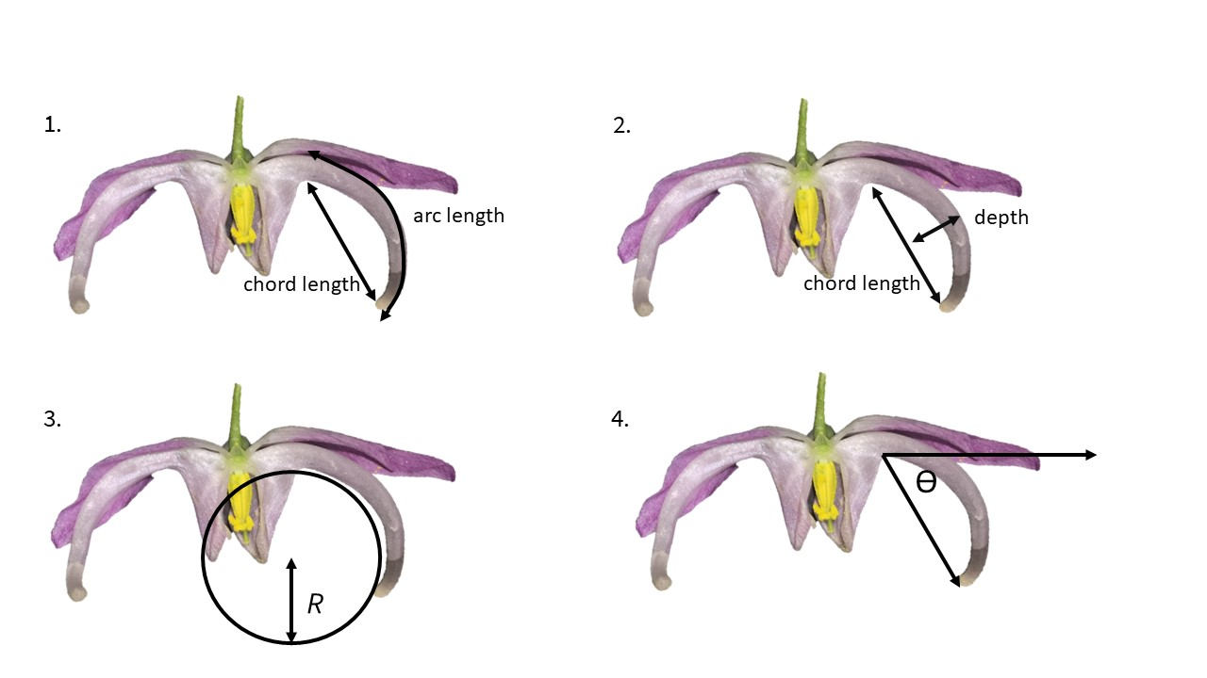

Figure 1. Overview of most commonly used curvature metrics within pollination ecology. 1. arc:chord ratio. 2. mandibular index 3. inverse radius. 4. angle of deflection

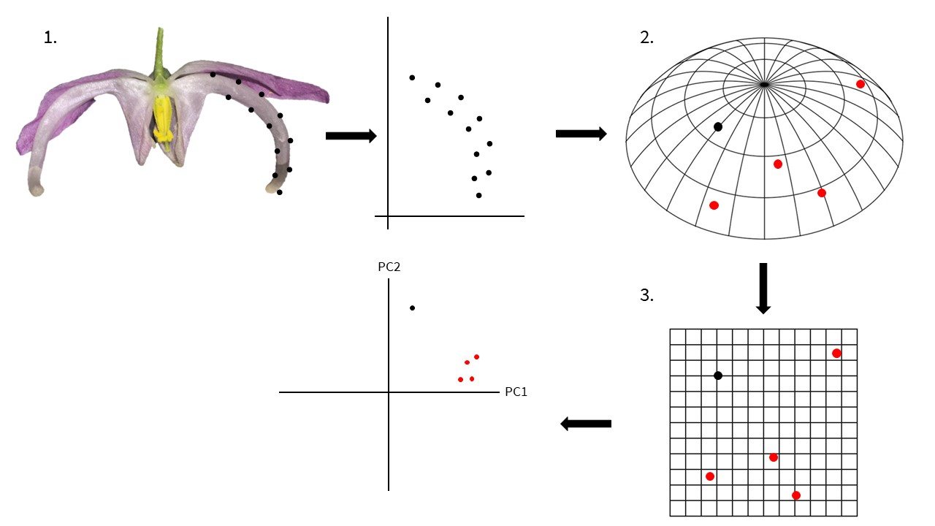

Figure 2. Overview of a geometric morphometrics protocol. 1. Landmarks and semi-landmarks are assigned to a specimen. Each landmark is assigned an xy coordinate. 2. For each specimen a configuration of landmarks exists as a single point in a non-Euclidian shape space (abstracted here as a sphere segment). Red points represent landmark configurations from other specimens. 3. Shape data is projected onto a Euclidian plane – a tangent space approximation. This allows statistical analyses of shape variation (e.g. principal components analysis).

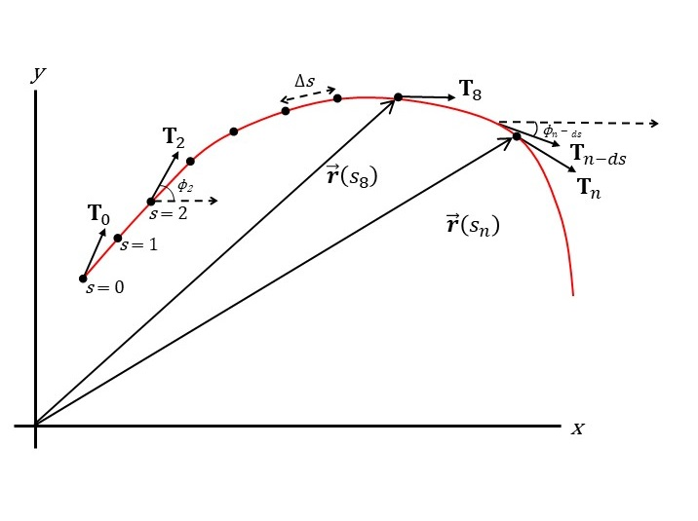

Figure 3. A curve parameterized by arc length, $s$. When $s=8$, the vector $r(s_{8})$ points to the location on the curve $(x_{8},y_{8})$. $T_{0}$, $T_{2}$, and $T_{8}$ are the tangents ( $\frac{dr}{ds}$) at $s=0$, $s=2$, and $s=8$, respectively. Curvature at $s_{i}$ is defined in equation (4).

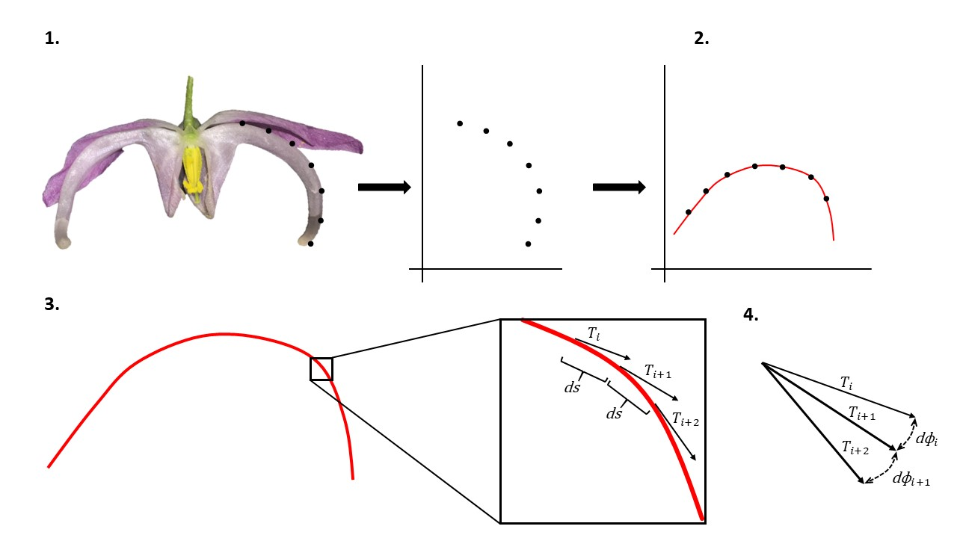

Figure 4: Proposed protocol for measuring curvature. 1. A specimen (in this case *Epimedium violaceum*) is landmarked, semi-landmarked and assigned *xy* coordinates within a Cartesian plane. 2. The *xy* coordinates are rotated so that a single-valued function can be fitted to the landmarks. 3. The tangent vector $T$ is calculated at an arbitrarily large number of increments, $ds$, along the curve. 4. Curvature is calculated as the rate of change of the tangent vectors point-wise along the curve. Total curvature is calculated by the methods outlined in Section 3.

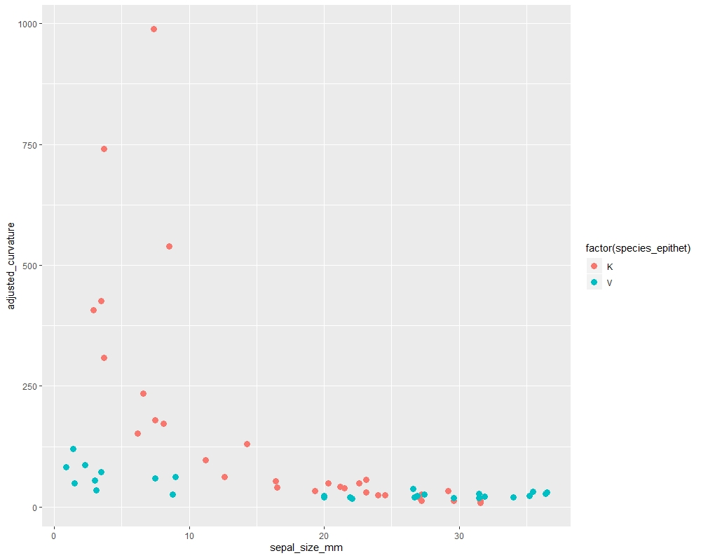

Figure 5: size vs curvature

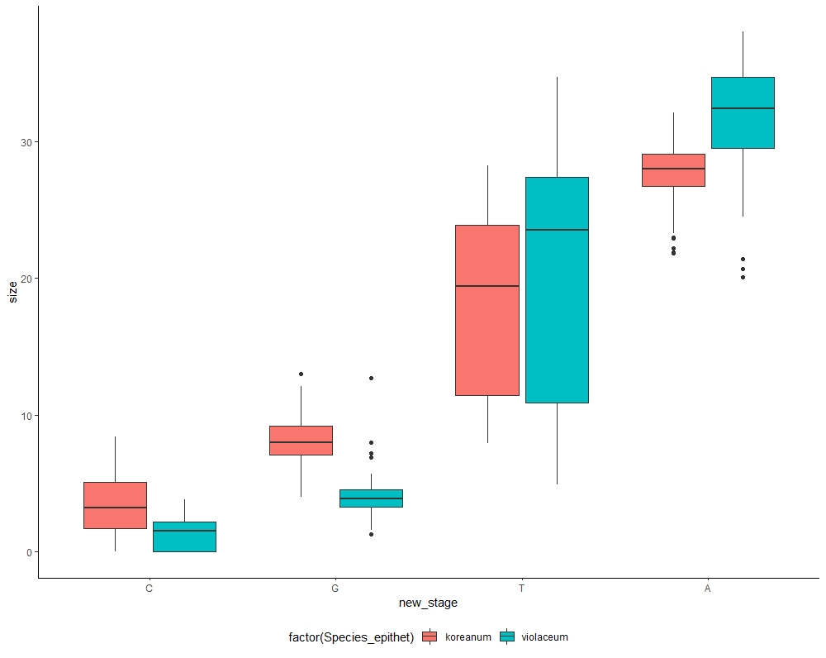

Figure S1: Comparison of developmental stages in *Epimedium*. Size is in mm. Tukey’s HSD: p<0.01 for all within-species comparisons

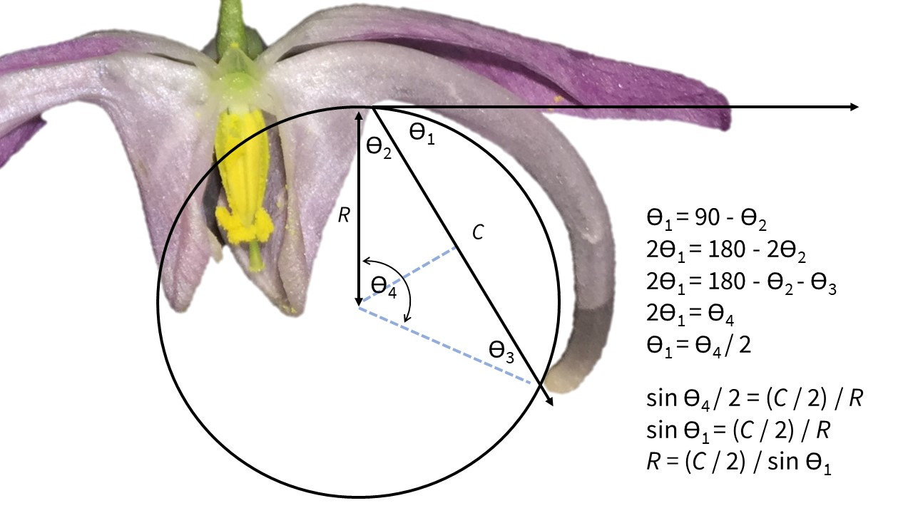

Figure S2. Demonstration that the angle of deflection and inverse radius methods are interchangeable

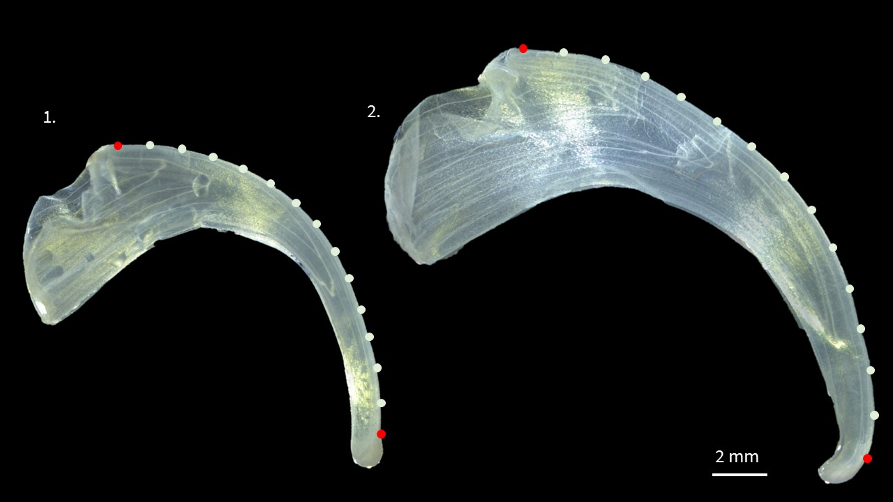

Figure S3. Landmarks (red) and semi-landmarks (white) used to compare curvature between *Epimedium* specimens. Left: *E. koreanum*, Top Right: *E. violaceum*. Petals sampled at anthesis.

Table 1: Summary of literature reviewed for the role of curvature in plant-pollinator systems.

|  |  |  |
| --- | --- | --- |
| Citation | System | Stated or Inferred Method |
| Feinsinger and Colwell (1978) | Community organization among neotropical nectar-feeding birds | arc:chord ratio |
| Snow and Snow (1972) | Feeding niches of hummingbirds in a Trinidad valley | qualitative |
| Stiles (1975) | Corolla morphology of *Heliconia* (Zingerberales) and bill morphology of nine hummingbird species at La Selva, Costa Rica. | qualitative |
| Gill and Wolf (1978) | Sunbird bill diversity and abilities to extract nectar from Kenyan *Leonotis nepetifolia* (Lamiaceae). | mandibular index |
| Carothers (1982) | Effects of trophic morphology and behavior on foraging rates of three Hawaiian honeycreeper | angle of deflection |
| Grant and Grant (1983) | Hawkmoth pollination of *Mirabilis longiflora* (Nyctaginaceae) | qualitative |
| Paton and Collins (1989) | Correlates (Geography, Age, Sex, Tongue structure, foraging mode) of bill morphology on nectar extraction 198 hummers (and other birds). | mandibular index |
| Smith et al. (1995) | Evolutionary Consequences of Extinctions in Populations of a Hawaiian Honeycreeper | inverse radius |
| Stiles (1995) | Effects of bill morphology on insect foraging strategy by 11 species of hummingbirds at La Selva, Costa Rica. | arc:chord ratio |
| Mclntyre and Browne (1996) | Phototropism in Helianthus and effects on cotyledon curvature | angle of deflection |
| Cotton (1998) | Survey and description of 16 hummingbird species occurring at Amacayacu National Park, Colombia. | qualitative |
| Temeles et al. (2000) | Sexual dimorphism of bill shape in Purple-throated caribs (*Eulampis jugularis*), pollinatiors of *Heliconia* at Quilesse Reserve, Saint Lucia. | angle of deflection, inverse radius |
| Borgella Jr et al. (2001) | Effects of bill morphology (21 hummingbird spp.) on pollen loads (35 plant spp.) at Coto Brus, Costa Rica. | arc:chord ratio |
| Temeles and Kress (2003) | Floral curvature in *Heliconia* pollinated by purple-throated caribs (*Eulampis jugularis*) | angle of deflection |
| Travers et al. (2003) | Nectar spurs of Impatiens spp. and Ruby-throated hummingbird (Archilochus colubris) at Franklin County, Massachusetts. | angle of deflection |
| Temeles et al. (2005) | Sexual dimorphism of bill shape in Purple-throated caribs (Eulampis jugularis), pollinatiors of Heliconia at Quilesse Reserve, Saint Lucia. | angle of deflection, inverse radius |
| Collins (2008) | Foraging efficiency from artificial and natural (15 spp.) flowers by 4 species of hummingbirds at Monteverde, Costa Rica | mandibular index |
| Stiles (2008) | Correlations of bill morphology to the elevational distributions of 150 spp. of hummingbirds in the Andes. | arc:chord ratio |
| Young (2008) | Selection on spur shape in *Impatiens capensis* (Balsaminaceae) | angle of deflection |
| Martén-Rodrı́guez et al. (2009) | Testing the pollination syndrome hypothesis in Antillean Gesneriaceae. | angle of deflection |
| Temeles et al. (2009) | Effects of natural (*Heliconia*) and artificial flower morphologies on foraging performance of purple-throated caribs (*Eulampis jugularis*) at Saint Lucia. | angle of deflection, inverse radius |
| Luo and Li (2010) | Effects of light and low temperature on the reciprocal style curvature of flexistylous *Alpinia* (Zingiberaceae) | angle of deflection |
| Temeles et al. (2010) | Sexual dimorphism of bill shape in 21 species of Central and South American hummingbirds. | angle of deflection, inverse radius |
| Berns and Adams (2010) | Sexual dimorphism of bill shape in black-chinned hummingbird (*Archilochus alexandri*) and ruby-throated hummingbird (*Archilochus colubris*). | geometric morphometrics |
| Berns and Adams (2013) | Sexual dimorphism of bill shape in 219 hummingbird spp. | geometric morphometrics |
| Wang et al. (2013) | Pollinators and nectar robbers cause directional selection for large spur circle in *Impatiens oxyanthera* (Balsaminaceae) | angle of deflection |
| Maglianesi et al. (2014) | Trait matching and resource use in a plant-hummingbird network, La Selva, Costa Rica. | angle of deflection |
| Rico-Guevara and Araya-Salas (2014) | Bills as weapons in lekking *Phaethornis longirostris* at La Selva, Costa Rica. | arc:chord ratio |
| Alexandre et al. (2015) | QTL analysis comparing hummingbird pollinated and generalist *Rhytidophyllum* flowers (Gesneriaceae). | angle of deflection |
| Maglianesi et al. (2015b) | Differential preferences of artificial and natural (65 spp.) flower populations visited by 3 species of hummingbird in Braulio Carrillo National Park, Costa Rica. | angle of deflection |
| Maglianesi et al. (2015a) | Plant-pollinator specialization along an elevational gradient at Braulio Carrillo National Park, Costa Rica. 21 hummingbird spp. and 208 plant species examined. | angle of deflection |
| Rocha et al. (2015) | Auxin and physical constraint exerted by the perianth promote androgynophore bending in *Passiflora mucronata* (Passifloraceae) | arc:chord ratio |
| Miller et al. (2017) | Ecological divergence among closely related, morphologically similar honeyeaters co-occurring in arid Australian environments | arc:chord ratio |
| Lagomarsino et al. (2017) | Evolution of pollination syndromes in Andean Campanulaceae. | arc:chord ratio |
| Boehm (2018) | Review of nectar robbing in *Centropogon* (Campanulaceae) | qualitative |
| Hadley et al. (2018) | Effects of forest fragmentation on hummingbird bill morphologies (19 spp.) representative of specialization. Coto Brus, Costa Rica. | arc:chord ratio |
| Joly et al. (2018) | Analysis of polliation syndromes in Antillean Gesneriaceae. | geometric morphometrics |
| Partida-Lara et al. (2018) | Spatio-temporal structure of the taxonomic and functional diversity of hummingbirds at the biosphere reserve El Triunfo, Chiapas, Mexico | inverse radius |
| Dellinger et al. (2019) | Floral trait changes correlated with the repeated shifts away from buzz pollination in the Melastomataceae. | qualitative |
| Sonne et al. (2019) | Distribution of morphological specialization along an elevational gradientin Ecuador. | arc:chord ratio |

Table S1: Additional literature reviewed for the role of curvature in plant-pollinator systems.

|  |  |  |
| --- | --- | --- |
| Citation | System | Stated or Inferred Method |
| Baldwin et al. (1931) | Measurements of birds | inverse radius |
| Hamilton (1975) | Comparative behavior of the American Avocet and the Black-necked Stilt (Recurvirostridae) | inverse radius |
| Buttrose et al. (1977) | Significance of curvature of style branches in *Hibiscus trionum* (Malvaceae) for pollination | qualitative |
| Mountainspring (1987) | sexual dimorphism and foraging preferences of the Hawaiian honeycreeper (*Pseudonestor xanthophrys*) | mandibular index |
| Muller (1995) | curved bristles on the proboscis on European bees for the extraction of pollen. | qualitative |
| Manning and Goldblatt (1997) | Tangle-veined fly pollination of South African Iridaceace, Geraniaceae, Orchidaceae | qualitative |
| Ortiz et al. (2000) | Pollination and breeding system of *Putoria calabrica* (Rubiaceae), a Mediterranean dwarf shrub | qualitative |
| Lindqvist et al. (2003) | Cladogenesis and reticulation in the Hawaiian endemic mints (Lamiaceae) | qualitative |
| Ruan et al. (2008) | The impact of pollen tube growth on stigma lobe curvature in *Kosteletzkya virginica* (Malvaceae) | qualitative |
| Kawabata et al. (2009) | Quantitative analysis of corolla shapes and petal contours in single-flower cultivars of *Lisianthus* (Gentianaceae) | fourier analysis |
| Dalayap et al. (2011) | Petal, sepal, and labellum shapes in Mokara orchids (Orchidaceae) | geometric morphometrics |
| Nii and Kawabata (2011) | Assessment of the association between the three-dimensional shape of the corolla and two-dimensional shapes of petals using Fourier descriptors and principal component analysis in *Eustoma grandiflorum* (Gentianaceae) | fourier analysis |
| Campos et al. (2015) | Generating 3D printed flowers to test efficacy of moth pollination | curve decay parameter |
| Berger et al. (2017) | Quantifying morphological modifications to floral form in gene knockdowns in *Fedia graciliflora* (Caprifoliaceae) | geometric morphometrics |
| Pour et al. (2018) | Curvature-based pattern recognition for cultivar classification of *Anthurium* (Araceae) flowers | point-wise curvature |
| Song et al. (2018) | Quantitative classification of the morphological traits of ray florets in large-flowered *Chrysanthemum* (Asteraceae) | angle of deflection |
| Peng et al. (2019) | Morphospace exploration reveals divergent fitness optima between plants and pollinators | curve decay parameter |

# References

Adams, D.C., and Otárola-Castillo, E. (2013). Geomorph: An R package for the collection and analysis of geometric morphometric shape data. Methods in Ecology and Evolution *4*, 393–399.

Alexandre, H., Vrignaud, J., Mangin, B., and Joly, S. (2015). Genetic architecture of pollination syndrome transition between hummingbird-specialist and generalist species in the genus *Rhytidophyllum* (Gesneriaceae). PeerJ *3*, e1028.

Armbruster, W.S., and Muchhala, N. (2009). Associations between floral specialization and species diversity: Cause, effect, or correlation? Evolutionary Ecology *23*, 159–179.

Baldwin, S.P., Oberholser, H.C., and Worley, L.G. (1931). Measurements of birds (Cleveland Museum of Natural History).

Bardini, G., and Gianella, G.M. (2016). A historical walk along the idea of curvature, from Newton to Gauss passing from Euler. International Mathematical Forum *11*, 259–278.

Bell, J. (1956). Tangent, chord theorem. The Mathematical Gazette *40*, 211–212.

Berger, B.A., Ricigliano, V.A., Savriama, Y., Lim, A., Thompson, V., and Howarth, D.G. (2017). Geometric morphometrics reveals shifts in flower shape symmetry and size following gene knockdown of *CYCLOIDEA* and *ANTHOCYANIDIN SYNTHASE*. BMC Plant Biology *17*, 205–214.

Berns, C.M., and Adams, D.C. (2010). Bill shape and sexual shape dimorphism between two species of temperate hummingbirds: Black-Chinned hummingbird (*Archilochus alexandri*) and Ruby-Throated hummingbird (*Archilochus colubris*). The Auk *127*, 626–635.

Berns, C.M., and Adams, D.C. (2013). Becoming different but staying alike: Patterns of sexual size and shape dimorphism in bills of hummingbirds. Evolutionary Biology *40*, 246–260.

Blüthgen, N., Menzel, F., and Blüthgen, N. (2006). Measuring specialization in species interaction networks. BMC Ecology *6*, 9–21.

Boehm, M. (2018). Biting the hand that feeds you: Wedge-billed hummingbird is a nectar robber of a sicklebill-adapted andean bellflower. Acta Amazonica *48*, 146–150.

Bonhomme, V., Picq, S., Gaucherel, C., and Claude, J. (2014). Momocs: Outline analysis using R. Journal of Statistical Software *56*, 1–24.

Bookstein, F.L. (1978). The measurement of biological shape and shape change (Springer Science & Business Media).

Bookstein, F.L. (1991). Morphometric tools for landmark data: geometry and biology (Cambridge University Press).

Borchers, H.W. (2019). Pracma: Practical numerical math functions. R package version 2.2.5.

Borgella Jr, R., Snow, A.A., and Gavin, T.A. (2001). Species richness and pollen loads of hummingbirds using forest fragments in southern Costa Rica. Biotropica *33*, 90–109.

Buttrose, M., Grant, W., and Lott, J. (1977). Reversible curvature of style branches of *Hibiscus trionum* L., a pollination mechanism. Australian Journal of Botany *25*, 567–570.

Campos, E.O., Bradshaw, H.D., and Daniel, T.L. (2015). Shape matters: Corolla curvature improves nectar discovery in the hawkmoth *Manduca sexta*. Functional Ecology *29*, 462–468.

Cardinal, S., and Danforth, B.N. (2013). Bees diversified in the age of eudicots. Proceedings of the Royal Society B: Biological Sciences *280*, 20122686.

Carothers, J.H. (1982). Effects of trophic morphology and behavior on foraging rates of three Hawaiian honeycreepers. Oecologia *55*, 157–159.

Casey, J. (1996). Exploring Curvature (Braunschweig, Germany: Friedr. Vieweg & Sohn Verlagsgesellschaft mbH).

Claude, J. (2008). Morphometrics with R (Springer Science & Business Media).

Coen, E., and Rebocho, A.B. (2016). Resolving conflicts: Modeling genetic control of plant morphogenesis. Developmental Cell *38*, 579–583.

Collins, B.G. (2008). Nectar intake and foraging efficiency: Responses of honeyeaters and hummingbirds to variations in floral environments. The Auk *125*, 574–587.

Coolidge, J.L. (1952). The unsatisfactory story of curvature. The American Mathematical Monthly *59*, 375–379.

Cosgrove, D.J. (1990). Rapid, bilateral changes in growth rate and curvature during gravitropism of cucumber hypocotyls: Implications for mechanism of growth control. Plant, Cell & Environment *13*, 227–234.

Cotton, P.A. (1998). Temporal partitioning of a floral resource by territorial hummingbirds. Ibis *140*, 647–653.

Dalayap, R.M., Torres, M.A.J., and Demayo, C.G. (2011). Landmark and outline methods in describing petal, sepal and labellum shapes of the flower of mokara orchid varieties. International Journal of Agriculture and Biology *13*, 652–658.

Dehling, D.M., Töpfer, T., Schaefer, H.M., Jordano, P., Böhning-Gaese, K., and Schleuning, M. (2014). Functional relationships beyond species richness patterns: Trait matching in plant–bird mutualisms across scales. Global Ecology and Biogeography *23*, 1085–1093.

Dellinger, A.S., Chartier, M., Fernández-Fernández, D., Penneys, D.S., Alvear, M., Almeda, F., Michelangeli, F.A., Staedler, Y., Armbruster, W.S., and Schönenberger, J. (2019). Beyond buzz-pollination–departures from an adaptive plateau lead to new pollination syndromes. New Phytologist *221*, 1136–1149.

Feinsinger, P., and Colwell, R.K. (1978). Community organization among neotropical nectar-feeding birds. American Zoologist *18*, 779–795.

Gill, F.B., and Wolf, L.L. (1978). Comparative foraging efficiencies of some montane sunbirds in Kenya. The Condor *80*, 391–400.

Gómez, J., Perfectti, F., Bosch, J., and Camacho, J. (2009). A geographic selection mosaic in a generalized plant–pollinator–herbivore system. Ecological Monographs *79*, 245–263.

Graham, C.H., Parra, J.L., Rahbek, C., and McGuire, J.A. (2009). Phylogenetic structure in tropical hummingbird communities. Proceedings of the National Academy of Sciences *106*, 19673–19678.

Grant, V. (1949). Pollination systems as isolating mechanisms in angiosperms. Evolution *3*, 82–97.

Grant, V., and Grant, K.A. (1983). Hawkmoth pollination of *Mirabilis longiflora* (Nyctaginaceae). Proceedings of the National Academy of Sciences *80*, 1298–1299.

Hadley, A.S., Frey, S.J., Robinson, W.D., and Betts, M.G. (2018). Forest fragmentation and loss reduce richness, availability, and specialization in tropical hummingbird communities. Biotropica *50*, 74–83.

Hainsworth, F.R. (1973). On the tongue of a hummingbird: Its role in the rate and energetics of feeding. Comparative Biochemistry and Physiology Part A: Physiology *46*, 65–78.

Hamilton, R.B. (1975). Comparative behavior of the American Avocet and the Black-necked Stilt (Recurvirostridae). Ornithological Monographs iii–98.

Hodges, S.A., and Arnold, M.L. (1995). Spurring plant diversification: Are floral nectar spurs a key innovation? Proceedings of the Royal Society of London. Series B: Biological Sciences *262*, 343–348.

Hughes, M., Möller, M., Edwards, T.J., Bellstedt, D.U., and De Villiers, M. (2007). The impact of pollination syndrome and habitat on gene flow: A comparative study of two *Streptocarpus* (Gesneriaceae) species. American Journal of Botany *94*, 1688–1695.

Joly, S., Lambert, F., Alexandre, H., Clavel, J., Léveillé-Bourret, É., and Clark, J.L. (2018). Greater pollination generalization is not associated with reduced constraints on corolla shape in Antillean plants. Evolution *72*, 244–260.

Kawabata, S., Yokoo, M., and Nii, K. (2009). Quantitative analysis of corolla shapes and petal contours in single-flower cultivars of *Lisianthus*. Scientia Horticulturae *121*, 206–212.

Kay, K.M., and Sargent, R.D. (2009). The role of animal pollination in plant speciation: Integrating ecology, geography, and genetics. Annual Review of Ecology, Evolution, and Systematics *40*, 637–656.

Lagomarsino, L.P., and Muchhala, N. (2019). A gradient of pollination specialization in three species of Bolivian *Centropogon*. American Journal of Botany *106*, 633–642.

Lagomarsino, L.P., Forrestel, E.J., Muchhala, N., and Davis, C.C. (2017). Repeated evolution of vertebrate pollination syndromes in a recently diverged Andean plant clade. Evolution *71*, 1970–1985.

Lindqvist, C., Motley, T.J., Jeffrey, J.J., and Albert, V.A. (2003). Cladogenesis and reticulation in the Hawaiian endemic mints (Lamiaceae). Cladistics *19*, 480–495.

Luo, Y.-L., and Li, Q.-J. (2010). Effects of light and low temperature on the reciprocal style curvature of flexistylous Alpinia species (Zingiberaceae). Acta Physiologiae Plantarum *32*, 1229–1234.

MacLeod, N. (2002). Geometric morphometrics and geological shape-classification systems. Earth-Science Reviews *59*, 27–47.

MacLeod, N., and Rose, K.D. (1993). Inferring locomotor behavior in paleogene mammals via eigenshape analysis. American Journal of Science *293*, 300–355.

Maglianesi, M.A., Blüthgen, N., Böhning-Gaese, K., and Schleuning, M. (2014). Morphological traits determine specialization and resource use in plant–hummingbird networks in the Neotropics. Ecology *95*, 3325–3334.

Maglianesi, M.A., Blüthgen, N., Böhning-Gaese, K., and Schleuning, M. (2015a). Functional structure and specialization in three tropical plant–hummingbird interaction networks across an elevational gradient in Costa Rica. Ecography *38*, 1119–1128.

Maglianesi, M.A., Böhning-Gaese, K., and Schleuning, M. (2015b). Different foraging preferences of hummingbirds on artificial and natural flowers reveal mechanisms structuring plant–pollinator interactions. Journal of Animal Ecology *84*, 655–664.

Manning, J.C., and Goldblatt, P. (1997). The *Moegistorhynchus longirostris* (diptera: Nemestrinidae) pollination guild: Long-tubed flowers and a specialized long-proboscid fly pollination system in southern Africa. Plant Systematics and Evolution *206*, 51–69.

Martén-Rodrı́guez, S., Almarales-Castro, A., and Fenster, C.B. (2009). Evaluation of pollination syndromes in Antillean Gesneriaceae: Evidence for bat, hummingbird and generalized flowers. Journal of Ecology *97*, 348–359.

Mclntyre, G., and Browne, K. (1996). Effect of darkening the cotyledons on the growth and curvature of the sunflower hypocotyl: Evidence of hydraulic signalling. Journal of Experimental Botany *47*, 1561–1566.

Miller, E.T., Wagner, S.K., Harmon, L.J., and Ricklefs, R.E. (2017). Radiating despite a lack of character: Ecological divergence among closely related, morphologically similar honeyeaters (Aves: Meliphagidae) co-occurring in arid Australian environments. The American Naturalist *189*, E14–E30.

Milnor, J. (1954). On total curvatures of closed space curves. Mathematica Scandinavica *1*, 289–296.

Minnaar, C., Jager, M. de, and Anderson, B. (2019). Intraspecific divergence in floral-tube length promotes asymmetric pollen movement and reproductive isolation. New Phytologist 1160–1170.

Mountainspring, S. (1987). Ecology, behavior, and conservation of the Maui Parrotbill. The Condor *89*, 24–39.

Muller, A. (1995). Morphological specializations in Central European bees for the uptake of pollen from flowers with anthers hidden in narrow corolla tubes (Hymenoptera: Apoidea). Entomologia Generalis *20*, 43–57.

Nath, U., Crawford, B.C., Carpenter, R., and Coen, E. (2003). Genetic control of surface curvature. Science *299*, 1404–1407.

Niet, T. van der, and Johnson, S.D. (2012). Phylogenetic evidence for pollinator-driven diversification of angiosperms. Trends in Ecology & Evolution *27*, 353–361.

Nii, K., and Kawabata, S. (2011). Assessment of the association between the three-dimensional shape of the corolla and two-dimensional shapes of petals using Fourier descriptors and principal component analysis in *Eustoma grandiflorum*. Journal of the Japanese Society for Horticultural Science *80*, 200–205.

Nilsson, L.A. (1988). The evolution of flowers with deep corolla tubes. Nature *334*, 147–149.

Ollerton, J. (2017). Pollinator diversity: Distribution, ecological function, and conservation. Annual Review of Ecology, Evolution, and Systematics *48*, 353–376.

Olsen, A.M. (2017). Feeding ecology is the primary driver of beak shape diversification in waterfowl. Functional Ecology *31*, 1985–1995.

Ortiz, P., Arista, M., and Talavera, S. (2000). Pollination and breeding system of *Putoria calabrica* (Rubiaceae), a Mediterranean dwarf shrub. Plant Biology *2*, 325–330.

Partida-Lara, R., Enriquez, P.L., Vazquez Perez, J.R., and Pineda Diez de Bonilla, E. (2018). Spatio-temporal structure of the taxonomic and functional diversity of hummingbirds at the biosphere reserve El Triunfo, Chiapas, Mexico. Ornitologia Neotropical *29*, 37–50.

Paton, D., and Collins, B. (1989). Bills and tongues of nectar-feeding birds: A review of morphology, function and performance, with intercontinental comparisons. Australian Journal of Ecology *14*, 473–506.

Peng, F., Campos, E.O., Sullivan, J.G., Berry, N., Song, B.B., Daniel, T.L., and Bradshaw Jr, H. (2019). Morphospace exploration reveals divergent fitness optima between plants and pollinators. PloS One *14*, e0213029.

Pour, A.S., Chegini, G., Zarafshan, P., and Massah, J. (2018). Curvature-based pattern recognition for cultivar classification of *Anthurium* flowers. Postharvest Biology and Technology *139*, 67–74.

Preibisch, S., Saalfeld, S., and Tomancak, P. (2009). Globally optimal stitching of tiled 3D microscopic image acquisitions. Bioinformatics *25*, 1463–1465.

R Core Team (2017). R: A language and environment for statistical computing (Vienna, Austria: R Foundation for Statistical Computing).

Rico-Guevara, A., and Araya-Salas, M. (2014). Bills as daggers? A test for sexually dimorphic weapons in a lekking hummingbird. Behavioral Ecology *26*, 21–29.

Robertson, C. (1889). Flowers and Insects. II. Botanical Gazette *14*, 172–178.

Rocha, D., Monte Bello, C., Sobol, S., Samach, A., and Dornelas, M. (2015). Auxin and physical constraint exerted by the perianth promote androgynophore bending in *Passiflora mucronata* L. (Passifloraceae). Plant Biology *17*, 639–646.

Rohlf, F.J. (2015). The tps series of software. Hystrix *26*.

Rolhf, F.J. (1990). Fitting Curves to Outlines. In Proceedings of the Michigan Morphometrics Workshop, F.J. Rolhf, and F.L. Bookstein, eds. (Ann Arbor, MI: University of Michigan Museum of Zoology), pp. 177–188.

Ruan, C., Li, H., and Mopper, S. (2008). The impact of pollen tube growth on stigma lobe curvature in *Kosteletzkya virginica*: The best of both worlds. South African Journal of Botany *74*, 65–70.

Rueden, C.T., Schindelin, J., Hiner, M.C., DeZonia, B.E., Walter, A.E., Arena, E.T., and Eliceiri, K.W. (2017). ImageJ2: ImageJ for the next generation of scientific image data. BMC Bioinformatics *18*, 529–555.

Rutter, J.W. (2000). Geometry of Curves (Boca Raton, FL: CRC Press, Taylor; Francis Group).

Scott-Elliot, G. (1890). Ornithophilous flowers in South Africa. Annals of Botany *4*, 265–280.

Silva, A.R. da, and Lima, R.P. de (2017). Determination of maximum curvature point with the R package soilphysics. International Journal of Current Research *9*, 45241–45245.

Smith, T.B., Freed, L.A., Lepson, J.K., and Carothers, J.H. (1995). Evolutionary consequences of extinctions in populations of a Hawaiian honeycreeper. Conservation Biology *9*, 107–113.

Snow, B.K., and Snow, D. (1972). Feeding niches of hummingbirds in a Trinidad valley. The Journal of Animal Ecology 471–485.

Song, X., Gao, K., Fan, G., Zhao, X., Liu, Z., and Dai, S. (2018). Quantitative classification of the morphological traits of ray florets in large-flowered Chrysanthemum. HortScience *53*, 1258–1265.

Sonne, J., Zanata, T.B., Martı́n González, A.M., Cumbicus Torres, N.L., Fjeldså, J., Colwell, R.K., Tinoco, B.A., Rahbek, C., and Dalsgaard, B. (2019). The distributions of morphologically specialized hummingbirds coincide with floral trait matching across an Andean elevational gradient. Biotropica *51*, 205–218.

Stearn, W.T. (2002). The genus *Epimedium* and other herbacious Berberidaceae including the genus *Podophyllum* (Portland, OR: Timber Press, Inc.).

Stiles, F.G. (1975). Ecology, flowering phenology, and hummingbird pollination of some Costa Rican *Heliconia* species. Ecology *56*, 285–301.

Stiles, F.G. (1995). Behavioral, ecological and morphological correlates of foraging for arthropods by the hummingbirds of a tropical wet forest. Condor 853–878.

Stiles, F.G. (2004). Phylogenetic constraints upon morphological and ecological adaptation in hummingbirds (Trochilidae): Why are there no hermits in the paramo. Ornitologia Neotropical *15*, 191–198.

Stiles, F.G. (2008). Ecomorphology and phylogeny of hummingbirds: Divergence and convergence in adaptations to high elevations. Ornitologia Neotropical *19*, 511–519.

Suzuki, K. (1984). Pollination system and its significance on isolation and hybridization in Japanese *Epimedium* (Berberidaceae). The Journal of Plant Research *97*, 381–396.

Temeles, E.J. (1996). A new dimension to hummingbird-flower relationships. Oecologia *105*, 517–523.

Temeles, E.J., and Kress, W.J. (2003). Adaptation in a plant-hummingbird association. Science *300*, 630–633.

Temeles, E.J., Pan, I.L., Brennan, J.L., and Horwitt, J.N. (2000). Evidence for ecological causation of sexual dimorphism in a hummingbird. Science *289*, 441–443.

Temeles, E.J., Goldman, R.S., and Kudla, A.U. (2005). Foraging and territory economics of sexually dimorphic Purple-Throated Caribs (*Eulampis jugularis*) on three *Heliconia* morphs. The Auk *122*, 187–204.

Temeles, E.J., Koulouris, C.R., Sander, S.E., and Kress, W.J. (2009). Effect of flower shape and size on foraging performance and trade-offs in a tropical hummingbird. Ecology *90*, 1147–1161.

Temeles, E.J., Miller, J.S., and Rifkin, J.L. (2010). Evolution of sexual dimorphism in bill size and shape of hermit hummingbirds (Phaethornithinae): A role for ecological causation. Philosophical Transactions of the Royal Society B: Biological Sciences *365*, 1053–1063.

Terral, J.-F., Alonso, N., Capdevila, R.B. i, Chatti, N., Fabre, L., Fiorentino, G., Marinval, P., Jordá, G.P., Pradat, B., and Rovira, N. (2004). Historical biogeography of olive domestication (*Olea europaea* L.) as revealed by geometrical morphometry applied to biological and archaeological material. Journal of Biogeography *31*, 63–77.

Travers, S.E., Temeles, E.J., and Pan, I. (2003). The relationship between nectar spur curvature in jewelweed (*Impatiens capensis*) and pollen removal by hummingbird pollinators. Canadian Journal of Botany *81*, 164–170.

Tripp, E.A., and McDade, L.A. (2013). Time-calibrated phylogenies of hummingbirds and hummingbird-pollinated plants reject a hypothesis of diffuse co-evolution. Aliso: A Journal of Systematic and Evolutionary Botany *31*, 89–103.

Vamosi, J.C., Magallón, S., Mayrose, I., Otto, S.P., and Sauquet, H. (2018). Macroevolutionary patterns of flowering plant speciation and extinction. Annual Review of Plant Biology *69*, 685–706.

Wang, Q., Li, Y., Pu, X., Zhu, L., Tang, Z., and Liu, Q. (2013). Pollinators and nectar robbers cause directional selection for large spur circle in *Impatiens oxyanthera* (Balsaminaceae). Plant Systematics and Evolution *299*, 1263–1274.

Webster, M., and Sheets, H.D. (2010). A practical introduction to landmark-based geometric morphometrics. The Paleontological Society Papers *16*, 163–188.

Young, H.J. (2008). Selection on spur shape in *Impatiens capensis*. Oecologia *156*, 535–543.

Zahn, C.T., and Roskies, R.Z. (1972). Fourier descriptors for plane closed curves. IEEE Transactions on Computers *100*, 269–281.