**OUTLIER DETECTION LIVEBOOK: NOTES**

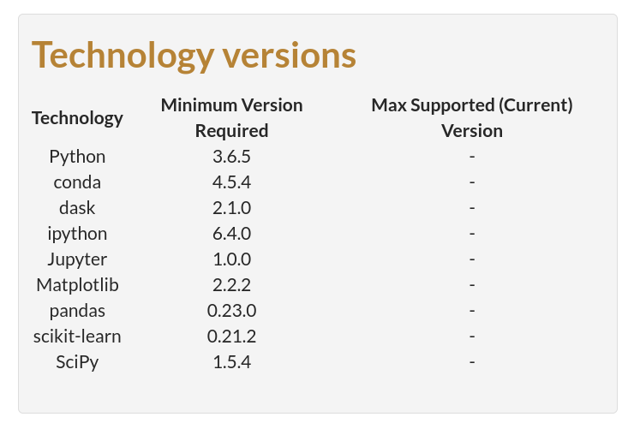

**Conda Environment:** AnomDetn

conda activate AnomDetn

conda activate AnomDetn

conda --version

conda 4.13.0

conda install -n AnomDetn

# https://docs.conda.io/projects/conda/en/stable/user-guide/tasks/manage-python.html

conda install -c anaconda python=3.8

conda install -c anaconda dask ipython Jupyter Matplotlib pandas scikit-learn SciPy

Documented in more detail under Technical:Projects:Learning:Manning Anomaly Detection

