**J2ME**

Car Rental Mobile Application

**Car Rental**

This application is based on customer registering a Car Rental. The name of the Company is XYZ Car Rental. In the first screen the customer enter his LoginID and password to access the system. After entering the system, user have to select a car of his choice from the list of car displayed on the form. Then customer is provided with date selection form and customer select the date (date in) he want to rent the car and the date he will return the car to the rental office (date out). Then system will inform the customer of his registration information and the confirmation number to the customer.

The ContactUs menu will display the information about how the customer will contact the rental car company. The Location menu displays all the location of the rental car company in the neighborhood. CarModel menu display all the available car model in the company, customer can view all the model before he can register the car. The RecordDisplay menu will store the current registration in the Record Store. All the bookings are stored in the system as soon as customer books his car and this menu will display all the customer who has registered in the system already.

**Setup:**

**Database** directory is the Servlet implementation.

**MobileApplication1** directory is the mobile application.

Both applications are developed using NetBeans IDE 6.01 and Database is compiled and deployed in Tomcat Server embedded in the NetBeans IDE.

The J2ME application was developed using *NetBeans IDE 6.0.1.*

Servelet was developed using NetBeans IDE 6.0.1 and is deployed in the TOMCAT server 6.0.14.

J2ME Wireless Toolkit 2.5.2 embedded with NetBeans used for this project.

**Servlet Implementation:**

The servlet was implemented and is deployed in the Tomcat Server. The first command that is passed as an argument to the servlet is command. The servlet will read other parameters in the URL and invoke particular function based on the command that is sent from the mobile application.

E.g.,

final String url = "http://localhost:8084/Database/NewServlet?cmd=new&name="+userName.getString()+"&acc="+password.getString();

From the above url, cmd is the command that servlet will use to invoke particular function and and the user name and password are passed to the servlet using this url.

class RentalInfo created in the servlet to store the customer booking information in the ArrayList that is coming from the mobile application. The ArrayList store all the customer information for later reterival.

**Application Implementation:**

The mobile application opens network connection using the url that is created in the application. Separate thread is used in order to retrieve the data from the server to avoid the deadlock.

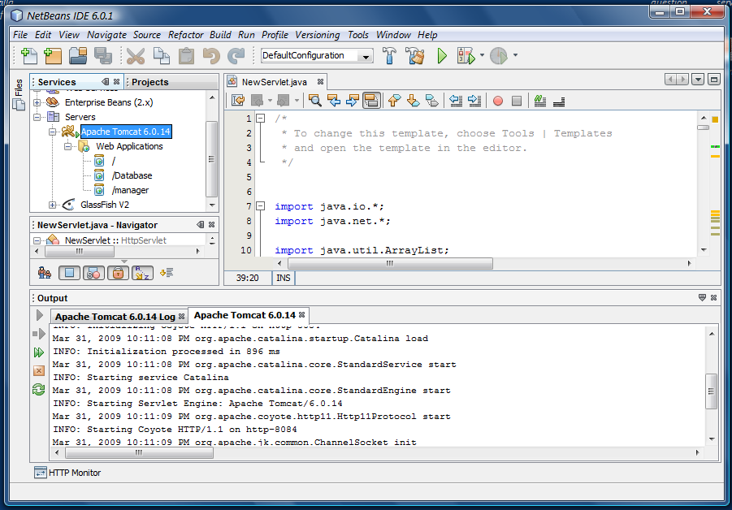

**Mobile Application Implementation:**

The mobile application is designed with a ticker item which will display all the available car in the rental company.

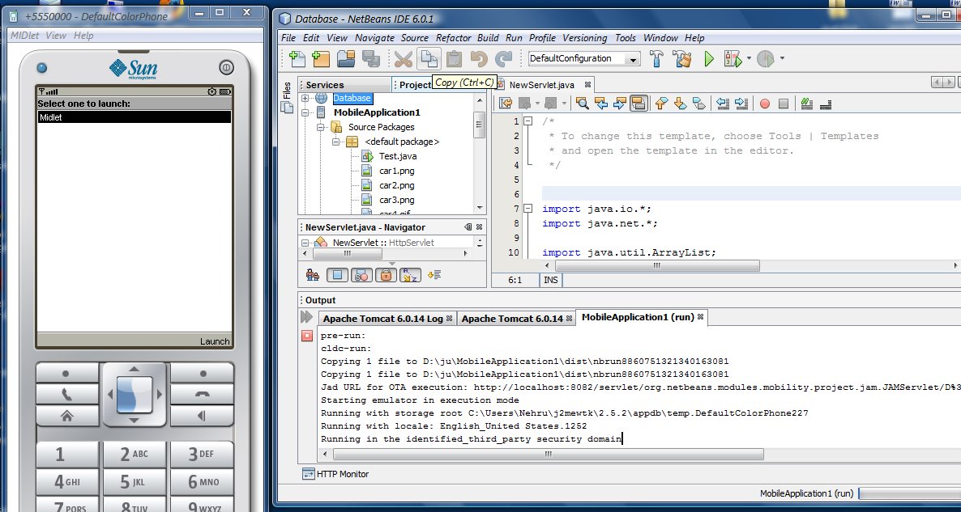

The above figure shows the application launch.

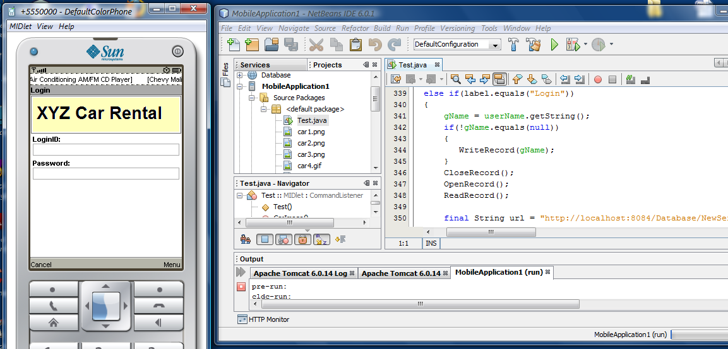

Initial application for customer input.

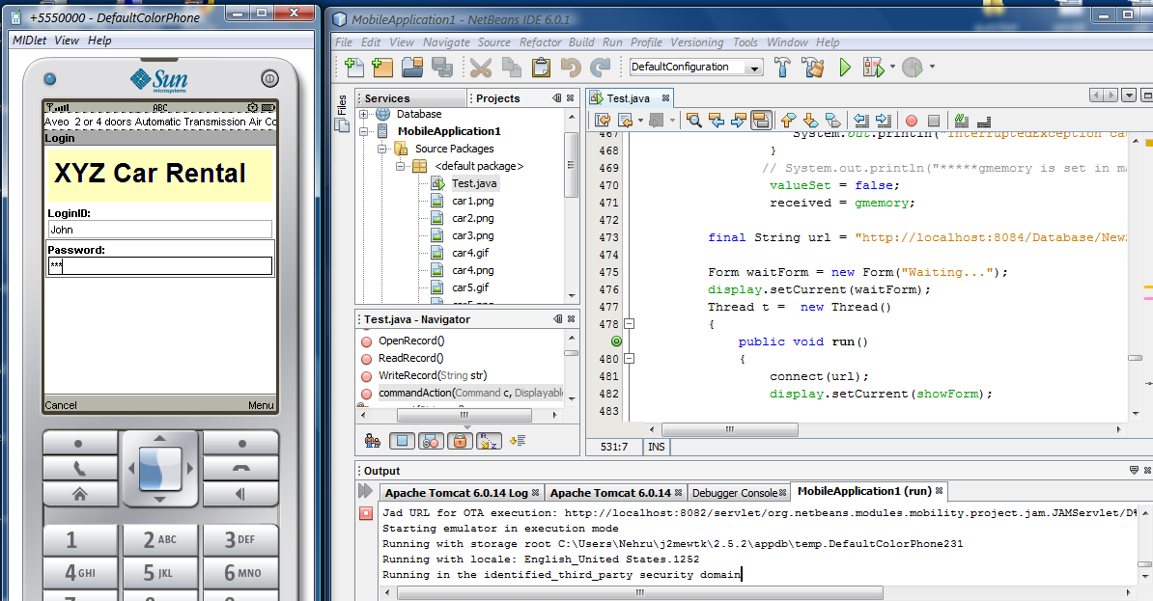

Customer enters his name and password to login to system for car booking.

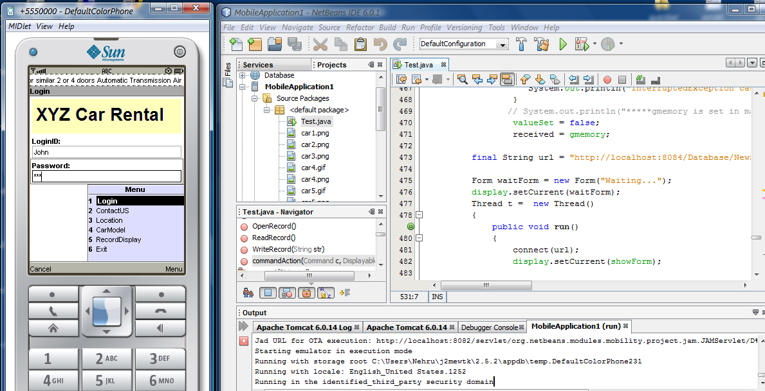

Menu displays all the available menu items on the application.

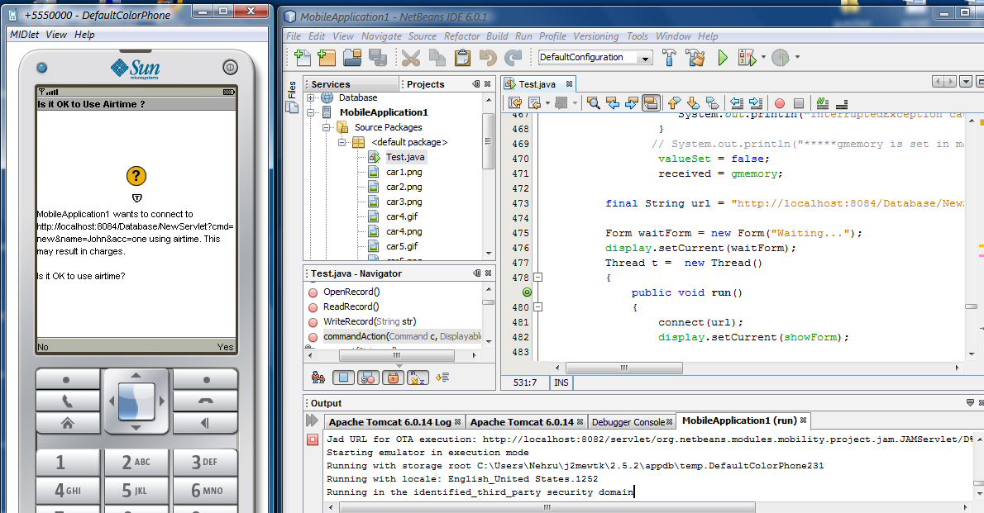

Waiting for permission from the customer for connecting the application server (Tomcat) in order to invoke servlet.

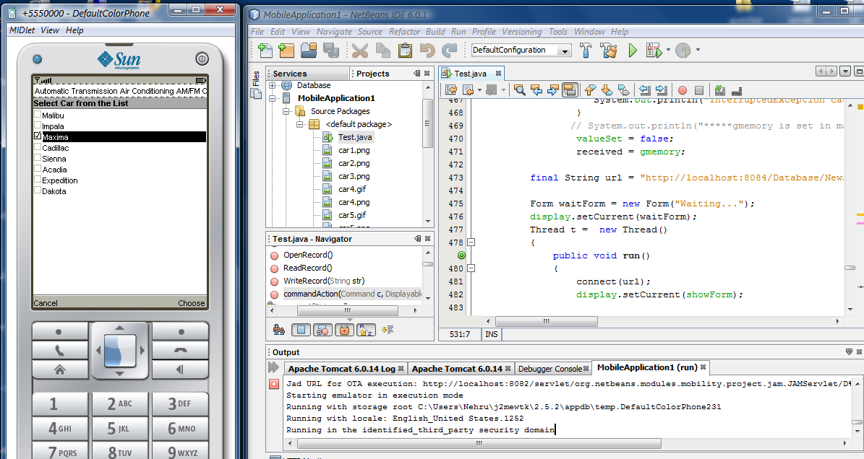

Customer selected car model Maxima car from the list.

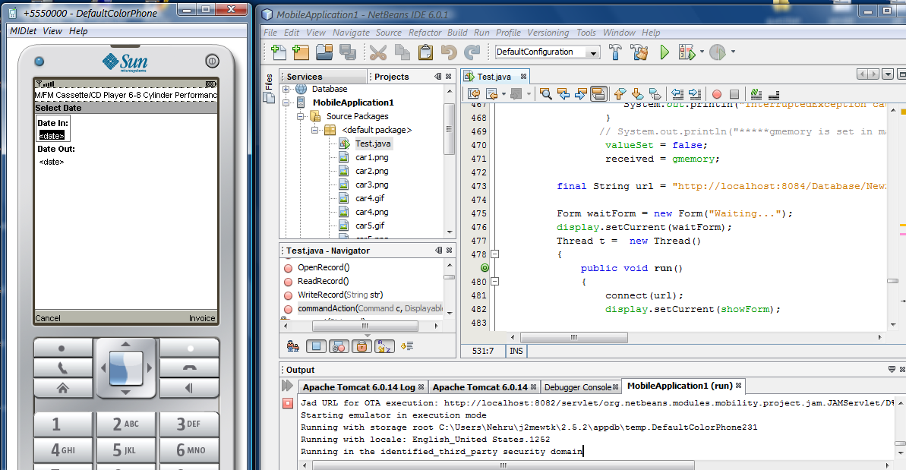

Customers have to select the car rental dates.

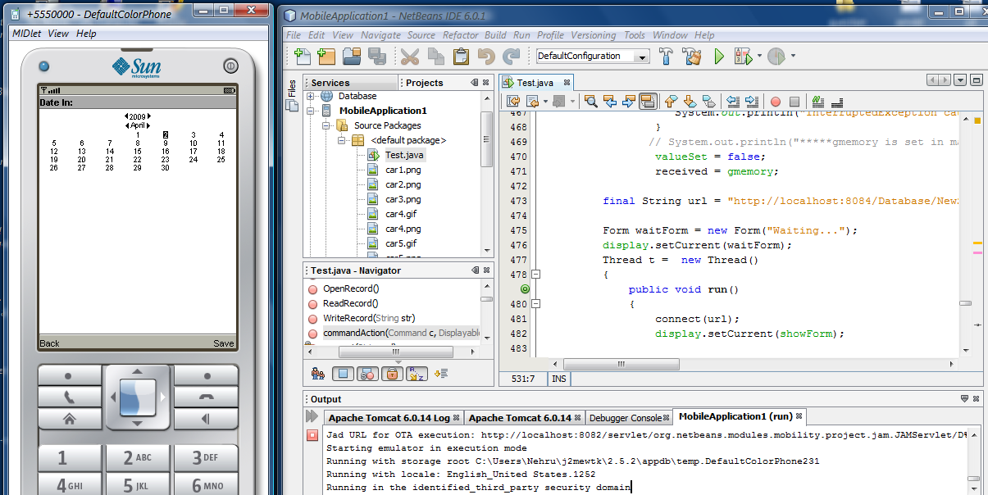

Select date from the above show figure.

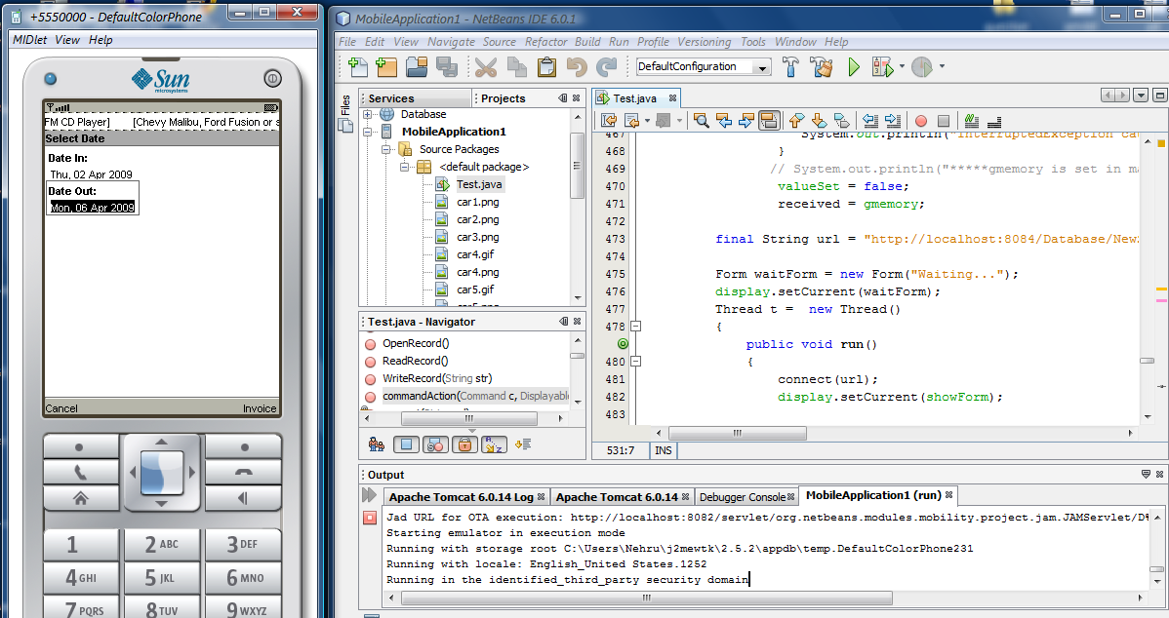

Customer selected the car rental date.

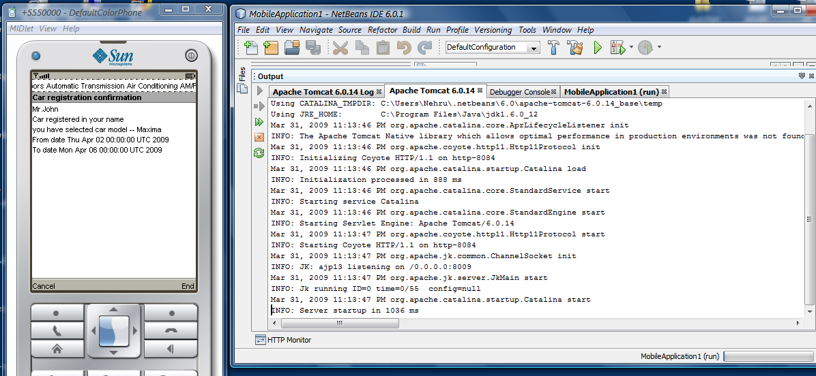

System displays the car registration information.

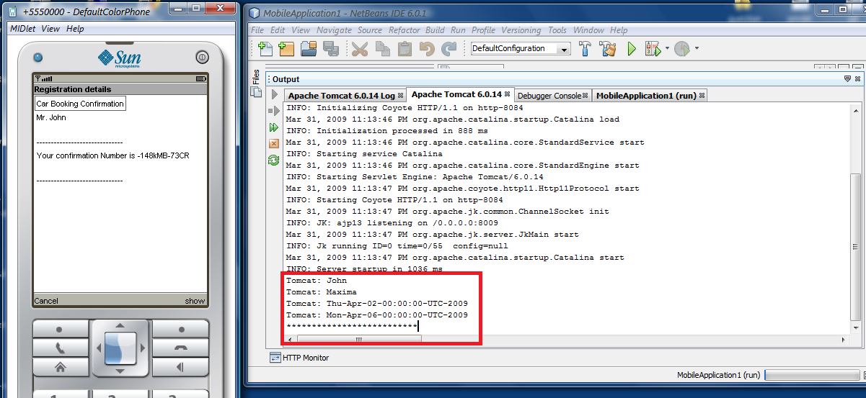

System displays the confirmation number and the Tomcat server displays the User information that is retrieved from the ArrayList in the Servlet in the Tomcat Server.

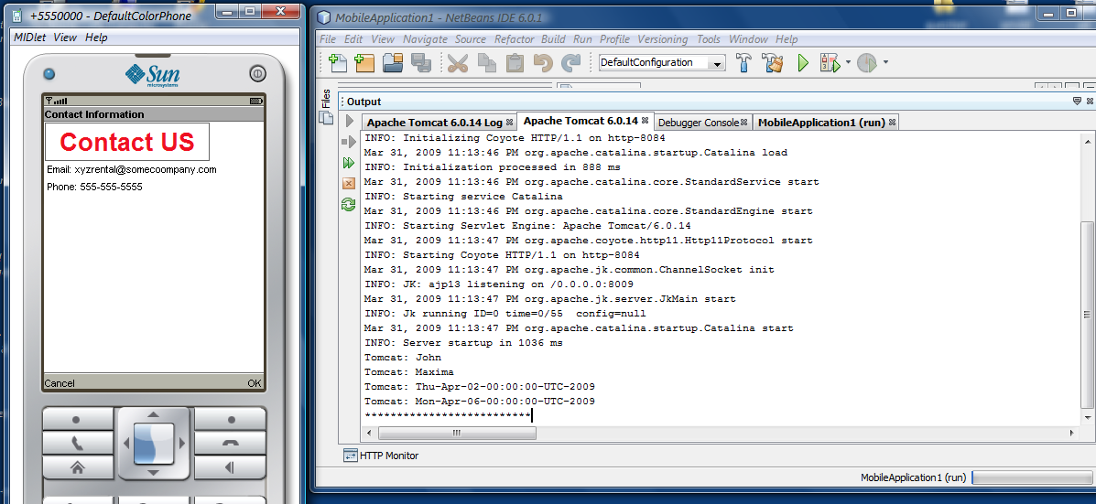

Contact information for the Rental Company.

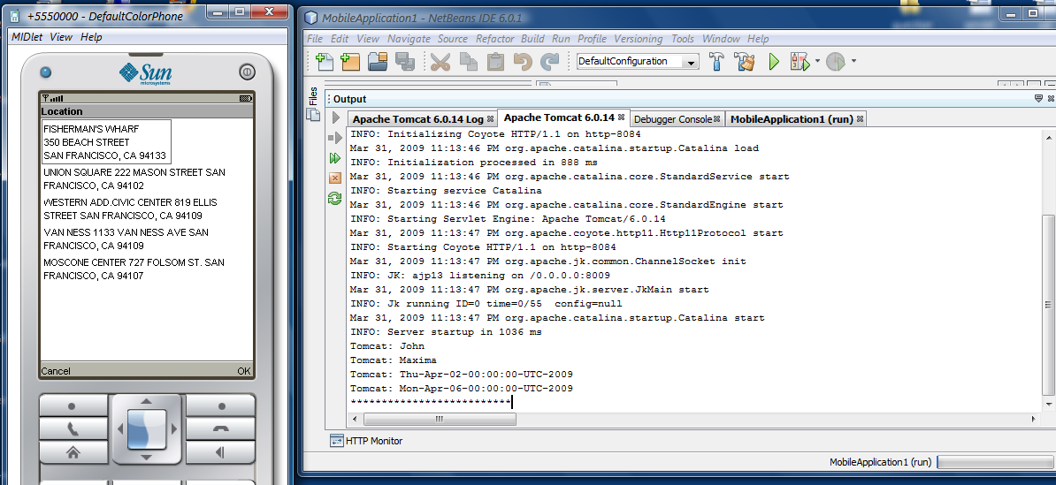

Above figure displays the other locations of the car company.

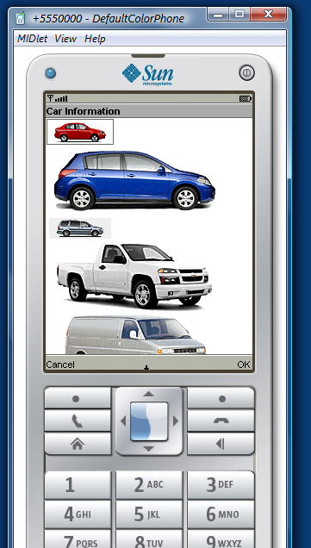

Displays available car model in the company.

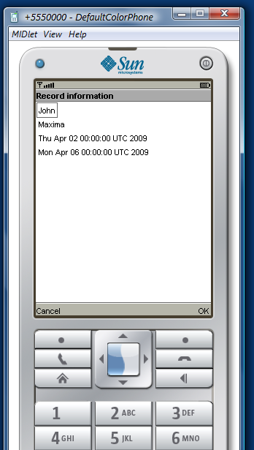

Displays the data that was stored by using persistent feature provided by J2me.

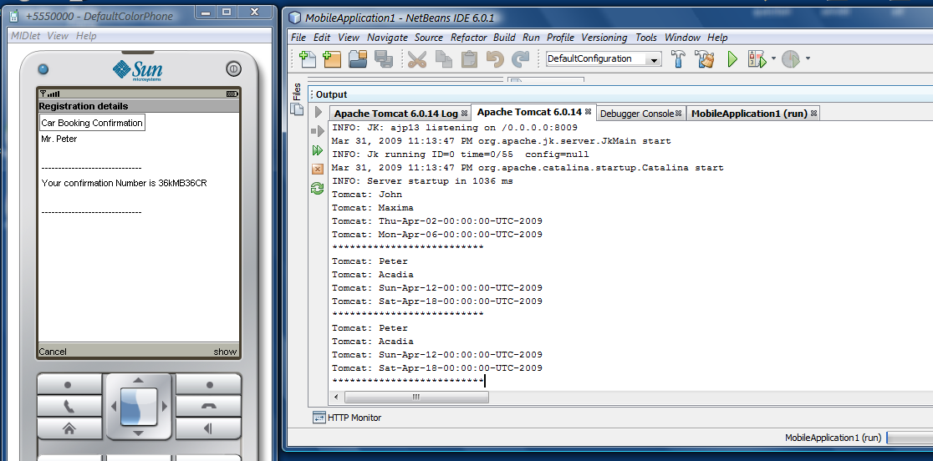

Different customer booking a car.

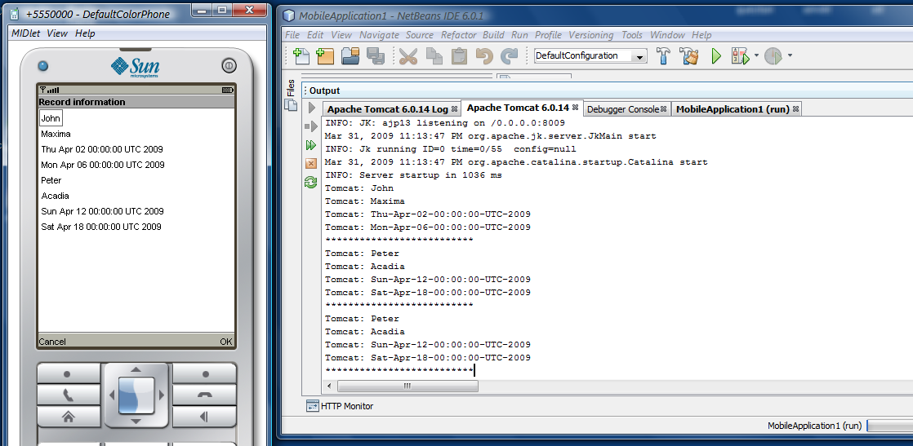

Persistent feature in J2ME displays the local stored data.

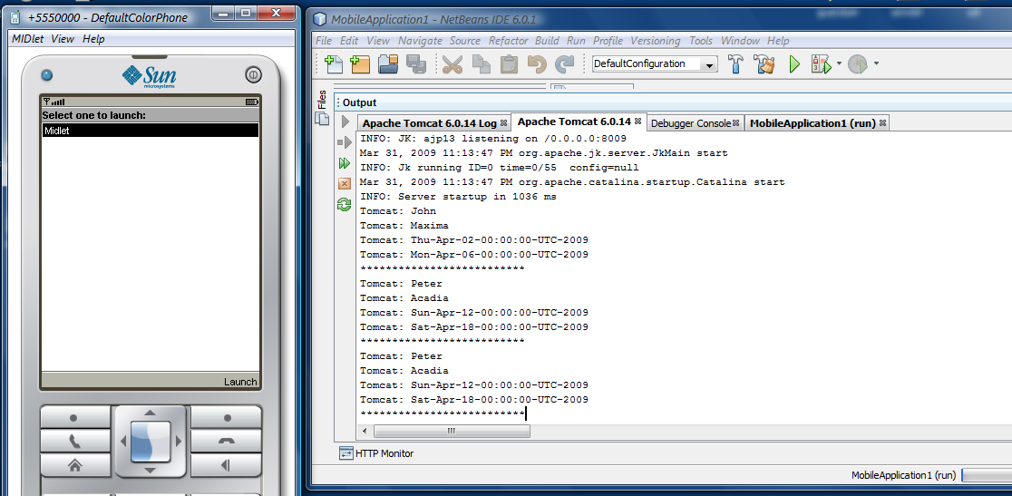

Exit menu helps to exit the car rental application from the mobile phone.

Technical merit consists of how the application contains all the features in order to perform flawlessly. Artistic merit consists of how we present the application to the customers and ease of use i.e., graphical user interface and picture. Ease of use is an important aspect of an application.