Understanding Audience & Personas
Brand: Spice Garden
Completed Activities: Customer Classification, Persona Building and Customer Visuals

Activity 1: Identify Customers
Spice Garden has three important customer groups. Each group is classified using demographics, psychographics and behavioral patterns.

Customer Type 1: Young Deal Seekers

Demographics
- Age: 18-24 years
- Occupation: College students, interns and first-jobbers
- Income: Low to lower-middle income; usually pocket money or a starter salary
- Location: Colleges, hostels and neighbourhoods close to Spice Garden

Psychographics
- Social, trend-aware and experience-driven
- Enjoy aesthetic restaurants, colourful food and mocktails
- Value affordability, variety and a fun place to meet friends
- Interested in Instagram Reels, food trends and group outings

Behavioral Patterns
- Visit after college and on weekends, usually in groups
- Choose combos, student deals, shareable snacks and discounts
- Check Instagram, Google reviews and friends recommendations
- Order online during study sessions or small celebrations

Customer Type 2: Working Convenience Seekers

Demographics
- Age: 24-35 years
- Occupation: Corporate employees, professionals and entrepreneurs
- Income: Middle income; approximately Rs. 30,000-Rs. 80,000 per month
- Location: Nearby offices, co-working spaces and residential areas

Psychographics
- Busy, practical and digitally connected
- Want hygienic food, dependable taste and quick service
- Like comfortable places for casual meetings or after-work dinners
- Prefer brands that make ordering easy and consistent

Behavioral Patterns
- Order weekday lunch or dinner through delivery apps
- Visit with colleagues after work or for team lunches
- Compare ratings, delivery time, portion size and value
- Respond to lunch combos, loyalty rewards and quick reordering

Customer Type 3: Family Experience Seekers

Demographics
- Age: 30-50 years for parents and decision-makers
- Occupation: Salaried professionals, homemakers and business owners
- Income: Middle to upper-middle household income
- Life stage: Couples or parents dining with children and elders

Psychographics
- Family-oriented, quality-conscious and comfort-seeking
- Value cleanliness, safety, courteous service and menu variety
- Prefer familiar Indian flavours with options for every age
- Enjoy relaxed meals, celebrations and dependable hospitality

Behavioral Patterns
- Visit mainly on weekends, festivals and special occasions
- Reserve tables or order larger family meals
- Rely on Google ratings, word of mouth, parking and service quality
- Prefer family platters, child-friendly dishes and festive offers

Activity 2: Create One Customer Persona

Riya Mehta - The Social Deal Seeker
Age: 21 years
Location: Mumbai
Occupation: BMS student
Monthly personal budget: Rs. 5,000-Rs. 8,000
Riya is a college student who loves discovering aesthetic yet affordable food spots with her friends. She visits after lectures or on weekends, checks Instagram and Google reviews, and prefers group combos, colourful mocktails and shareable dishes. A student offer and an engaging Reel showing the ambience can quickly influence her to visit Spice Garden.

Persona Details
Goals: Have fun with friends, try trending food, capture shareable moments and stay within budget.
Pain points: High prices, small portions, slow service, hidden charges and an ambience that does not match online photos.
Decision triggers: Student discounts, combo value, positive reviews, attractive presentation, an easy location and friend recommendations.
Preferred channels: Instagram Reels and Stories, Google Maps, WhatsApp and food-delivery apps.
Best marketing message: Big flavours, fun vibes and student-friendly combos made for your whole gang.

STP Application
Segmentation: Divide the market using age, student status, spending level, dining motivation and group-order behavior.
Targeting: Focus on Mumbai college students aged 18-24 who enjoy affordable group dining and actively use Instagram.
Positioning: Position Spice Garden as the lively, Instagram-worthy Indian restaurant offering generous taste and group-friendly value.

Activity 3: Customer Visuals
The following images show the lifestyle and behavior of each customer type. The images have no added text or promotional copy.

Customer Type 1: Young Deal Seekers
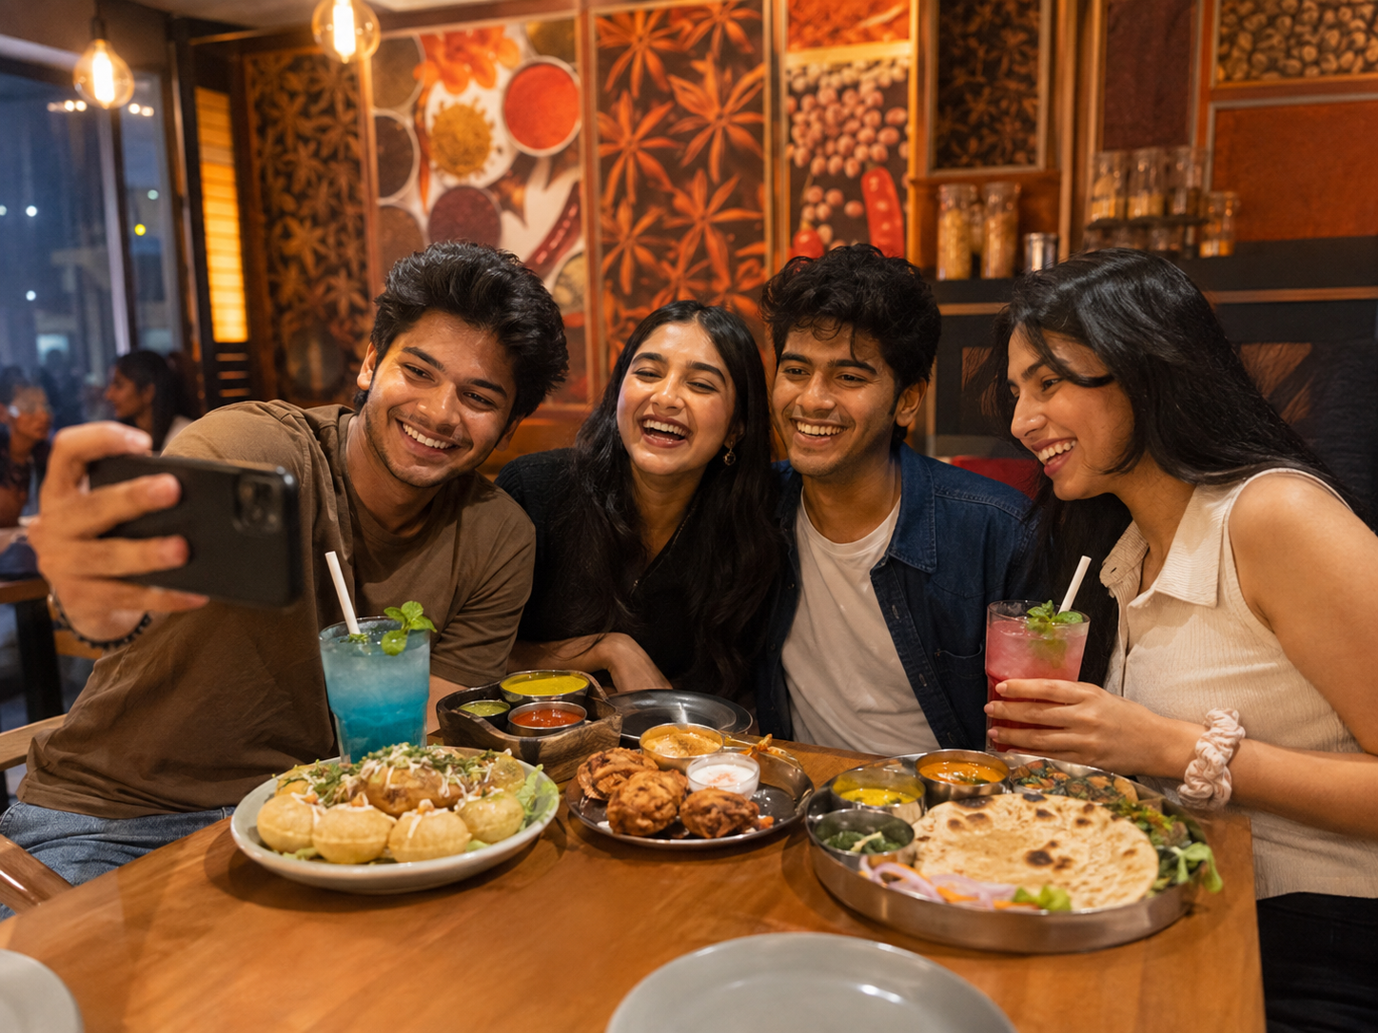
Friends enjoying shareable food, mocktails and a social dining experience.

Customer Type 2: Working Convenience Seekers
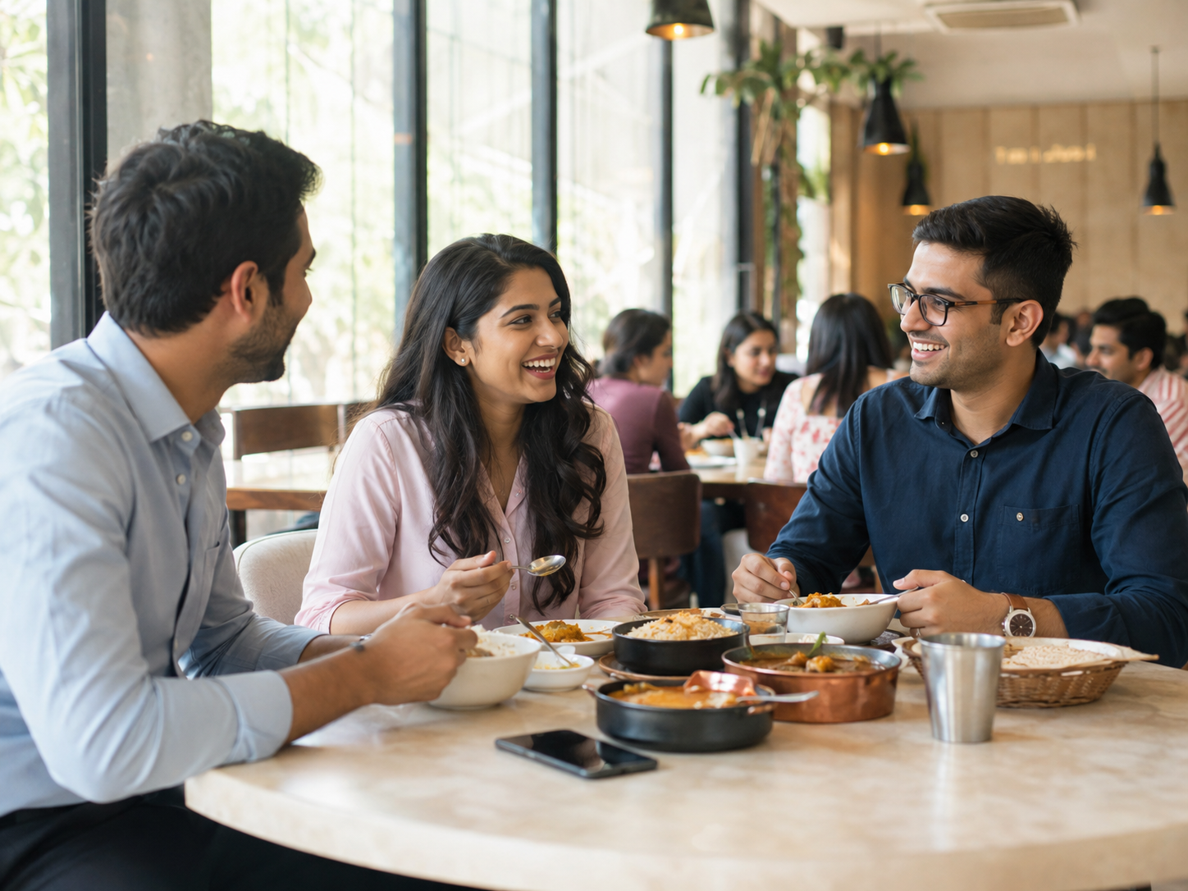
Young professionals choosing a convenient and comfortable lunch experience.

Customer Type 3: Family Experience Seekers
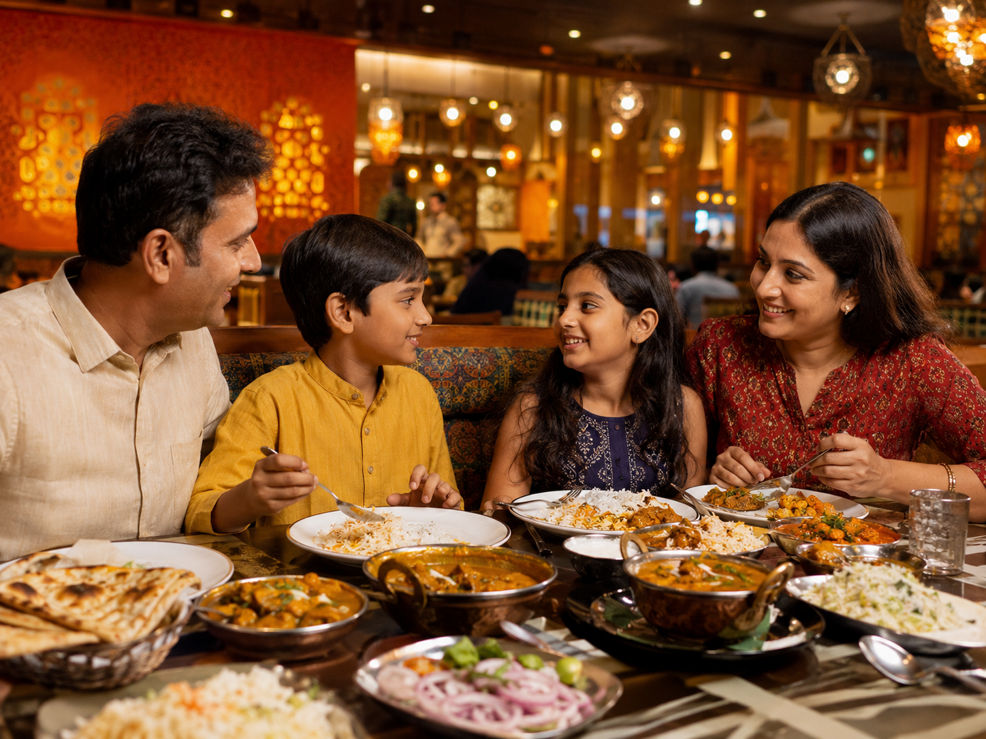
A family enjoying variety, comfort and quality time during a weekend meal.

Final Marketing Takeaways
Students: Use group combos, student offers, Instagram Reels and creator content.
Professionals: Highlight quick service, hygienic weekday meals, online ordering and lunch bundles.
Families: Promote family platters, strong reviews, celebration packages and weekend offers.

