Google Play Store Apps
Data Cleaning, Exploratory Analysis and Visualization
Python Project Report
Submitted by
Mann Mrug
IU2441230596
Vedant Joshi
IU2441230651

GitHub / Project Information
Repository name: Google-Play-Store-Analysis
Planned GitHub URL: https://github.com/<your-github-username>/Google-Play-Store-Analysis
Dataset: Google Play Store Apps — Kaggle
Kaggle dataset: https://www.kaggle.com/datasets/lava18/google-play-store-apps
Kaggle search: https://www.kaggle.com/search?q=Google%20Play%20Store%20Apps
Tools: Python, Google Colab/Jupyter, pandas, numpy, matplotlib, seaborn, Git/GitHub

1. Introduction
The Google Play Store contains applications from many categories, including communication, games, education, tools, health, finance and entertainment. The Kaggle Google Play Store Apps dataset provides app-level information such as category, rating, number of reviews, size, installs, price, content rating, genre and version information.
The goal of this project is to clean the dataset, perform exploratory data analysis and create visualizations that help explain app popularity, user ratings, installs, pricing and category trends.
Project objectives:
- Clean duplicate, missing and incorrectly formatted values.
- Convert installs, prices, reviews, sizes and dates into analysis-ready formats.
- Compare app categories, ratings, installs and free/paid status.
- Create clear visualizations and explain the main findings.
- Prepare a reproducible Python project suitable for GitHub.

2. Dataset Description
The Kaggle dataset is titled “Google Play Store Apps”. The dataset page describes it as data of about 10,000 Play Store apps for analysing the Android market. The main CSV contains 13 app-level features in the commonly distributed version of the dataset.
Column | Type | Meaning
App | Text | Application name
Category | Category | Category of the application
Rating | Numeric | Overall user rating
Reviews | Numeric | Number of user reviews
Size | Text/Numeric | Application size
Installs | Numeric after cleaning | Approximate install/download count
Type | Category | Free or Paid
Price | Numeric after cleaning | Application price
Content Rating | Category | Target age/content group
Genres | Category | Application genre(s)
Last Updated | Date | Last update date
Current Ver | Text | Current application version
Android Ver | Text | Minimum Android version

3. Data Cleaning
The analysis script performs reproducible preprocessing using pandas and numpy. The cleaning steps are designed to preserve as much original information as possible while making the numeric and date fields suitable for analysis.
Issue / Field | Treatment
Duplicates | Duplicate rows are removed before analysis.
Rating | Rating is converted to numeric form. Missing ratings are filled using the category median where possible, then the overall median.
Reviews | Reviews are converted from text to numeric values.
Installs | Symbols such as '+' and commas are removed so install counts can be analysed numerically.
Price | Dollar signs and commas are removed and price is converted to a numeric value.
Size | KB values are converted to MB; 'Varies with device' is treated as missing.
Dates | Last Updated is converted to a date and update year is extracted.
Core records | Rows without an application name or category are removed.

4. Exploratory Analysis and Visualizations
Eight visualizations are generated automatically by the project. They are intentionally chosen to cover category distribution, ratings, pricing, installs, engagement and relationships between numeric variables.
Figure 1: Number of Apps by Category
Shows which Play Store categories contain the largest number of applications.
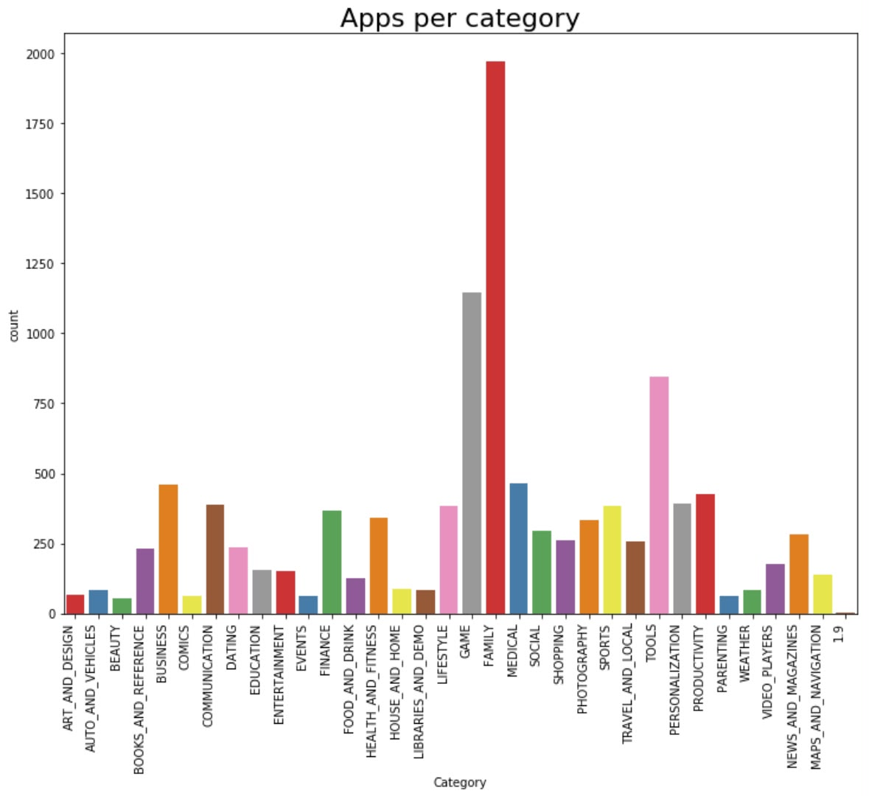
Figure 1: Apps per Category
Figure 2: Distribution of App Ratings
Shows how user ratings are distributed across the dataset.
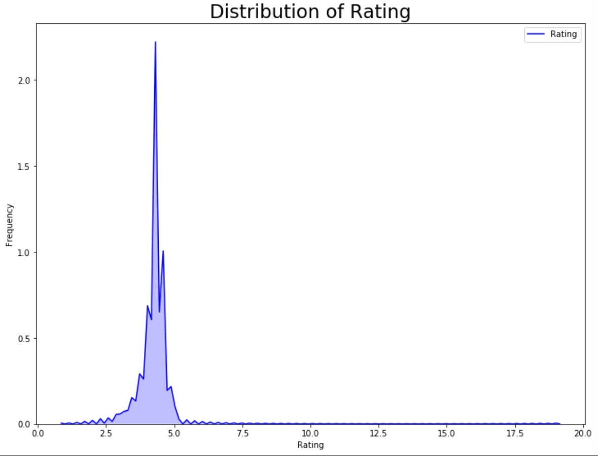
Figure 2: Distribution of Rating
Figure 3: Free vs Paid Apps
Compares the number of free applications with paid applications.
Figure 4: Top 10 Categories by Total Installs
Highlights categories with the greatest aggregate install counts.
Figure 5: Rating VS Installs
Shows the relationship between app ratings and install counts.
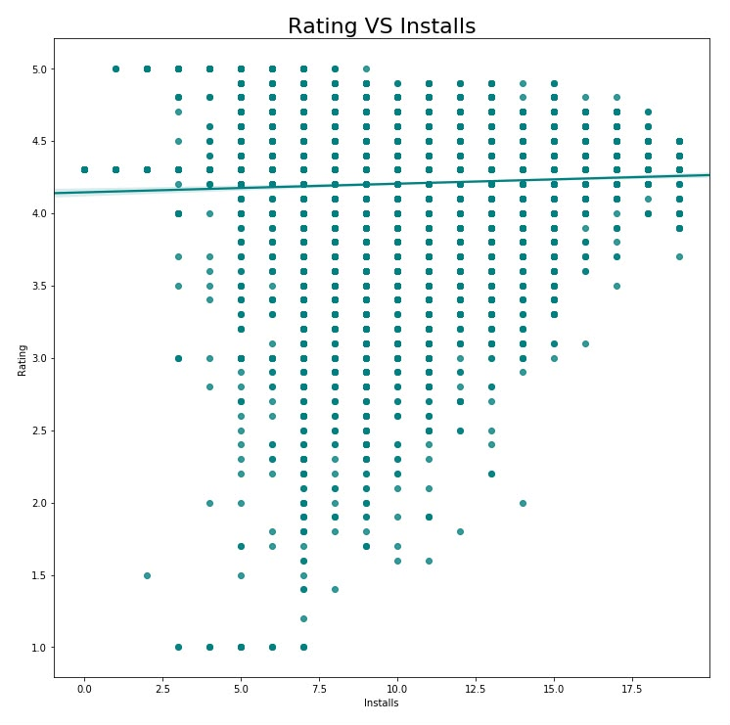
Figure 5: Rating VS Installs
Figure 6: Average Rating — Free vs Paid
Compares average user ratings for free and paid applications.
Figure 7: Content Rating Distribution
Shows how applications are distributed across content-rating groups.
Figure 8: Correlation Heatmap
Summarizes linear relationships between rating, reviews, installs, price and size.

5. Key Findings
- The dataset contains more than 10,000 application records and covers many different Play Store categories.
- Free applications form the large majority of the dataset, while paid applications are a much smaller group.
- The distribution of ratings is concentrated toward higher ratings, so the average rating alone should be interpreted together with review count.
- Install counts vary greatly between categories and individual applications; popular categories contain applications with very large install totals.
- Reviews and installs generally move together: applications with more installs tend to accumulate more user reviews, although this is an association rather than proof of causation.
- Category size and category popularity are not identical. A category can contain many applications without having the highest aggregate install count.
- Pricing is strongly skewed because most applications are free and a relatively small number of paid apps have much higher prices.
- The analysis is descriptive and should not be interpreted as a causal study of what makes an application successful.

6. Limitations
- The dataset is a historical snapshot and does not represent the current Google Play Store.
- Install values are reported as ranges such as 1,000+ rather than exact counts, so numeric install totals are approximate.
- Ratings contain missing values, and the project uses median imputation for reproducibility.
- Correlation does not imply causation.
- The dataset reflects the collection methodology and time period described by the Kaggle source.

7. Tools and Libraries
Python — Programming language
pandas — Data loading, cleaning and aggregation
numpy — Numerical processing
matplotlib — Charts and figure generation
seaborn — Statistical visualizations and heatmaps
Jupyter / Google Colab — Notebook execution
Git / GitHub — Version control and project sharing

8. Team Contribution
Member | Enrollment No. | Contribution
Mann Mrug | IU2441230596 | Dataset collection, data cleaning, preprocessing and dataset documentation
Vedant Joshi | IU2441230651 | Exploratory analysis, visualization, interpretation and report formatting

9. Project Structure
- data/googleplaystore.csv — original Kaggle dataset (to be downloaded by the team)
- src/google_play_store_analysis.py — complete cleaning and visualization script
- notebooks/Google_Play_Store_Analysis.ipynb — notebook runner
- outputs/ — cleaned dataset, charts and summary generated by the script
- README.md — project documentation
- requirements.txt — Python dependencies

10. Conclusion
This project demonstrates a complete beginner-friendly data analysis workflow using the Google Play Store Apps dataset. The raw data is converted into analysis-ready fields, cleaned and explored through multiple visualizations. The resulting analysis can help students understand how app category, reviews, installs, pricing and ratings can be studied together. The project is designed so that the same results can be regenerated from the original Kaggle CSV using the included Python script.

References
Kaggle. “Google Play Store Apps.” Lavanya Gupta. https://www.kaggle.com/datasets/lava18/google-play-store-apps
Kaggle search: https://www.kaggle.com/search?q=Google%20Play%20Store%20Apps

