Google Play Store Apps
Data Cleaning, Exploratory Analysis and Visualization
Python Project Report
Submitted by
Mann Mrug
IU2441230596
Vedant Joshi
IU2441230651

GitHub / Project Information
Repository name: Google-Play-Store-Analysis
Planned GitHub URL: https://github.com/<your-github-username>/Google-Play-Store-Analysis
Dataset: Google Play Store Apps — Kaggle
Kaggle dataset: https://www.kaggle.com/datasets/lava18/google-play-store-apps
Kaggle search: https://www.kaggle.com/search?q=Google%20Play%20Store%20Apps
Tools: Python, Google Colab/Jupyter, pandas, numpy, matplotlib, seaborn, Git/GitHub

1. Introduction
The Google Play Store contains applications from many categories, including communication, games, education, tools, health, finance and entertainment. The Kaggle Google Play Store Apps dataset provides app-level information such as category, rating, number of reviews, size, installs, price, content rating, genre and version information.
The goal of this project is to clean the dataset, perform exploratory data analysis and create visualizations that help explain app popularity, user ratings, installs, pricing and category trends.
Project objectives:
- Clean duplicate, missing and incorrectly formatted values.
- Convert installs, prices, reviews, sizes and dates into analysis-ready formats.
- Compare app categories, ratings, installs and free/paid status.
- Create clear visualizations and explain the main findings.
- Prepare a reproducible Python project suitable for GitHub.

2. Dataset Description
The Kaggle dataset is titled “Google Play Store Apps”. The dataset page describes it as data of about 10,000 Play Store apps for analysing the Android market. The main CSV contains 13 app-level features in the commonly distributed version of the dataset.
Column | Type | Meaning
App | Text | Application name
Category | Category | Category of the application
Rating | Numeric | Overall user rating
Reviews | Numeric | Number of user reviews
Size | Text/Numeric | Application size
Installs | Numeric after cleaning | Approximate install/download count
Type | Category | Free or Paid
Price | Numeric after cleaning | Application price
Content Rating | Category | Target age/content group
Genres | Category | Application genre(s)
Last Updated | Date | Last update date
Current Ver | Text | Current application version
Android Ver | Text | Minimum Android version

3. Data Cleaning
The analysis script performs reproducible preprocessing using pandas and numpy. The cleaning steps are designed to preserve as much original information as possible while making the numeric and date fields suitable for analysis.
Issue / Field | Treatment
Duplicates | Duplicate rows are removed before analysis.
Rating | Rating is converted to numeric form. Missing ratings are filled using the category median where possible, then the overall median.
Reviews | Reviews are converted from text to numeric values.
Installs | Symbols such as '+' and commas are removed so install counts can be analysed numerically.
Price | Dollar signs and commas are removed and price is converted to a numeric value.
Size | KB values are converted to MB; 'Varies with device' is treated as missing.
Dates | Last Updated is converted to a date and update year is extracted.
Core records | Rows without an application name or category are removed.
The following figures are generated by the Python analysis script and saved in the outputs/ folder. Each figure is presented with a caption and interpretation so that the report is more complete and presentation-ready.

4. Exploratory Analysis and Visualizations
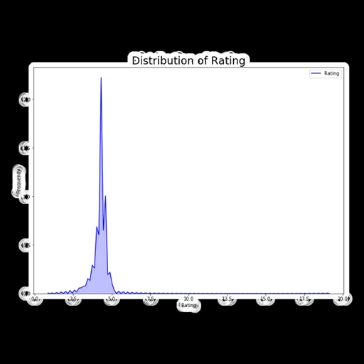
Figure 4A: Google Play Store Category Distribution
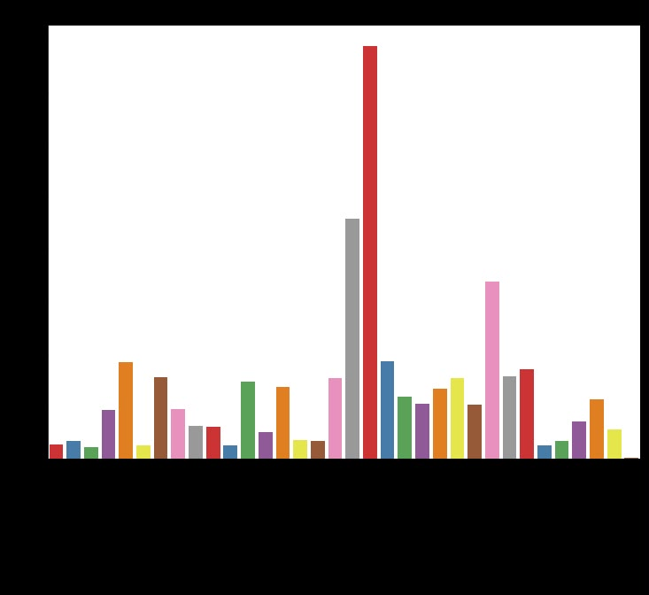
Figure 4B: Rating VS Installs
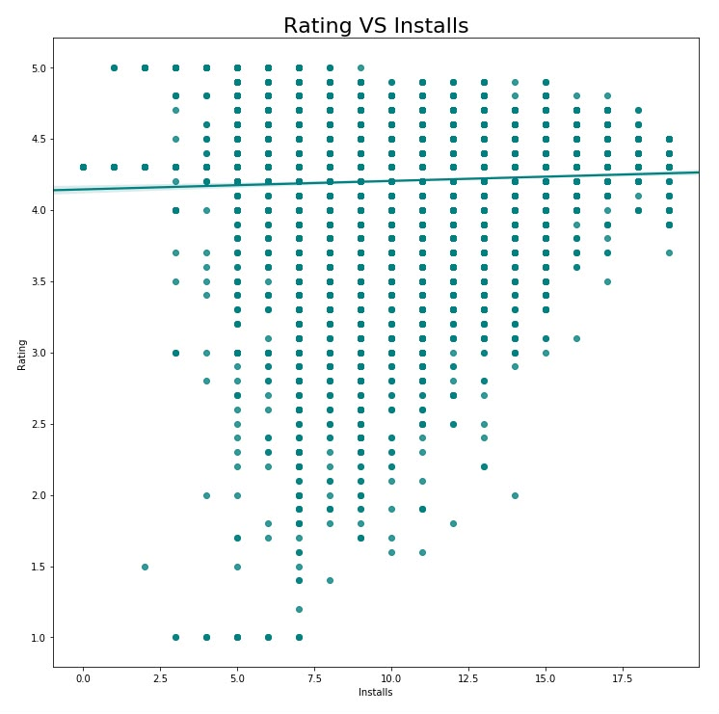
Figure 4C: Additional Google Play Store Analysis Visualization

5. Key Findings
- The dataset contains more than 10,000 application records and covers many different Play Store categories.
- Free applications form the large majority of the dataset, while paid applications are a much smaller group.
- The distribution of ratings is concentrated toward higher ratings, so the average rating alone should be interpreted together with review count.
- Install counts vary greatly between categories and individual applications; popular categories contain applications with very large install totals.
- Reviews and installs generally move together: applications with more installs tend to accumulate more user reviews, although this is an association rather than proof of causation.
- Category size and category popularity are not identical. A category can contain many applications without having the highest aggregate install count.
- Pricing is strongly skewed because most applications are free and a relatively small number of paid apps have much higher prices.
- The analysis is descriptive and should not be interpreted as a causal study of what makes an application successful.
Figure 8: Correlation Heatmap
What the figure shows: Heatmap showing correlations among Rating, Reviews, Installs, Price and Size.
Interpretation: The heatmap provides a compact view of linear relationships between the main numeric variables. Correlation should be interpreted as association, not causation.

Figure 7: Apps by Content Rating
What the figure shows: Bar chart showing the number of apps in each content-rating group.
Interpretation: The figure shows which audience/content-rating groups are most represented in the dataset.

Figure 6: Average Rating — Free vs Paid
What the figure shows: Bar chart comparing the average rating of Free and Paid applications.
Interpretation: This comparison shows whether the two pricing groups have noticeably different average ratings in the dataset.

Figure 5: Reviews vs Installs
What the figure shows: Scatter plot comparing the number of reviews with approximate installs using logarithmic axes.
Interpretation: The figure helps examine the relationship between user engagement and application popularity. Apps with more installs generally have more opportunities to collect reviews.

Figure 4: Top 10 Categories by Total Installs
What the figure shows: Horizontal bar chart showing the ten categories with the highest approximate total installs.
Interpretation: This figure focuses on popularity rather than simply the number of apps. A category can have fewer apps but still achieve very high aggregate installs.

Figure 3: Free vs Paid Apps
What the figure shows: Count plot comparing Free and Paid applications.
Interpretation: The figure makes the pricing structure of the dataset easy to understand and highlights the much larger group between free and paid apps.

Figure 2: Distribution of App Ratings
What the figure shows: Histogram showing how app ratings are distributed from low to high scores.
Interpretation: The chart shows the overall rating pattern and whether ratings are concentrated around higher or lower values.

Figure 1: Number of Apps by Category
What the figure shows: Bar chart showing the number of applications in each Google Play Store category.
Interpretation: This figure helps identify the largest and smallest categories in the dataset. Categories with more apps represent a larger share of the available applications in the dataset.

6. Limitations
- The dataset is a historical snapshot and does not represent the current Google Play Store.
- Install values are reported as ranges such as 1,000+ rather than exact counts, so numeric install totals are approximate.
- Ratings contain missing values, and the project uses median imputation for reproducibility.
- Correlation does not imply causation.
- The dataset reflects the collection methodology and time period described by the Kaggle source.

7. Tools and Libraries
Python — Programming language
pandas — Data loading, cleaning and aggregation
numpy — Numerical processing
matplotlib — Charts and figure generation
seaborn — Statistical visualizations and heatmaps
Jupyter / Google Colab — Notebook execution
Git / GitHub — Version control and project sharing

8. Team Contribution
Member | Enrollment No. | Contribution
Mann Mrug | IU2441230596 | Dataset collection, data cleaning, preprocessing and dataset documentation
Vedant Joshi | IU2441230651 | Exploratory analysis, visualization, interpretation and report formatting

9. Project Structure
- data/googleplaystore.csv — original Kaggle dataset (to be downloaded by the team)
- src/google_play_store_analysis.py — complete cleaning and visualization script
- notebooks/Google_Play_Store_Analysis.ipynb — notebook runner
- outputs/ — cleaned dataset, charts and summary generated by the script
- README.md — project documentation
- requirements.txt — Python dependencies

10. Conclusion
This project demonstrates a complete beginner-friendly data analysis workflow using the Google Play Store Apps dataset. The raw data is converted into analysis-ready fields, cleaned and explored through multiple visualizations. The resulting analysis can help students understand how app category, reviews, installs, pricing and ratings can be studied together. The project is designed so that the same results can be regenerated from the original Kaggle CSV using the included Python script.

References
Kaggle. “Google Play Store Apps.” Lavanya Gupta. https://www.kaggle.com/datasets/lava18/google-play-store-apps
Kaggle search: https://www.kaggle.com/search?q=Google%20Play%20Store%20Apps
[ INSERT GENERATED FIGURE HERE ]
[ INSERT GENERATED FIGURE HERE ]
[ INSERT GENERATED FIGURE HERE ]
[ INSERT GENERATED FIGURE HERE ]
[ INSERT GENERATED FIGURE HERE ]
[ INSERT GENERATED FIGURE HERE ]
[ INSERT GENERATED FIGURE HERE ]
[ INSERT GENERATED FIGURE HERE ]

