**THE UNIVERSITY OF TEXAS AT ARLINGTON**

**COMPUTER SCIENCE AND ENGINEERING**

**EMBEDDED SYSTEMS II**

**FALL 2024**

**Brew Buddy Project Report**

**Group 2**

Guided by,

**Dr. Habeeb Olufowobi**

Project by,

**Andrew Howard**

**James Revette**

**Madison Gage**

**Table of Contents**

**Abstract** 3

**System Design and Architecture** 4

**High-Level Description** 4

**Block Diagram** 4

**Components** 5

**Design Decisions** 6

**Implementation** 9

**Hardware Implementation** 9

**Software Code** 10

**Challenges** 12

**Results and Testing** 13

**Conclusion and Future Work** 15

# **Abstract**

BrewBuddy is a smart coffee heater designed to maintain beverages at the perfect drinking temperature with precision, convenience, and safety. By combining accurate temperature sensing, configurable heating control, and robust safety mechanisms, BrewBuddy solves the common problem of coffee cooling too quickly while offering users precise control over their experience.

The device utilizes an embedded system to detect and regulate the coffee's temperature, displaying real-time temperature readings for added clarity. Users can set highly configurable target temperatures to match their preferences, ensuring a personalized and enjoyable coffee-drinking experience. The heating plate operates efficiently, activating only when necessary to conserve energy, while integrated safety features prevent overheating for peace of mind.

BrewBuddy delivers a reliable and precise solution that transforms how users enjoy their coffee. It showcases the potential for embedded systems to enhance daily convenience, with opportunities for future upgrades like smart connectivity and expanded user customization.

# **System Design and Architecture**

## **High-Level Description**

The BrewBuddy coffee heater is designed to ensure that coffee remains at a user-configurable, ideal drinking temperature. The system accomplishes this by detecting the presence of coffee, measuring its temperature, and regulating heat output precisely.

* System Functionality
  + Measure the coffee’s temperature using an infared thermometer.
  + Display the temperature of the coffee with an LCD display.
  + Heat the coffee to a user-specified temperature via a heating plate controlled by a solid state relay.
* Key Features
  + User Configurability: Temperature can be set in increments of 10 by holding a push button or precise increments over UART.
  + Safety Mechanism: A thermistor-based temperature monitor ensures that the heating plate doesn’t exceed safe operating limits, triggering a safety shutdown if necessary.
  + Energy Efficiency: The heater only activates when coffee is detected and the temperature is below the desired threshold, minimizing power usage.

## **Block Diagram**

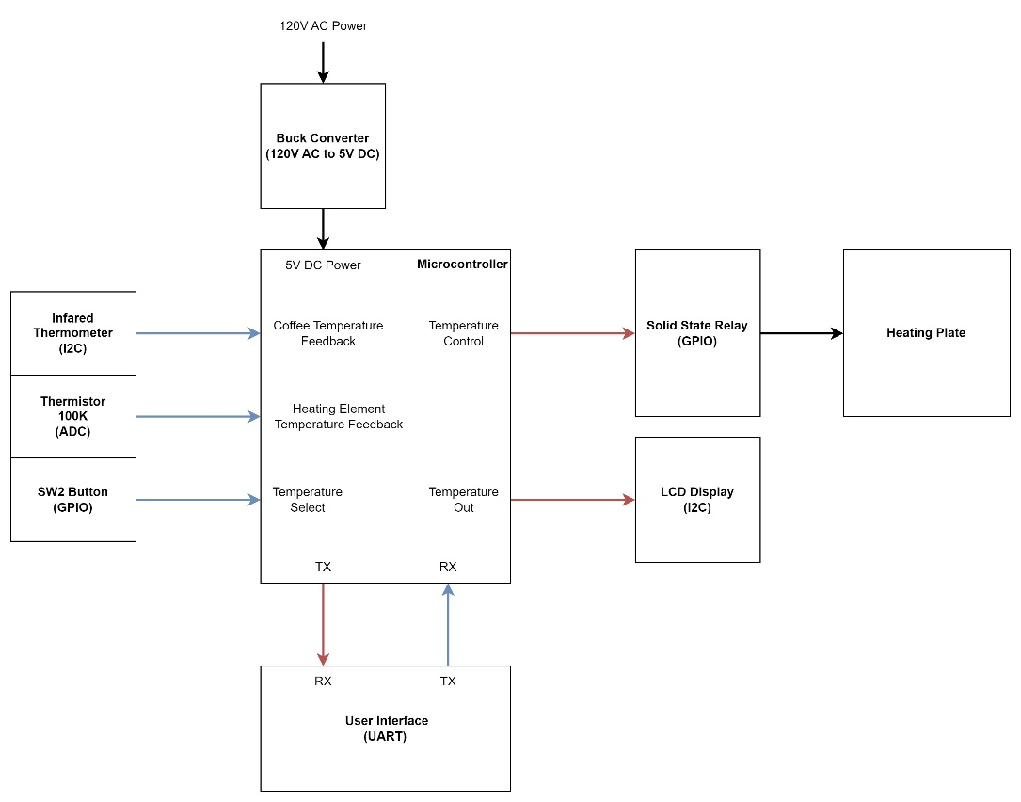

## **Components**

* **Sensors**:
  + **Infrared Thermometer (I2C)**: Measures coffee surface temperature accurately without physical contact.
  + **100K Thermistor**: Integrated with a voltage divider circuit to monitor heating plate temperature and prevent overheating.
* **Microcontroller (TM4C123GH6PM):**
  + Reading sensor data from the I2C infrared thermometer.
  + Retrieving voltage data from the thermistor ADC.
  + Controlling the heating plate via GPIO and solid-state relay.
  + Handling user input from the GPIO button and UART communication.
  + Driving the I2C LCD display for real-time updates.
* **Heating Element and Control System**:
  + **Solid-State Relay**: Provides reliable and efficient control of the 120V AC heating element using a GPIO signal from the microcontroller**.**
  + **Heating Plate**: Directly warms the coffee cup with regulated energy output.
* **User Interface**:
  + **LCD Display (I2C)**: Provides real-time updates on temperature and user settings for an intuitive experience.
  + **GPIO Button**: Enables users to set broad target temperatures.
  + **UART Interface:** Allows external devices to configure safety parameters, set precise temperature levels, and monitor system performance.
* **Power Supply**:
  + **120V to 5V DC Buck Converter**: Converts high-voltage AC to low-voltage DC for powering the microcontroller and auxiliary components.

## **Design Decisions**

1. **Infrared Thermometer (I2C)**
   1. **Why Chosen**:
   * **Non-Contact Measurement**: The infrared thermometer provides accurate surface temperature measurements without physical contact, which is essential for maintaining the purity of the coffee and preventing interference.
   * **I2C Communication**: This interface allows for easy integration with the microcontroller, minimizing the number of pins needed for communication. It also supports multiple devices, making it a flexible solution for future expansions.

* **Trade-offs**:
  + **Cost vs Accuracy**: Infrared thermometers are typically more expensive than simple thermocouples or thermistors. However, the non-contact nature to detect the temperature of the coffee justifies the cost.

1. **100K Thermistor with Voltage Divider**

* **Why Chosen**:
  + **Cost-Effectiveness**: Thermistors are affordable and readily available, making them a solid choice for monitoring the heating plate’s temperature without adding significant cost to the overall system.
  + **Simplicity**: Using a voltage divider circuit to convert the thermistor’s resistance to a readable voltage ensures simple and effective temperature detection. The ADC on the microcontroller can easily process this signal.
* **Trade-offs**:
  + **Accuracy vs Complexity**: While thermistors provide good accuracy for the application, they are less precise than more expensive temperature sensors (e.g., RTDs). However, the cost savings and simplicity of implementation outweigh the slight reduction in accuracy for this application.

1. **Solid-State Relay (GPIO-Controlled)**

* **Why Chosen**:
  + **Reliability and Longevity**: Solid-state relays (SSRs) provide faster switching times and are more durable than mechanical relays, which would wear out over time. This is essential for ensuring long-term, reliable operation of the coffee heater.
  + **Silent Operation**: SSRs have no moving parts, leading to quieter operation compared to mechanical relays, which is important for consumer products.
* **Trade-offs**:
  + **Cost vs Switching Speed**: SSRs are typically more expensive than mechanical relays. However, their reliability, quiet response, and ability to handle high currents justify the added cost in this context.

1. **LCD Display (I2C)**

* **Why Chosen**:
  + **User Experience**: The LCD display provides an intuitive way for users to monitor the real-time temperature of their coffee. The I2C interface reduces wiring complexity, allowing a more streamlined design.
* **Trade-offs**:
  + **Size vs Cost**: While a larger or more advanced display could offer more features, such as touch functionality or a higher resolution, a simple LCD display was chosen to balance cost and the required functionality.

1. **120V to 5V DC Buck Converter**

* **Why Chosen**:
  + **Compact and Reliable**: Buck converters are compact, reliable, and readily available, making them a good choice for efficiently powering low-voltage components in a system that operates on high-voltage AC power.
* **Trade-offs**:
  + **Size vs Power Output**: While the buck converter provides efficient power conversion, there is a trade-off in terms of the physical size compared to simpler power supplies. However, the improved efficiency and stability of the system outweigh the slight increase in size.

1. **Heating Plate and Heating Element**

* **Why Chosen**:
  + **Efficiency and Heat Transfer**: The heating plate offers an even and efficient method for warming the coffee, ensuring consistent temperature regulation across the entire surface of the cup. It is crucial to maintain an ideal temperature without causing local overheating.
* **Trade-offs**:
  + **Power Consumption vs Control**: While the heating element provides sufficient power to heat the coffee effectively, there is a trade-off in power consumption. The system uses a solid-state relay and precise temperature regulation to mitigate this, balancing energy usage with performance.

1. **UART Interface**

* **Why Chosen**:
  + **Configuration Flexibility**: UART allows for easy configuration of system parameters, including temperature thresholds and safety limits. It facilitates debugging and external monitoring, making it a valuable tool for future adjustments and integrations.
* **Trade-offs**:
  + **Complexity vs Simplicity**: While UART provides a high degree of flexibility and configurability, it adds complexity to the design and communication. However, the added capability for remote configuration and adjustments makes it a worthwhile trade-off, especially for users who want more control over the system.

# **Implementation**

## **Hardware Implementation**

The hardware is built around a central microcontroller, which coordinates the operations of all other components. The system incorporates sensors, a heating element, a user interface, and a power supply. These elements are interconnected through GPIO, I2C, and ADC interfaces for seamless data exchange and control.

<https://github.com/mannndrew/BrewBuddy>

The circuit includes the following key subsystems:

* Temperature Monitoring Subsystem: An infrared thermometer measures the coffee’s surface temperature and communicates readings to the microcontroller via the I2C interface. A 100K thermistor, integrated into a voltage divider circuit, monitors the heating plate’s temperature for safety.
* Heating Subsystem: A solid-state relay (SSR) connects the microcontroller to the 120V AC heating plate. The SSR ensures safe and efficient switching of high voltage, controlled via GPIO signals.
* User Interface Subsystem: An I2C-connected LCD displays real-time temperature readings and system status. A GPIO button allows users to configure desired temperature settings.
* Power Supply Subsystem: A 120V to 5V DC buck converter powers the microcontroller and peripherals. This ensures stable operation across all components.

## **Software Code**

1. **Infrared Thermometer Module (Input - I2C Sensor):**

The infrared thermometer is responsible for measuring the surface temperature of the coffee without direct contact. The microcontroller communicates with the sensor over the I2C bus, periodically requesting temperature data. The module processes the data and ensures it is within a valid range. The measured temperature is then sent to the Temperature Control Module for further processing. The sensor ensures accurate and non-invasive monitoring of the coffee temperature.

1. **Thermistor Module (Input - ADC Sensor):**

The thermistor module monitors the temperature of the heating plate, using a voltage divider circuit to generate an analog voltage based on the temperature. This voltage is converted into a digital value by the microcontroller’s ADC. The thermistor ensures that the heating element does not overheat by providing real-time feedback to the Safety and Control Modules. It allows for safe operation by ensuring the system can detect excessive temperatures and take corrective action.

1. **Solid-State Relay Control Module (Output - GPIO):**

The solid-state relay (SSR) is responsible for switching the 120V AC heating element on or off based on the temperature control algorithm. The microcontroller sends a low-voltage GPIO signal to the SSR, which then triggers the SSR to control the high-voltage AC power to the heating element. The relay ensures efficient power management by providing precise control over the heating element, allowing the system to maintain the desired temperature. This method also improves safety by electrically isolating the low-voltage control circuitry from the high-voltage heating element, preventing potential damage or hazards. Additionally, the use of a solid-state relay enhances the durability and responsiveness of the system compared to mechanical relays, as it operates silently and with faster switching speeds.

1. **UART Communication Module (Input/Output - UART)**

The UART module provides a serial communication interface to allow for user-configurable settings, such as the desired coffee temperature and safety parameters. The microcontroller communicates over UART with an external device, such as a PC or mobile interface, to receive commands and send feedback. This feature allows users to fine-tune settings, monitor the system remotely, and update configurations. The UART communication is also used for debugging and diagnostics, making it an essential part of the system's flexibility.

1. **I2C Display Output Module (Output - I2C)**

The I2C display module provides real-time feedback to the user, showing the current temperature of the coffee, the target temperature, and the system's status. It continuously updates the display based on sensor readings and control actions. The display is connected to the microcontroller through the I2C bus, ensuring efficient data transfer with minimal pin usage. This module allows the user to monitor the system's operation at a glance, improving user interaction and ensuring the system is working as expected. The I2C interface makes it easy to integrate with the microcontroller while keeping the wiring and complexity low.

# **Challenges**

* **Wire Management and Insulation**:

Poor wire organization initially led to shorts, posing safety risks and damaging components. While insulated sleeves and cable ties have reduced the risk, achieving a fully robust solution remains a challenge. The current wiring setup is still susceptible to wear over time. Future improvements may include integrating a custom cable management system into the 3D-printed case for added protection and durability.

* **Infrared Sensor Accuracy:**

The infrared thermometer sometimes reports temperature deviations of up to 10 degrees. Calibration and smoothing algorithms help mitigate these inaccuracies, but the readings are still not perfectly precise. Switching to a higher-grade sensor or exploring more sophisticated calibration methods are potential next steps to improve reliability.

* **3D-Printed Case Stability and Fitting:**

The 3D-printed case experienced warping during fabrication, affecting its structural stability and alignment. Additionally, certain design placements, such as cutouts for wires and the LCD display, could be improved. There is also no dedicated holder for the infrared sensor. These issues could be addressed by refining the case design with more precise cutouts for wiring and components, as well as using higher-quality printing materials or techniques to minimize warping.

* **Algorithm Optimization:**

While the initial control algorithms were functional, they were inefficient, consuming tens of thousands of clock cycles per operation. Through optimization, this was reduced to a few thousand cycles, significantly improving performance. However, the code still has room for correction. Techniques to reduce loops, minimizing redundant calculations, and leveraging hardware-specific features of the microcontroller could further reduce computational overhead and enhance real-time responsiveness.

# **Results and Testing**

Describe how the system was tested and the outcomes:

1. **Testing Methodology**:
   * The infrared thermometer was tested for static accuracy at idle temperatures ranging from 70°F to 75°F. For dynamic conditions, it was also tested with heating elements, measuring temperatures between 70°F and 140°F to ensure it accurately detected the coffee surface temperature as it heated.
   * The 100k thermistor was evaluated at idle temperatures ranging from 70°F to 75°F to ensure static accuracy. During dynamic testing, temperatures between 70°F and 300°F were used to assess its performance in detecting the temperature of the heating element as it varied with heating.
   * The heating plate’s ability to raise a 250mL cup of coffee from room temperature (around 70°F) to 140°F was measured under controlled indoor conditions to evaluate heating time and effectiveness.
2. **Results**:

<https://youtu.be/UzA40Yut7Tc>

|  |  |  |
| --- | --- | --- |
| Time | Coffee Temperature | Heating Element Temperature |
| 0 minutes | 66 F | 76 F |
| 1 minutes | 68 F | 154 F |
| 2 minutes | 73 F | 209 F |
| 3 minutes | 78 F | 208 F |
| 4 minutes | 83 F | 203 F |
| 5 minutes | 86 F | 195 F |
| 6 minutes | 91 F | 196 F |
| 7 minutes | 95 F | 204 F |
| 8 minutes | 98 F | 210 F |
| 9 minutes | 100 F | 212 F |
| 10 minutes | 103 F | 184 F |
| 11 minutes | 105 F | 212 F |
| 12 minutes | 107 F | 196 F |
| 13 minutes | 113 F | 200 F |
| 14 minutes | 112 F | 209 F |
| 15 minutes | 112 F | 213 F |
| 16 minutes | 116 F | 203 F |
| 17 minutes | 118 F | 194 F |
| 18 minutes | 119 F | 203 F |
| 19 minutes | 121 F | 211 F |

* + Overall, the coffee heating element heats up relatively quickly when raising the temperature from 76°F to 200°F, with an average heating rate of 1.24°F per second.
  + However, the heat transfer to the coffee is slower when heating from 66°F to 130°F, with a measured rate of approximately 2°F per minute. This slower rate can be attributed to the low initial thermal energy of the coffee as well as the large mass that needs to be heated.

1. **Limitations**:
   * One limitation of the system is the infrared thermometer's accuracy, which has an error range of ±10°F. This means that while the sensor provides a general idea of the coffee surface temperature, small discrepancies in readings may occur, particularly when the temperature is near the threshold values. This could lead to slight variations in heating control.

# **Conclusion and Future Work**

1. **Summary of Achievements**:
   * Brew Buddy successfully fulfils its purpose of providing precise and energy-efficient coffee heating. The system accurately monitors coffee surface and heating element temperatures using an infrared thermometer and thermistor, ensuring safe operation with built-in temperature regulation. With an intuitive user interface featuring an LCD display and simple controls, Brew Buddy allows users to easily set and adjust their desired coffee temperature. The system's design prioritizes safety while offering reliable performance in maintaining ideal coffee temperatures.
2. **Future Enhancements**:
   * **Enhanced Durability:**

To make the system more robust, future versions could incorporate weatherproofing measures, such as water-resistant casing and sealed components, to withstand kitchen environments with exposure to moisture, dust, and temperature fluctuations. This would ensure Brew Buddy performs reliably in varied conditions to extend its lifespan.

* + **IoT/Bluetooth Integration:** Adding wireless functionality would enable remote control and monitoring via a mobile app or smart devices, improving convenience.
  + **Advanced Sensors:** Upgrading the infrared thermometer for improved accuracy and incorporating weight sensors could help detect coffee presence, enhancing control and performance.
  + **Commercial Scalability:** Scaling Brew Buddy for commercial use would involve higher-power heating elements and features like multiple heating elements for large volumes of coffee.