Unit 2 · be, have got, can — Lesson plans
3 lessons × 45 minutes · Round-Up 3 · Grade 3

Adapted for Grade 3 (age 8–9, CEFR A1): the ideas come from the Round-Up 3 unit; all exercises and texts are new.
Unit at a glance
In the book | Round-Up 3, Unit 2 — Personal pronouns / 'be' / 'have got' / 'can'
Topic | Who I am, what I have and what I can do
Vocabulary | swim, run, jump, ride a bike, sing, dance, draw, play football, climb, fly; pronouns I, you, he, she, it, we, they
Grammar | • be: I am · he / she / it is · you / we / they are (+ negative and questions)  • have got: I / you / we / they have got · he / she / it has got  • can / can't + verb: She can swim. He can't fly.

Vocabulary
 | English | O'zbekcha
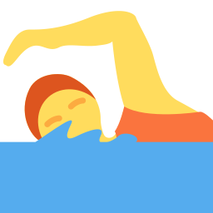 | swim | suzmoq
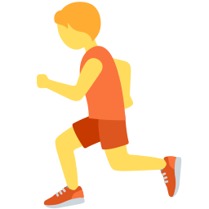 | run | yugurmoq
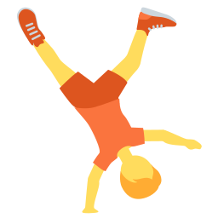 | jump | sakramoq
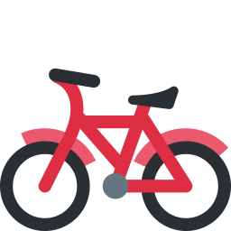 | ride a bike | velosiped haydamoq
 | sing | kuylamoq
 | dance | raqsga tushmoq
 | draw | rasm chizmoq
 | play football | futbol o'ynamoq
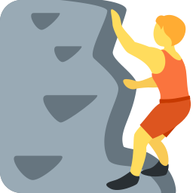 | climb | tirmashmoq
 | fly | uchmoq

Extra words used in the lessons
 | English | O'zbekcha
 | I | men
 | you | sen, siz
 | he | u (erkak)
 | she | u (ayol)
 | it | u (hayvon, narsa)
 | we | biz
 | they | ular

Lesson 1: I am, you are, he is
Focus | be with pronouns; negatives and questions
Aims (by the end of the lesson pupils can…) | • use am / is / are with I, you, he, she, it, we, they  • ask and answer: Are you ten? Yes, I am.
Key language | • I am · you are · he / she / it is · we / you / they are  • I'm not · isn't · aren't · Are you …?
Materials | • Pronoun cards (I, you, he, she, it, we, they)  • Grammar card  • Worksheet A exercise A; Worksheet B exercise B
Time | 45 minutes

Min | Stage | What happens | Interaction
3 | Greeting & organisation | Greet the class and introduce yourself: 'I am Miss … I am a teacher.' Invite pupils to do the same. | T-Ss
5 | Warm-up | Pronoun pick: point to people and say the pronoun (you, he, she, we, they) — pupils repeat. | T-Ss
10 | Presentation | Write the table on the board: I am / you are / he is … Colour the forms. Use the contractions I'm, you're, he's. Then show the negative (I'm not / he isn't) and questions (Are you …?). | T-Ss
12 | Controlled practice | Worksheet A exercise A (circle) and Worksheet B exercise B (fill in). Pairs check each other. | S / Ss-Ss
10 | Freer practice / production | Mingle: pupils ask 'Are you nine?' 'Are you from Tashkent?' and answer with short answers. | Ss-Ss / G
5 | Wrap-up & homework | Quick-fire: point at a pupil and say a pronoun; pupils say the full sentence 'He is …'. Homework. | T-Ss

Homework: Write five sentences about yourself with am / is / are.
Check learning: Listen for am / is / are in the mingle activity.
Teacher tips (o'qituvchi uchun)
- 'am / is / are' ni tushirmaslik: o'zbekcha 'Men ikkinchi sinfman' da bog'lovchi fe'l yo'q — inglizchada esa shart.
- he / she — o'zbekcha 'u' ikkalasi uchun bitta: rasm bilan farqlang.
- Support: show a pronoun–verb matching chart. Extension: add a question with Wh- words (oral).

Lesson 2: I've got, she's got
Focus | have got / has got (statements, negatives, questions)
Aims (by the end of the lesson pupils can…) | • say what they and others have got  • ask and answer: Has she got a cat? No, she hasn't.
Key language | • I've got · he's got · they've got  • haven't got · hasn't got · Have you got …? Has she got …?
Materials | • Picture cards (cat, dog, bike, computer, car)  • Worksheet A exercise B; Worksheet B exercise D
Time | 45 minutes

Min | Stage | What happens | Interaction
3 | Greeting & organisation | Ask 'Have you got a pet?' and collect answers on the board. | T-Ss
5 | Warm-up | Bag reveal: take items from a bag: 'I've got a book. I've got an apple. Have you got an apple?' | T-Ss
10 | Presentation | Show a boy and a girl with pictures. Model 'He has got a bike. She has got two cats.' Write the pattern with have for I / you / we / they and has for he / she / it. | T-Ss
12 | Controlled practice | Worksheet A exercise B (fill), Worksheet B exercise D (reading). Pairs ask and answer with picture cards. | S / Ss-Ss
10 | Freer practice / production | Find someone who has got…: pupils walk around and find classmates with a pet, a bike, a brother. | Ss-Ss / G
5 | Wrap-up & homework | Report back: 'Bobur has got a bike.' Homework. | T-Ss

Homework: Write what you and your family have got (six sentences).
Check learning: Check have / has agreement in the report-back.
Teacher tips (o'qituvchi uchun)
- 'have got' = 'menda bor'. 'He have got' — keng tarqalgan xato; he/she/it → has.
- Qisqa shakl: I've got, he's got (has got) — 'he's' = he is ham bo'lishi mumkin; kontekst bilan tushuntiring.
- Support: use sentence frames. Extension: add number words (two brothers).

Lesson 3: I can, I can't
Focus | can / can't for ability; questions and short answers
Aims (by the end of the lesson pupils can…) | • say what they and animals can and can't do  • ask and answer: Can you swim? Yes, I can.
Key language | • I can swim. · He can't fly.  • Can you ride a bike? — Yes, I can. / No, I can't.
Materials | • Ability flashcards (games/flashcards.pdf)  • Worksheet A exercises C–E; Worksheet B exercises A, C, E
Time | 45 minutes

Min | Stage | What happens | Interaction
3 | Greeting & organisation | Ask 'Can you swim?' — show thumbs up / down; count the class. | T-Ss
5 | Warm-up | Animal charades: mime an animal; the class guesses 'It can fly. It's a bird.' | T-Ss
10 | Presentation | Use the ability flashcards: 'I can swim. Can you swim?' Build the pattern on the board, including can't and the question form. Stress: can + bare verb. | T-Ss
12 | Controlled practice | Worksheet A exercises C (match animals and abilities), D (word search) and E (pictures). Worksheet B exercise A (circle). | S / Ss-Ss
10 | Freer practice / production | Find someone who can…: pupils ask 'Can you dance? Can you ride a bike?' and record names on a chart. | Ss-Ss
5 | Wrap-up & homework | Class result: 'Nine pupils can swim.' Homework. | T-Ss

Homework: Write three things you can do and three you can't do (Worksheet B exercise E).
Check learning: Listen for can + bare verb in the survey.
Teacher tips (o'qituvchi uchun)
- 'can' dan keyin fe'l o'zgarmaydi: She can swim (swims emas).
- 'can't' talaffuzi /kɑːnt/ — 'can' /kæn/ bilan adashtirmang; urg'u va ovoz cho'zilishiga e'tibor.
- Support: pictures for each verb. Extension: add adverbs (well, fast).

