Unit 3 · Possessives, this / that — Worksheet A
School things and possessives · Round-Up 3 · Grade 3

Name: ______________________________ Class: ________ Date: ______________
A Look and write the words.
notebook · bag · ruler · pencil · book · scissors · computer · pen

  1 ___________ |   2 ___________ |   3 ___________ |   4 ___________
  5 ___________ |   6 ____________ |   7 ____________ |   8 ____________

B Match the possessive adjective to the pronoun.
1 my ____ | A ours
2 your ____ | B theirs
3 her ____ | C mine
4 our ____ | D yours
5 their ____ | E hers

C Circle the correct word.
1 This is (my / mine) pen.
2 This pen is (my / mine).
3 That is (her / hers) bag.
4 That bag is (her / hers).
5 These are (our / ours) books.
6 Those books are (our / ours).
D Look and complete the words.
1 p_nc_l  __________ | 2 r_l_r  ________ | 3 n_t_b__k  ____________
4 sc_ss_rs  ____________ | 5 c_mp_t_r  ____________ | 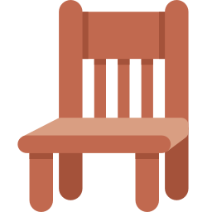  6 ch__r  ________

E Find eight school words.
Find these words (→ ↓ ↘)
PENCIL RULER NOTEBOOK SCISSORS BAG COMPUTER DESK CHAIR

W | T | K | A | D | C | A | G | X | T | M
V | Y | C | O | B | O | X | N | M | L | X
Y | S | H | B | A | M | M | O | U | W | J
B | C | A | P | G | P | I | T | D | F | T
X | I | I | T | O | U | L | E | T | M | V
F | S | R | C | T | T | V | B | P | K | F
X | S | U | K | W | E | H | O | E | K | X
S | O | D | K | M | R | E | O | N | K | K
M | R | E | A | M | F | Y | K | C | O | W
P | S | S | R | U | L | E | R | I | J | G
M | I | K | Z | I | N | O | X | L | J | I

F Draw your school bag. Label five things: my ___ .
My school bag

Score: ________ / 25

