Unit 4 · Articles: a, an, the — Lesson plans
3 lessons × 45 minutes · Round-Up 3 · Grade 3

Adapted for Grade 3 (age 8–9, CEFR A1): the ideas come from the Round-Up 3 unit; all exercises and texts are new.
Unit at a glance
In the book | Round-Up 3, Unit 4 — Articles
Topic | Which little word? a / an / the / nothing
Vocabulary | apple, orange, egg, elephant, umbrella, ice cream, ant, banana, dog, book (+ the sun, the moon)
Grammar | • a before a consonant sound (a dog), an before a vowel sound (an egg)  • the for a thing we both know, or only one (the sun)  • no article with plural things in general (I like dogs) and with names

Vocabulary
 | English | O'zbekcha
 | apple | olma
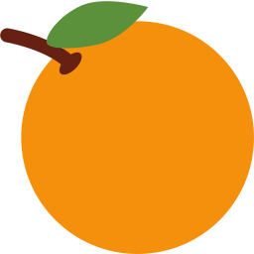 | orange | apelsin
 | egg | tuxum
 | elephant | fil
 | umbrella | soyabon
 | ice cream | muzqaymoq
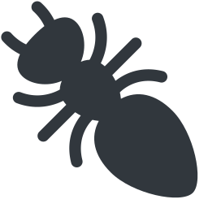 | ant | chumoli
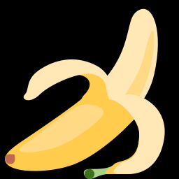 | banana | banan
 | dog | it
 | book | kitob

Extra words used in the lessons
 | English | O'zbekcha
 | the sun | quyosh
 | the moon | oy
 | the sea | dengiz
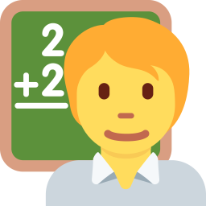 | the teacher | o'qituvchi

Lesson 1: a or an?
Focus | a / an with one thing
Aims (by the end of the lesson pupils can…) | • use a before consonant sounds and an before vowel sounds  • say: an apple, a banana
Key language | • a dog · a banana · a book · an apple · an egg · an elephant · an umbrella
Materials | • Flashcards (games/flashcards.pdf)  • Two boxes labelled a and an  • Grammar card
Time | 45 minutes

Min | Stage | What happens | Interaction
3 | Greeting & organisation | Hold up a flashcard: 'What's this? It's an apple.' Write 'an apple' on the board. | T-Ss
5 | Warm-up | a or an? Pupils stand for 'an' and sit for 'a' as you say the word. | T-Ss
10 | Presentation | Sort the flashcards into two boxes (a / an). Underline the first sound and say it: /æ/, /e/, /ɪ/, /ɒ/, /ʌ/ → vowel sounds → an. | T-Ss
12 | Controlled practice | Worksheet A exercises A (label with articles), C (circle) and D (word search). Pairs sort the flashcards. | S / Ss-Ss
10 | Freer practice / production | Shopping list: pupils write five things they want to buy with the correct article and read it out. | Ss-Ss / G
5 | Wrap-up & homework | Quick-fire: teacher says a word, pupils say 'a …' or 'an …'. Homework. | T-Ss

Homework: Write ten nouns with a / an (five from your room, five from your bag).
Check learning: Listen for a / an in the shopping list activity.
Teacher tips (o'qituvchi uchun)
- O'zbek tilida artikl yo'q — 'I have cat' xatosi juda keng tarqalgan. Har bir yakka ot oldida a / an tekshiring.
- Qoida harfga emas, tovushga bog'liq: an hour /aʊə/, a university /juː/.
- Support: sorting cards only. Extension: add adjectives (an old umbrella).

Lesson 2: the
Focus | the: something we know, the second time, or only one
Aims (by the end of the lesson pupils can…) | • use the for something already mentioned or unique  • tell a mini-story: I have a dog. The dog is brown.
Key language | • I have a dog. The dog is brown.  • the sun · the moon · the sea · the teacher
Materials | • Picture cards  • Worksheet A exercise E; Worksheet B exercises A, B
Time | 45 minutes

Min | Stage | What happens | Interaction
3 | Greeting & organisation | Say 'I have a pet. The pet is a cat.' and ask pupils 'What's my pet?' | T-Ss
5 | Warm-up | Story chain: pupil A says 'I have a cat.' Pupil B says 'The cat is black.' and adds 'I have a …' for C. | T-Ss
10 | Presentation | Show the rule with two sentences: first mention = a / an, second mention = the. Add things that are unique (the sun, the moon). | T-Ss
12 | Controlled practice | Worksheet A exercise E (write the) and Worksheet B exercises A and B. | S / Ss-Ss
10 | Freer practice / production | Two-sentence stories: pairs write and tell a short story with 'a' first and 'the' second. | Ss-Ss / G
5 | Wrap-up & homework | Volunteers read their story; class checks a / the. Homework. | T-Ss

Homework: Write a four-sentence story about an animal using a and the.
Check learning: Check a → the in the stories.
Teacher tips (o'qituvchi uchun)
- 'the' tanish narsa: suhbatdosh nimani nazarda tutganimni biladi. O'zbekchada buni 'o'sha' bilan ifodalash mumkin.
- 'the' talaffuzi: undosh oldida /ðə/, unli oldida /ði/ — hozircha faqat /ðə/.
- Support: give sentence starters. Extension: add adjectives.

Lesson 3: a, an, the or nothing?
Focus | Choose the right article (or none)
Aims (by the end of the lesson pupils can…) | • choose a, an, the or no article in short texts  • use no article with plurals in general and names
Key language | • I like dogs. · Aziz is my friend. · We have lunch at one.
Materials | • Article cards (a, an, the, —)  • Worksheet B exercises C–E
Time | 45 minutes

Min | Stage | What happens | Interaction
3 | Greeting & organisation | Write 'I like ___ ice cream. / I have ___ apple.' on the board and ask which word fits. | T-Ss
5 | Warm-up | Article cards: pupils hold up a / an / the / — cards for gaps you read aloud. | T-Ss
10 | Presentation | Sum up on the board with four examples (one per column of the grammar card). Explain that plural general nouns and names take no article. | T-Ss
12 | Controlled practice | Worksheet B exercises C (unscramble), D (reading) and E (writing). | S / Ss-Ss
10 | Freer practice / production | Article auction: teams 'buy' correct sentences with play money; wrong sentences lose money. | G
5 | Wrap-up & homework | Teacher reads three sentences; pupils hold up the right article card. Homework. | T-Ss

Homework: Correct five sentences with article mistakes (on your worksheet).
Check learning: Mark Worksheet B exercise E for articles.
Teacher tips (o'qituvchi uchun)
- 'I like the dogs' (hamma itlarni emas, umuman) — xato; umumiy fikrda artikl ishlatilmaydi.
- 'We have lunch at one' — ovqat nomlari oldida artikl yo'q.
- Support: articles in a table. Extension: write a riddle using a / the.

