Unit 4 · Articles: a, an, the — Worksheet A
a / an / the — forms · Round-Up 3 · Grade 3

Name: ______________________________ Class: ________ Date: ______________
A Look and write a or an + the word.
a banana · an elephant · an umbrella · an orange · an egg · a dog · a book · an apple

  1 ____________ | 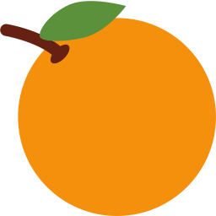  2 ______________ |   3 ___________ |   4 _______________
  5 _______________ |   6 ____________ |   7 ___________ |   8 ___________

B Circle the word that needs 'a', not 'an'.
1 | apple | egg | dog | orange
2 | ice cream | umbrella | banana | ant
3 | elephant | book | egg | apple

C Circle a or an.
1 I've got (a / an) apple.
2 He has (a / an) dog.
3 It's (a / an) umbrella.
4 She eats (a / an) egg.
5 This is (a / an) book.
6 I see (a / an) elephant.
D Find eight words.
Find these words (→ ↓ ↘)
APPLE ORANGE EGG ELEPHANT UMBRELLA BANANA DOG BOOK

W | K | W | O | Q | J | N | I | H | O
A | P | P | L | E | E | G | G | R | R
D | O | G | H | K | Q | I | T | L | A
P | W | G | D | G | Z | R | M | X | N
U | M | B | R | E | L | L | A | I | G
Z | R | E | H | A | A | U | K | O | E
B | D | E | L | E | P | H | A | N | T
O | E | S | B | A | N | A | N | A | O
O | B | L | I | O | N | I | T | J | K
K | S | U | I | S | I | B | N | A | K

E Write the, a or an.
a · an · The

1 ________ sun is hot today.
2 I've got ________ dog. ________ dog is brown.
3 ________ moon is in the sky.
4 She has ________ apple. ________ apple is red.
F Draw an elephant, a banana and an umbrella. Write the words with a / an.
Articles picture

Score: ________ / 23

