Unit 5 · How many? How much? — Quick quiz
15 minutes · Round-Up 3 · Grade 3

Name: ______________________________ Class: ________ Date: ______________
Part 1 · Food words (6 points)
A Look and write the words.
  1 ___________ |   2 ___________ |   3 ___________
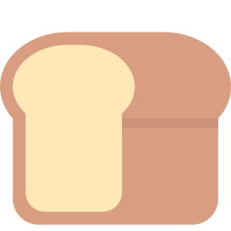  4 ___________ |   5 ___________ | 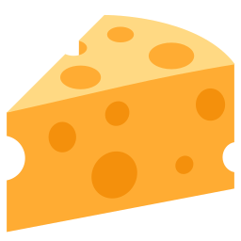  6 ___________

Part 2 · Grammar (8 points)
B Circle the correct word.
1 There are (some / any) bananas.
2 Is there (some / any) milk?
3 How (many / much) apples are there?
4 We haven't got (much / many) water.
C Complete the sentences.
any · a few · a lot of · some · How much

1 There aren't ________ eggs.
2 ____________ bread is there?
3 I have ________ tomatoes.
4 There is ____________ rice.
Part 3 · Reading and writing (6 points)
D Read and answer.
Bobur's kitchen
There are six eggs in Bobur's kitchen. There is a lot of bread, but there isn't any cheese. There are a few apples.

1 How many eggs are there?

2 Is there any cheese?

3 Is there a lot of bread?

E Put the words in the right order.
1 Is / there / water? / any

2 apples. / some / are / There

3 there? / How / are / many / eggs

Score: ________ / 20

