Unit 5 · How many? How much? — Worksheet A
Countable and uncountable food · Round-Up 3 · Grade 3

Name: ______________________________ Class: ________ Date: ______________
A Look and write the words.
water · bananas · milk · apples · tomatoes · bread · rice · eggs

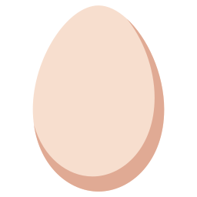  1 ___________ |   2 ___________ | 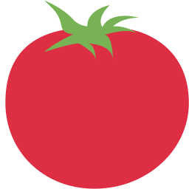  3 ____________ |   4 ___________
  5 ___________ |   6 ___________ | 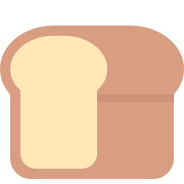  7 ___________ |   8 ___________

B Match the questions to the answers.
1 How many eggs are there? ____ | A There is a lot.
2 How much milk is there? ____ | B There are six.
3 Are there any apples? ____ | C Yes, there is some.
4 Is there any bread? ____ | D No, there aren't any.

C Circle many or much.
1 How (many / much) eggs are there?
2 How (many / much) milk is there?
3 How (many / much) apples have you got?
4 How (many / much) water is there?
5 How (many / much) bananas are there?
6 How (many / much) rice is there?
D Look and complete the words.
1 t_m_t__s  ____________ | 2 appl_s  __________ | 3 b_n_n_s  ___________
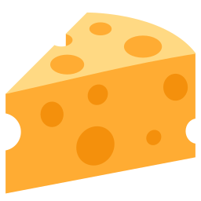  4 ch__s_  __________ |   5 h_n_y  ________ | 6 r_c_  ________

E Find eight food words.
Find these words (→ ↓ ↘)
EGGS APPLES TOMATOES BANANAS MILK WATER BREAD RICE

A | T | F | O | T | R | W | C | Z | N
P | B | O | V | R | R | I | C | E | Z
P | W | A | M | W | P | T | A | O | F
L | A | B | N | A | U | K | E | H | M
E | T | R | S | A | T | C | S | G | I
S | E | E | Q | N | N | O | J | Y | L
K | R | A | E | C | H | A | E | D | K
H | P | D | G | E | K | R | S | S | S
P | Y | I | G | S | Y | V | S | M | C
T | U | E | S | T | M | Z | R | Y | Y

F Draw your fridge with some food. Write: There are some ___ . There is some ___ .
My fridge

Score: ________ / 24

