Unit 6 · Present simple — Worksheet A
Verbs and the third-person -s · Round-Up 3 · Grade 3

Name: ______________________________ Class: ________ Date: ______________
A Circle the correct verb.
1 He (plays / play) football.
2 They (play / plays) in the park.
3 She (watches / watchs) TV.
4 My brother (studies / studys) English.
5 We (eat / eats) dinner at six.
6 It (sleeps / sleep) all day.
B Look and write the verbs.
watch · read · play · eat · drink · study · cook · get up

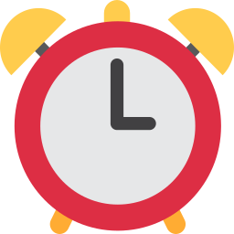  1 ___________ |   2 ___________ |   3 ___________ |   4 ___________
  5 ___________ |   6 ___________ |   7 ___________ |   8 ___________

C Write the correct form of the verb.
1 Aziz ________ (play) football.
2 Malika ________ (read) a book.
3 My mum ________ (cook) plov.
4 He ___________ (watch) TV.
5 She ___________ (study) English.
D Look and complete the verbs.
1 e_t  ________ | 2 dr_nk  ________ | 3 r__d  ________
4 st_dy  ________ | 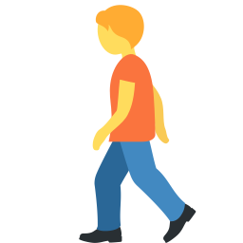  5 w_lk  ________ |   6 sl__p  ________

E Find eight verbs.
Find these words (→ ↓ ↘)
DRINK READ PLAY WATCH STUDY WALK SLEEP COOK

Z | U | W | H | W | I | T | O | G | R
V | X | A | R | S | A | X | L | Z | E
J | X | L | G | S | T | T | H | U | A
H | R | K | K | L | B | U | C | B | D
P | D | W | D | E | N | F | D | H | L
R | V | F | R | E | F | Z | J | Y | A
G | O | H | I | P | P | L | A | Y | K
L | T | A | N | M | Q | M | E | O | R
D | D | I | K | C | O | O | K | Q | O
K | B | T | I | Z | H | K | C | D | A

F Draw your morning. Write: I get up at ___ .
My morning

Score: ________ / 25

