Unit 8 · Where is it? Do! Don't! — Lesson plans
3 lessons × 45 minutes · Round-Up 3 · Grade 3

Adapted for Grade 3 (age 8–9, CEFR A1): the ideas come from the Round-Up 3 unit; all exercises and texts are new.
Unit at a glance
In the book | Round-Up 3, Unit 13 (prepositions of place) and Unit 14 (imperative)
Topic | Prepositions of place and classroom commands
Vocabulary | in, on, under, next to, behind, in front of, between (+ commands: sit down, stand up, open your book, be quiet, listen, don't run, don't shout)
Grammar | • Where is the ball? It's in / on / under / next to / behind / in front of / between …  • Imperatives: Sit down. · Open your book. · Don't run. · Let's play.

Vocabulary
 | English | O'zbekcha
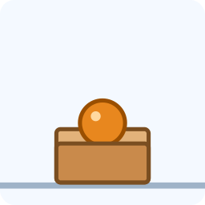 | in | ichida
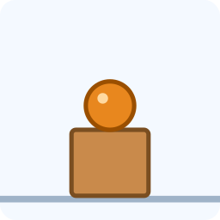 | on | ustida
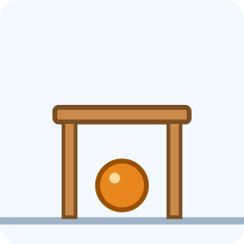 | under | tagida
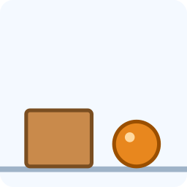 | next to | yonida
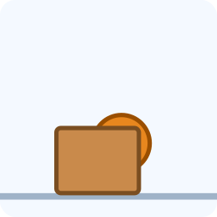 | behind | orqasida
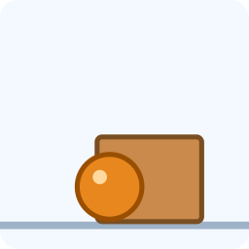 | in front of | oldida
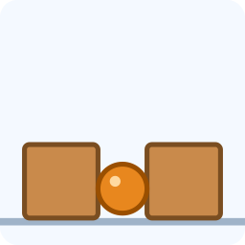 | between | orasida

Extra words used in the lessons
 | English | O'zbekcha
 | Sit down. | O'tiring.
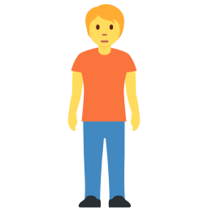 | Stand up. | Turing.
 | Open your book. | Kitobni oching.
 | Be quiet. | Jim bo'ling.
 | Listen. | Tinglang.
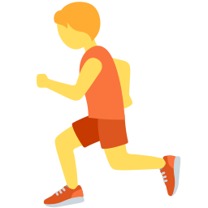 | Don't run. | Yugurmang.
 | Don't shout. | Baqirmang.

Lesson 1: Where is the ball?
Focus | Prepositions of place: in, on, under, next to, behind, in front of, between
Aims (by the end of the lesson pupils can…) | • say where something is  • ask and answer: Where is the ball? It's under the table.
Key language | • in · on · under · next to · behind · in front of · between  • Where is …? It's …
Materials | • A ball and a box (real objects)  • Flashcards of the seven pictures  • Grammar card
Time | 45 minutes

Min | Stage | What happens | Interaction
3 | Greeting & organisation | Hide a small toy in the classroom and ask 'Where is it?' Let pupils guess with Uzbek, then model 'It's under the book.' | T-Ss
5 | Warm-up | Hot and cold: one pupil leaves; the class hides an object; on return the pupil asks 'Is it in the bag?' | T-Ss
10 | Presentation | Use the ball and the box to show all seven prepositions, then show the flashcards. Drill with gestures (hands in / on / under). | T-Ss
12 | Controlled practice | Worksheet A exercises A (label the pictures), B (circle) and D (complete). Pairs place objects and describe. | S / Ss-Ss
10 | Freer practice / production | Barrier game: pairs sit back to back; A places a ball on a picture of a room and describes it; B draws. | Ss-Ss / G
5 | Wrap-up & homework | Teacher places the ball; pupils chorus 'It's in front of the box!' Homework. | T-Ss

Homework: Draw your room and write five sentences: 'My bag is next to the chair.'
Check learning: Listen for correct prepositions in the barrier game.
Teacher tips (o'qituvchi uchun)
- 'in / on / under' o'zbekchada -da, -ning ustida, -ning tagida; rasm + harakat bilan o'rgating.
- 'in front of' — uch so'zli ibora: bir birlik sifatida o'rgating.
- Support: use real objects. Extension: add 'opposite' and 'near'.

Lesson 2: Do! Don't!
Focus | Imperatives: Sit down. Don't run.
Aims (by the end of the lesson pupils can…) | • understand and give classroom commands  • say what we do and don't do in class
Key language | • Sit down. · Stand up. · Open your book. · Be quiet. · Don't run. · Don't shout.
Materials | • Command flashcards  • Worksheet B exercises A–E
Time | 45 minutes

Min | Stage | What happens | Interaction
3 | Greeting & organisation | Give commands in English with gestures: 'Stand up. Sit down.' | T-Ss
5 | Warm-up | Simon says: pupils follow only the commands with 'Simon says'. | T-Ss
10 | Presentation | Show the command cards and act each one. Write the pattern: verb (Do) / Don't + verb. Stress: no 'you', no -s. | T-Ss
12 | Controlled practice | Worksheet B exercises A (circle), B (fill), C (unscramble) and D (class rules text). | S / Ss-Ss
10 | Freer practice / production | Class rules poster: groups write four rules with Do and Don't and draw icons for each. | Ss-Ss / G
5 | Wrap-up & homework | Groups present their poster; class acts out the rules. Homework. | T-Ss

Homework: Write four home rules: 'Don't …', 'Wash your hands.'
Check learning: Check verb base forms (Sit, not Sits) and Don't + verb.
Teacher tips (o'qituvchi uchun)
- Buyruq = fe'lning asl shakli: 'Sit down' (Sits emas). O'zbekchada ham buyruq oddiy: 'O'tir!'.
- Muloyimlik: 'Sit down, please.' — 'please' ni doim ayting.
- Support: picture cards with commands. Extension: add 'Let's …'.

Lesson 3: Treasure hunt
Focus | Prepositions and imperatives together
Aims (by the end of the lesson pupils can…) | • give and follow instructions to find something  • use prepositions and imperatives in one text
Key language | • Look under the chair. · Go to the window. · It's behind the door.
Materials | • A hidden 'treasure' (toy or sweet)  • Clue cards  • Worksheet A exercise E; Worksheet B exercise E
Time | 45 minutes

Min | Stage | What happens | Interaction
3 | Greeting & organisation | Show the treasure box: 'Where is the treasure? Let's find it!' | T-Ss
5 | Warm-up | Give a command: pupils give the class one-word commands in turn (stand, jump, sit). | T-Ss
10 | Presentation | Read the first clue aloud: 'Look under the big book.' Model following it and reading the next clue. | T-Ss
12 | Controlled practice | Groups follow four clue cards with imperatives and prepositions; each clue leads to the next. | G
10 | Freer practice / production | Write your own clues: pairs write three clues for another pair using 'Look …' and prepositions. | Ss-Ss
5 | Wrap-up & homework | The group that finds the treasure reads the last clue aloud. Homework. | T-Ss

Homework: Write two treasure-hunt clues for your family.
Check learning: Check that clues use correct prepositions and imperatives.
Teacher tips (o'qituvchi uchun)
- Xavfsizlik: yugurmang, sekin yuring — 'Don't run!' qoidasini amalda qo'llang.
- Support: give a clue frame. Extension: pupils draw a map.

