Unit 8 · Where is it? Do! Don't! — Quick quiz
15 minutes · Round-Up 3 · Grade 3

Name: ______________________________ Class: ________ Date: ______________
Part 1 · Where is it? (6 points)
A Look and write the word.
  1 ___________ |   2 ___________ | 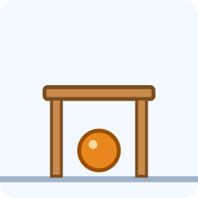  3 ___________
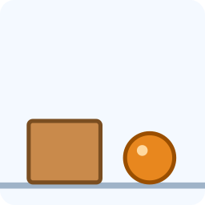  4 ___________ | 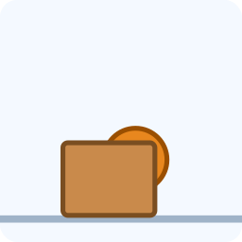  5 ___________ | 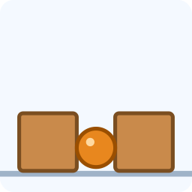  6 ___________

Part 2 · Grammar (8 points)
B Circle the correct word.
1 (Sit / Sits) down.
2 (Don't / Doesn't) run.
3 The cat is (under / in) the table.
4 Let's (go / goes) to the park.
C Complete the sentences.
in · behind · Don't · on · Open

1 The ball is ________ the box.
2 ________ your book, please.
3 The bag is __________ the door.
4 ________ shout.
Part 3 · Reading and writing (6 points)
D Read and answer.
Class rules
In our class we listen to the teacher. We don't shout. We sit on our chairs. We put our bags under the desks.

1 Do they shout?

2 Where do they sit?

3 Where do they put their bags?

E Put the words in the right order.
1 run. / Don't

2 is / desk. / book / on / The / the

3 bag. / Open / your

Score: ________ / 20

