Unit 8 · Where is it? Do! Don't! — Worksheet A
Prepositions of place · Round-Up 3 · Grade 3

Name: ______________________________ Class: ________ Date: ______________
A Look and write the word.
under · next to · on · behind · in front of · in · between

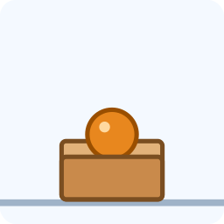  1 ___________ | 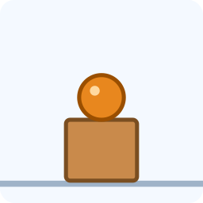  2 ___________ | 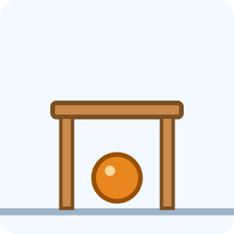  3 ___________ | 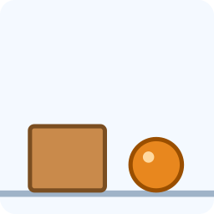  4 ___________
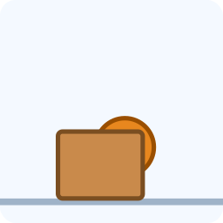  5 ___________ | 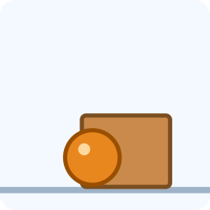  6 _______________ | 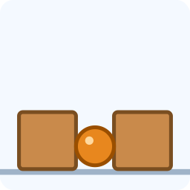  7 ___________

B Look and circle the correct word.
1 The ball is (in / on / under) the box.
2 The ball is (in / on / under) the box.
3 The ball is (in / on / under) the table.
4 The ball is (next to / behind / on) the box.
5 The ball is (in front of / behind / under) the box.
6 The ball is (between / on / in) the boxes.
C Look and complete the words.
1 und_r  ________ | 2 b_h_nd  __________ | 3 b_tw__n  ___________

D Complete the sentences.
under · next to · behind · in · on

1 The cat is ________ the table.
2 The book is ________ the desk.
3 The bag is ___________ the chair.
4 The boy is __________ the door.
E Find words.
Find these words (→ ↓ ↘)
UNDER BEHIND BETWEEN TABLE BALL

O | D | X | C | U | E | S | B | V
X | C | W | S | U | M | A | A | T
B | A | Z | Y | N | X | D | L | A
O | E | V | D | D | U | W | L | B
C | Z | H | S | E | D | S | C | L
C | H | L | I | R | N | H | C | E
Q | F | Z | Z | N | A | Q | H | C
A | Y | M | L | M | D | H | K | Q
B | E | T | W | E | E | N | O | U

F Draw a ball in a box, on a box and under a table. Write the words.
My pictures

Score: ________ / 20

