Progress test B
Mini-units 6–9: school life · food and shopping · weather and seasons · clothes and appearance · 30 points · 30 minutes · Destination A1 · Grade 3

Name: ______________________________ Class: ________ Date: ______________
Part 1 · Choose (8 points)
A Circle the correct word.
1 We (have / has) Maths on Monday.
2 I like Art (because / but) it's fun.
3 How (much / many) is the milk?
4 There aren't (some / any) apples.
5 It's (sunny / sun) today.
6 What's the weather (like / is)?
7 She (has / is) got long hair.
8 They (are / is) wearing gloves.
Part 2 · Complete (8 points)
B Complete the sentences.
because · coat · has · What's · autumn · summer · is · water · have · How much

1 __________ your favourite subject?
2 I like English ___________ it is fun.
3 I'd like a bottle of ________, please.
4 ____________ is the bread?
5 In __________ it's hot and sunny.
6 I wear a ________ in winter.
7 He ________ got short hair.
8 She ________ wearing a red dress.
Part 3 · Words (4 points)
C Look and write the words.
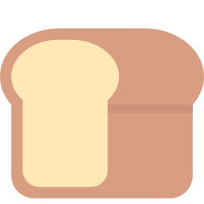  1 ___________ | 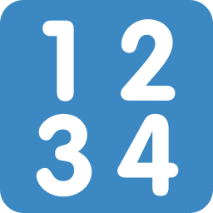  2 ___________ |   3 ___________ |   4 ___________

Part 4 · Reading and sentences (6 points)
D Read and answer.
Aziza at the market
It is Saturday and it is sunny. Aziza is at the market with her dad. She is wearing a yellow dress and a white hat.
They want some tomatoes and a loaf of bread. 'How much is the bread?' asks Dad. 'It's 4,000 sum,' says the shop assistant.

1 What's the weather like?

2 What is Aziza wearing?

3 How much is the bread?

E Put the words in the right order.
1 How / much / the / is / milk?

2 winter / snowy. / like / because / I / it's

3 hats. / are / They / wearing

Part 5 · Writing (4 points)
F Write 4 sentences about you.
Help box
My favourite subject is ___ because ___ .
I like ___ .
In ___ it's ___ .
I'm wearing ___ .

Score: ________ / 30

